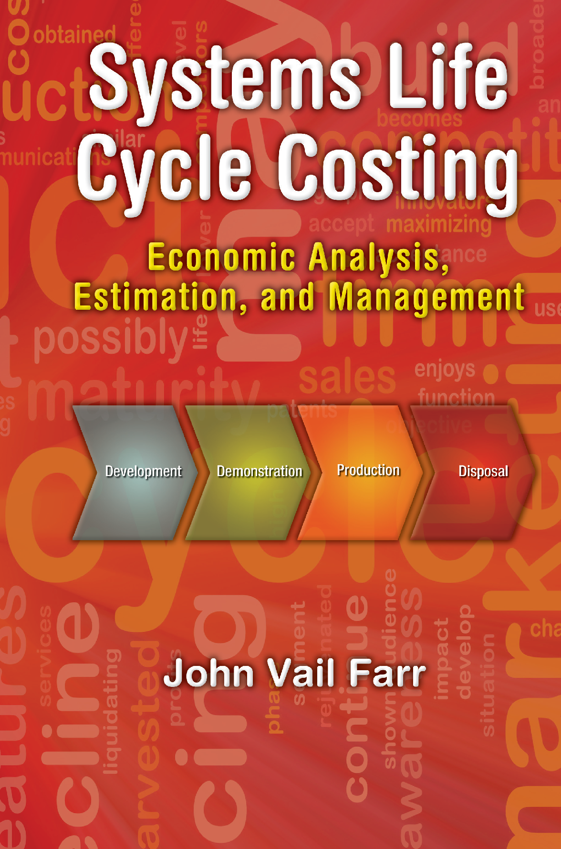

**Systems Life Cycle Costing**

**Economic Analysis, Estimation, and Managment**

Engineering Management Book Series

*Series Editors*

Timothy George Kotnour – Associate Professor Waldemar Karwowski – Professor & Chair *Department of Industrial Engineering and Management Systems University of Central Florida (UCF), Orlando, FL*

Published Titles:

Systems Life Cycle Costing: Economic Analysis, Estimation, and Management,

*John Vail Farr*

Transforming Organizations: Strategies and Methods

*Timothy George Kotnour*

Forthcoming Titles:

Lean Six Sigma for the Healthcare Enterprise: Methods, Tools, and Applications

*Sandra L. Furterer*

Systems Engineering Focus to Business Architecture: Models, Methods, and Application

*Sandra L. Furterer*

Systems Life Cycle Costing

**Economic Analysis, Estimation, and Managment**

**John Vail Farr**

Boca Raton London New York

CRC Press is an imprint of the

Taylor & Francis Group, an **informa** business

CRC Press

Taylor & Francis Group

6000 Broken Sound Parkway NW, Suite 300 Boca Raton, FL 33487-2742

© 2011 by Taylor & Francis Group, LLC

CRC Press is an imprint of Taylor & Francis Group, an Informa business

No claim to original U.S. Government works Version Date: 20110707

International Standard Book Number-13: 978-1-4398-2892-2 (eBook - PDF)

This book contains information obtained from authentic and highly regarded sources. Reasonable efforts have been made to publish reliable data and information, but the author and publisher cannot assume responsibility for the validity of all materials or the consequences of their use. The authors and publishers have attempted to trace the copyright holders of all material reproduced in this publication and apologize to copyright holders if permission to publish in this form has not been obtained. If any copyright material has not been acknowledged please write and let us know so we may rectify in any future reprint.

Except as permitted under U.S. Copyright Law, no part of this book may be reprinted, reproduced, transmit- ted, or utilized in any form by any electronic, mechanical, or other means, now known or hereafter invented, including photocopying, microfilming, and recording, or in any information storage or retrieval system, without written permission from the publishers.

For permission to photocopy or use material electronically from this work, please access www.copyright. com (<http://www.copyright.com/)> or contact the Copyright Clearance Center, Inc. (CCC), 222 Rosewood Drive, Danvers, MA 01923, 978-750-8400. CCC is a not-for-profit organization that provides licenses and registration for a variety of users. For organizations that have been granted a photocopy license by the CCC, a separate system of payment has been arranged.

**Trademark Notice:** Product or corporate names may be trademarks or registered trademarks, and are used only for identification and explanation without intent to infringe.

**Visit the Taylor & Francis Web site at** [**http://www.taylorandfrancis.com**](http://www.taylorandfrancis.com/)

**and the CRC Press Web site at** [**http://www.crcpress.com**](http://www.crcpress.com/)

# Contents

Preface xi

Acknowledgments xiii

Author xv

**Chapter 1** Overview of Systems Life Cycle Costing 1

* 1. Introduction to Systems Life Cycle Costing 1
  2. Systems Life Cycle Costing 2
  3. Economic Analysis 4
  4. Cost Estimation 5
     1. Parametric Cost Estimation 5
     2. Analogy Cost Estimating 6
     3. Engineering Buildup 7
  5. Cost Management 7
  6. Summary 9

Questions 10

References 10

Bibliography 11

Chapter 2 Introduction to Engineering Economy 13

* 1. Introduction 13
  2. Capital Budgeting Decision 14
     1. Basic Concepts in Capital Budgeting 14
     2. Benefit and Cost Development 15
  3. Time Value of Money 16
     1. Interest 16
        1. Simple Interest 17
        2. Compounded Interest 18
        3. Interest Compounded Other

than Yearly 21

* 1. Amortization 22
  2. Investment Measures 26
  3. Inflation/Deflation 29
  4. Summary 30

Question 30

Problems 31

Reference 37

Bibliography 37

v

**Chapter 3** Advanced Economic Analysis of Alternatives 39

* 1. Introduction to Advanced Cash Flow Analysis 39
     1. Depreciation 39
     2. Corporate Income Taxes 42
  2. Income and Cash Flow Statements 43
  3. Expected Value 43
  4. Sensitivity Analysis 47
  5. Break-Even Analysis 50
  6. Summary 50

Questions 50

Problems 50

Reference 58

Bibliography 58

Chapter 4 Life Cycle Framework and Techniques 59

* 1. Introduction to Developing Life Cycle Models 59
  2. Developing LCC Models 59
  3. Life Cycle Cost Categories 60
     1. Industrial Base and Supplier/Vendor

Relationships 61

* + 1. Research, Development, Testing, and Evaluation 61
    2. Acquisition 61
    3. Operations and Support 62
    4. Disposal or Retirement 63
  1. Estimating LCC throughout the Product

Development Cycle 65

* + 1. Analogy 65
    2. Parametric 65
    3. Detailed Engineering Builds 67
    4. Cost Accounting 67
  1. Summary 68

Questions 68

Problems 70

References 73

Bibliography 74

Chapter 5 Simulation-Based Costing 75

* 1. Introduction 75
     1. Ways to Study a System 76
     2. Advantages and Disadvantages of Simulations 77
  2. Review of Probability and Statistics 78
     1. Introduction 78
     2. Random Variables 78
     3. Probability Density Functions 80
     4. Cumulative Distribution Functions 82
     5. Special Distributions 85
        1. Uniform Distribution 85
        2. Normal Probability Distribution 85
        3. Poisson Distribution 88
  3. Discrete Process Generators 89
  4. Continuous Process Generators 93
     1. Inverse Transform Method 93
     2. Exponential CPG Derived 95
  5. Probability and Statistics Summary 97
  6. Simulation in Practice 98
     1. Introduction 98
     2. Building Complex Simulations 98
  7. Using Readiness Levels for Model Input 101
  8. Simulation Using Spreadsheets 104
  9. Building Systems Simulations 106
  10. Summary 106

Questions 107

Problems 109

Appendix 5A 131

References 133

Chapter 6 Costing of Complex Systems 135

* 1. Introduction 135
  2. Issues Surrounding Complex Systems 135
  3. Systems Engineering and Management Costs 136
     1. Hardware Costs 136
     2. Software Costs 138
     3. Interfaces and Integration at the System Level 138
     4. Systems Engineering/Project Management Costs 138
  4. From Requirements to Architectures 144
  5. Summary 145

Questions 146

Problem 147

References 147

Bibliography 148

Chapter 7 Software-Intensive Systems 149

* 1. Introduction 149
  2. Software Estimating Techniques 150
     1. Overview 150
     2. Expertise Based and Hybrid 152
     3. Algorithmic 152
        1. Original or Basic COCOMO Model 153
        2. Intermediate COCOMO 159
        3. Advanced COCOMO 159
        4. Function Points 160
     4. Mathematical and Statistical 163
  3. Summary 165

Questions 165

Problems 166

Appendix 7A 168

References 170

Bibliography 171

Chapter 8 Parametric Cost Estimating 173

* 1. Introduction 173
  2. Role of Statistics 178
  3. Some CERs of Interest 179
     1. Learning Curves 179
     2. Wright’s Method 180
  4. Summary and Conclusions 181

Questions 182

Problems 182

References 184

Bibliography 184

Chapter 9 Cost as an Independent Variable 185

* 1. Introduction 185
  2. CAIV Evolution through the Life Cycle 187
     1. Conceptual Exploration 187
     2. Component Advanced Development, Systems Integration Preliminary Design 188
     3. Systems Demonstration, Test, and Evaluation 189
     4. Production 190
     5. Operation, Support, and Disposal 190
  3. CAIV Metrics 190
  4. Design to Cost versus CAIV 190
     1. Introduction 190
     2. Overview of Design to Cost 192
        1. DTC Roles and Responsibilities 192
        2. Impact of LCC in the Program 192
        3. Elements of DTC Program 193
        4. DTC Plan 193
        5. Cost Controls (Goals) 194
        6. DTC Trade Space Studies 194
        7. Provide Incentives and Awards 194
        8. Establish Metrics 195
        9. Implementing Risk Management 195
     3. Role of CAIV and DTC 196
        1. CAIV Plan 196
        2. Set Cost Goals 196
        3. Establish Cost Performance Integrated Product Team 197
        4. Perform Tradeoff Studies 197
        5. Provide Incentives 198
        6. Establish Metrics 198
        7. CAIV Templates 199
        8. Implementing Risk Management 200
     4. Differences between DTC and CAIV 200
        1. Concept Focus 202
        2. Costs Tradeoffs 202
        3. Trading Off Performance

Requirements 202

* + - 1. Reducing LCC 203
      2. Incentives 203
    1. Summary of DTC as Related to CAIV 203
  1. Summary 204

Questions 204

References 205

Bibliography 205

**Chapter 10** Costing and Managing Off-the-Shelf Systems 207

* 1. Introduction 207
  2. COTS 211
     1. Hardware-Centric COTS 214
     2. Software-Centric COTS 217
     3. Integration Costs 220
  3. GOTS 221
  4. Software Reuse 221
     1. LCC Associated with Software Reuse 222
     2. Cost Reductions Achieved with Software Reuse 223
  5. Open Source 223
  6. Summary 225

Questions 227

Problems 228

References 229

Bibliography 230

Chapter 11 Cost of Quality 231

* 1. Introduction 231
     1. Definition of the Cost of Quality (CoQ) 233
  2. Six Sigma 235
  3. CMMI 236
  4. Generic Cost of Quality Models 236
     1. Cost of Quality from a Software Perspective 237
  5. Conclusions 238

Questions 239

Problems 239

References 240

Bibliography 240

**Chapter 12** Project Management’s Role in Life Cycle Costing 241

* 1. Introduction 241
  2. Basics of Networks 241
     1. Development of the ADM Network 244
     2. CPM Calculations 245
  3. Work Breakdown Structure 246
  4. Progress Measurement 247
     1. Evaluation of CPM 249
  5. Simulation of Networks 251
  6. Summary 251

Question 252

Problems 252

References 261

Bibliography 261

Appendix A: Abbreviations and Acronyms 263

Appendix B: Excel® Tutorial to Support Economic Analysis and

Simulation-Based Costing 267

* 1. Introduction 267
  2. Excel 2007 Basics 267
     1. Excel Basics 267
     2. Some Basic Functions 270
     3. Recording Simulation Run Data Using Excel 272
  3. Graphing with Excel 273
  4. Managing Your Worksheet and Workbook 276
  5. Interest Rates, Time Value of Money, and IRR 277
     1. Calculating the Rate of Return Factors Using Excel 285
  6. Sensitivity Analysis Using the Excel Spreadsheet function 287
  7. Additional Functions of Time Value of Money 290

References 294

# Preface

At the undergraduate level, most engineers are at best introduced to engineering economics as their only exposure to the costing and estimating of projects. Many universities provide only an introduction to that material in some type of capstone class. Few require a whole course on the subject. At the graduate level, most pro- grams are domain centric; to receive any exposure to cost estimation and manage- ment, engineers must pursue an MBA or learn the appropriate skills via on-the-job training. Thus, most engineers are ill prepared to enter and excel in the job market and work on interdisciplinary projects where cost analysis, estimation, and manage- ment skills are not only valued but required. Their formal training having failed them, they must learn the requisite costing, accounting, and management skills via on-the-job training or return to school to pursue a business or related degree. It was with this backdrop that this text was written. Unfortunately, most formal education business and management programs do not provide the skills needed to be a program or product manager, to bring products to market on time and within budget, to under- stand the true costs of a product, and to conduct tradeoff analyses.

I chose the title, *Systems Life Cycle Costing: Economic Analysis, Estimation, and Management*, because it reflects the philosophy and skills needed by modern engineers and other technology professionals. First and foremost in importance are the cost analysis, estimation, and management of systems. Although components are important, the more challenging and relevant problems are complex systems. Second, engineers must worry about life cycle costing (LCC) and not simply devel- opment costs. All too often, engineers cost only their own piece of the life cycle and do not make sound acquisition decisions using quantifiable and defendable LCC analysis. Last, an engineer must be able to conduct economic analysis, estimate the cost of the system, and manage people and resources as part of the business enter- prise to ensure that an efficient product is developed.

Unlike the mature knowledge encompassed by the traditional engineering disci- plines, the techniques and tools for costing and managing complex systems are rap- idly evolving and being driven mainly by the commercial sector. Also, the methods, processes, tools (MPTs), and techniques are often not presented in the open literature because of the competitive advantage afforded any company that can accurately esti- mate the LCC of a product. Thus, much of the MPTs referenced here were gleaned from government sources, especially the Department of Defense (DoD) and the National Aeronautics and Space Administration (NASA). This was not my desire; however, the DoD and NASA are in many ways the intellectual thought leaders on costing and estimating of complex systems because of the sheer size and complexity of their projects and programs.

When I started this text I had hoped to improve on the engineering economy material taught in most engineering programs. I originally thought this text could be used in graduate programs in engineering management, mechanical engineer- ing, systems engineering, etc. As my ideas matured and I collected feedback from

**xi**

**xii** Preface

students and other customers, I became convinced that this was the right set of MPTs and should replace engineering economy courses at both the undergraduate and graduate levels. First, tools such as Excel®* have made teaching real-world costing problems possible. Second, most engineers work in an interdisciplinary world and must understand the LCC of their products. To succeed, entry-level engineers simply need more than the mathematics of the time value of money; in other words, more than what is taught in traditional engineering economics. Life cycle costing is at best an immature industry-driven discipline. Unfortunately, textbooks such as this are often long on theory and short on meaningful examples, real data, and so forth.

My former colleagues at West Point, along with the students and faculty at Stevens Institute of Technology, contributed to much of the material presented herein. Although I made every effort to correctly reference the material, I suspect there are phrases and other elements of the book that are not properly referenced. If you encounter a phrase, figure, or other element that is not correctly cited, please send me the correct information. I also welcome your ideas and comments regard- ing problems, mistakes, or even new material. Leave your feedback at [http://www.](http://www/) systemscosting.com/, where you will also find lecture material, problem solutions, and other teaching/learning aids.

#### John V. Farr

* Excel is a registered trademark of Microsoft Corporation.

# Acknowledgments

I would like to thank some of the many people who contributed to the publishing of this textbook. First and foremost, I would like to thank my former colleagues at West Point and at Stevens Institute of Technology, whose dedication to excel- lence motivated me to write and more importantly to complete this text. Their high standards for knowledge creation and dissemination sustained me when writing this book became tedious.

At the risk of unintentionally not recognizing someone who contributed to this effort, I would like to specifically thank

* + Anirban Ganguly, who wrote most of the Excel guide contained in Appendix B
  + Tom Herald, Lockheed Martin Corporation and Stevens, for helping me develop a meaningful outline and making sure the content was relevant to industry
  + Bruce Barker and Larry Bernstein, both from Stevens Institute of Technology whom I consider authorities on software estimating and costing
  + Greg Stinson and Steve Charbonneau, former colleagues of mine at West Point, who wrote some of the material and example problems in Chapter 5 on simulation for a course they taught in engineering management
  + The many students who took my engineering cost management class, who provided me with feedback and much of the material contained herein; in particular,
    - Diane Perazzo, Northrop Grumman, who wrote elements of the mate- rial in Chapter 11 on quality as part of her term paper for my class in life cycle costing
    - Janet Oren, Department of Defense, who wrote some of the material on software reuse and developed several of the problems in Chapter 10
    - Ivonne Donate, Department of Defense, who wrote much of the mate- rial comparing design to cost and cost as an independent variable in Chapter 9

I would be remiss if I did not thank the many students beyond those specifically mentioned who encouraged me to write the book and contributed to much of the material used in the text.

Most importantly I would like to thank my wife, Michele, and my two sons, Michael and David, for their patience during the many nights I worked late on this book and their understanding as I traveled around the world to teach the course for which it was developed.

**xiii**

# Author

**John V. Farr, PhD,** is a professor of engineering management and director of the Center for Nation Reconstruction and Capacity Development at the U.S. Military Academy at West Point. Prior to returning to West Point in 2010, he was a profes- sor of systems engineering and engineering management in the School of Systems and Enterprises at Stevens Institute of Technology. He was the founding direc- tor of the Department of Systems Engineering and Engineering Management at Stevens, which he led from 2000 to 2007. He served as associate dean for academics from 2007 to 2010. He taught at West Point from 1992 to 2000 and achieved the rank of professor of engineering management. Dr. Farr was one of the first permanent civilian professors in engineering at the academy.

Dr. Farr is a past president and fellow of the American Society for Engineering Management, a fellow of the American Society of Civil Engineers, and a former member of the Army Science Board, and is currently a member of the Air Force Studies Board of the National Academies. He is a former editor of the *Journal of Management in Engineering* and the founder of the *Engineering Management Practice Periodical*. He has authored more than 100 technical publications, includ- ing several textbooks. He is a registered civil engineer in New York and Mississippi and holds an undergraduate degree from Mississippi State University, a master’s from Purdue University, and a PhD in civil engineering from the University of Michigan.

**xv**

# Overview of Systems Life Cycle Costing

1

## INTRODUCTION TO SYSTEMS LIFE CYCLE COSTING

In today’s global business environment, engineers, information technology profes- sionals and practitioners, and other related product development professionals inte- grate hardware, software, people, and interfaces to produce economically viable and innovative applications while ensuring that all pieces of the enterprise are working together. No products or services are immune from cost, performance, schedule, quality, risks, and tradeoffs. Yet engineers spend most of their formal education focused on performance and most of their professional careers worrying about resources and schedules. Too often they become fixated on the technical perfor- mance to meet the customer’s expectations without worrying about the downstream costs that contribute to the total life cycle costs (LCC) of a system. Unfortunately, in many cases the LCC or total ownership costs (TOC) are ignored because either the total costs would make the project untenable (especially for large government projects) or the increased acquisition costs needed to reduce the LCC would make the project unacceptable.

Engineers have an extensive array of economic techniques and tools at their dis- posal to predict and monitor costs and schedules, yet overruns are commonplace and in general are the rule rather than the exception, especially for software-enabled systems. They do not understand either the technical or nontechnical aspects of LCC and the associated risks. Figure 1.1 shows some of the external and internal factors one must tackle in conducting cost analysis and then address in order to manage the program in the most effective manner.

Engineering has changed dramatically in our technology-driven global economy. Beyond technical excellence, understanding the economics or business aspects of modern engineering is key to success. In a profession where network-centric sys- tems of systems are commonplace, engineers must be involved in all aspects of new product development. Accounting, project management, leadership, and marketing are just some of the necessary skills for success in the workforce. It is against this backdrop that this book was written, to serve as a collection of methods, processes, tools (MPTs), and terminology needed to understand the business aspects of modern engineering.

This book consists of three sections: analysis, estimation, and management. The engineering analysis section (Chapters 2–5) presents techniques such as engineering economics and simulation-based costing (SBC), with the focus on total life cycle understanding and perspective. The techniques introduced for detailed analysis are relevant for modern complex systems. In the estimation section (Chapters 6–8), the

**1**

***Ce Current***

***Environment***

Multiple Prime/Subcontractor Teams

Eroding Industrial Base, Outsourcing, and Greater International Competition

Extended System Life Cycles

Longer Acquisition Times

Changing Technology

Higher Overall non Project Costs (Litigation, Environmental, Etc)

Dwindling Resources

Development Centric Instead of Life Cycle Cost Perspective

Constantly Changing Requirements

Increasing System Complexities with Exponential Software Growth

**FIGURE 1.1** Some of the factors that can affect the cost of a system. (Modified from Stevens Institute of Technology. 2008. “SYS 625 Fundamentals of Systems Engineering.” Class notes.)

analogies or “rules of thumb” techniques are grouped with the MPTs for conducting a detailed engineering buildup for costing. This section presents the estimating cost- ing of complex systems and software. Finally, in the management section (Chapters 9–12) we explore design to cost (DTC), cost as an independent variable (CAIV), the role of commercial off-the-shelf (COTS) technology, cost of quality, and the role of project management in LCC management.

## SYSTEMS LIFE CYCLE COSTING

Life cycle cost is the TOC of a product over its useful life. Life cycle costs are all the anticipated costs associated with a project or program throughout its life. They are the sum total of the direct, indirect, recurring, nonrecurring, and other related costs incurred, or estimated to be incurred, in design, research and development (R&D), investment, operations, maintenance, retirement, and other support of a product over its life cycle (i.e., its anticipated useful life span). All relevant costs should be included regardless of funding source, business unit, management con- trol, etc. Determining LCC is important for systems because the acquisition is a small part in relation to the true or total costs associated with owning and operating the systems.

The four generally accepted methods for determining LCC include

* + 1. Engineering costs—direct estimation at the component level leading to a detailed engineering build of the system
    2. Cost accounting—modern cost management systems to track and allocate expenses
    3. Analogy—an estimate using historical results from similar products or components
    4. Parametric—based on mathematical relationships between costs and some product- and process-related parameters

Any combination of these four can be used to develop TOCs.

Analogy and parametric cost estimates (PCEs) would be considered top-down estimating techniques in which the costs are estimated by looking at historical data based on the customer’s requirements. Engineering costs (or detailed engineering builds) and accounting techniques are bottom-up methods and refer to estimating and tracking costs by breaking down the project into elements using work break- down structure (WBS) and physical and functional architectures.

In its simplest form, LCC comprises initial and future expenses. However, clearly defining initial costs can be a challenge. For example, take a typical standard new product development process, as shown in Figure 1.2. How does one allocate invest- ments to the industrial base for major projects? What about spare parts? Should they be categorized as production or operations and support? Very quickly decision mak- ing becomes mired in determining how and when to allocate expenses. Figure 1.2 also shows the standard LCC terminology and model adopted for this text and how costs are committed and incurred as a function of phases in my LCC model. This figure will be referenced throughout the text because of its importance in illustrating how programs and funds are committed early in a program as well as what tech- niques should be utilized and when.

Conceptual Exploration

Component Advanced Development

Systems Systems I D

ntegration/ emonstration

,

Preliminary Test, and

Production

Design

Evaluation

Operations, Support, & Disposal

Less Ability to Influence LCC (85% of Cost Decisions Made)

High Ability to Influence LCC (70-75%

of Cost Decisions Made)

(10%-15%)

Little Ability to Influence LCC (90-95% of Cost Decisions Made)

(5%-10%)

**28% Life Cycle Cost**

Minimum Ability to Influence LCC (95% of Cost Decisions Made)

**72% Life Cycle Cost**

**FIGURE 1.2** Costs incurred and committed during the systems life cycle acquisition pro- cess. (Modified from Andrews, Richard. 2003. *An Overview of Acquisition Logistics*. Fort Belvoir, VA: Defense Acquisition University. Accessed April 2, 2007, https://acc.dau.mil/ CommunityBrowser.aspx?id=32720)

**Economics** Engineering Economy Cost of Capital Overhead

Labor and Subcontracting Supplier Demand

**Cost Management**

Budget

Full Cost Management Project Evaluation

Life Cycle Perspective

**Competencies Needed For Economic Analysis, Estimation, and Management**

**Compliance** Import/Export Standard Laws/Legislation Internal Processes

**External Relationships** Lateral Relationships

Expectations Management Vendors Relationships

**Technical Acumen** Production and Operation Technical Planning

Risk

Systems Perspective Interface Management

**Engineering Depth** Technical Discipline Depth Domain Applications Methods, Processes, Tools SoS and LCC Perspective Operations

**Quantitative Ability** Data Analysis Knowledge Capture Quantitative Methods

**Accounting**

GAAP

Proposal Analysis Cost Tracking

**FIGURE 1.3** Competency model for economic analysis, estimation, and management.

The MPTs and terminology presented are important in that they can be used to:

1. Estimate the total costs to the various stakeholders
2. Reduce/capture TOC through use of LCC tradeoffs in the systems engi- neering or product development process
3. Control cost through use of LCC contractual provisions in procurements
4. Assist in day-to-day acquisition management actions by providing timely, consistent, and relevant cost information
5. Determine whether to proceed to the next development phase (through an understanding of the TOC)

Figure 1.3 presents just some of the competencies needed for good cost analy- sis, estimating, and management. Although probably incomplete, the figure does demonstrate the diverse skills needed to conduct accurate estimates and manage a project.

## ECONOMIC ANALYSIS

All engineers must make tradeoffs in the four domains shown in Figure 1.4. Good engineers follow a disciplined and structured approach when developing a product or system. Costing hardware, software, and integration requires an understanding of many MPTs and terminology, but few engineers have received this formal training. Once technical characteristics have been ascertained from the requirements, select- ing the right MPTs is critical to accurately determining costs early in the develop- ment cycle and estimating realistic LCC.

The most common engineering cost analysis techniques are those often taught in engineering economy and include the time value of money. Chapters 2 and 3 of this text focus on using the time value of money techniques as the basic building block for more advanced techniques, such as SBC. The ability to conduct relevant economic

Performance

Risk/Quality

Cost

Schedule

**FIGURE 1.4** Domains in which engineers make tradeoffs for any project.

analysis is key to technologically innovative solutions grounded in business reality. Chapter 4 addresses the elements of LCC, with a focus on terminology. Many of the techniques presented in Chapter 2 are used to demonstrate the importance of a life cycle perspective when developing TOCs.

Chapter 5 uses traditional simulation to quantify risk for cost analysis. Simulation- based costing has become the methodology of choice for estimating cost and sched- ule for large systems. Although complex and data intensive, SBC has tremendous utility in assessing risk and variability.

Because of complexity and technology, the costing of complex systems has become a tremendous challenge. Most cost estimators understand how to cost hardware and to a lesser extent software. However, we are still developing tools and processes for costing the integration and interfaces of complex systems. As engineers design and develop scale to larger and more complex systems, system of systems (SoS), and enterprises, our ability to determine costs becomes less relevant and reliable.

## COST ESTIMATION

Cost estimation techniques can be divided into three categories: PCEs, analogies, and detailed engineering builds. Figure 1.5 shows their applicability throughout the product development life cycle. Accounting will not be addressed in the text. However, capturing expenses in a formal manner is certainly the best way to ascer- tain costs. Obviously, developing true costing amounts and utilizing good cost man- agement requires good accounting practices and the tracking of expenses using activity-based costing techniques. Figure 1.6 illustrates some of the challenges a cost estimator faces and some of the ways to mitigate them.

* + 1. **PARAMETRIC COST ESTIMATION**

Parametric cost estimates are usually based on mathematical equations or mod- els. Simple mathematical relationships such as linear and nonlinear regression are mainly utilized. Often they are based on historical data from like projects. Tools

Conceptual Exploration

Component Advanced Development

Systems Systems I / D

ntegration emonstration

,

Preliminary Test, and

Production

Design

Evaluation

Operations, Support, & Disposal

**Parametric Cost Estimation**



**Analogy**

**Detailed Engineering Build Up**



Primary Technique Some Applicability Little or No Utility



**FIGURE 1.5** Cost estimation techniques throughout the life cycle. (Modified from National Aeronautics & Space Administration (NASA). 2008. “Cost Estimating Handbook.” [www.](http://www/) nasa.gov/ceh_2008/2008.htm)

**On Time, On Budget Project Cost and Schedule Overruns**



Lack of and Inexperienced Unreliable and Poorly

Data Trained Analysts

Detailed Stable and Do ion

cumentat Adequate

Well Defined

Stable Leadership

Available Budget Risk

Analysis and

Mitigation

Requirements

Unstable and Inadequate Budget

New Methods, Processes, and Tools

No Risk

Mismatched

Mitigation Plan Expectations

Significant In y

teroperabilit

Requirements

Stable

Complex Immature No Historical Integration Technology Data

Well Trained Historical

and Experienced Data Analysts Available

Poor Leadership Software Centric Industrial Base Requirements

Unstable or

Complex

Lack of Robust Unstable

Systems

**FIGURE 1.6** Challenges cost estimators typically face. (Modified Government Accounting Office (GAO). 2009, March. “Cost Estimating and Assessment Guide Best Practices for Developing and Managing Capital Program Costs,” GAO-09-3SP.)

such as Excel can be utilized easily to fit these relationships. The biggest challenge is determining the relationship between the dependent and independent variables and their range of usefulness.

* + 1. **ANALOGY COST ESTIMATING**

Analogy estimates are performed on the basis of comparison and extrapolation using like items or efforts. In many instances this can be accomplished using sim- ple relationships or equations representative of detailed engineering builds of past projects. The preferred means to conduct a cost estimate early in the product life

cycle is to use data from programs that are technically representative of the pro- gram to be estimated. Cost data are then subjectively adjusted upward or down- ward, depending on whether the subject system is felt to be more or less complex than the analogous program (NASA, 2004).

* + 1. **ENGINEERING BUILDUP**

Sometimes referred to as “bottom-up” estimating, the engineering buildup meth- odology rolls up individual estimates for each element, item, or component into the overall cost estimate. This can be accomplished at the WBS element or at the com- ponent level. This costing methodology involves the computation of the cost of a WBS element by estimating at the lowest level of detail and computing quantities and levels of effort to determine the total system cost. This is the most accurate means to develop a cost estimate. The challenge early in the systems development process is that a bottom-up approach cannot be used because the systems have not been fully designed. Ideally, one would take bottom-up estimates and scale based on experience.

The techniques used in estimating software (here software is treated sepa- rately from systems) are much more mature than systems. At best, the tools com- monly used in systems are estimates and analogies and have little mathematical basis. Chapter 6 addresses the costing of complex systems. Chapter 7 addresses solely software. Whether purely a service-centric or a physical system, most products now have a significant software element. The methodology for esti- mating software has been around for more than 30 years and can be classed as a PCE tool. However, because of new languages, hardware/software integration challenges, computer-aided software tools, etc., techniques and algorithms must be continually updated. Software estimating is still dominated by experience supplemented with quantitative techniques. Chapter 8 presents the details of PCEs, which, early in the development cycle, are probably the most popular technique.

## COST MANAGEMENT

Engineering cost management can be defined as the process to identify, allocate, manage, and track resources needed to meet the stakeholder’s requirements. This integrated, process-centered approach, backed with quantifiable data and docu- mented processes, provides real and tangible benefits to all stakeholders throughout the life cycle. Engineering cost management can best be described as an integrated, process-centered, measurable, and disciplined approach to LCC and management to make the tradeoffs among cost, performance, schedule, and risk. Good cost manage- ment practices, supported by sound analysis, can lead to:

* Complete, unambiguous, and documented functional requirements in order to meet LCC goals
* Bounded and clearly defined product functional expectations and accep- tance criteria, understood and agreed to by all stakeholders
* More accurate, credible, and defensible scope, cost, and schedule estimates with realistic assessments of risk
* More complete and timely risk identification, leading to more effective risk mitigation
* Properly quantifying, evaluating, and controlling the acceptance and tim- ing of changes to requirements (i.e., precluding “scope creep”)
* Final products that deliver better reliability, adaptability, usability, perfor- mance, maintainability, supportability, and functionality—in short, higher quality and value
* Insight into near-, mid-, and long-term technology, design, infrastructure, and operational investment needs as they relate to different effects on the phases and tradeoffs within the life cycle
* Earlier and more consistent visibility of problems (fewer surprises)
* Understanding the costs for each step in the development process
* More efficient project management
* Organizational credibility and reputation (modified from NASA, 2008)

Engineers play a critical role in corporate or business planning. Engineers are involved in cost management from top-level corporate planning to entry-level engi- neers costing components and subsystems. All require the same basic understanding of time value of money, risk, and life cycle perspective.

Engineering cost management is employed as a means of balancing a project’s scope and expectations of risk, quality, and technical performance to ensure that the most cost-effective solution is delivered. It consists of three steps:

* + 1. Define the requirements, level of quality desired, and the budget.
    2. Ensure that the risk, scope, and quality are aligned with the budget.
    3. Monitor and manage the balance of these four components (scope, risk, quality, and technical performance) throughout the life of the project by using sound engineering techniques.

The ability to use analysis techniques such as those discussed allow an engineer to conduct defendable and rigorous analysis that can not only provide representative costs but also help scope a technical problem.

The last four chapters in this text are placed under the category of engineering cost management. Chapter 9 presents the concept of cost as an independent vari- able (CAIV). Although mainly a technique used solely by government, its underly- ing principles have utility in the commercial sector. Chapter 10 deals with open source and off-the-shelf technology. These present a unique costing challenge because integration, not development, is the key cost driver. Chapter 11 deals with a subject that has been the issue of much research, but not from an LCC perspec- tive. The cost of quality is reinvented every few years under a new name. However, the issues are still the same. Quality can be a major cost driver for any project. Chapter 12 presents an overview of project management with the intent to use formal techniques to develop activities and flows in order to estimate, track, and manage costs.

## SUMMARY

In our global service sector economy, engineers now serve as key systems integra- tors, enablers, and managers of people, technology, and processes to produce eco- nomically viable and innovative products and services. Engineers must play a key role in all phases of new product development, and not just as technical experts. Most important, they must understand how to and the limitations of good cost analysis, estimation, and management.

Figure 1.7 shows how this course is organized. We will discuss PCE, analogies, and engineering builds in the conduct of life cycle analysis. Engineering economy and simulation-based costing are critical tools needed to conduct any type of mean- ingful LCC. As stated, although accounting is not discussed, like the other tools, it is an important technique for ascertaining costs.

Too often, performance (features and functionality) is used as the entire measure of system effectiveness. As shown in Figure 1.8, consideration must be given to TOC

Exploration

Conceptual Component I Systems /

Development Preliminary

Advanced

ntegration Demonstration, Production

Systems

Design

Test, and Evaluation

Operations, Support, & Disposal

**Parametric Cost Estimation**



**Analogy**

**Detailed Engineering Build Up**

**Simulation Based Costing Accounting**

Primary Technique Some Applicability Little or No Utility



**Engineering Economy**

**FIGURE 1.7** Methods, processes, and tools used in costing complex systems.

Functions Requirements

Priorities

Reliability

Performance

Technical Effectiveness

Maintainability Supportability

Availability

System

Producibility

Operation Maintenance

Process

Effectiveness

Logistics Efficiency Production

Profitability

Total Ownership Costs

**FIGURE 1.8** Components of operational effectiveness. (Modified from Stevens Institute of Technology. 2008. “SYS 625 Fundamentals of Systems Engineering.” Class notes.)

to develop financially viable products. The broader point is that often in designing systems, engineers focus most of their attention on the functions to be provided, the operational requirements. When one takes LCC into account, only then is opera- tional effectiveness achieved.

## QUESTIONS

* 1. Your subcontractor company has teamed with a large defense contractor and been awarded the new super fighter—the largest procurement con- tract in defense history. List three areas for each of the following stake- holders that should be your primary focus when monitoring, billing, and paying the government:
     + Program manager for large defense contractor
     + Program manager for your subcontractor company
     + Large defense contractor corporate headquarters
     + Defense sponsoring agency
     + Legislative
  2. When people buy cars, homes, major appliances, etc., they focus mainly on the upfront costs (mainly purchase price) and seldom assess the life cycle costs of such a major investment. Unfortunately, their decisions pri- marily are driven by performance. From your own buying experience, write down your thought process for buying a new car and weigh the major components of your decision (upfront costs, trade-in, gas mileage, looks, accessories, etc). List and assign the weights (must add up to 100%) given to each component of upfront and recurring costs?
  3. Figure 1.1 lists ten factors that can affect the cost of a system. One of the key challenges is that we fixate on development costs with little or no regard to downstream LCC costs. Briefly explain why you think this occurs. Is this more of a problem for large government programs than for private projects?
  4. Firm fixed price (FFP) contracts are defined as providing for a preestab- lished price. They place more risk and responsibility for costs and result- ing profit or loss on the contractor and provide more incentive for efficient and economical performance (GAO, 2008). People’s everyday lives are governed by FFP contracts (home construction, car maintenance, etc.), yet few large contracts are FFP. What cultural obstacles must be over- come to institutionalize FFP contracts for government?

## REFERENCES

Andrews, Richard. 2003. *An Overview of Acquisition Logistics*. Fort Belvoir, VA: Defense Acquisition University. Accessed April 2, 2007, https://acc.dau.mil/CommunityBrowser. aspx?id=32720

Government Accounting Office (GAO). 2008, March. “2008 Defense Acquisitions, Assessments of Selected Weapon Programs,” GAO-08-467SP.

Government Accounting Office (GAO). 2009, March. “Cost Estimating and Assessment Guide Best Practices for Developing and Managing Capital Program Costs,” GAO-09-3SP.

National Aeronautics & Space Administration (NASA). 2008. “Cost Estimating Handbook.” [www.nasa.gov/ceh_2008/2008.htm](http://www.nasa.gov/ceh_2008/2008.htm)

Stevens Institute of Technology. 2008. “SYS 625 Fundamentals of Systems Engineering.” Class notes.

## BIBLIOGRAPHY

Department of Defense (DoD). 2001. *Indirect-Cost Management Guide—Navigating the Sea of Overhead*. 3rd ed. Defense Systems Management College Press (Accessed November 3, 2010, [http://www.dau.mil/pubs/gdbks/icm_guide.pdf).](http://www.dau.mil/pubs/gdbks/icm_guide.pdf))

# Introduction to Engineering Economy

2

## INTRODUCTION

The need for an in-depth understanding of economic analysis is twofold. In our flat, global, and complex world, engineers work on multidisciplined projects that encompass “cradle to grave” dimensions, including finance, design, construction, operation, maintenance, and retirement. To compete in regional and international markets, all industries face and must respond to increased competition because of lower cost operations from nontraditional sources. Economic analysis is impor- tant from the traditional perspectives of LCC, analysis of alternatives, business operations, etc. Economic analysis will become the key business driver for engi- neers. Many parameters can influence an economic analysis (Figure 2.1). In all these cases, an in-depth understanding of the economic factors affecting a project allows us to remain competitive in today’s ever-changing markets.

Engineering economics provides relatively simple mathematical techniques for decision-making about capital projects by making comparisons of various alterna- tives. Engineering economy techniques allow for comparisons by accounting for the time value of money and is the primary economic analysis technique.

Spreadsheets have dramatically changed how we conduct economic analysis of alter- natives. What once involved manipulation of equations and tables can now be modeled in a spreadsheet using only a few basic commands. Spreadsheets are ideal because:

* + 1. Most problems involve repetitive calculations that can be expressed as sim- ple formulas as a function of time. Note that Excel has built-in functions for most engineering economy equations.
    2. Sensitivity analysis is key to conducting good analysis, and by properly design- ing a spreadsheet the parameters can be changed and plots easily developed to conduct meaningful what-if analysis.
    3. Complex models can be rapidly and easily built and are for the most part self-documenting.
    4. The user can develop professional reports and plots using the functionality in most spreadsheets.

Appendix B contains a summary of some of the economic analysis functions used in Excel. The way spreadsheet models are developed means that problem formula- tion is often more comprehensive and transparent and defensible than with tradi- tional equation-based models.

**13**



Stakeholder Objectives

Opportunity Costs

Alternatives

Parameters of Economic Decisions

Uncertainty/ Risk

External Economic Conditions

Time Horizon

**FIGURE 2.1** Parameters of economic decisions.

## CAPITAL BUDGETING DECISION

The ability to plan and evaluate economically major projects is a part of most large government agencies and engineering firms. Most agencies have guidelines and reg- ulations to evaluate rationally proposed projects with regard to their economic feasi- bility. Almost all guidelines and regulations require that the benefits of the proposed project exceed the cost of the project. Because corporate investment in projects has serious consequences for the financial viability of a corporation, private-sector proj- ects are often easier to evaluate than their public-sector counterparts. Corporate policies require rational and deliberate analysis of capital budgeting decisions before projects are approved. Corporate investment is different from government invest- ment in major capital projects because corporate entities must also consider the source of funding. In many instances, the ability to finance a project (in lieu of the most economical alternative) determines its feasibility. In some cases, capital proj- ects may be financed through corporate bonds or other vehicles. Invariably, when the project nears realization, financing will depend on borrowed money. The method of financing must be considered in the corporate capital budgeting decision because this factor may determine the viability of the project.

It is important to understand that the economic evaluation of alternatives and the evaluation of alternative financing for a project are key to the viability of that project. Economic evaluation involves developing the cash flows representing the benefits and costs associated with the acquisition and/or operation of the system. The cash flow over the life cycle is often referred to as the economic cash flow. Economic analysis of a program or project should include the financing plan—the cash flow representing the incomes and expenses for funding the project.

* + 1. **BASIC CONCEPTS IN CAPITAL BUDGETING**

The object of the economic evaluation is to select the most cost-effective alterna- tive that will satisfy the stakeholder requirements. It may be to approve or reject

a single project or a family of projects (i.e., a program). Thus, prior to performing the economic analysis, one must identify the alternatives. To analyze the invest- ment under consideration, you need to collect stakeholder requirements and then establish a life cycle. For some agencies and types of projects, regulations govern the life cycle. For instance, most federal and state flood control projects have a life cycle of 50 years. A co-generation plant (a plant that produces steam for a customer and sells excess energy, perhaps as electricity, to another organization) may have a life cycle of 20 years. The life cycle should bear some relationship to the life of the product.

To determine whether a project is feasible, you must compare its rate of return to a minimum attractive rate of return (MARR) or the required rate of return for the project. The MARR should be greater than the rate of return one may obtain with roughly the same risk in another venture. A project should be feasible if its rate of return exceeds the MARR. Obviously, MARR has different implications for public- and private-sector projects.

In economic evaluations, project alternatives are analyzed with respect to their cash flow profiles over *n* periods in the life cycle. This type of analysis is usually shown in the spreadsheet format and will be referred to as cash flow schedules. The interest period is traditionally, but need not be, in years.

Once money is invested in a project, those funds are no longer available for investment. The term *opportunity cost* is the return that could have been realized by investing in the next best alternative, if defined, or another opportunity that becomes known after the decision is made. In general, the MARR reflects the opportunity cost of capital, the market interest rates for borrowing and lending, and the risks associated with the investment in the capital project. For public agencies, policies or regulations may specify the MARR.

* + 1. **BENEFIT AND COST DEVELOPMENT**

For commercial for profit products, the benefit or revenue of a capital project is rela- tively easy to determine. The basic revenue is what you can sell the product for, the rental income it can produce, the depreciation or other asset available for tax credit, the rental cost to avoid by relocating staff, etc. For the co-generation plant, it is the steam revenue from the primary user, the revenue from the electricity sold to the grid, etc. For an office building, it is the rental avoidance as well as any rental income provided; both may include tax credits.

For public capital projects such as roads, dams, bridges, mental health, etc., the benefits may be harder to ascertain. For a flood control project, the expected benefits are the lack of property loss, lives not being disrupted, public facilities staying open, etc. The social benefits are more difficult to quantify.

The costs, on the other hand, are more easily quantified. Certainly all the capital costs (labor, equipment, materials, supplies, financing, etc.) in addition to the costs to operate and maintain the facility may be calculated. Finally, the most complicated cost may be the amount and type of financing involved. The amount will have a great impact on the cash flow analysis. Depending on the discount rate, the method of debt repayment may make the difference between a viable and a nonviable project.

## TIME VALUE OF MONEY

Decisions are typically based on the time value of money. To explore these concepts further, we propose the following definitions:

*i* ≡ interest rate per payment period

*n* ≡ total number of payments

*P* ≡ present value/present worth (time zero)

*F*n ≡ future value/future worth (time *n*)

*A* ≡ annuity or uniform payment occurring at uniform time

Most engineering economy texts use cash flow diagrams as a way to define and visualize the solution concept. Like free body diagrams, they are an important step in taking a word problem to a form that can be readily analyzed using mathematical techniques. An example of a cash flow diagram is shown Figure 2.2. Arrows point- ing in the positive *Y* direction (up) show positive cash flow (receipts, savings, etc.), whereas arrows pointing in the negative *Y* direction (down) denote negative cash flows (disbursements, costs, etc.). Note that one of the key assumptions implied by this diagram is that all interest occurs at the end of a time period. Otherwise, the analysis would be too complex to perform. Also, an arrow means that cash changes hands. If money were deposited in a savings account, the interest paid monthly would not be represented with positive arrows on a cash flow diagram. A down arrow would be drawn when the money is withdrawn from the bank. Figure 2.3 shows two types of cash flow diagrams along with an explanation of the information usually pre- sented in such a diagram.

* + 1. **INTEREST**

Interest is simply the cost of money. It is either the rent you pay on money bor- rowed from a bank, bonds issued by a corporation, or the money you receive for investing money in a bank or other financial institution. Interest rates are normally stated on an annual basis. For example, when the federal discount rate is said to be 6.5%, it is generally understood to be an annual percentage rate (APR).

I = 6%

$60 $60 $60

$1240

0

1 2 3 4

$1000

**FIGURE 2.2** Typical cash flow diagram.

**Information Contained on Diagrams:**

-The first period of the cash flow diagram.

-The last period of the cash flow diagram.

-The appropriate negative or positive vector for each discrete cash flow.

-The value of each discrete cash flow.

-The value for a uniform series of cash flows.

-The interest rate.

**Discrete Cash Flows:**

0

$1000

**Uniform Cash Flows:**

I=8%

$250

1

*i*=0.08

$1500

2

0 1 5

**FIGURE 2.3** Cash flow diagrams for engineering economy.

$250

#### Simple Interest

Simple interest has little application in the modern business world beyond some types of bonds. However, it is useful for demonstrating the concept of interest. As an example, a car loan might be given to a young college graduate. The used car dealer lends the customer an amount of money, *P*. The customer must pay back the car dealer an amount of money (interest plus principal), *F*, at the end of *n* years if the interest rate is *i*. For simple interest:

*F* = *P*(1 + *ni*) (2.1)

For example, if you borrow $180,000 for a new capital project, for a period of 4 years at 12% simple interest, you must repay the bank

*F* = $180,000(1.48) = $266,400

Note that simple interest assumes the total loan amount is held for the entire life of the loan, even though periodic payments may be made. Thus, the borrower pays more than the interest on the unpaid balance.

#### Compounded Interest

Compounded interest means that the interest is paid on the capital and the interest. The loan payment amount depends on the unpaid balance of the loan. All business interest is compounded. Using current technology, calculators, and spreadsheets, students of the time value of money should know two equations. These two equa- tions are easy to derive and remember and are shown in Examples 2.1 and 2.2.

Other equations may be obtained from these two equations using finite series. Table 2.1 summarizes these compounding and discrete payment formulas. Note that many textbooks on engineering economy present closed form solutions for

**EXAMPLE 2.1**

Derive by induction the future-payment equation from the single-payment equation.

i

F=?

0

1

2

n

P

**SOLUTION**

a. Establish a pattern for *n* = some finite number:

b. Assume for *n* = *k* that *F* = *P*(1+*i*)*k.*

c. Prove for *n* = *k* + 1 that *F* = *P*(1+*i*)*k*+1:

d. Therefore, *F* = *P*(1+*i*)n. From the patterns shown in part a, this can be easily deduced.

|  |  |  |  |
| --- | --- | --- | --- |
| **Period** | **Capital** | **Interest** | **Future Worth** |
| 0 | *P* | 0 | *P* |
| 1 | *P* | *Pi* | *P*(1+*i*) |
| 2 | *P*(1+*i*) | *P*(1+*i*)*i* | *P*(1+*i*)2 |
| 3 | *P*(1+*i*)2 | *P*(1+*i*)2*i* | *P*(1+*i*)3 |

|  |  |  |  |
| --- | --- | --- | --- |
| *k* | *P*(1+*i*)*k*–1 | *P*(1+*i*)*k*–1*i* | *P*(1+*i*)*k* |
| *k*+1 | *P*(1+*i*)*k* | *P*(1+*i*)*ki* | *P*(1+*i*)*k*+1 |

**EXAMPLE 2.2**

Derive the equal payment or uniform series equation.

*Fn*

0

1

2

3

*n*

**SOLUTION**

Let

*Fn*  *A*  *A*(1  *i*)1  *A*(1  *i*)2  *A*(1  *i*)3   *A*(1  *i*)*n*–1

or

*Fn*  *A*[1  (1  *i*)1  (1  *i*)2  (1  *i*)3   (1  *i*)*n*–1]

(1  *i*)*Fn*  *A*[(1  *i*)1  (1  *i*)2  (1  *i*)3   (1  *i*)*n* ]

Subtracting these equations,

*Fn* (1  *i*) – *Fn*  *A*(1  *i*)*n* – *A*

or

*F*  *A*

*n*





(1  *i*) – 1

*i*

*n*





of nondiscrete or nonuniform cash flows. For example, formulas for linear (linear increasing or decreasing dollar amounts) and geometric (increasing or decreasing percentage amounts) gradient cash flows are not presented. Those types of cash flows are rarely used in practice and will not appear herein.

The equations in Table 2.1 are incorporated into most popular spreadsheet pro- grams. Example 2.3 shows how the time value of money can be used to make an engineering decision based on life cycle costs. Note that many texts use a shorthand notation instead of writing out the formulas shown in Table 2.1. For example, the single-payment formula

*P*  *F*

(1  *i*)*n*

#### TABLE 2.1

**Formulas for Single and Uniform Payments**

**Cash Flow**

**Type Formula Cash Flow Diagram**

I F

Single

*P*  *F*

(1  *i*)*n*

*F*  *P*(1  *i*)*n*

0

P=? 0

P

0

1 2

I

1 2

1 2 3

A=?

n F=?

n

n

*A*  *P* 

*i*(1  *i*)*n* 

Uniform payment

 (1  *i*)*n* – 1

p i

A

*P*  *A*  (1  *i*)*n* – 1 0

1 2 3 n

 *i*(1  *i*)*n* 

P=? 0

i

1 2 3 A=? n

*A*  *F*  *i* 

 (1  *i*)*n* – 1

Uniform i F

payment

0 1 2 3 A n

*F*  *A*  (1  *i*)*n* – 1

 *i* 

i F=?

can be expressed as

(*P*/*F*, *i*, *n*)

In words, this is “*P* given *F*, *i*, and *n*.”

Note in Example 2.3 that because each system has a different system life, uniform costs must be used to compare alternatives.

**EXAMPLE 2.3**

Several heating, ventilation, and air conditioning (HVAC) contractors have bid to replace the air conditioners in a major capital renovation project. You have narrowed the choices to two final competitors.

**Air Conditioner System A**

Initial cost: $200,000.00

Annual maintenance costs: $12,000 System life: 10 years

**Air Conditioner System B**

Initial cost: $240,000.00

Annual maintenance costs: $8000 System life: 12 years

You plan on using an annual effective interest rate of *i* = 5%.

**SOLUTION**

a. Draw the two cash flow diagrams.

0 1

I = 5%

10

0 1

I = 5%

12

$12,000

$8,000

$200,000 $240,000

b. Based upon a comparison of uniform payment costs, recommend the more economical option

*A*  *P*  *i*(1  *i*)*n*



 (1  *i*)*n* – 1

System A: 25,901 + 12,000 = $37,901 System B: 27,078 + 8000 = $35,078

Thus, System B is the more economical choice by virtue of the cheaper uni- form or annual cost. This is often referred to as equivalent annual value (EAV). For options with equal system lives, the cash flows can be converted to a single amount at a given year, usually year zero, and compared. This comparison is referred to as a net present value (NPV) analysis.

#### Interest Compounded Other than Yearly

Most real-world problems have interest compounding periods other than yearly. In fact, most interest is compounded daily. Yet most payments are made monthly. The formulas in Table 2.1 require that the interest be in the same time units as the pay- ments. Examples up to now have dealt with the value of money at different points

in time, with various payment methods using the same units of time. Now we will determine the real interest rates used in most business transactions. Interest is usu- ally compounded more frequently than once per year, but it is usually expressed in terms of APR (compounded yearly). When compounding occurs more frequently than annually, the APR does not reflect the true interest accumulated in a year. Thus, an effective interest rate must be used. Depending on the frequency of compounding, the effective interest rate can differ significantly from the APR or nominal rate.

Several methods can be used to convert interests to time units. The simplest is probably the two-step method. To explain the two-step method, we first present these definitions:

*r* ≡ APR

*i*per ≡ periodic interest rate

*i*eff ≡ annual effective interest rate

*m* ≡ compounding frequency or the number of interest periods per year

*k* ≡ number of payment periods per year

The first step is to relate the annual effective interest rate to the APR by:

*i*eff  (1  *r* )*m* – 1 (2.2)

*m*

The second step is to take that annual effective interest rate and convert it to equivalent interest for the period of interest:

1

*i*per  (1  *ia* ) *k* – 1

(2.3)

Example 2.4 demonstrates how this two-step process is used.

## AMORTIZATION

Amortization is from the Latin word “to kill.” When we amortize a loan, we trace the life of the loan and retire it (Figure 2.4). To explain the concept of amortization, we present these definitions:

*Bn* ≡ remaining balance at the end of period *n*, with *B*0 = *P*

*In* ≡ interest payment in dollars in period *n*, where *In* = *Bn*–1 *i*per *Pn* ≡ principal payment in period *n*

Note that the annuity uniform payment is composed of both an interest and princi- pal component

*A* = *Pn* + *In* (2.4)

All popular spreadsheet programs have an amortization function. The principle of amortization is shown in Example 2.5.

**EXAMPLE 2.4**

Suppose you want to obtain a home mortgage in the amount of $135,000 for 30 years. The mortgage company quotes you a rate of 8.5% APR compounded daily. Determine your monthly payments and the amount of interest you will pay over the life of the loan.

**SOLUTION**

a. Determine *i*eff:

*i* 

eff 

1  *r*

*m*



*m*

– 1  



1 

0.085

365



365

− 1  0.0887

b. Determine *i*per:

1

1

*i*per  (1  *i*eff ) *k* – 1  (1  0.00887)12 – 1  0.007108 *per month*

c. Draw the cash flow diagram:

$135,000

I = 8.5% APR

1 360

0

*A*=?

d. Determine *A* (the monthly payments):

*A*  *P*

 *i*(1  *i*)*n*  135, 000  0.007108(1.007108)360 

 (1  *i*)*n* – 1 





1.007108360 – 1

 $1040.87 *per month*

e. Total amount paid = $1040.87 * 360 = $374,711.95. If we subtract the $135,000 loan amount from the total amount paid, we determine that approximately $239,711.95 will be paid in interest over the life of the loan.

Obviously, the tabular method shown in Example 2.5 could not be used for problems with large numbers of payment periods if you were interested in one specific time period. For example, it would be tedious to determine the balance after the 217th payment for a 30-year mortgage. We use the remaining balance method to solve these types of problems. This method is used to determine the balance remaining after the *n*th period, or *Bn*, by computing the equivalent value of *N* – *n* payments, as in Figure 2.5. Example 2.6 demonstrates the remaining

*A*

Principal

Interest

0

Payment

*n*

Time

**FIGURE 2.4** Principal versus interest over the life of a loan.

**EXAMPLE 2.5**

Suppose you need to borrow $100,000 to purchase a computer system. Your banker quotes you an APR of 10% compounded daily for these types of capital equipment loans. Develop an amortization table, assuming you will pay off the loan in three equal annual payments.

**SOLUTION**

a. Draw the cash flow diagram:

$100,000

*i* = 10% APR

0

1

3

*A*=?

b. Calculate the effective annual interest rate:

*i* 

eff



1 

.10

365



365

– 1  10.516%

c. Calculate your annual payments:

*A*  100,000  .10516(1  .10516)3   $40,576.98 *per year*

 (1  .10516)3 – 1



d. Develop the amortization table:

**Annual**

**End of Period Payment**

0 —

1 $40,576.98

2 $40,576.98

3 $40,576.98

**Interest Payment**

*I****n* = (***B****n*–1)***i***per**

—

$10,515.58

$7,354.45

$3,860.91

**Reduction in Principal**

*P****n*=** *A* **–** *I****n* Balance**

— $100,000

$30,061.40 $69,938.60

$33,222.53 $36,716.07

$36,716.07 0

*P*

1

2

*n*

*N*

0

*N – n* = Number of remaining periods

**FIGURE 2.5** Concept of remaining balance method.

**EXAMPLE 2.6**

You are purchasing a condominium for $110,000. You must finance $77,000 of that amount. The mortgage company quotes you a rate of 10% APR com- pounded monthly. The loan term is 30 years, payable monthly. You can retire in about 7 years, at age 62, which will be roughly 89 months after you closed on the condo. At that time, you plan to cash in some tax-deferred investments to pay off the mortgage. How much money will you need to retire the loan?

**SOLUTION**

a. Draw the cash flow diagram:

$77,000

I = 10% APR

0

1

89

360

*A*=?

1. Calculate the effective annual interest rate:

*i*eff  1  .10 12 – 1  0.01047

12

1. Calculate the effective monthly interest rate:

*i*per  (1  .1047)1/12 – 1  0.008333

1. Calculate your monthly payments:

*A*  77,000 .008333(1  .008333)360   $681.85/month

(1  .00833)360 – 1 

1. Determine the balance after the 89th period:

*B*  *A*  (1  *i*)*N* –*n* – 1  681.85

(1  0.00833)271 – 1

  $73,191.34

89 

*i*(1  *i*)*N* –*n* 

 0.00833(1  0.00833)271 

Note that we have reduced the principal by only $3808.66 in approximately 7½ years!

balance method and utilize the following equation to determine the remaining balance:

*B*  *A*  (1  *i*)*N* –*n* – 1

*n*  (1  *i*)*N* –*n i* 

(2.5)

## INVESTMENT MEASURES

An investment measure is an indicator of the profitability or desirability of a project from the standpoint of a decision maker. Because various measures are used by deci- sion makers for different purposes, the assumptions, limitations, and advantages of using these profit measures should be fully understood.

The objective of investments in the private sector is to maximize profit during a specific life cycle. The public-sector objective, usually specified by regulation, is to maximize benefits to the public. Each investment measure is intended to be an indi- cator of profit or net benefit for a project under consideration. With the availability of Excel and other computer-based analysis and commercial software, measures can be computed quickly. However, it is important to define them precisely:

* + 1. *Net present value*. The NPV is the current worth of the cash flows over the life cycle. The cash flows are discounted over the course of the life cycle at the MARR to obtain the NPV if the MARR is close to the current value of

money. If a large disparity exists between the normal discount rate (the cur- rent value of money) and the MARR, then a compromise interest rate must be assumed.

* + 1. *Equivalent annual value*. The EAV is a uniform flow of benefits less costs at equally spaced time periods over the life cycle of the project. It is a mea- sure of the net return on a project on an annualized or amortized basis. EAV can also be calculated simply by converting the project NPV to an annuity or uniform cash flow. Example 2.7 demonstrates the concept of EAV.
    2. *Benefit–cost ratio*. The benefit–cost ratio (BCR) can be defined as the ratio of the benefits divided by the costs at the same point in time. Its use also requires the choice of a life cycle and an MARR. Because some savings may be interpreted as a negative cost to be deducted from the denominator or as a positive benefit to be added to the numerator of the ratio, the BCR is not an absolute numerical measure. However, if the ratio of the NPV of benefit to the present value of costs exceeds 1, the project is profitable irre- spective of different interpretations of such benefits or costs. Calculate the BCR as follows:

*BCRx*

 *BPVx*

*NPVx*

(2.6)

where *BPVx* is the present value of the project benefits. The BCR is typically not used to compare projects because it does not capture the magnitude of the benefits and costs. It is simply a ratio. The BCR is primarily used by government agencies to evaluate alternative projects.

* + 1. *Internal rate of return*. The internal rate of return (IRR) is defined as the interest rate that sets the NPV of a series of cash flows over the life cycle equal to zero. The IRR is the third primary measurement of an invest- ment’s worth, after NPV and EAV. However, you must use IRR with caution because it fails to capture the magnitude of the investment. If a project con- sists of a single cost at the beginning and generates a stream of net benefits afterward, a unique value of IRR indicates the return over cost per period from funds that remain invested in the project. However, the IRR does not consider the external reinvestment opportunities related to the timing and intensity of the outlays and returns at the intermediate points over the life cycle. Multiple values of IRR for complex cash flows may exist.

Financial executives tend to prefer the IRR methodology for evaluating projects because it represents a return on equity invested. Caution must be exercised when comparing alternative projects using IRR, because it does not capture the magnitude of the cash flows. The equation for finding the IRR is

*n NCF*



*n*  0 (1  *i*\*)*n*

(2.7)

*t*0

where NCF*n* is the net cash flow for period *n* and *i*\* is the IRR. Example 2.8 demonstrates the functionality of Excel in determining IRR.

#### EXAMPLE 2.7

Your company is deciding whether to invest in a new piece of testing equip- ment. The device costs $5000 and has a life of 24 months before new technol- ogy will make it obsolete. You estimate that the device can generate $600 in profits per month for your company and will have a salvage value of $700. If your company’s MARR is 15%, is this a good investment using NPV and EAV measures?

#### SOLUTION

* + - 1. Develop the cash flow diagram:

MARR=.15

$700

$600/month

0 1 24

$5000

* + - 1. Convert the interest rate to an effective monthly rate:

*imonth*  (1  .15)1/12 – 1  0.011715/*month*

* + - 1. Conduct the NPV analysis:

NPV(15%)  –*P*  *A*  (1  *i*)*n* – 1  *F*(1  *i*)–*n*

 *i*(1  *i*)*n* 

 –5000  600 

(1  .01172)24 – 1

  700(1  .01172)–24

 $8018.02

 .01172(1  .01172)24 

The NPV is a positive number. Therefore, this is an acceptable invest- ment for an MARR of 15%.

* + - 1. Conduct the EAV analysis:

EAV = NPV 

*i*(1  *i*)*n*

  8018.02  .15(1  .15)2   $4932/year

(1  *i*)*n* – 1 (1  .15)2 – 1

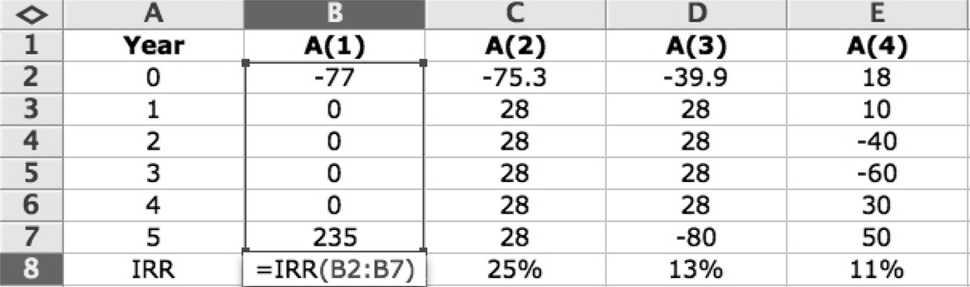

**EXAMPLE 2.8**

Consider this set of four cash flows.

Determine the internal rate of return of each. The IRR equation can be solved by trial and error in a spreadsheet, or you can use the built-in functionality of Excel.

For simple problems, such as Alternative 1 [A(1)], you can calculate the IRR directly using the equations in Table 2.1.

* + 1. *Return on investment*. For a multiyear project, the stream of cash flows can be broken up into annual rates of return. The return on investment (ROI), as used by accountants, usually means the accountant’s rate of return for each year of the project duration based on the ratio of the income (revenue less depreciation) for each year and the underappreciated asset value (invest- ment) for the same year. Hence, the ROI varies from year to year, with a very low value during the early project years and a high value in the later years.

## INFLATION/DEFLATION

Inflation is simply the loss of purchasing power over time. Conversely, deflation is the opposite—prices decrease over time. To evaluate meaningful options for capital projects, we must include inflation in the analysis.

For most engineers, inflation affects:

* Revenues
* Costs
* Operations and maintenance costs
* Labor/wages
* Leases/rents

In others words, revenue and expenses over the life cycle costs are affected by inflation. Two terms are used to describe inflation: average inflation rate and general infla- tion rate. The average inflation rate is used for a specific market item or sector and

is calculated by

1

*f*   cos*tn* *n* – 1 (2.8)

 cos*t*0 

where the costn and the cost0 terms are simply the costs at two different times. Of more interest for evaluating capital projects is the general inflation rate, which is calculated by

1

*f*   cos*tn* *n* – 1 (2.8)

 cos*t*0 

1

*f*   *CPIn* *n* – 1

 *CPI*0 

(2.9)

CPI refers to the consumer price index.

Interest rates may or may not be adjusted for inflation. Inflation-free interest rates (*i*´) are often referred to as the real interest rate. The market interest rate, or simply *i*, includes the cost of capital and inflation. The market interest rate can be related to the inflation-free interest rate:

*i*  *i*ʹ  *f*  *i*ʹ*f* (2.10)

Two types of economic analysis can be conducted to account for the effects of infla- tion. An actual dollar analysis consists of cash flows that include inflation. For this type of analysis, the cash flows are adjusted by applying the general inflation rate to the base year dollar amounts. The market interest rate should be used also. In addition, you can conduct a constant dollar analysis. This type of analysis assumes purchasing power is independent of time. Real interest rates should be used for this type of analysis.

## SUMMARY

The engineering profession is no different from any other business in that costs are a key business driver. From analysis of alternatives for large projects to personal finance, understanding economic analysis of alternatives governs most of our deci- sions. Engineers cannot replace professional accountants, business administrators, lawyers, etc. However, turnkey projects (financing, designing, building, operating, and retiring) and smart business practices are driven by a basic understanding of the time value of money from an LCC perspective. For any engineer, a basic understanding of economic analysis is key and essential for conducting meaningful LCC analysis.

## QUESTION

2.1 The modern engineer must be able to conduct cost analysis and estimation as well as manage the economic aspects of a complex interdisciplinary project. He or she must accurately bid projects and then manage to that cost to ensure profitability. He or she must be able to read financial state- ments and understand tax implications and strategic investments. Discuss

why each of these abilities is important to both the company and one’s own career management.

## PROBLEMS

* 1. You are evaluating two potential IT systems. Each has an initial cost, a hardware upgrade at 24 months, a monthly maintenance charge, and a salvage value after 4 years. Cash flow diagrams for each option are show below. Which option is the best investment?

$2,000 $1,000

1

MARR = 15% APR

24

A = $500/month

48

1

MARR = 15% APR

24

A = $800/month

48

0 0

$15,000 $5,000 $10,000 $7,000

* 1. The cost estimate for your project is $3.5 million. Annual costs for main- taining and operating the facility are forecast as $250,000 per year. After 8 years, you anticipate selling the facility for $2.0 million. If the owner requires a 15% return on the investment, what net annual income must be received to recover the capital investment for the project?
  2. What is the internal rate of return on an investment of $10,000 if the com- pany expects to receive $2000 each year for the next 10 years?
  3. Determine the equal annual end-of-year payments required over the life of these loans to repay them fully during the stated term:

|  |  |  |  |
| --- | --- | --- | --- |
| **Loan** | **Principal** | **Interest** | **Term** |
| A | $12,000 | 8% | 3 |
| B | $60,000 | 12% | 10 |
| C | $75,000 | 10% | 30 |
| D | $4000 | 15% | 5 |

* 1. For each of these mixed streams of cash flows, determine the future value at the end of the final year if deposits are made into an account paying annual interest of 12%, assuming no withdrawals are made during the period.

|  |  |  |  |
| --- | --- | --- | --- |
| **Year** | **A** | **B** | **C** |
| 1 | $900 | $30,000 | $1200 |
| 2 | $1000 | $25,000 | $1200 |
| 3 | $1200 | $20,000 | $1000 |
| 4 |  | $10,000 | $900 |
| 5 |  | $5000 |  |

* 1. A person borrows $20,000 to be repaid in 8 years with 14% annually compounded interest. The loan may be repaid at the end of any earlier year with no prepayment penalty.
     1. What amount would be due if the loan is paid off at the end of year 1?
     2. What about the end of year 4?
  2. A local heavy machinery company is trying to sell a new line of motor graders. As an incentive, they are offering zero down and 9% compounded daily financing. For the motor grader of interest, you are provided this information:

Loan amount: $200,000.00 Length of loan: 48 months Monthly payment: $4979.48

* + 1. Calculate the equivalent monthly periodic and annual interest rate.
    2. Calculate the interest portion of the 25th payment.
    3. Calculate the loan balance after the 29th payment.
  1. You plan to buy an apartment on Riverside Drive for $180,000. You put

$30,000 initial equity into the apartment, leaving you with a $150,000 mortgage. Using a spreadsheet, develop a mortgage repayment schedule for the first year, showing the payment, amount of interest in that pay- ment, amount of principal being repaid, and the remaining balance of the loan. The mortgage is for 30 years at a fixed rate of 8.5% APR com- pounded daily.

* 1. Your company is considering building or leasing a new office facility. The two options are (A) construct an office complex with other space for rent or (B) construct an office to house only your operations.

Below are the revenue and expenses for each of the options:

|  |  |  |
| --- | --- | --- |
|  | **A** | **B** |
| Initial cost | $1,000,000 | $500,000 |
| Annual maintenance | $50,000 | $30,000 |
| Income | $10,000/month | 0 |
| Salvage value | $100,000 | $30,000 |
| Life of facility | 10 years | 10 years |
| MARR | 18% | 18% |

Which option is more desirable?

* 1. The Port Authority of New York and New Jersey estimates that the annual net revenues for the George Washington Bridge will total $13M by the end of this year. At the end of 3 years, they expect a toll increase of 10%. Revenues will then remain constant for the next 6 years (years

4 through 10). The Port Authority would like to reinvest this revenue in a comprehensive maintenance and repair program. However, it will take 2 years to develop plans and specifications and award contracts. How much should the Port Authority expect to spend each year for a 5-year contract beginning at year 2, with equal payments made at the end of each year? The Port Authority uses an MARR of 7% for all public works projects.

* 1. Using annual, semiannual, and quarterly compounding periods, cal- culate the future value for each of these scenarios if $5000 is initially deposited:

1. At 12% for 10 years
2. At 16% for 8 years
3. At 20% for 6 years
   1. For each of the following cases, calculate the future value of the annu- ity at the end of the deposit period, assuming that the annuity cash flows occur at the end of each year. The interest is compounded daily for the annuity.

|  |  |  |  |
| --- | --- | --- | --- |
| **Case** | **Amount** | **APR** | **Periods** |
| A | $2500 | 8% | 10 |
| B | $500 | 12% | 6 |
| C | $30,000 | 20% | 5 |
| D | $11,500 | 9% | 8 |
| E | $6000 | 14% | 30 |

* 1. You are estimating the costs to emplace water pump units in remote vil- lages in a third world country, to decrease the distance people have to travel during the dry season to get water. Each village will require a 20 HP unit that will last 4 years. The number of operating hours per year depends on the amount of rainfall during the rainy season.

Option 1: An $1800 electric pump requiring a power supply will have a

$400 salvage value at the end of 4 years. Electric power costs $1.10 per hour of operation and maintenance cost is $360/year.

Option 2: A gasoline-powered pumping unit that costs $550. This unit will have no salvage value after 4 years. The cost of fuel and oil is

$0.35 per operating hour and the estimated labor cost to operate the unit is $1.40 per operating hour.

Determine the minimum number of annual operating hours required to justify purchasing the electric pump (Option 1) if your MARR is 10% (effective annual interest).

* 1. You are considering investing $15,000 for a new file server to handle office e-mail, central document storage, and so forth. The computer sales- person offers you a plan in which you can finance 100% of the purchase price with terms of monthly payments at 6%, compounded daily, for the next 4 years. The computer will be obsolete at that point and have zero salvage value. Draw a cash flow diagram and determine the monthly pay- ments for this loan. What portion of the 15th payment is interest? What is the payoff after the 25th payment?
  2. Develop a payment calculator using Excel. Assume that interest will be compounded daily. Your input should include the following:
* Number of payment periods (months)
* Loan amount
* Interest rate expressed as an APR

Develop a loan amortization table similar to the one shown below. The “extra payment” column requires a significant amount of logic and thus is optional.

|  |  |
| --- | --- |
| Inputs (variables) |  |
| Amount | $400,000.00 |
| Payment time | 360 |
| (months) |  |
| Interest (APR) | 6.5% |
| Formulas |  |
| (intermediate |  |
| values) |  |
| *i*eff | 0.067152849 |
| *i*per | 0.005430878 |
| Payments | $2,532.76 |
| Payments (via | ($2,532.76) |
| Excel) |  |

|  |  |  |  |  |
| --- | --- | --- | --- | --- |
| Total principal paid via monthly |  | $400,000.00 |  | |
| Total principal paid via extra |  | $0.00 |
| Total principal paid |  | $400,000.00 |
| Total interest paid |  | $511,793.61 |
| Total payment |  | $911,793.61 |
| **Monthly End of Period Payment** | **Interest Payment** | **Principal Payment** | **Extra Payment** | **Balance** |
| 0 |  |  |  | $400,000.00 |
| 1 $2532.76 | $2172.35 | $360.41 |  | $399,639.59 |
| 2 $2532.76 | $2170.39 | $362.37 |  | $399,277.23 |
| 3 $2532.76 | $2168.43 | $364.33 |  | $398,912.89 |

* 1. A review of my credit card statement showed that I had a balance of

$2103.82 with a minimum monthly payment of $43.00. Below is informa- tion the credit card company provides regarding interest rates and other terms. How long will it take to pay off the balance if I make only the mini- mum payment each month? How much do I need to pay monthly in order to have a zero balance after 18 months? (Note: The rates that apply to the account are either fixed (F) or variable (V), as noted in the table.)

**Average Daily Balances**

**Daily Periodic Rates**

**Nominal Annual Percentage Rates**

**Annual Percentage Rates**

**Periodic Finance Charges**

**Transaction Fee Finance Charges**

|  |  |  |  |  |  |  |
| --- | --- | --- | --- | --- | --- | --- |
| Current Billing Period: 28 Days | | | | | | |
| Purchases | $0.00 | 0.03627% | 13.24% V | 13.24% | $0.00 | none |
| Cash  advances | $0.00 | 0.06299% | 22.99% F | 22.99% | $0.00 | none |
| Previous Billing Period: 31 days | | | | | | |
| Purchases | $0.00 | 0.03627% | 13.24% V | 13.24% | $0.00 | none |

* 1. You have been tasked with fielding an interactive video communications systems. Your job is to provide the U.S. Army with the least expensive system (for the next 5 years) from the following alternatives:
* *Intertactical*. An interactive communications system designed to rely on current satellite systems. The Army must spend $10,590,843.42 now (*t* = 0) and $1.7 million this year (*t* = 1), increasing that investment by 13% in subsequent years for 4 additional years (*t* = 2 through 5).
* *TacLine*. Provides interactive communications that operate through existing phone lines. The Army must spend $4 million now (*t* = 0) and $3 million dollars this year (*t* = 1), increasing its investment by by

$500,000 each year thereafter for 4 additional years (*t* = 2 through 5).

* + 1. Draw and label the cash flow diagrams for the ventures. (Draw in PowerPoint and then copy into your Excel spreadsheet solution.)

Intertactical

TacLine

* + 1. Using an effective annual interest rate of 8%, conduct a present worth analysis for the first venture (*Intertactical*).
    2. Using an effective annual interest rate of 9%, conduct a present worth analysis of the second venture (*TacLine*).
    3. Are these two ventures equivalent? Why or why not?
  1. The engineers are going to install air conditioners in your building. They have narrowed the choices of air conditioning systems to two final com- petitors. Assume that there will be a continuing need for the system and that costs and revenues will continue to repeat at the same amounts.

**Air Conditioner System A Air Conditioner System B**

Initial cost: $200,000.00 Initial cost: $240,000.00

Annual maintenance costs: $12,000 Annual maintenance costs: $8000 System life: 10 years System life: 12 years

The government uses an annual effective interest rate of *i* = 10%.

* + 1. Draw the two cash flow diagrams from the head engineer’s perspective.
    2. Using equivalent annual cost, recommend the more economical option.
    3. How much would the annual equivalent cost of the recommended alternative need to increase for you to change your recommendation to the other alternative?
  1. On March 2, 2009, the Los Angeles Dodgers pulled a $45 million, 2-year offer to Manny Ramirez. The issue separating the two sides appeared to be how much the contract was worth in present-day dollars. The Dodgers wanted to pay him $20 million for the current (2009–2010) season and spread out the remaining $25 million, with deferred payments of $10 million for 2010–2011, $10 million for 2011–2012, and $5 million for 2012–2013. Ramirez’s agent stated that Ramirez’s proposed compromise was for a 2-year contract with “some deferred compensation” for a “net present value” of $43.5 million (NBC Sports, 2009). What is the NPV of the contract proposed by the Dodgers?
  2. Your kids have finally left for college and you now have the opportu- nity to buy a black 2009 Harley Davidson Road King Classic motorcycle. You plan to pay $7000 down and finance the remaining $12,500 for 5 years at 7.5% APR compounded daily. Using Excel, make the following calculations:

**Calculation Excel Function**

Monthly payment PMT

Interest portion of payments 12, 24, 36, and 60 IPMT

Principal portion of payments 12, 24, 36, and 60 PPMT

Cumulative interest over payments 12, 24, 36, and 60 CUMIPMT

Cumulative principal over payments 12, 24, 36, and 60 CUMPRINC

## REFERENCE

*NBC Sports.* Accessed March 2009, <http://nbcsports.msnbc.com/id/29455060/>

## BIBLIOGRAPHY

Griffis, Fletcher H., and John V. Farr. 1999. *Construction Planning for Engineers*. New York: McGraw-Hill.

Lang, H. J., and D. N. Merino. 1993. *The Selection Process for Capital Projects*, New York: John Wiley & Sons.

Newnan, D. G., T. G. Eschenbach, and J. P. Lavelle. 2008. *Engineering Economic Analysis*.

9th ed. New York: Oxford University Press.

Park, C. S. 2004. *Fundamentals of Engineering Economics,* Upper Saddle River, NJ: Pearson/ Prentice Hall.

Park, W. R., and D. E. Jackson. 1984. *Cost Engineering Analysis: A Guide to Economic Evaluation of Engineering Projects.* 2nd ed. New York: John Wiley & Sons.

Sage, A. P. 1983. *Economic Systems Analysis: Microeconomics for Systems Engineering, Engineering Management, and Project Selection*. New York: North-Holland.

# Advanced Economic Analysis of Alternatives

3

## INTRODUCTION TO ADVANCED CASH FLOW ANALYSIS

The basic engineering economic analysis techniques presented in Chapter 2 can be used for simple comparison of alternatives. To conduct meaningful analysis, how- ever, we must address the effects of taxes, time value of money, and depreciation of capital assets. This is often referred to as after-tax analysis. After-tax analysis is vital for the selection and optimization of projects and program portfolios. After-tax consists mainly of developing income and cash flow statements. It is important that engineers possess a fundamental understanding of their effects when planning and executing programs.

The first step in conducting an analysis of a project is to investigate the following:

Cash outflows

* + - Procurement costs
    - Operations and support
    - Disposal costs
    - Interest and repayment of borrowed funds
    - Income tax

Cash inflows

* + - Borrowed funds
    - Revenue from cost avoidance or savings
    - Salvage value
    1. **DEPRECIATION**

Depreciation is simply the systematic allocation of cost of a capital expenditure item over its useful life. In reality, depreciation is nothing more than an account- ing charge that reduces the overall value of an asset, due to its depletion, for income tax purposes. Depreciation can be calculated with many methods. To demonstrate depreciation we shall present both the straight-line and the modified accelerated cost recovery system (MACRS) methods. MACRS is the most com- mon for tax depreciation because, as the name implies, they allow for accelerated depreciation.

**39**

Straight-line depreciation is simply

*D*  *I*  *S*

*n n*

(3.1)

where:

*Dn* = depreciation allowance in year *n I* = cost base

*S* = salvage value

*n* = useful life of asset in years

Note that the cost base includes both the actual cost and the cost to put the asset into operation. The book value of the asset at year *n* can be expressed as

*N*

*Bn*  *I*  *Dn*

*n*1

(3.2)

MACRS is used both for tax purposes and for internal accounting. It allows for the recovery of more costs early in the life of the investment. Depending on the type of asset, the Internal Revenue Service (IRS) allows for different cost recovery peri- ods. A yearly depreciation rate is then multiplied by the cost base to determine the annual depreciation amount. Example 3.1 shows how the MACRS allows for earlier depreciation of assets when compared to the straight-line method. With the excep- tion of this example, the details of MACRS depreciations are not presented because those rates are subject to change by the IRS.

**EXAMPLE 3.1**

Your small consulting company is evaluating a circuit board testing machine. The device costs $35,000 and the maker estimates that it will have a salvage value of $6000 after 5 years of use. Determine the annual depreciation using both the straight-line method and the MACRS method.

**SOLUTION**

a. Straight-line:

*D*  *I*  *S*  35,000  6000  $5800 per year

*n*

*n*

5

|  |  |  |
| --- | --- | --- |
|  | **Depreciation** | **Book** |
| **Amount** | **Value** |
| *n* | *Dn* | *Bn* |
| 0 | — | $35,000 |
| 1 | $5800 | $29,200 |
| 2 | $5800 | $23,400 |
| 3 | $5800 | $17,600 |
| 4 | $5800 | $11,800 |
| 5 | $5800 | $6000 |

b. MACRS: Under IRS guidelines (IRS, 2009), a circuit board testing machine would be classed as “high-technology equipment,” which has a 5-year recovery period. Thus, the equipment could be depreci- ated according to this schedule:

|  |  |
| --- | --- |
| ***n*** | **Depreciation Percent** |
| 1 | 20 |
| 2 | 32 |
| 3 | 19.2 |
| 4 | 11.52 |
| 5 | 11.52 |
| 6 | 5.76 |

|  |  |  |
| --- | --- | --- |
|  | **Depreciation Amount** | **Book Value** |
| *n* | *Dn* | *Bn* |
| 0 | — | $35,000 |
| 1 | .2(35,000) | $28,000 |
| 2 | .32(35,000) | $16,800 |
| 3 | .192(35,000) | $10,080 |
| 4 | .1152(35,000) | $6048 |
| 5 | .1152(35,000) | $2016 |
| 6 | .0576(35,000) | 0 |

Note that a 5-year recovery period is depreciated over 6 years. This is based on the assumption that the equipment will be sold during the sixth year. Also note that if a piece of capital equipment is sold before it can be depreciated fully, one-half the normal amount can be depreciated during that year.

**EXAMPLE 3.2**

A small software company has this balance sheet:

Determine how much the company must pay in taxes.

Internally developed software is amortized on a straight-line basis over 5 years (or shorter if you can show it is appropriate). Software obtained as part of a business acquisition can be amortized over 15 years. Purchased software is generally amor- tizable over 3 years. Depreciation can play a role in choosing whether to develop in house or procure commercially, because software can be amortized over differ- ent time horizons depending on whether it is an off-the-shelf item or is internally developed.

* + 1. **CORPORATE INCOME TAXES**

Corporate taxes in the United States, like personal taxes, have a progressive struc- ture, as shown in Table 3.1 using 2008 data. Example 3.2 demonstrates how corpo- rate rates are calculated.

After-tax analysis consists of developing a project’s cash flow statement. In its simplest form, it consists of an income statement and a cash flow statement.

#### TABLE 3.1

**Corporate Tax Structure for Year 2008**

|  |  |  |
| --- | --- | --- |
| **Taxable Income** | **Tax Rate** | **Tax** |
| $0–$50,000 | 15% | *X* * .15 |
| $50,001–$75,000 | 25% | $7500 + [(*X* – 50,000) * .25] |
| $75,001–$100,000 | 34% | $13,750 + [(*X* – 75,000) * .34] |
| $100,001–$335,000 | 39% | $22,250 + [(*X* – 100,000) * .39] |
| $335,001–$10,000,000 | 34% | $113,900 + [(*X* – 335,000) * .34] |
| $10,000,001–$15,000,000 | 35% | $3,400,000 + [(*X* – 10,000,000) * .35] |
| $15,000,001–$18,333,333 | 38% | $5,150,500 + [(*X* – 15,000,000) * .38] |
| Over $18,333,333 | 35% | $6,416,667 + [(*X* – 18,333,333) * .35] |

|  |  |
| --- | --- |
| Gross income: Expenses: | $27,000,000 |
| Salaries | $10,000,000 |
| Depreciation | $3,000,000 |
| Leases | $2,500,000 |
| Taxable income | $11,500,000 |

**SOLUTION**

From Table 3.1:

Tax = $50,000 * .15 + $25,000 * .25 + $25,000 * .34 + $235,000 * .39

+ $9,665,000 * .34 + $1,500,000 * .35

= $3,925,000

or $3,400,000 + [($11,500,000 – 10,000,000) * .35] = $3,925,000

## INCOME AND CASH FLOW STATEMENTS

Discussions of depreciation, income taxes, and inflation are for the sole purpose of developing net cash flow schedules and conducting after-tax analysis. In evaluating capital projects, you must use income and cash flow statements similar to those in Example 3.3 to compare alternatives.

Companies typically finance projects with a mixture of borrowed funds (debt) and internal cash (equity). Many companies have policies regarding the ratio of the total debt to the total investment in a project (debt ratio). Since interest is tax deductible, the debt ratio can affect the viability of a project, especially for companies or individ- uals in the higher tax brackets. Example 3.4 shows how financing affects cash flows. Often, especially early in a project, expenses may be greater than revenues, pro- ducing a negative taxable income. This does not mean that the government will give you a refund or tax credit. It means that the negative income must be offset by other projects in the company’s portfolio. Remember that after-tax analysis is for a single project and often does not reflect the financial health of the total company. Also, the corporate income tax rate for the company is still applicable regardless of the finan-

cials of an individual project.

## EXPECTED VALUE

The expected value of the net present worth is often used as a measure of probability distribution. Each possible value is multiplied by an associated probability to deter- mine the expected value. Since the probabilities are weights, they must sum to 1. We classify these probabilities as objective or subjective:

* Objective probabilities are based on objective data (historical data); assumes that the same trends/characteristics of the past will prevail in the future.
* Subjective probabilities tend to be assigned according to subject matter expert opinion.

Example 3.5 demonstrates this concept.

#### EXAMPLE 3.3

To expand your fledgling materials testing business, you are considering the ben- efits of acquiring a new light delivery van. You estimate incremental cash flows from this investment will include annual revenues of $8000 and annual operating costs of $3500 for the next 6 years. You have two options for acquiring this van:

Option 1: Purchase the van for $20,000 cash. You will sell the van for

$2000 at the end of 6 years.

Option 2: Lease the van for an initial payment of $3000 and six annual end-of-year payments of $1500. At the end of 6 years, you will return the van.

Your inflation-adjusted MARR is 12%. You can use the MACRS tax depre- ciation schedule shown in Example 2.9 and a marginal tax rate of 34%. All cash flows given are actual dollar amounts. Should you lease or purchase this van? Ignore the effects of inflation.

#### SOLUTION

**OPTION 1**

**Depreciation Schedule**

|  |  |  |  |  |  |  |  |
| --- | --- | --- | --- | --- | --- | --- | --- |
| End of year | 0 | 1 | 2 | 3 | 4 | 5 | 6 |
| Depreciation % | — | 20 | 32 | 19.2 | 11.52 | 11.52 | 5.76 |
| Depreciation amount | $0 | $4000 | $6400 | $3840 | $2304 | $2304 | $1152 |
| (*Dn*)  Book value (*Bn*) | $20,000 | $16,000 | $9600 | $5760 | $3456 | $1152 | $0 |
| **Income Statement** | | | | | | | |
| End of year | 0 | 1 | 2 | 3 | 4 | 5 | 6 |
| Revenues |  | $8000 | $8000 | $8000 | $8000 | $8000 | $8000 |
| Operating expenses |  | ($3500) | ($3500) | ($3500) | ($3500) | ($3500) | ($3500) |
| Depreciation |  | ($4000) | ($6400) | ($3840) | ($2304) | ($2304) | ($1152) |
| Taxable income |  | $500 | ($1900) | $660 | $2196 | $2196 | $3348 |
| Tax |  | ($170) | $646 | ($224) | ($747) | ($747) | ($1138) |
| Net income |  | $330 | ($1254) | $436 | $1449 | $1449 | $2210 |
| Cash Flow Statement |  |  |  |  |  |  |  |
| Net income |  | $330 | ($1254) | $436 | $1449 | $1449 | $2210 |
| Depreciation |  | $4000 | $6400 | $3840 | $2304 | $2304 | $1152 |
| Investment | ($20,000) |  |  |  |  |  |  |
| Salvage |  |  |  |  |  |  | $2000 |
| Gains tax |  |  |  |  |  |  | ($680) |
| Net cash flow | ($20,000) | $4330 | $5146 | $4276 | $3753 | $3753 | $4682 |

*NPW (12%) = –$2101.00.*

**OPTION 2**

**Net Cash Flow Schedule**

*NPW (12%) = $5,140.59.*

As you can see, the NPW for Option 1 is $2101.00 and for Option 2 is $5140.59. Therefore, Option 2 (leasing) is the better option.

|  |  |  |  |  |  |  |  |
| --- | --- | --- | --- | --- | --- | --- | --- |
| End of year | 0 | 1 | 2 | 3 | 4 | 5 | 6 |
| Revenues |  | $8000 | $8000 | $8000 | $8000 | $8000 | $8000 |
| Operating expenses |  | ($3500) | ($3500) | ($3500) | ($3500) | ($3500) | ($3500) |
| Lease payment | ($3000) | ($1500) | ($1500) | ($1500) | ($1500) | ($1500) | ($1500) |
| Taxable income |  | $3000 | $3000 | $3000 | $3000 | $3000 | $3000 |
| Tax |  | ($1020) | ($1020) | ($1020) | ($1020) | ($1020) | ($1020) |
| Net income |  | $1980 | $1980 | $1980 | $1980 | $1980 | $1980 |
| Net cash flow | ($3000) | $1980 | $1980 | $1980 | $1980 | $1980 | $1980 |

**EXAMPLE 3.4**

You are buying a new computer-aided drafting and design system for your business that costs $100,000 today. To use this system fully, you must invest an additional $25,000 in training costs. You finance $80,000 of the total investment cost at an effective annual interest rate of 8%, payable in five annual payments. The manufacturer has guaranteed you a salvage value of

$20,000 for the system at the end of 5 years. The incremental cash flows gen- erated with this system include $800,000 in annual revenues and $200,000 in annual noncapital expenses. Your MARR is 12%. Use the MACRS tax depreciation schedule in Example 3.1 and a marginal tax rate of 34%. The estimated general inflation rate is 4.5%. Develop the income and cash flow statement and the resulting NPV of this investment.

Note that MARR is often adjusted for inflation. Typically,

*i* = MARR with inflation

*i’* = MARR without inflation, *i’* < *i f’* = inflation rate

Thus, MARR considering inflation:

*i* = *i’* + *f’* + *i’ f’*

#### SOLUTION

|  |  |  |  |  |  |  |
| --- | --- | --- | --- | --- | --- | --- |
| **Amortization Table** | | | | | | |
| End of period | 1 | 2 | 3 | 4 | 5 | |
| Payment | $20,036.52 | $20,036.52 | $20,036.52 | $20,036.52 | $20,036.52 | |
| Interest payment | $6400.00 | $5309.08 | $4130.88 | $2858.43 | $1484.18 | |
| Principal reduction | $13,636.52 | $14,727.44 | $15,905.64 | $17,178.09 | $18,552.31 | |
| Loan balance | $66,363.48 | $51,636.04 | $35,730.40 | $18,552.31 | 0 | |
| **Depreciation Schedule** | | | | | | |
| End of year | 0 | 1 | 2 | 3 | 4 | 5 |
| Depreciation % | — | 20 | 32 | 19.2 | 11.52 | 11.52/2 |
| Depreciation |  | $25,000 | $40,000 | $24,000 | $14,400 | $7200 |
| amount (*Dn*) Book value (*Bn*) | $125,000 | $100,000 | $60,000 | $36,000 | $21,600 | $14,400 |

Because you are selling the system 1 year before it is fully depreciated, the IRS allows for ½ of the full depreciation amount during that year.

**Income Statement**

|  |  |  |  |  |  |  |
| --- | --- | --- | --- | --- | --- | --- |
|  | 0 | 1 | 2 | 3 | 4 | 5 |
| Revenues |  | $836,000 | $873,620 | $912,933 | $954,015 | $996,946 |
| Expenses |  | ($209,000) | ($218,405) | ($228,233) | ($238,504) | ($249,236) |
| Depreciation |  | ($25,000) | ($40,000) | ($24,000) | ($14,400) | ($7200) |
| Interest payments |  | ($6400) | ($5309) | ($4131) | ($2858) | ($1484) |
| Taxable income |  | $595,600 | $609,906 | $656,569 | $698,253 | $739,026 |
| Tax |  | ($202,504) | ($207,368) | ($223,233) | ($237,406) | ($251,268 |
| Net income |  | $393,096 | $402,538 | $433,336 | $460,847 | $487,758 |
| **Cash Flow Statement** | | | | | | |
| Net income |  | $393,096 | $402,538 | $433,336 | $460,847 | $487,758 |
| Depreciation |  | $25,000 | $40,000 | $24,000 | $14,400 | $7200 |
| Investment | ($125,000) |  |  |  |  |  |
| Salvage |  |  |  |  |  | $24,924 |
| Gains tax |  |  |  |  |  | ($3578) |
| Borrowed funds | $80,000 |  |  |  |  |  |
| Loan principal  pay |  | ($13,637) | ($14,722) | ($15,906) | ($17,178) | ($18,552) |
| Net cash flow | ($45,000) | $404,459 | $427,811 | $441,430 | $458,069 | $497,752 |

Note the salvage value = $20,000($1.045)5 = $24,924.

The gains are determined by ($24,924 – $14,400) * .34 = $3578.

*i’* = 12%, *f’* = 4.5%, *i* = 17.04%. Thus, NPV (17.04%) = $1,358,889.

#### EXAMPLE 3.5

Consider three possible investment returns on a new product. The income is based on your competitor’s response and the volume of sales. An $8 million initial investment is required. Your MARR is 12%. You expect the income to be uniform for 4 years. On the basis of marketing results, you have decided that the following probabilities and income are appropriate:

|  |  |  |  |
| --- | --- | --- | --- |
|  | **Light** | **Moderate** | **High** |
| Demand | $1.3M | $2.5M | $4M |
| *P*[NPW] | .2 | .4 | .4 |

NPW (high) = –$8M + $4M (P/A,.12,4) = –$8M + $4M(3.0373)

= $4.1492M

NPW (moderate) = –$.4068M NPW (light) = –$4.0515M

*E*[NPW] = (–4.0515)(.2) + (–.4068)(.4) + (4.1492)(.4) = $.6867M

Thus, considering the expected value, we should invest in this project.

Mathematically, we define *expected value* as

*E*[NPW] = NPW1*p*1 + NPW2*p*2 + … + NPWj*p*j (3.3)

If *E*[NPW] > 0, then we would invest in this new product.

## SENSITIVITY ANALYSIS

Sensitivity analysis is the study of how the input, variation, and assumptions affect the output of a mathematical model. Excel has made sensitivity analysis not only easy but an important component of all economic analysis. Sensitivity analysis allows us to:

* Identify the key input elements, which can allow for more effort quantify- ing the value of the most important inputs.
* Develop a visual presentation of the effects of various inputs on the output.
* Play a “what-if” game to determine the amount of change in a data point that might change the output of the analysis.

Examples 3.6 and 3.7 demonstrate how sensitivity analysis can be used to make capital decisions.



**EXAMPLE 3.6**

The economics of hybrid cars is confusing at best. The benefit of driving a hybrid is a function of miles driven per year, cost of fuel, maintenance, salvage value, insurance, and other factors. Considering all things equal, conduct a sensitivity analysis based solely on initial costs and miles driven annually. Use the following information:

Develop a plot of annual costs as a function of gasoline prices. Assume the full price of the cars will be financed at 8% for 36 months, which will produce monthly payments for the Prius of $681.04 and for the Corolla $444.99.

$3,000.00

$2,500.00

$2,000.00

$1,500.00

$1,000.00

Prius

Corolla

$500.00

1

3

5

7

Price per Gallon, $

Monthly Cost, $

|  |  |  |
| --- | --- | --- |
|  | **Prius** | **Corolla** |
| MSRP (2009) | $22,000 | $15,350 |
| Millage estimates | 48 mpg | 38 mpg |
| Driving (miles per year) | 15,000 mpy | 15,000 mpy |

**EXAMPLE 3.7**

For road construction and utility upgrades in urban environments with a high density of businesses, two options are often analyzed. First, the contract can be divided into two separate contracts, with each job starting in the middle of the area to be revitalized and working toward the edge. Although more expen- sive, this method minimizes construction/disruption time. Many businesses fold because of lengthy disruptions to traffic, parking, and so forth. The other option

is simply to use one contract, starting work at one end of the roadway and mov- ing toward the other end. With input from the estimating department, you are able to quantify the costs for both types of construction. However, you have also decided to conduct a sensitivity analysis as a function of the value of every lost business, which you will present to the mayor, based on the following input:

|  |  |
| --- | --- |
| **Two Construction Contracts** | |
| Interest rate | 0.05 |
| Award fee | $16,000,000 |
| Length of contract (months) | 14 |
| Cost per month | $2,800,000 |
| Businesses lost per month | 1.5 |
| Cost per lost business | Unknown |
| **One Construction Contract** | |
| Award fee | $5,000,000 |
| Interest rate | 0.05 |
| Length of contract (months) | 30 |
| Cost per month | $1,500,000 |
| Businesses lost per month | 1 |
| Cost per lost business | Unknown |

Using NPV, your analysis produced the following:

$0.00 $0 ($10.00)

($20.00)

($30.00)

($40.00)

Contract Cost

($50.00)

($60.00)

($70.00)

($80.00)

($90.00)

($100.00)

$250,000 $500,000 $750,000 $1,000,000

One Contract

Two Contracts

Cost per Lost Business

Even though two contracts really is the better economic solution when the opportunity cost for each lost business is $275,000, the mayor decides to award two contracts.

Sensitivity analysis is important for building confidence in a model. It plays an important role in model validation and verification.

## BREAK-EVEN ANALYSIS

Break-even analysis has many applications in engineering economy and is often used to describe internal rate of return, the price of one or more variables when one decision is more economically viable than another, or simply the amount of goods one needs to produce to make a profit. The analysis of the sensitivity of the input variables to a decision is important to conducting meaningful analysis.

## SUMMARY

The engineering profession is no different from any other business in that costs are a key business driver. From analysis of alternatives for large projects to personal finance, understanding economic analysis of alternatives governs most of our deci- sions. Engineers cannot replace professional accountants, business administrators, lawyers, and other professionals. However, turnkey projects (financing, designing, building, operating, and retiring) and smart business practices are all driven by a basic understanding of the time value of money from an LCC perspective. For any engineer, a basic understanding of economic analysis is essential to conducting meaningful LCC analysis.

## QUESTIONS

* 1. Consider the hybrid problem in Example 3.6. Most alternative energy solutions will cost significantly more than the current fossil fuel solution. What other noneconomic factors should be considered for (a) buying a hybrid car, (b) investing in wind and solar energy, (c) green construction, and (d) choosing between nuclear power and fossil fuel.
  2. Most large service providers use an MARR of between 3 and 40%. Can you think of industries or companies that might have a higher or lower MARR?

## PROBLEMS

* 1. You can use the so-called “rule of 72” to quickly estimate the number of years required for an investment to double. The equation can be expressed as

*n*double = 72/*i*

where *i* is a percentage (i.e., 10% would be expressed as 10). Develop a plot of time versus interest to double your investment. Overlay the actual formula or 2 = 1 * (1 + *i*)*n* and comment on the accuracy of the rule of 72.

* 1. Telephone switching equipment is purchased by your business for

$20,000 at the beginning of the year. The estimated salvage value after 5 years is $4000.

* + 1. Calculate the straight-line depreciation amount for each of years 1–5.
    2. Determine the MACRS depreciation schedule for this equipment using the following table:

|  |  |  |  |  |  |  |  |
| --- | --- | --- | --- | --- | --- | --- | --- |
| **End of Year** | **0** | **1** | **2** | **3** | **4** | **5** | **6** |
| Depreciation % | — | .20 | .32 | .192 | .1152 | .1152 | .0576 |
| Depreciation |  |  |  |  |  |  |  |
| amount (*Dn*) Book value (*Bn*) |  |  |  |  |  |  |  |

* + 1. If you sell the equipment for $4000 at the end of 7 years, determine the after-tax (net) cash flows from this investment if the marginal tax rate is 34%.
  1. Your firm is planning a major capital expansion. You plan to invest

$1,000,000 initially, using cash on hand, all of which is depreciable over 5 years using straight-line depreciation. The company should receive

$600,000 annually in revenues while incurring $250,000 in operat- ing expenses. The equipment should be salvageable after 5 years for

$250,000. The MARR for this project is 20%. Develop a net cash flow schedule using a marginal tax rate of 34%. Do not adjust income and expenses for inflation. After determining the NPV, conduct a sensitivity analysis of MARR.

* 1. Your boss has asked you to evaluate an athletic training center in Atlanta for use by world athletes before and during the Olympics. Your company has an MARR of 12%. Ignoring inflation and given the following infor- mation, what is your recommendation about this venture?
* Planning horizon: 2 years (time before and during the Olympics)
* Expected revenues: $300,000 each year
* Labor costs: $100,000 each year
* Operating costs: $100,000 each year
* Depreciation schedule: Assume this is an MACRS 20-year property (allows for 3.75% and 7.219% for the first 2 years)
* Amortization schedule: Loan amount = $300,000

|  |  |  |  |
| --- | --- | --- | --- |
| **Year** | **Payment** | **Interest Portion** | **Principal Portion** |
| 1 | $172,857.14 | $30,000.00 | $142,857.14 |
| 2 | $172,857.14 | $15,714.29 | $157,142.85 |

* Tax rate: 40%
* Capital investment: $500,000
* Salvage: $450,000 (salvage at the end of the second year)
  1. Develop an actual dollar net cash flow schedule using the information contained in Example 3.4, with a general inflation rate of 4.5%. Conduct this analysis using a spreadsheet. Conduct a sensitivity analysis of MARR and plot the results.
  2. Your firm is considering investing in a trash-to-steam plant to process certain solid wastes into steam. The steam will then be sold to a local power company. All values are in constant dollars.
* Debt-to-equity ratio: 60% (i.e., 60% of the total costs will be borrowed)
* Initial cost: $800,000 for the plant only (you already own the land)
* Loan for the portion of the initial cost that will be financed through debt: 8%, compounded annually; your firm will repay the entire loan amount in three equal annual payments
* Your company’s MARR: Equal to a market interest rate of 18%
* Economic life of the assembly line: 6 years
* Depreciation is by the 5-year MACRS property schedule
* Annual revenues are expected to be $580,000/year
* Annual expenses are expected to be $248,000/year
* General inflation rate: 6% for the next 7 years
* Marginal tax rate: 40%
* Plant salvage value: Estimated to be 1% of the original cost

Construct an after-tax cash flow schedule to determine if your firm should invest in the trash-to-steam plant. Use the following tables:

**Amortization Schedule**

**Year 0 1 2 3**

Payment Interest Principal Balance

**Depreciation Schedule**

|  |  |  |  |  |  |  |
| --- | --- | --- | --- | --- | --- | --- |
| **End of Year** | **0** | **1** | **2** | **3** | **4** | **5 6** |
| Depreciation % | — | 20 | 32 | 19.2 | 11.52 | 11.52 5.76 |
| Depreciation |  |  |  |  |  |  |
| amount (*Dn*) Book value (*Bn*) |  |  |  |  |  |  |

Revenues Expenses Labor

Materials Operating Depreciation

Interest payment Taxable income Income tax

*Net income*

Cash from operations Net income Depreciation Investment

Salvage Gain/(loss) Borrowed funds

**Income Statement**

**0 1 2 3 4 5 6**

**Cash Flow Statement**

Loan principal payment

*Net cash flow*

* 1. Your company (YOURs Inc.) is bidding on the Army’s computer/radio subsystem (C/RS), which consists of four separate components: a light- weight notebook computer, soldier radio, squad radio, and GPS receiver. To support your bid, you must develop a thorough actual dollar after-tax cash flow analysis. The YOURs board of trustees has approved $1 mil- lion for the initial investment. The bank has agreed to a 3-year loan at 8% APR, compounded daily, to finance the remainder of the debt. The YOURs policy for establishing an MARR for all investment projects is 19%. The corporation’s marginal tax rate, from all sources, is 35%. This includes federal, state, and local taxes. The corporation will receive a tax credit for any years showing a negative taxable income at the marginal total tax rate. The tax credit will be treated as a positive cash flow in the year assessed. The production costs for each element are as follows:

|  |  |  |  |  |
| --- | --- | --- | --- | --- |
|  | **Soldier Radio** | **Squad Radio** | **Computer** | **GPS** |
| Initial investment | $2,225,000.00 | $1,645,750.00 | $1,500,000.00 | $6,545,000.00 |
| Annual O&M  costs | $1,765,400.00 | $2,565,000.00 | $2,325,000.00 | $1,965,850.00 |
| Material costs per component | $275.00 | $355.00 | $375.00 | $335.00 |

We expect that the annual operation and maintenance (O&M) costs will increase at a rate of 4% annually, exclusive of inflation. Assume an inflation rate of 3%. Material costs are estimated to increase at a rate of 3% annually, exclusive of inflation. The annual increase in both O&M and material costs will begin at time 0, which will affect the payment at the end of the first year. Administrative costs are a fixed annual cost associated with all opera- tions. It is estimated that they will remain at $1,875,500.00 annually. Annual administrative costs represent the administrative costs for production of a C/ RS, which includes the squad radio, soldier radio, computer, and GPS.

If YOURs is awarded the contract, you will be required to produce 10,000 C/RS per year for the next 3 years. To execute this contract, you must purchase new equipment for each alternative. The cost of the new equipment is represented by the initial investment cost noted above for each. Assume that each piece of equipment has a 3-year MACRS recov- ery period. Upon completion of the contract, Motorola will sell all equip- ment purchased for this project. YOURs estimates it can sell (salvage) the components of C/RS for 30% of the original purchase price. The exist- ing equipment has already been fully depreciated and must be kept upon completion of the new contract in order to meet current obligations.

Construct an after-tax cash flow worksheet using actual dollars to determine your bid price.

* 1. Because of new federal regulations, your small town can no longer oper- ate its own landfill. The town has proposed contracting for disposal of all municipal solid waste (MSW) to a regional landfill. However, these disposal fees will dramatically increase taxes. The law allows for your town to still dispose of large construction and industrial debris (LCID), to include limbs, leaves, and so forth, in the existing landfill. A private venture has proposed a waste transfer facility (WTF) to sort and store the LCID, as shown below:

Traffic Flow

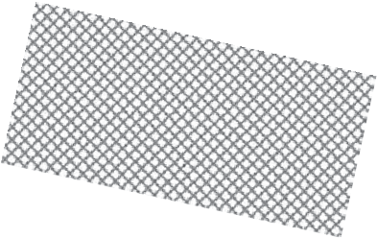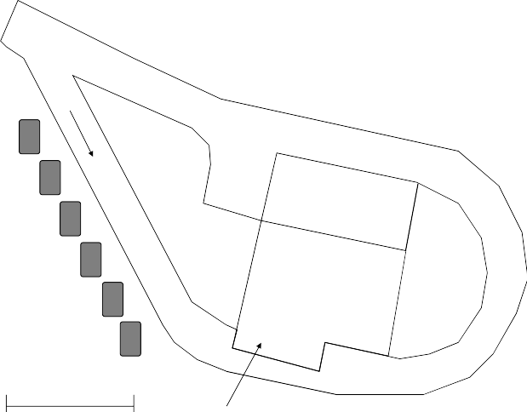

**Unloading Area**

Recycle Bins **LCID**

**MSW**

100 ft

MSW Tractor trailer loading area

The construction costs of the WTF are $150,000. The expenses to operate the WTF are shown below:

Weigh station operator: $15 per hour Bobcat operator: $15 per hour

Bobcat operator and truck driver: $15 per hour WTF supervisor: $35,000 per year

Two Bobcat loaders: $525 per week rental on a 5-year fixed lease

One dumptruck: $50,000 initial cost and $10,000 per year operating costs

The Bobcats will be used to sort the MSW from the LCID. Use a 40% overhead factor on labor costs for personnel benefits. Assume that recycling is a break-even operation. The WTF processes 40 tons per day, on average, of which 20% can be disposed of as LCID. Your subcontractor charges you

$65 per ton to dispose of MSW (fixed for 5 years). You collect industrial and household waste 260 days a year. As town engineer, you must evaluate the economic viability of the proposal.

Develop a 5-year budget to operate the WTF. Use a 5-year straight-line depreciation for the truck and 20 years for the WTF. The truck and WTF have salvage values of $8000 and $50,000, respectively. The CPI for 1986

= 100 and for 1999 = 164. Using an MARR of 12%, is this a cost-effective operation, or would it be more economically feasible to haul all waste directly to the regional landfill?

* 1. The town of Middletown is considering investing in a trash-to-steam plant to process certain solid wastes into steam. The steam will then be sold to a local power company. All values are in constant dollars.
* Debt-to-capital ratio: 60%
* Initial cost: $800,000 for the plant only (you already own the land)
* Loan for the portion of the initial cost that will be financed through debt: 8%, compounded annually; your firm will repay the entire loan amount in three equal annual payments
* Cost of equity financing: 13%
* Economic service life of the assembly line: 6 years
* Depreciation is by the 5-year MACRS property schedule
* Annual revenues are expected to be $580,000/year
* Annual expenses are expected to be $248,000/year
* Market interest rate: 16%
* General inflation rate: 6% for the next 7 years
* Marginal tax rate: 40%
* Plant salvage value: Estimated to be 1% of the original cost at the end of the sixth year

Construct an after-tax cash flow worksheet using actual dollars to deter- mine if your firm should invest in the trash-to-steam plant.

* 1. Orange Country, Florida, is proposing the construction of a light rail proj- ect to alleviate traffic congestion, strategically revitalize some depressed areas of Orlando, and promote economic growth. The current political administration also has made available significant federal funding for regional infrastructure projects that eliminate greenhouse gases and conserve fuel. Unfortunately, resistance from the hotel and resort indus- tries has limited the development to the central businesses of Orlando, the University of Central Florida (UCF), and the Orlando International Airport. The initial proposal under evaluation calls for the construction of four major train stations. Additional stops will comprise this light rail system but will initially be limited to ticketing machines and metered parking. The Orlando Regional Corridor Association (ORCA), consisting of the affected communities, the airport, Orlando proper, and UCF repre- sentatives, governs the transit system development. The mandate for the taxpayers is simple: minimize the costs while maximizing convenience.

The ORCA has conducted an initial cost analysis of this project. From other contracts, interviews, detailed cost estimates, and so forth, they have estimated the following nonrecurring cost items:

**Nonrecurring Cost Item Number Estimated Cost/Item Retail/Office**

Major regional train stations (MRTSs)

3 $4.5M 10,000/20,000 sq. ft.

Central train station (CTS) 1 $9M 20,000/30,000 sq. ft.

Neighborhood train stations (NTSs)

40 $1M 300 parking spaces 5000 sq. ft. retail

Each of these is being considered as standalone entities because they will be funded from different sources. The trains, maintenance facility, and tracks will be built with federal and state funding, tax increases, and municipal bonds. The hope is that the minor train stations will be built with private investor funding and that charging for parking and retail space will make them viable projects without taxpayer support. The major regional train stations will also be built with private funding, under the assumption that retail, parking, and local property improvements will attract major property developers and investments from the local communities, UCF, and the airport. The CTS will house the central offices for ORCA.

Your company is interested in being a part of this program. You have three options:

1. Pursue the development of a CTS.
2. Develop one of the MRTSs.
3. Develop some of the neighborhood train stations. (Assume this will be broken into four contracts with a maximum of ten stations per contract.) Because of political considerations, each one of the projects will be awarded to a different company. Each team will develop a business case for these projects.

The following assumptions are applicable to this problem:

1. Assume that ORCA will sign a 20-year lease with any developer. After that, ORCA owns the facility, equipment, and supporting infrastructure.
2. The local communities will be responsible for any major infrastruc- ture improvements (roads, bridges, etc.).
3. ORCA will be responsible for train platforms (but not garages and walkways to the train platforms).
4. Your board of directors has set an MARR of 20% on these types of projects.
5. Inflation figures are shown below as measured by the consumer price index. Assume that all increases (parking, utilities, and so forth) will increase at inflation plus 1%.

|  |  |  |  |
| --- | --- | --- | --- |
| 1985 | 172.600 | 1998 | 257.100 |
| 1986 | 175.100 | 1999 | 262.000 |
| 1987 | 180.900 | 2000 | 270.500 |
| 1988 | 187.200 | 2001 | 278.000 |
| 1989 | 196.000 | 2002 | 280.800 |
| 1990 | 204.600 | 2003 | 287.700 |
| 1991 | 214.300 | 2004 | 293.500 |
| 1992 | 220.400 | 2005 | 303.800 |
| 1993 | 227.500 | 2006 | 315.900 |
| 1994 | 233.300 | 2006 | 317.200 |
| 1995 | 240.800 | 2007 | 323.808 |
| 1996 | 248.600 | 2008 | 337.543 |
| 1997 | 254.300 | 2009 | 335.227 |

1. The ORCA estimated cost per item is only for their planning pur- poses but was needed also for public relations.
2. For the CTS, you will be able to charge market rates to the 100 ORCA employees that will occupy the facility and charge for parking.
3. You should use actual or then-year dollars in your income balance sheet.
4. Your bank has agreed to finance this venture for 8 years at an interest rate of 8% APR, compounded daily. They will finance 100% of the construction amount, to be repaid with annual payments.
5. Commercial property (building only) is generally depreciated over 39 years using straight-line depreciation. Assume the building will have a salvage value equal to 25% of the construction costs.
6. Retail property on average rents for $25 per sq. ft. per year. Use a 50% occupancy rate for the first year, with the space to be fully utilized by the end of the second year. Expenses are $2.50 per sq. ft. per year.
7. Office property on average rents for $15 per sq. ft. per year. Use a 50% occupancy rate for the first year, with the space to be fully utilized by the end of the second year. Expenses are $1.75 per sq. ft. per year.
8. Assume $100,000, $125,000, and $250,000 major capital improve- ments at years 5, 10, and 15, respectively, for the CTS and MRTS. These are in then-year dollars (already accounts for inflation).
9. Marketing studies have shown that from years 1 to 5 ridership will increase from 20 to 100%. The rail system will initially have 50 engines, with four cars per train. Each car has a capacity of 100 peo- ple. The ORCA assumes that the number of riders will grow 2% per year after year 5. During peak hours, the following occupancy rates are expected:

**Occupancy Runs/Hour**

|  |  |  |
| --- | --- | --- |
| **Time—Workday** | | |
| 7:00–9:00 am & 3:00–6:00 pm | 90% | 1 |
| 9:00 am–3:00 pm | 50% | .5 |
| 5:00–7:00 am & 6:00 pm–12:00 am | 50% | .25 |
| **Time—Weekend** | | |
| 7:00–9:00 am & 3:00–6:00 pm | 50% | .5 |
| 9:00 am–3:00 pm | 25% | .25 |
| 5:00–7:00 am & 6:00 pm–12:00 am | 25% | .125 |

Pick one of the three options (CTS, MRTS, or ten NTSs) and con- struct an after-tax cash flow worksheet, using actual dollars to support your bid. Final bids are to be submitted in the form of a one-page executive summary and supporting analysis. In the event the project is not profitable, please provide other alternatives to generate income to make this venture profitable (e.g., tax riders, tax vendors, creative partnering for real estate development) in your proposal. Please use information from the Internet if needed to augment your analysis.

## REFERENCE

Internal Revenue Service. 2009. Publications 534 and 946. [www.irs.ustreas.gov](http://www.irs.ustreas.gov/)

## BIBLIOGRAPHY

Griffis, Fletcher H., and John V. Farr. 1999. *Construction Planning for Engineers*. New York: McGraw-Hill.

Lang, H. J., and D. N. Merino. 1993. *The Selection Process for Capital Projects*. New York: John Wiley & Sons.

Newnan, D. G., T. G. Eschenbach, and J. P. Lavelle. 2008. *Engineering Economic Analysis*.

9th ed. New York: Oxford University Press.

Park, C. S. 2004. *Fundamentals of Engineering Economics,* Upper Saddle River, NJ: Pearson/ Prentice Hall.

Park, W. R., and D. E. Jackson. 1984. *Cost Engineering Analysis: A Guide to Economic Evaluation of Engineering Projects.* 2nd ed. New York: John Wiley & Sons.

Sage, A. P. 1983. *Economic Systems Analysis: Microeconomics for Systems Engineering, Engineering Management, and Project Selection*. New York: North-Holland.

Sullivan, William G., Elin M. Wicks, and C. Patrick Koelling. 2008. *Engineering Economy*.

14th ed. Upper Saddle River, NJ: Prentice Hall.

# Life Cycle Framework and Techniques

4

## INTRODUCTION TO DEVELOPING LIFE CYCLE MODELS

The specific purposes for an LCC perspective in acquisition management, product development, product upgrades, and so forth include

* Estimating the TOC to the stakeholder
* Reducing/capturing TOC through use of LCC tradeoffs in the systems engineering/product development process
* Controlling costs through use of LCC contractual provisions in procurements
* Assisting in day-to-day procurement decisions
* Understanding TOC implications to determine whether to proceed to the next development phase

LCCs in general are viewed from a pre- and postproduction perspective, with typical main categories as shown in Figure 4.1. This partial list of LCC general cat- egories can be used to develop more detailed costs. Every system is unique, and this is by no means an all-encompassing list.

## DEVELOPING LCC MODELS

LCC analysis (LCCA) is an economic evaluation technique that determines the total cost of owning, operating, and disposing of a system over its life. When building a model for LCCA, you should consider two principal types of uncertainty:

* + 1. Uncertainty regarding the cost-generating activities
    2. Uncertainty regarding the expected cost of these activities

Both present unique challenges. In many respects, developing the categories is more challenging than estimating the costs. As W. Edwards Deming once said, “The greatest costs in business are unknown and unknowable.” This was the motive for developing and presenting a categorization methodology, with Figure 4.1 represent- ing the top-level categories.

Once you develop the categories, the next step is to ascertain the costs and then develop an LCC model. A simple process for developing a LCC model is shown in Figure 4.2.

The LCC categories shown in Figure 4.1 are applicable for the development of a large system. They are not applicable to all products. For example, consider an LCC

**59**



Conceptual Exploration

Component Advanced Development

Systems

I

Preliminary Design

ntegration/

Systems

De ion,

monstrat

Production

Evaluation

Test, and

Operations, Support, & Disposal

Industrial Base

RDT&E

Acquisition Operations and Support

Product Upgrades Product Upgrades Product Upgrades

Disposal Costs

**FIGURE 4.1** Some general LCC categories.

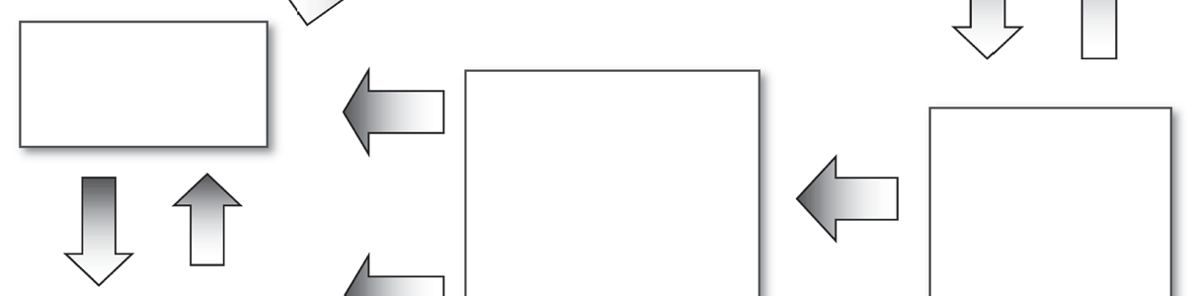

Understand Stakeholder Requirements

Define the Scope

* WBS
* Architecture

Collect Data

Conduct LCC Analysis

Sensitivity Analysis

Determine Cost Estimating Methodologies

* PCE
* Analogy
* Engr build

Develop LCC

Categories

**FIGURE 4.2** Process for developing an LCC model.

analysis of a new facility such as a school. The main categories might include initial investment cost, operational cost, maintenance and repair cost, and finally residual or retirement value.

## LIFE CYCLE COST CATEGORIES

Figure 4.1 shows some of the cost categories that should be included in developing an LCC model. The list is not all-inclusive. The figure is presented to demonstrate the complexity and time phasing of when to plan for and when the actual costs are incurred. The problem is further exacerbated because until the product goes into production we do not know the detailed hardware/software/interface components and thus have no way of developing life cycle categories and the appropriate costs. Thus, as we progress through the various phases in the product life cycle, we must update our LCC categories and costs. This section provides a brief discussion of each of the main categories shown in Figure 4.1.

* + 1. **INDUSTRIAL BASE AND SUPPLIER/VENDOR RELATIONSHIPS**

Much has changed because of globalization. Many specialized, large-ticket items require an investment in the industrial base to support their value chain. This is especially true for defense systems such as tanks and submarines. Cultivating supplier/vendor relation- ships has become critical in an era when just-in-time inventory practices are the rule instead of the exception. New items may require primary contractors to invest in upgrad- ing subcontractor capabilities to ensure quality and responsiveness. In our global envi- ronment, where offshore outsourcing and international partnerships are key, creating and sustaining the industrial base for major products while understanding and accounting for these costs throughout the product life cycle are important and significant. Table 4.1 summarizes some of these associated cost categories and elements.

* + 1. **RESEARCH, DEVELOPMENT, TESTING, AND EVALUATION**

Research, development, testing, and evaluation (RDT&E) is the most commonly accepted term used to encompass development activities prior to production. From a development perspective (preproduction), these are the most difficult costs to ascer- tain because the product architecture has not been developed. Maturing technology for production is often impossible to plan and cost. Postproduction RDT&E costs are easier to ascertain because the makeup of the system is known. Table 4.2 lists some of the cost categories and elements used in developing an LCC model.

* + 1. **ACQUISITION**

Once the product is designed, you can more accurately determine LCC because a detailed engineering bottom-up model is now possible. However, if you refer to Figure 1.2, you will see that 70 to 75% of the cost decisions are made during concept exploration. The problem is that you cannot develop realistic LCC because the sub- systems and components of the system are not fully defined early in the life cycle. In other words, we cannot get a good handle on realistic LCC costs until late in the systems demonstration phase—once the costs are committed. At this point we can start to populate our LCC model. Table 4.3 is a partial list of cost categories and ele- ments associated with acquisition or production.

One item often overlooked is inventory-holding costs. These costs can range between 15 and 35% of the item value per year simply in lost opportunity costs,

#### TABLE 4.1

**Industrial Base LCC Categories**

**Cost Category Cost Element**

Infrastructure investment Workforce development and retention

Physical infrastructure

Minimum sustainment production

Other costs Other costs

#### TABLE 4.2

**RDT&E LCC Categories**

**Cost Category Cost Element**

Systems engineering Systems engineering costs

Project management Project management costs

Support and test program Test and evaluation sets and expenses Training costs

Data costs Demonstration costs

Software and hardware development Prime and subcontractor development Prime and subcontractor

infrastructure

Licensing agreements

Product development costs Hardware acquisition Hardware modification Software acquisition Software modification Software licensing Systems integration RDT&E

Contingency Evolving requirements

Other costs Other costs

rent, pilferage, insurance, etc. Modern inventory management practices were created simply to minimize these costs.

* + 1. **OPERATIONS AND SUPPORT**

Too often, operations and support (O&S) costs play a secondary role in the trade space studies used during concept exploration. We often focus on the development cost because:

* + - * Once we have stakeholder buy-in and the product is under development, it can be hard to terminate the project.
      * We simply do not know how to calculate LCC.
      * The LCC is so overwhelming that many programs will never enter into production if the TOC influences the decision process.

Obviously, the operational life of a product drives the postproduction LCC. Table 4.4 presents rough orders of magnitude for purchase price as a function of TOC. As you can see, developing good postproduction costs for O&S is critical to capturing the TOC.

#### TABLE 4.3

**LCC Categories for Acquisition Expenses Cost Category Cost Element** Infrastructure Physical plant

Storage and spares

Start-up cost Tooling

Product development Initial item management

Initial training Initial technical data

Inventory holding costs Opportunity costs

Finance costs Infrastructure

Production Software acquisition Software modification Hardware acquisition Hardware modification Interface acquisition Licensing

Warranty considerations Initial spares Transportation

Quality assurance Test program sets and cost Contingency Evolving requirements

Other Other

#### TABLE 4.4

**Development Costs as a Function of TOC**

**Purchase or Development Cost as a Percentage**

**Product of TOC**

Automobiles 30–40%

Major defense systems 10–20%

Commercial buildings 10–15%

*Note:* These numbers do not include financing costs.

Table 4.5 lists LCC categories for the O&S phase. In building an LCC model, it is critical that you ascertain these costs, because of their relative contribution to TOC.

* + 1. **DISPOSAL OR RETIREMENT**

Unless special conditions apply, planning for disposal costs is relatively straightfor- ward. The problems arise in special cases such as asbestos, nuclear, funding retirement

#### TABLE 4.5

**LCC Categories for Operations and Support Expenses**

**Cost Category Cost Element**

Personnel costs Labor maintenance costs Other support personnel

Operational crews and management

Consumable goods Energy

Consumable components

Some technology (e.g., personal computers)

Maintenance cost Overhaul support

Spares consumption costs Training and management costs Spares replenishment costs Pilferage and damage of spares Infrastructure support

Warranty and vendor maintenance

Inventory-holding costs Opportunity costs Finance costs Infrastructure

Continuing system improvement Software modifications

Hardware modifications Integration/interfaces

Contractor support Contract management

Sustainment support Systems engineering and project management

Product improvement programs/parts Documentation

Value engineering

Software maintenance/licensing Packaging and transportation

Support equipment upgrades/replacement

Indirect support Operational support personnel Operational personnel training

Infrastructure Training facilities

Support personnel facilities and costs General training and education Basic and initial skill training

Education infrastructure

Acquisition Acquisition

Other Other costs

plans, and some drugs. For example, as of February 2005, Wyeth Pharmaceuticals had placed more than $16 billion in reserves for associated lawsuits for the diet drug Fen-Phen and had settled only 9000 out of 70,000 lawsuits (Fen-Phen Eresource, 2005). Table 4.6 lists cost categories and elements for disposal or retirement of a product.

#### TABLE 4.6

**LCC Categories for Disposal Expenses**

**Cost Category Cost Element**

Environmental Cleanup Regulatory

Postproduction support Personnel

Spares Facilities

Retirement Sell-off costs Storage costs Early retirements

Other Documentation

## ESTIMATING LCC THROUGHOUT THE PRODUCT DEVELOPMENT CYCLE

In Figure 1.5 we presented three techniques for determining costs throughout a typi- cal product development cycle and the applicability of each of these techniques at each step in the life cycle. Example 4.1 demonstrates the use of a life cycle approach to capturing both total and annual costs. Below is a discussion of these techniques, with the exception of accounting.

* + 1. **ANALOGY**

When you are developing a new system, which consists of immature technology, sig- nificant research and development (R&D), and little historical data, such as a complex SoS, not capturing all the activities in the model can lead to an inexact LCC. As shown in Figure 1.5, when we enter into the O&S phases, recurring cost estimations are based mainly on rules of thumb, heuristics, existing data, etc. A specific example might be if there is a high level of uncertainty with respect to maintenance requirements for the equipment as well as the procedures for operating and maintaining the supporting facilities. Developing analogies early in the life cycle is often the only way to estimate rough order of magnitude (±100%). Even if the activities are fairly mature systems that have a significant level of commercial off-the-shelf (COTS), software-intensive, sub- contractor or outsourced components, the immature technology and other factors can produce imprecise models. Unfortunately, increases in software and hardware often do not scale linearly. Also, you must have substantial experience to develop any type of predictions to determine the appropriate independent and dependent variables.

* + 1. **PARAMETRIC**

Parametric models are not necessarily more accurate than analogy models. Yet they are the only means available when a substantial database does not exist. Parametric models are based on relationships between costs and some product- and process- related parameters. Probably the most well-known group of models is the COCOMO

#### EXAMPLE 4.1

A nuclear-powered carrier costs about $8.1 billion, or about 58% more than a conventionally powered carrier, to acquire, operate, and support for 50 years and then to inactivate. The investment cost for a nuclear-powered carrier is more than $6.4 billion, which we estimate is more than double that for a conventionally powered carrier. Annually, the costs to operate and support a nuclear carrier are almost 34% higher than those to operate and support a conventional carrier. In addition, it will cost the Navy considerably more to inactivate and dispose of a nuclear carrier than a conventional carrier, primar- ily because of the extensive work necessary to remove spent nuclear fuel from the reactor plant and to remove and dispose of the radiological contaminated reactor plant and other system components.

#### Life Cycle Costs for Conventional (CV) and Nuclear Aircraft Carriers (CVN)a

**Cost Category CV CVN**

|  |  |  |
| --- | --- | --- |
| **Investment Costs**  Ship acquisition cost | $2050 | $4059 |
| Midlife modernization cost | $866 | $2382 |
| Total investment cost | $2916 | $6441 |
| Average annual investment cost | $58 | $129 |
| **Operating and Support Costs**  Direct operating and support cost | $10,432 | $11,677 |
| Indirect operating and support cost | $688 | $3205 |
| Total operating and support cost | $11,125 | $14,882 |
| Average annual operating and support cost | $222 | $298 |
| **Inactivation/Disposal Costs**  Inactivation/disposal cost | $53 | $887 |
| Spent nuclear fuel storage cost | n/a | $13 |
| Total inactivation/disposal cost | $53 | $899 |
| Average annual inactivation/disposal cost | $1 | $18 |
| *Total LCC* | *$14,094* | *$22,222* |
| *Average annual LCC* | *$282* | *$444* |

*Source:* Federation of American Scientists. 2007. Accessed December 13, 2007, <http://www.fas.org/man/gao/nsiad98001/c3.htm>

a Based on a 50-year service life using fiscal year 1997 dollars in millions.

**Software Cost Models**

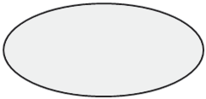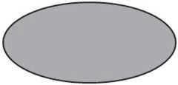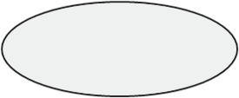

Other Independent Estimation Models

COCOTS COSYSMO

2000 2002

COSoSIMO 2004

COCOMO 81

1981

COCOMO II 2000

COGOMO 2007

COINCOMO 2004

COQUALMO 1998

iDAVE 2003

COPLIMO 2003

COPSEMO 1998

COSECMO 2004

ODC COQUALMO 2007

**Software Extensions**

**Legend:**

COPROMO 1998

CORADMO 1999

Model has been calibrated with historical project data and expert (Delphi) data Model is derived from COCOMO II

Initial model framework established; model being refined

*Dates indicate the time that the first paper was published for the model*

**FIGURE 4.3** COCOMO-based family of models. (From University of Southern California. 2008. Modified from <http://sunset.usc.edu/publications/TECHRPTS/>2005/usccse2005-509/ usccse2005-509.pdf. Accessed January 2008.)

(constructive cost model)-based family of models, which are shown in Figure 4.3. These models are all built using empirical data that take the form of a nonlinear equation multiplied by numerous factors developed to capture the complexity, size, maturity, etc., of the systems.

* + 1. **DETAILED ENGINEERING BUILDS**

The most desired method for calculating cost is direct estimation at the component level. This is often referred to as a detailed engineering build of the system and is the most accurate means of costing a system. Obviously, we must know the architecture of the system before we can cost the system. Thus, we cannot accurately develop an LCC model until well into the systems demonstration phase.

Detailed engineering builds consist at the highest levels of three categories: hard- ware, software, and integration. The hardware costs of mature technology are well known, and most developers have well-developed parametric models for costing software. The most difficult element to cost early in the product life cycle is the integration aspects.

* + 1. **COST ACCOUNTING**

Modern cost accounting tools and techniques must be used throughout the life cycle to track and allocate expenses. Once production has begun, good cost accounting is needed to track costs so that the true TOC can be captured. Unfortunately, the recent

collapses of Enron and Worldcom have shown that accounting techniques can be manipulated to produce misleading results.

Many new accounting techniques have been developed to accurately represent the true TOC. For example, activity-based costing techniques, which assign the cost of each activity resource to products and services according to the actual expenditure, have greatly improved our ability to track the true costs of a system.

## SUMMARY

This chapter has provided an overview of LCC categories and methods for determin- ing the associated costs. Unfortunately, some items do not fit in a neat box in a life cycle model. Systems engineering, project management, and quality are some of these elements. Much has been written in the open literature about the cost of quality (Campanella, 1999; Harrington, 1987).

When developing an LCC model or conducting an analysis, it is useful to incor- porate the following:

* The model should be useful as a management and analysis tool and should be responsive to design changes and varied operational scenarios (e.g., reliabil- ity, maintainability, supportability, and concept of operations, or CONOPs).
* All significant cost drivers needed to identify TOC issues should be incorporated.
* The model should be sensitive to key performance parameters from the trade space studies.
* Accurate input data should be readily available at the appropriate level of detail.
* The model should be flexible, traceable, and scalable.
* Inputs and outputs should be expressed in terms that are familiar to the stakeholders.
* All input data should be quantifiable and, thus, defensible.

The main theme of this text is to convey how LCC analysis must be used to fully understand how to determine and interpret the TOC of a system. As discussed, we often fixate on the upfront costs, which can lead to bad investment decisions.

## QUESTIONS

* 1. What types of projects have
     1. High-cost conceptual design phases?
     2. High-cost advanced development and detailed design phases?
     3. High-cost production phases?
     4. High costs for operating and maintaining the system?
     5. High-cost divestment phases?
  2. As we get further into the life cycle of a product, our ability to capture the TOC improves. In essence, we go from trying to predict to capturing. Transitioning from analogous/parametric prediction methods to detailed

engineering builds and finally to good cost accounting requires an under- standing of the architecture/product and data collection. At what point in the product life cycle should you start developing a detailed engineering LCC model? Why?

* 1. The tsunami warning system, managed by the U.S. Department of Commerce, National Oceanic and Atmospheric Administration, is designed to detect tsunamis and provide prompt notification to all nations bordering the Pacific Ocean. You have been tasked with soliciting bids to install sensors over a 2-year period at two sites that use pressure detectors to measure changes in water depth as a tsunami wave passes overhead. The sensors then transfer the information to a surface buoy, which relays it to the monitoring stations by satellite. The low bidder provided the fol- lowing detailed costs:

**Year 0 1 2 3 4 5**

**Development and Procurement**

|  |  |  |  |  |  |  |
| --- | --- | --- | --- | --- | --- | --- |
| Salary | $74,000 | $76,220 | $0 | $0 | $0 | $0 |
| Travel | $15,000 | $11,000 | $5150 | $0 | $0 | $0 |
| Hardware  acquisition | $30,000 | $30,000 | $0 | $0 | $0 | $0 |
| Software | $10,000 | $10,300 | $0 | $0 | $0 | $0 |
| System integration | $15,000 | $10,300 | $0 | $0 | $0 | $0 |
| System testing | $20,000 | $10,000 | $20,600 | $0 | $0 | $0 |
| Hardware  modification | $5000 | $3000 | $3000 | $0 | $0 | $0 |
| Software  modification | $11,000 | $3000 | $3090 | $0 | $0 | $0 |
| Documentation | $3000 | $3090 | $0 | $0 | $0 | $0 |
| Training | $11,000 | $11,330 | $0 | $0 | $0 | $0 |
| Warranty  considerations | $600 | $642 | $687 | $735 | $786 | $842 |
| **Operations and Support** | | | | | | |
| Salary | $0 | $0 | $36,000 | $37,080 | $38,192 | $39,338 |
| Repairs and  maintenance | $0 | $8000 | $8240 | $8987 | $9257 | $9535 |
| Travel | $0 | $0 | $7030 | $7241 | $7458 | $7682 |
| Cost by year in | $194,600 | **Costs**  $176,882 $83,797 | | $54,043 | $55,694 | $57,396 |
| actual dollars |  |  | |  |  |  |
| Total project cost  in actual dollars | $622,412 |  | |  |  |  |
| Cost in 2008  dollars @ 3% | $194,600 | $171,730 $78,987 | | $49,457 | $49,483 | $49,510 |
| *Total project cost in 2008 dollars* | *$593,767* |  | |  |  |  |

Are any cost categories missing from the LCC presented by the con- tractor? Your RFP called for a COTS that was proven and did not require development. However, you believe that the contractor is in essence hav- ing you pay for further adaptation/development of their sensors for this application. Considering the large integration, testing, modification, and O&S costs, do you believe more details are warranted?

* 1. Document Storage Plus has hired you to conduct a life cycle analysis of its operations. Currently, trucks pick up documents from a host of custom- ers and transport them to a distribution center. They are then placed on pallets, wrapped, and trucked to multiple warehouses near the customers. One distribution center may handle all of the New York City area and another might handle North and South Dakota. You propose to develop several large regional storage facilities and rail the documents to mini- mize costs. What are the advantages and disadvantages from an LCC perspective of this type of approach?

**Current Operations Consolidated Operations**



Pickup Distribution center Warehouse



## PROBLEMS

* 1. Several heating, ventilation, and air conditioning contractors have bid to replace the air conditioners in a major capital renovation project. You have narrowed the choices to two final competitors:

**Air Conditioner System A**

**Air Conditioner System B**

Initial cost $200,000 $240,000

Annual maintenance costs $12,000 $8000

System life 10 years 12 years

You plan to use an annual effective interest rate of *i* = 5%. Using LCC, what is the most cost-effective system? (Hint: Note the different system life; thus, you cannot use present value.)

I = 5%

0 1

$12,000

10 0 1

I = 5%

12

$8,000

$200,000 $240,000

* 1. Using net present value analysis, determine which of these three hot water heaters is the most economical. (Hint: Make a plot of NPV versus year.)

|  |  |  |  |  |
| --- | --- | --- | --- | --- |
|  | | **Electric Water Heater** | **Natural Gas Water Heater** | **Solar Water Heater** |
| Energy produced Cost per unit |  | 4300 kWh  $0.10 | 200 Therms  $1.00 | 4300 kWh |
| Energy inflation rate | 10% | 10% | NA |  |
| Inflation rate |  | 3% | 3% | 3% |
| Purchase cost | Year | $300.00 | $1500 | $5000 |
| Cost to operate | 1 | $430.00 | $200.00 |  |
|  | 2 | $473.00 | $220.00 |  |
|  | 3 | $520.30 | $242.00 |  |
|  | 4 | $572.33 | $266.20 | $220.00 |
|  | 5 | $629.56 | $292.82 |  |
|  | 6 | $692.52 | $322.10 |  |
|  | 7 | $761.77 | $354.31 |  |
|  | 8 | $837.95 | $389.74 | $275.00 |
|  | 9 | $921.74 | $428.72 |  |
|  | 10 | $1013.92 | $471.59 |  |
|  | 11 | $1115.31 | $518.75 |  |
|  | 12 | $1226.84 | $570.62 | $300.00 |
|  | 13 | $1349.52 | $627.69 |  |
|  | 14 | $1484.48 | $690.45 |  |
|  | 15 | $1632.92 | $759.50 |  |
|  | 16 | $1796.22 | $835.45 | $350.00 |
|  | 17 | $1975.84 | $918.99 |  |
|  | 18 | $2173.42 | $1010.89 |  |
|  | 19 | $2390.76 | $1111.98 |  |
|  | 20 | $2629.84 | $1223.18 |  |

Does the life expectancy of the hot water heater affect your answer?

* 1. Your company is looking at buying a fleet of cars for service techni- cians. Below is a table of characteristics of the three options you are investigating:

|  |  |  |  |  |
| --- | --- | --- | --- | --- |
|  | **Purchase** | **Gas Mileage** | **Maintenance Costs (End of** | **Salvage (End of** |
| **Car** | **Price** | **(mpg)** | **Years 1, 2, and 3)** | **Year 4)** |
| Midsize | $17,000 | 25 | $1200 | $9000 |
| Hybrid | $25,000 | 45 | $500 | $3000 |
| Economy | $13,000 | 31 | $1000 | $5000 |

On average, each service technician travels 40,000 miles/year. Varying gas prices from $2.50 to $4.00 per gallon in $.25 increments, conduct a sensitivity analysis and develop a meaningful plot for management to make an informed decision about the fleet makeup. (Hint: Assume an inflation rate and convert everything to an annual cost.)

* 1. You are evaluating whether to replace electric motors at a wastewater treatment plant. Using an inflation rate of 3.5% and a salvage value of 15% of the initial costs, determine which of these pumps is the most eco- nomical from a life cycle perspective:

|  |  |  |  |  |
| --- | --- | --- | --- | --- |
| **Input** | **Option A** | **Option B** | **Option C** | **Option D** |
| Cost | $5000 | $2250 | $21,500 | 0 |
| Annual energy cost | $11,000 | $6700 | $5500 | $11,000 |
| Annual maintenance | $500 | $500 | $1000 | $500 |
| Annual inspection/  certification cost | $2500 | $2500 | $2500 | $2500 |
| Life | 8 | 6 | 12 | 5 |

* 1. The following table contains cost data needed to compare a hybrid ver- sus a conventional SUV. Develop a plot of TOC versus price per gallon. Assume that you will average 15,000 miles/year. What is the break-even point in terms of fuel costs at which the hybrid becomes the more eco- nomic option? (Hint: Assume an inflation rate and convert everything to an annual cost.)

|  |  |  |  |
| --- | --- | --- | --- |
| **Cost Categories** | **Cost Categories Decomposed** | **2008 Toyota Highlander Hybrid Ltd** | **2008 Toyota Highlander Ltd** |
| Purchase price | Purchase price (year 0) | $40,450.00 | $34,350.00 |
|  | Taxes & fees (year 0) | $3891.06 | $3294.94 |
| U.S. federal hybrid  incentives | Tax credit (year 0) | $0.00 | $0.00 |

|  |  |  |  |
| --- | --- | --- | --- |
| Five-year/75,000- mile ownership  cost | Fuel consumption | 34 mpg | 28 mpg |
|  | Insurance (annual costs) | $1084.60 | $1013.00 |
|  | Maintenance & repair  (total for 5 years) | $3004.00 | $2992.00 |
|  | Financing (cash  purchase) | NA | NA |
| Residual value | Projected resale price (year 5 income) | $16,584.50 | $15,423.15 |

For financing, you can make numerous assumptions. For example, if you pay cash for the car, you can invest the difference for 5 years and treat the lost income as an additional car ownership cost. Or, you can borrow all of the money and determine the difference in car payments as an additional expense.

* 1. Below is a bid for a microwave transmission tower and support equipment to be installed in a remote region of southwest Asia. This system consists of an antenna and on-site computers with operators. You expect this sys- tem to have a life of 10 years.

|  |  |  |
| --- | --- | --- |
|  | **Hours** | **Cost** |
| Management | 44,093 | $7,731,153 |
| Systems egineering | 20,094 | $3,619,772 |
| Software | 42,915 | $7,183,903 |
| Hardware | 3006 | $500,355 |
| Installation | 38,183 | $6,937,304 |
| Integration and testing | 41,492 | $7,062,878 |
| Training | 9635 | $1,695,175 |
| Travel | 0 | $2,142,724 |
| Infrastructure | 0 | $1,174,913 |
| Proposal development | 682 | $491,848 |
| *Total bid* | *200,100* | *$38,540,024* |

Use the various life cycle categories listed in Tables 4.5 and 4.6 to identify which cost categories are relevant as you try to develop the total life cycle costs.

## REFERENCES

Campanella, Jack. 1999. *Principles of Quality Costs: Principles, Implementation, and Use*.

Milwaukee, WI: American Society for Quality.

Federation of American Scientists. 2007. Accessed December 13, 2007, <http://www.fas.org/> man/gao/nsiad98001/c3.htm

Fen-Phen Eresource. 2005, February. Accessed August 21, 2008, http://www.fen-phen-ere- source.com/fallout.cfm

Harrington, James. 1987. *Poor-Quality Cost*. Milwaukee, WI: ASQC Quality Press. University of Southern California. 2008. Accessed January 2008, modified from [http://sunset.](http://sunset/)

usc.edu/publications/TECHRPTS/2005/usccse2005-509/usccse2005-509.pdf

## BIBLIOGRAPHY

Andrews, Richard. 2003. *An Overview of Acquisition Logistics*. Fort Belvoir, VA: Defense Acquisition University. Accessed April 2, 2007, https://acc.dau.mil/CommunityBrowser. aspx?id=32720

Department of Defense (DoD). 1983, April 1. “Life Cycle Cost in Navy Acquisition.” MIL- HDBK-259 (NAVY). Washington, DC.

Department of Defense (DoD). 2006. “Risk Management Guide for DoD Acquisition.” 6th ed. Version 1.

Dhillon, B. S. 1989. “Life Cycle Costing: Techniques, Models and Applications.” OPA (Amsterdam) B.V., under license by Gordon and Breach Science Publishers, S.A. Emblemsvåg, Jan. 2003. *Life-Cycle Costing: Using Activity-Based Costing and Monte Carlo*

*Methods to Manage Future Costs and Risks.* New York: John Wiley & Sons.

# 5 Simulation-Based Costing

## INTRODUCTION

Systems and enterprises at the most basic level are an integrated composition of elements or subsystems governed by processes that provide a capability to sat- isfy a stated need or objective. Thus, simulation is an ideal way to analyze these systems. To develop a system or enterprise successfully you must first define the problem that exists; identify the mission requirements (or business drivers) of the organization(s) that need to solve the problem; evaluate a high-level concept of operations (CONOPS) for solving the problem; select the concept that makes the most sense in light of the product or mission requirements; develop an operational concept around the selected concept; create architectures and derived require- ments for the subsystems, components, and configuration items consistent with the decomposition of the system; design the integration, test, and evaluation pro- cess for the parts of the system; conduct the integration and test process for the parts of the system; manufacture/assemble the parts of the system; deploy the system; train operators and maintainers; operate/maintain the system; refine the system; and finally retire the system. Simulation can play a key role during each of these phases to assess risk for operational analysis and LCC. Simulation can be used to prototype the systems, evaluate CONOPS, and determine the cost and associated risk.

Both buyers and developers incorporate modeling and simulation (M&S) into all phases of the development of new products, covering the entire life cycle from concept development to retirement. The military (DoD, 2005) has used M&S for many years because it can provide a realistic and cheaper way to train and con- duct analysis of complex material and force structure. Specifically, M&S can be used (1) to evaluate requirements for new systems and equipment; (2) to evaluate and conduct research, development, and analysis activities; (3) to develop digi- tized prototypes and avoid the building of costly full-scale mockups; and (4) to plan for efficient production and sustainment of the new systems and equipment. Because M&S has become a catchall term for all aspects of computer-based analy- sis and is domain dependent, we need to start with some basic terms and points of discussion:

* A *model* is a physical, mathematical, or logical representation of a system, entity, phenomenon, or process.
* A *simulation* is the implementation of a model over time. It is a technique that can be used for design, testing, analysis, or training. You can see the model(s) in the simulation moving—whether it shows military units

**75**

moving across a battlefield or engine parts moving in a simulated car engine. M&S provides virtual duplication of products and processes and represents those products or processes in readily available and operation- ally valid environments. Use of M&S can reduce the LCC.

The DoD (2005) has established three classes of simulations—virtual, construc- tive, and live:

* + 1. *Virtual simulations* represent systems both physically and electronically. Think of a video game or a cockpit mockup used to train pilots; these are virtual simulations.
    2. *Constructive simulations* represent systems and their employment through the use of extensive, complex mathematical and decision-based modules and statistical techniques. A constructive simulation is a computer program. The user inputs data to cause an event to occur, then gets the results. For example, a military user may input data on a military unit, telling it to move and to engage an enemy target. The constructive simulation determines the speed of movement, the effect of the engagement with the enemy, and any battle damage that may occur. Results can be provided digitally or visually, depending on the type of simulation used.
    3. *Live simulations* are simulated operations conducted by real operators using real equipment. Military training events using real equipment are live simu- lations. They are considered simulations because they are not conducted against a live enemy.

For simulation-based costing (SBC) analysis, constructive simulations are the pri- mary analysis tool. Simulation is important for cost analysis because

* The system can be prototyped
* CONOPS and “what-if” trade space studies can be conducted
* A combination of the above can be used to assess the variability/risk of an LCC estimate
  + 1. **WAYS TO STUDY A SYSTEM**

Analysis of a component, subsystem, system, etc., can be accomplished in many ways, as shown in Figure 5.1.

Obviously, building a prototype and testing it in actual field trials is the desired— but certainly not the most cost-effective—method to develop and test a new system. “What-if” analyses and large enterprise-wide solutions can be conducted only in a synthetic environment. From the simplest component to modern airplanes, detailed models are developed and simulated under a wide variety of conditions. Only then should prototypes be built and actual tests conducted. Before the advent of cheap computing, most engineering analysis was conducted using physical models. Today, few physical models are still used in RDT&E, even below the system level. However,

**Complex System/Enterprise**

Finite Element & Difference, etc.

Closed Form

Event-Driven Simulation

Monte Carlo Simulation

Systems Dynamics

Scaled Prototype

Simulation

Mathematical Model

Actual System

**FIGURE 5.1** Ways to model a system.

they are still used extensively to develop input and understand fundamental behavior that occurs below the system level.

A mathematical model is an abstract model that uses mathematical/computer lan- guage to describe the behavior of a system. Few closed-form solutions can be used to represent the behavior of complex systems.

* + 1. **ADVANTAGES AND DISADVANTAGES OF SIMULATIONS**

The advantages of simulation:

* + - 1. Once the model is explained, most people can understand it and accept its results as legitimate representations of the system under consider- ation; a simulation is more “intuitive” than a closed-form mathematical equation.
      2. Simulation can be used for complex, real-world situations or conditions that are not included in analytical models.
      3. We can simulate extended periods of time in a short period of time on a computer.
      4. It is much less expensive to build something in a computer language and experiment with the model than it is to construct the physical system for experimentation.
      5. Simulation allows for easier “what-if” analysis and variations on the exist- ing model (sensitivity analysis).
      6. It is relatively straightforward, with minimal cost.
      7. It is easier to apply than analytical methods.
      8. It allows greater flexibility in representing the real system; fewer simplify- ing assumptions.
      9. It precludes loss of lives and damage to the environment.
      10. A model can be used repeatedly.

The disadvantages of simulation:

1. It is not an optimizer.
2. It does not lead to fundamental understanding. (We observe outcomes on a process but may not understand why the outcomes are as they are.)
3. It is an abused analytical tool that is often used inappropriately.
4. The best M&S languages can be expensive and require a great investment in time to learn the software.
5. Simulation models do not provide optimal solutions.
6. Only the conditions that are included in the model can be examined.
7. You may not discover fundamental relationships that are sometimes illumi- nated by analytical models.

## REVIEW OF PROBABILITY AND STATISTICS

* + 1. **INTRODUCTION**

Many of the simulation techniques presented in this text require some knowledge of probability and statistics. Rather than present the material in-depth, this section will introduce and review the concepts of probability theory and elements of statistics.

In probability, properties of the population are assumed to be known and can be modeled mathematically. The term probability refers to the study of randomness and uncertainty. Probability can be used to answer questions about the sample. Statistics is used to determine properties from a sample that can be applied to the general population. These relationships are shown in Figure 5.2.

* + 1. **RANDOM VARIABLES**

A random variable is a special type of function critically important to the science of mathematical statistics and thus simulation. The concept of a random variable allows us to relate the exponential outcomes to a numerical function describing the outcome. It is a function that

**Probability**



Population

Sample

Mythical - Exact World

Statistics

Random - Real World

**FIGURE 5.2** The relationship between probability and statistics.

* + - * Has as its domain the sample space
      * Assigns one and only one number to each point in the sample space (integer, 0 or 1, or real)
      * Has a value that can be found only through an experiment

The value assumed by a random variable associated with an experiment depends on the outcome of the experiment. As a convention, this text will use a capital letter (usually *X* or *Y*) to represent a random variable and its lower case to represent a spe- cific numerical value of the random variable. Example 5.1 shows a simple probability problem with this notation.

**EXAMPLE 5.1**

You are trying to determine the probability of a contractor filing more than two claims for a given contract. You analyze the last five jobs for number of claims:

Let *X* be the number of claims. The four possible outcomes are 0, 2, 4, and

5. Then

*p*(0)  *P*(*X*  0)  1  0.2

5

*p*(2)  *P*(*X*  2)  2  0.4

5

*p*(4)  *P*(*X*  4)  1  0.2

5

*p*(5)  *P*(*X*  5)  1  0.2

5

These values specify the probability distribution function. In simple terms, for every possible value of *x*, the probability distribution specifies the probability of observing that value when the experiment is performed. Thus,

*P*(*X* ≥ 2) = 1 – [*P*(*X =* 0) + *P*(*X =* 1) + *P*(*X =* 2)] = 1 – [0.2 + 0 + 0.4] = 0.4

|  |  |  |  |  |  |
| --- | --- | --- | --- | --- | --- |
| Job | 1 | 2 | 3 | 4 | 5 |
| Claims | 0 | 4 | 2 | 5 | 2 |

* + 1. **PROBABILITY DENSITY FUNCTIONS**

The probability distribution (or density) function (PDF) provides a complete descrip- tion of a random variable. A PDF is an important part of engineering planning when trying to model complex processes (e.g., construction). Typically, the expected value and some measure of scatter are used to summarize the important characteristics of a PDF.

Let *X* be a random variable such that *P*(*X* = *x*) = *f*(*x*) is known for each *x* in the sample space. The term *f*(*x*) is the PDF of *X*. It describes the probability for *X* over the entire sample space. There are two types of random variables, the discrete and the continuous, depending on whether the results are countable or infinite:

1. *Discrete type of random variable*. Let *X* be a special type of random variable defined on the set of real numbers in a way that for any finite interval there exists a finite number of values. Let *f*(*x*) be a function such that

*n*

 *f* (*xi* )  1 (5.1)

*i*1

1. *Continuous type of random variable*. A random variable is said to be continuous when the value constitutes an infinite set between two numbers (say, *a* and *b*). Let *X* be a random variable such that

*b*

*P*(*a*  *X*  *b*)   *f* (*x*)*dx*

*a*

(5.2)

and

* 1. *f*(*x*) ≥ 0 for all *x*
  2. *a* < *b*
  3. *f*(*x*) has, at most, a finite number of discontinuities on every finite interval

*b*

⇩ *f* (*x*)*dx*  1

*a*

Then *X* is said to be a continuous random variable.

Whether the random variable is continuous or discrete, the function *f*(*x*) com- pletely defines its probability properties. The function *f*(*x*) is called the probability distribution function of *x*. Examples 5.2 and 5.3 present a discrete PDF problem.

#### EXAMPLE 5.2

As part of a major land development project, 125 construction sites have been assigned a 1–5 rating, with 5 being the most desirable. Factors contributing to the ratings included view, trees, constructability, access, and lot size. Our study of the area produced the following values:

|  |  |  |  |  |  |
| --- | --- | --- | --- | --- | --- |
| Lot rating, *x* | 1 | 2 | 3 | 4 | 5 |
| Number | 10 | 35 | 20 | 27 | 33 |
| Probability, *p*(*x*) | 0.08 | 0.28 | 0.16 | 0.216 | 0.264 |

The numbers 1 through 5 are the values of the random variable. A PDF of a discrete random variable is defined for every number *x* by *p*(*x*) = *P*(*X* = *x*), or

*p*(1) = *P*(*X* = 1) = 0.08

*p*(2) = *P*(*X* = 2) = 0.28

*p*(3) = *P*(*X* = 3) = 0.16 *p*(4) = *P*(*X* = 4) = 0.216 *p*(5) = *P*(*X* = 5) = 0.264

An equivalent description, and the most widely used for a PDF, is

 0.08 *if x*  1, 

 0.28



*f* (*x*)   0.16

0.216



0.264

*x*  2, 



*x*  3, 

*x*  4, 



*x*  5, 

 *otherwise*



0



Below is a graph of the relative frequency histograms:

0.3

0.2

f(x)

0.1

0

1 2 3 4 5

Lot Rating

|  |  |  |  |  |
| --- | --- | --- | --- | --- |
| *X* | 1 | 2 | 3 | 4 |
| *p*(*x*) | .4 | .3 | .2 | .1 |

* + 1. **CUMULATIVE DISTRIBUTION FUNCTIONS**

**EXAMPLE 5.3**

The PDF for the number of contractors that will bid on a computer upgrade for a major federal client:

Thus,

*P*(*X* ≤ 1) = 0.4 = *p*(1)

*P*(*X* ≤ 2) = 0.7 = *p*(1) + *p*(2)

*P*(*X* ≤ 3) = 0.9 = *p*(1) + *p*(2) + *p*(3)

*P*(*X* ≤ 4) = 1.0 = *p*(1) + *p*(2) + *p*(3) + *p*(4)

The CDF is

0

.4

*F*(*x*)   7

.

.9



1.0

*otherwise x*  1

*x*  2

*x*  3

*x*  4

For some fixed value of *x* we often wish to compute the probability that the observed value of *X* will be at most *x*. Consider the random variable *X*. Take *x* to be a real number and consider the unbounded set –∞ to *x*, including the point *x* itself. Let *F*(*x*)

= *P*(*X* ≤ *x*). The function *F*(*x*) is called the cumulative distribution function (CDF) of the random variable *X*. Since *F*(*x*) = *P*(*X* ≤ *x*), then with *f*(*x*) the PDF

*x*

*F*(*x*)   *f* (*n*)

*n*

(5.3)

for the discrete type of random variable.

For the continuous type of random variable, the CDF can be expressed as

*x*

*F*(*x*)   *f* (*u*)*du*



In Figure 5.3, for each *x*, *F*(*x*) is the area under the PDF curve to the left of *x*.

(5.4)

**f(x) F(x)**

**Probability Distribution Function**

**1**

**.4 .8**

**.6**

**.2 .4**

**.2**

**.4375**

**7**

**Cumulative Distribution Function**

**0 2 4 6 8 10**

**X**

**x 0**

**0 2 4 6**

**x**

**8 10**

**X**

**FIGURE 5.3** A PDF and associated CDF.

**EXAMPLE 5.4**

Let the random variable *X* have the PDF

*f* (*x*)  2*x*

0



0  *x*  1

*otherwise*

Find *P*(1/2 ≤ *X* ≤ 3/4) and *P*(–1/2 ≤ *X* ≤ 1/2).

3/4

*P*(1/2  *X*  3/4)   2*xdx*  3/42  1/22   5/16

1/2

0

1/2

*P*(1/2  *X*  1 / 2)   0 *dx*   2*xdx*  1/4

1/ 2

0

Note here that *F*(*x*) is a function of the point *x* and

*dF*(*x*)

*dx*

 *f* (*x*)

(5.5)

The probability *p*(*a* ≤ *X* ≤ *b*) = *F*(*b*) – *F*(*a*) except in rare functions involving discontinuities.

Examples 5.4 and 5.5 contain problems demonstrating continuous PDFs.

#### EXAMPLE 5.5



Let *x* possess the PDF

*f* (*x*)   *cx*

0  *x*  2

 *elsewhere*

0



1. Find *c*.

*b*

For this to be a continuous function,  *f* (*x*)*dx*  1. Thus,

*a*

2 2

*cxdx*  1  *c*  *x*2 

 *c*[4  0]  2

⇩  2 0

0

Thus, *c* = ö.

1. Find *F*(*x*).

*x x*

1 1 *x*2 *x*2

*F*(*x*) 

⇩

*xdx*    

2 2  2 0 4

 

0

Check the CDF at *x* = 0, *F*(*x*) = 0, at *x* = 2, *F*(*x*) = 1. Thus,

 *x*2

*F*(*x*)   4



 0

*for* 0  *x*  2

*Elsewhere*

1. Graph *f*(*x*) and *F*(*x*).

**PDF Plot**

2

*f(x)*

0

0 0.5 1

*X*

*F(x)*

*f*(*x*)



1

0.5

0

**CDF Plot**

0

0.5

1

*X*

1.5

2

4. Determine *P*(1 ≤ *X* ≤ 2).

*P*(1  *X*  2)  *F*(2) – *F*(1)  0.5  22  12   0.75

 2 2 

1

*b* – *a*

*x*

*a b*

**FIGURE 5.4** The uniform distribution.

* + 1. **SPECIAL DISTRIBUTIONS**

Several distributions are typically used to describe the properties of most variables. These special distributions (uniform, normal, and Poisson) find applications in a wide class of engineering problems.

#### Uniform Distribution

Let *X* be a random variable defined on an interval from *a* to *b*. Place a requirement on the PDF *f*(*x*) that each number in the interval have an equal likelihood of selection. A model for this assertion is termed the uniform distribution. The equation for this distribution is in Figure 5.4.

One of the most important uses of a uniform distribution is for the selection of a random number for a Monte Carlo and event-driven simulation. Drawing a random number from a uniform distribution means that each number in the interval (0,1) has an equal likelihood of selection. Most computer languages and spreadsheets have an internal random number generator.

#### Normal Probability Distribution

One of the most important continuous random variables is the normal (or Gaussian) distribution. It describes the behavior of many natural systems. For instance, con- sider the errors of a survey crew measuring the centerline of a highway. Using a

stadia rod, a sonic measuring device, or a laser device, the distance will be made up of a series of shorter measurements. These measurements will be read to some discrete length—say, to the nearest millimeter, nearest one-hundredth of an inch, etc. Then a distance of 100 meters will be between 99.99 and 100.01 meters if the accuracy is to the nearest millimeter.

The normal distribution theory describes the behavior of random variables in these situations:

* + - * 1. The sum of random variables in which no single random variable dominates
        2. Errors in measurements
        3. Capacity of a system that fails after the saturation of redundant components has taken place; for example,

Capacity of road or the sum of its lane capacities

Collapse mechanism of a ductile, elastic–plastic frame

The sum of constants times the yield moments of specific joints

The distribution of total annual rainfall run-off over a specific area

The normal distribution is also important because of the central limit theorem (CLT). Under very general conditions, it states that the average of a large number of random variables can be approximated by a normal distribution. Also, the normal distribution is often used as an approximation to other distributions in some situa- tions, including the Poisson (when the mean is large), binomial, and gamma.

The PDF for the normal distribution is of the following form:

◎ 1  *x*  2

⇩

*f* (*x*)  1 *e* 2  

⬧



2

*dx*   *x*  

(5.6)



A shorthand notation of *N*(µ,σ2) is often used where µ is the mean or expected value of the population, *T* is the standard deviation, and *T*2 is the population variance. A plot of a normal distribution is shown in Figure 5.5.

A normal distribution with the parameters µ = 0 and σ = 1 is called the stan- dard normal distribution. Although not used for existing problems, it has utility from which information about other normal distributions can be obtained. Because of its wide usage, a special notation, Φ(*z*), is commonly used. The distribution function *N*(0,1) is usually tabulated in tables. However, with the development and prolifera- tion of portable computers, Excel, and most hand-held calculators, the use of tables is obsolete technology. Using the standard normal PDF, one can determine the proper- ties of other normal PDFs. Suppose for *N*(µ,σ2) then,

Figure 5.6 shows the standard notation for determining the cumulative area or probability using the normal probability distribution.

◎ 1  *x*  2

⇩

*P*(*a*  *X*  *b*)  1 *e* 2    *dx*

⬧



2

(5.7)



0.4

N(0,1)

0.3

0.2

*f(x)*

0.1

0

–4 –2 0 2 4

*x*

**FIGURE 5.5** Graph of a normal PDF.

φ(*z*) = P(Z ≤ *z*)

Shaded Area = φ(*z*)

0 Z

**FIGURE 5.6** Standard normal curve area.

The solution to this integral does not exist in closed form. It can be evaluated indi- rectly, however, by making this change of variable:

Then,

*z*  *x*  

⬧

*and dx*   *dz*

*b*

⬧

1 1 2



2

*P*(*a*  *X*  *b*) 

⇩ *e* 2 *z dz*

*a*

⬧

(5.8)

If you set µ = 0 and σ = 1 in Equation 5.7 it will reduce to Equation 5.8. Thus, Equation 5.9 is the area of the standard normal PDF between (*a* – µ)/σ and (*b* – µ)/σ. Thus,

*P*(*a*    *b*)  *b*    *a*   

*T T* (5.9)

Example 5.6 demonstrates how Excel can be used to determine probabilities based upon the normal probability distribution.

#### Poisson Distribution



**EXAMPLE 5.6**

Suppose you are planning to develop a new shopping mall in an area that adjoins a flood plain. Data analysis of the gauge readings from the small river that flows through the middle of the flood plain is *N*(40,100). The proposed eleva- tion for the parking lots and grade of the mall is 52 mean sea level (MSL). Use the NORMDIST and NORMINV functions in Excel to solve this problem:

1. What is the probability that the mall and parking lot will flood?

*P*(*X*  52)  *P*( 52  *X*  ∞)  (∞) –  52  40 



10



 1.0 – NO**R**MDIST(40,52,10,1)  11.5%

2. Your insurance company wants you to build the mall to a height where it will flood only 1% of the time. Based on *N*(40,100), what is the height of the first floor finished grade?

Using Excel,

NORMINV(.99,40,10) = 63.2 MSL

0.04

0.03

0.02

0.01

Area = 88.9%

Area = 1%

0

0

20

40

52 60 63.3

80

*x* (River Gauge Reading, MSL)

There is no simple experiment on which the Poisson distribution is based. However, a number of random events that occur in a unit of time, space, or any other dimension follow this distribution.

A random variable *X* is said to have a Poisson distribution if the PDF of *X* is

*f* (*x*)  *e**x*

*f* (*x*)

*x*!

*x*  0, 1, 2, ..........

(5.10)

Like all PDFs, the Poisson probabilities sum to unity. That is,

◎

*F*(*x*)  

*x*0

*xe*

*x*!

*x*

◎

 *e*  *x*!  *e**e*  1

*x*0

## DISCRETE PROCESS GENERATORS

Discrete process generators (DPGs) associate an outcome with a random number generated from a uniform (0,1) distribution. We use a *U*(0,1) because this is the only random number distribution most software applications can approximate. Other ran- dom number generators in software applications are nothing more than functions of the *U*(0,1) distribution. You will use a DPG when you wish to simulate an experiment that has a finite set of possible outcomes.

Before we discuss the actual development of a DPG, we will discuss the concept. Understanding DPGs is easy if you think of it in terms of a spinner that comes with a board game. Assume we have a game with four outcomes, and each outcome has a different chance of occurring. The outcomes and their associated probabilities are given in Table 5.1.

If we were to represent the outcomes and probabilities from Table 5.1 on a game spinner, it would look like Figure 5.7. The area of the circle allocated to each out- come is equal to the associated probability for each outcome. Therefore, if we were to spin the spinner, 50% of the area where it could end up would indicate the out- come “Go Forward 1.” Each outcome has a portion of the circle that is equal to its probability of occurrence.

We could take this spinner analogy one step further and associate it with random numbers. You could also use 100 equal-sized pieces of paper, number them from 0 to 99, and toss them into a hat. Then you could randomly draw, with replacement, a piece of paper. The number on the paper would correspond to one of the possible out- comes. Because 50% of the area is associated with “Go Forward 1,” we could let the

#### TABLE 5.1

**Game Outcome Generator**

|  |  |  |  |
| --- | --- | --- | --- |
| **Outcome** | **Probability** | **CDF** | **Number Range** |
| Go forward 1 | .50 | .50 | 0 ≤ *r* < .50 |
| Go back 1 | .25 | .75 | 50 ≤ *r* < .75 |
| Go forward 2 | .20 | .95 | .75 ≤ *r* < .95 |
| Go back to start | .05 | 1.0 | .95 ≤ *r* ≤ 1.0 |

Go Back 1

25%

Go Forward 1

50%

Go Forward 2

20%

5%

Start Over

**FIGURE 5.7** Spinner for game.

numbers 0 through 49 indicate the outcome of moving forward 1. Because 25% of the area is associated with “Go Back 1,” we should let 25 of the numbers indicate the outcome of going back one. We cannot use 0 through 24 because those numbers are included in “Go Forward 1.” Therefore, we will use the next 25 numbers (50 through 74). We continue in this way until all of the numbered pieces of paper are associated with an outcome on the board. Table 5.1 shows which numbers correspond with each outcome. For example, if you pull the number 64 out of the hat, you know you “Go Back 1.” Likewise, drawing an 83 means you “Go Forward 2.”

Developing a DPG is similar to drawing numbers out of a hat; it is just a lot faster and more useful in simulation. In the hat example we had only 100 numbers to draw. In a *U*(0,1) distribution, we can draw an infinite number between 0 and 1. We can handle that, however, when we set up the DPG. Developing a DPG consists of four steps:

* + 1. *Classify and count outcomes*. From a sample set of historical data, identify all possible, relevant outcomes on the process you wish to model. Then, based on the historical data, determine how many times each outcome occurred or was observed.
    2. *Determine relative frequency of occurrence*. Divide the number of times each outcome was observed by the total number of observations. This is the probability mass function for the experiment.
    3. *Determine the CDF*.
    4. *Determine random number ranges*. Identify the range of numbers, based on the CDF, that will associate a *U*(0,1) random number with a specific out- come from the observed event. The CDF is used to set the lower and upper bounds for each range.

These four steps, when carried out in sequence, define a DPG that will return appropriate outcomes on the experiment, based on a series of random numbers from a *U*(0,1) generator. Each step is demonstrated in the following scenario.

You wish to simulate the business at a local call center so you can determine how many employees of certain types should be trained and hired. You observed the order counter during the lunch rush one day. One of the pieces of information you collected was the type of information ordered by each customer. The results of your observations are provided in Table 5.2.

We can see in Table 5.3 that this consists of a finite set of outcomes and that we could use it to develop a DPG in order to simulate the ordering process. We shall use the four steps to develop the DPG:

1. Classify and count outcomes: We see there are only five different choices to make for the customers. We identify and classify them by their type: order status, shipping status, payment questions, technical support, and the request for supervisor. We count the number of times each outcome was observed and we record it as shown in Table 5.3.

#### TABLE 5.2

**Call Center Information Demand**

Shipping status Payment questions

Shipping status Payment

questions

Order status

Order status Shipping status Order status Order status Shipping

status

Technical support Order status Technical

support

Order status Order status

Payment questions Technical support Shipping status Technical support Shipping

status

Technical support Shipping status Technical

support

Payment questions

Technical support

Payment questions Technical support Request for

supervisor

Technical support Payment

questions

#### TABLE 5.3

**Number of Observations**

**Number of Observations Information Request Simulated**

7 Order status

9 Technical support

1 Request for supervisor

1. Payment questions
2. Shipping status

Total = 30

1. Determine relative frequency of occurrence: Divide each value by 30, the total number of observations, and record the resulting decimal value in the table.
2. Determine the CDF: Add each of the previous probabilities to derive a CDF value for each outcome in the experiment. We do this so we can avoid duplicate outcomes for some random numbers, as discussed in the spinner example.
3. Determine random number ranges: By developing a range from the cal- culated CDFs, and comparing a *U*(0,1) random number, *r*, to the set of ranges, we can simulate random information request orders that follow the probability distribution from the original observed data. We develop each range by allowing each outcome’s CDF value to be the upper bound of its range and the previous outcome’s CDF value to be the lower bound for the range.

Notice only the lower bound value has the “equality” associated with it. There are two reasons for this. First, we cannot let the value .2333 represent both the order status and the shipping status outcomes, so we will let any value just up to but not including .2333 represent the order status. Second, although the random number gen- erator can produce the value “0,” it cannot produce the value “1.” Therefore, we do not want to erroneously bias the DPG against the request for supervisor frequency by inadvertently decreasing its range.

We use the DPG by generating a series of random numbers. Each of these random numbers represents a customer’s information requests. Therefore, from five different random numbers, we could generate five requests. Table 5.4 shows an application of the constructed information request DPG. Just the DPG alone does not generate sufficient information to qualify as a simulation; generally a DPG will be used in conjunction with other process generators in order to create a model that returns interesting information.

A graphical representation of the DPG and how the information requested selec- tion is related to the random number is presented in Figure 5.8. The random number *r* receives the value .50; its location is identified on the *r* axis (vertical axis). We extend a line from the axis to the CDF function. Where it touches the CDF, we drop a line and identify which information request was generated via the information request DPG and the *U*(0,1) random number.

#### TABLE 5.4

**Information Request DPG Being Used**

**Information Requested**

**Times**

**Ordered Frequency CDF Random Number Range**

|  |  |  |  |  |  |  |  |  |
| --- | --- | --- | --- | --- | --- | --- | --- | --- |
| Order status | 7 | .2333 | .2333 | 0 | ≤ | *r*1 | < | .2333 |
| Shipping status | 7 | .2333 | .4666 | .2333 | ≤ | *r*1 | < | .4666 |
| Payment questions | 6 | .2000 | .6666 | .4666 | ≤ | *r*1 | < | .6666 |
| Technical support | 9 | .3000 | .9666 | .6666 | ≤ | *r*1 | < | .9666 |
| Request for supervisor | 1 | .0333 | 1.000 | .9666 | ≤ | *r*1 | ≤ | 1 |

**1.00**

**R = 0.50**

**.9666**

**.6666**

**r**

**.4666**

**.2333**

**0.0**

**Order Status**

**Technical Support**

**Technical Support**

**Payment Questions**

**Shipping Status**

**Information Requested**

**FIGURE 5.8** Graphical representation of information request DPG.

## CONTINUOUS PROCESS GENERATORS

The DPGs you learned in the previous lesson are extremely useful and cover many applications. You will find yourself using them frequently in simulation. But not all processes are discrete. Some of them have continuous results; the sample space is infinite. For example, the quantity of oil pumped from a well in 1 hour could be 34 barrels, 34.12 barrels, or 34.1275 barrels; in fact, it could be any number of barrels between 0 and some reasonable number. An infinite number of possibilities exists, and therefore the process must be simulated with a CPG (continuous process generator).

* + 1. **INVERSE TRANSFORM METHOD**

The method used to develop random numbers from a continuous distribution is called the inverse transform method (ITM). The algorithm for using the inverse transform method is as follows:

*Step 1*. Generate a random outcome, *r*, from the uniform (0,1) distribution.

*Step 2*. Substitute the number *r* into the CDF of the continuous distribution and solve for *x* using

*x* = *F* – 1 (*r*)

**FIGURE 5.9** CDF for an exponential distribution.

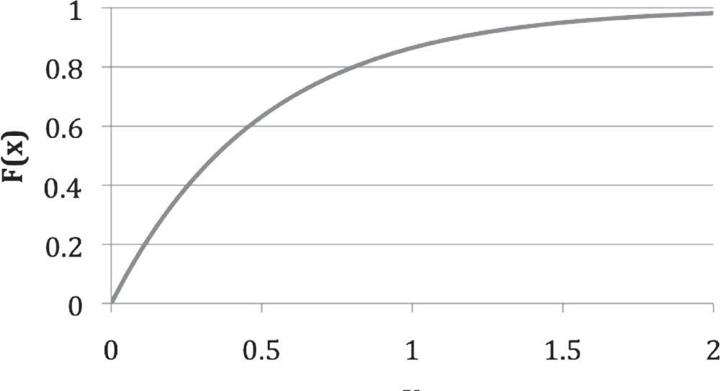

.667

. 55

2

1.5

1

**X**

0.5

0

1

0.8

0.6

0.4

0.2

0

**F (x)**

You need to select or develop the inverse of the CDF (*F* – 1 (*r*)) only once for each different distribution and then evaluate that expression as many times as you need a random number from that distribution. The ITM makes more sense if you look at it graphically. As an example, Figure 5.9 shows the CDF for an exponential distribu- tion with λ = 2, given by the expression

*F*(*x*)  1  *e**x*

If you want to know the probability of getting a value of .55 or smaller, follow the dashed line up to where it intersects with the CDF curve, then read across the solid line to determine the probability of approximately .667. Alternatively, you could use the equation for the CDF and the desired *x* value and determine the probability of getting .55 or less directly:

*F*(*x*)  1  *e*2(.55)  .667

As shown in the figure, the same CDF curve but instead shows what the ITM does. You provide the probability (in this case, .80) and trace the dotted line until you reach the CDF curve. Then trace the solid line down to determine the *x* value for which the CDF has value .80. From Figure 5.9 we see it is approximately .80. You could use the equation for the inverse of the CDF of the exponential distribution and determine the *X* value approximately:

*F*(*x*) = 1 – *e*– 2*x* = 0.80 1 – .8 = *e*– 2*x*

ln(.2) = –2*x*

ln(.2)/–2 = *x* = .805

The difficulty for some is how we relate a *U*(0,1) random number to a probability from an exponential distribution. To see how this can be the case, assume we have the CDF of a continuous distribution. By definition, the CDF is

*F*(*x*) = *P*[*X* < *x*]

Now let the following hold true:

*Y* = *F*(*X*)

What this means is we will map each outcome, *x*, on the process to a value, *y* = *F*(*x*). Now *Y* is a random variable and its distribution is *U*(0,1). To see this, construct *Y*’s CDF, *F*y(*y*), and see it is the CDF of a *U*(0,1) distribution (i.e., *F*y(*y*) = *y* for 0 < *y* < 1). Using the definition of CDFs, for any *y* between 0 and 1, we have:

*F*y(*y*) = *P*[*Y* < *y*] (definition of *y*’s CDF)

= *P*[*F*(*X*) < *y*] (because *Y* = *F*(*X*)—we made a substitution)

= *P*[*X* < *F*–1(*y*)] (solved the equation inside the brackets, *F*(*X*) < *y*, for *X*)

= *F*(*F*–1(*y*)) (this is nothing more than the definition of the CDF again, but this time we have replaced the right-hand side of the equation with the left-hand side of the equation)

= *y* (the function of its inverse is the identity—you get back what you put in)

So now we have *F*(*y*) = *y* for 0 < *y* < 1, which is a uniform distribution, and is what we set out to prove in the first place. The significance of this is, for any random variable *X* with a continuous distribution and a CDF, we can generate outcomes on *X* by generating outcomes on *Y* = *F*(*X*) (which can be done with a *U*(0,1) generator) and “inverse” transforming them to corresponding outcomes on

*X*. This is the basis of almost all CPGs. Over the long run, this will provide us with a sample of *x* values that are exponentially distributed. Since probabilities are limited between 0 and 1, and they are evenly spaced across the *F*(*X*) axis (the probability axis) in a CDF, in simulations we make the substitution of the *U*(0,1) number for the *F*(*X*) or *P*(*X* < *x*) value and solve for the corresponding *X* value. We could expect to evenly sample all probabilities from 0 to 1; this in turn would generate *X* values that cover the spectrum of the stated distribution. This is easier to perform than it is to understand.

A distinct disadvantage with the ITM is it does not work for continuous distribu- tions that do not have a closed form CDF. For example, the normal distribution cannot be solve in closed form. For these cases, special approximations have been created.

Appendix 5A contains some basic probability distributions and the associated process generators.

* + 1. **EXPONENTIAL CPG DERIVED**

There is no magic involved with generating the CPG functions provided in this sec- tion. They are nothing more than the inverse CDFs, with respect to the *x* value of the CDFs for certain distributions. Recall that for an exponential distribution the CDF is *F*(*x*) = 1−*e*–λ*x*.

Let *r* be a *U*(0,1) outcome and substitute it for *F*(*x*):

*r* = 1−*e*–λ*x*

Isolate the term with *x* in it:

*r* − 1 = −*e*–λ*x*

Multiply through by –1:

1 − *r* = *e*–λ*x*

Take the natural log of both sides:

ln(1 − *r*) = ln(*e*–λ*x*) ln(1 − *r*) = –λ*x*

Divide through by –λ:

− ln(1  *r*)  *x*

●

which gives the CPG for the exponential distribution. If you know λ and you have the means to produce *U*(0,1) random numbers, you can create exponential (λ) random numbers with this CPG.

To demonstrate the application of the exponential CPG, let us take a situa- tion from queuing theory and simulate the arrival rate of customers entering a system. Assume customers arrive at the Quickie Mart for Squishies on average every 4 minutes (following an exponential distribution). We can simulate this process by using the exponential CPG and substituting the appropriate values for *r* and λ.

First we develop the CPG. We are given an average inter-arrival time (1/λ), not a rate (λ), so we must convert it to a rate. The arrival rate is

●  1  1  1 customer  .25 customers

❍ 4 minutes

1 customer

4 minutes

minute

Therefore, the exponential CPG for this situation is

− ln(1  *r*)  *x*   ln(1  *r*)  *x*

● .25

#### TABLE 5.5

**Table of Generated Inter-Arrival Times**

|  |  |  |  |
| --- | --- | --- | --- |
| *r* | **Time (min)** | *r* | **Time (min)** |
| 0.313283 | 1.503335 | 0.402831 | 2.062223 |
| 0.2114 | 0.949982 | 0.996252 | 22.3462 |
| 0.366326 | 1.82488 | 0.76487 | 5.790461 |
| 0.894921 | 9.012186 | 0.125705 | 0.537352 |
| 0.234296 | 1.067839 | 0.032982 | 0.134152 |
| 0.232669 | 1.05935 | 0.817108 | 6.795447 |
| 0.257893 | 1.193047 | 0.525263 | 2.979975 |
| 0.978617 | 15.3806 | 0.316599 | 1.522691 |
| 0.206963 | 0.927544 | 0.067519 | 0.279627 |
| 0.799827 | 6.434295 | 0.96842 | 13.82097 |

Using the following stream of random numbers, *r*, obtained through calls to a *U*(0,1) generator, we can now determine the appropriate inter-arrival time between customers (Table 5.5).

The first value from Table 5.5 is calculated in detail below:

− ln(1  *r*)   ln(.313283)   ln(.68671)  .37583  1.5033 minutes

1 .25

.25

.25

The average of the sample of inter-arrival times is 4.7811. You may think this is not too close to the theoretical inter-arrival time of 4.0 minutes, but do not forget that we have only 20 observations. If you were to repeat this experiment with many observations, you would find that averaging the data would give values asymptotically approaching the true mean. Figure 5.10 shows the histogram of the data.

## PROBABILITY AND STATISTICS SUMMARY

Obviously, one short chapter in a textbook cannot begin to develop the probabi- listic and statistical concepts needed by an engineer. Statistical analysis must be persuasive in our professions. A better understanding of the randomness that affects complex systems, combined with better analytical tools, enables us to incorporate statistical methods in the design and costing process.

DPGs allow us to simulate events with limited outcomes and control each out- come’s probability of happening. The four steps already explained in detail make it

**Histogram**

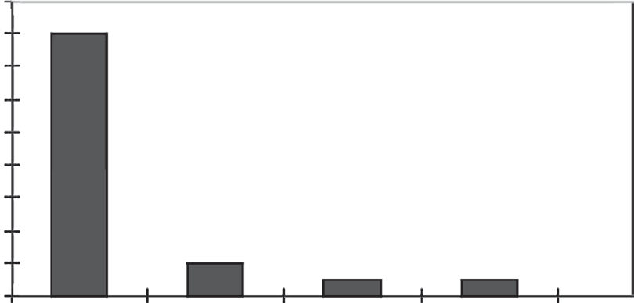18

16

14

12

Frequency

10

8

6

4

2

0

7 14 21 28

Bin Width

**FIGURE 5.10** Histogram of random numbers.

possible for you to successfully create DPGs regardless of the discrete event being modeled. The concept and development of DPGs presented here integrate seamlessly with spreadsheet simulations.

## SIMULATION IN PRACTICE

* + 1. **INTRODUCTION**

Almost any process associated with making a decision can be modeled using simu- lations: business processes, inventory, forecasting, project delivery, combat models, reliability, etc. In fact, given the world of modern simulation software, everything from biological systems to complex processes associated with a large human/ hardware/software system of systems can be replicated in a virtual environment. The challenges are developing the appropriate level of resolution, mathematically describing the entity behavior, and understanding and modeling the processes and interactions associated with entities in the system. Figure 5.11 provides a visual rep- resentation of a simple logistics simulation in which airplanes unload LOGPACS (logistics packages) at an airport.

* + 1. **BUILDING COMPLEX SIMULATIONS**

Creating a simulation is no different than any other software project requiring well- defined requirements, appropriate design, configuration management, and a struc- tured verification, validation, and accreditation (VV&A) approach.

Referring to Figure 5.11, the first step in the development of any system is to gather the customer’s requirements. Developing meaningful requirements by trans- lating the customer’s needs into meaningful requirements is a huge challenge for simulations because they are often developer driven. Once a need for a simulation has been identified, stakeholder requirements must be developed. Many companies

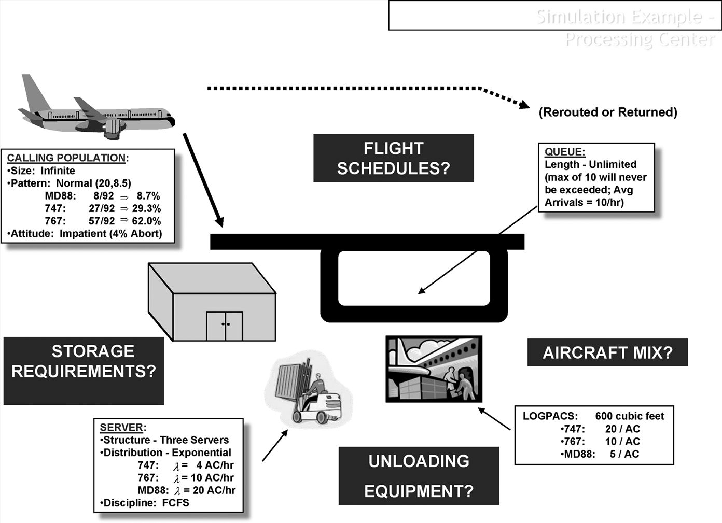

**FIGURE 5.11** Visual representation of a simple logistics simulation.

accomplish this using a formal process called “voice of the customer.” Whether or not a formal process is used, it is important to clearly identify the stakeholders and their requirements before system design begins. Simple good requirements practices should be followed to include no abstract language and no statement of “how to,” and all requirements should be quantifiable. Too often, simulations are built without knowing the problem, the customer, and the consumer. A simple simulation is shown in Example 5.7.

During a system’s design, many key decisions are made about the archi- tecture. Most of the life cycle cost commitments are made at this juncture. Simulations are often the victim of bad software language choices and inappro- priate levels of resolution for the processes and entities. Most simulations are void of formal techniques to help prioritize system design, such as quality function deployment.

Fabrication and coding have become the least of the challenges in developing a simulation. Modern computer-aided software engineering (CASE) has made mun- dane yet critical implementation issues such as configuration management easy to address.

Probably the most underfunded and least emphasized aspect of developing a sim- ulation is the VV&A (integrate and verify) process. As with many systems, funding is simply not a priority for testing as part of the VV&A process.

#### EXAMPLE 5.7

Use the following random number streams:

Stream 1: .11, .36, .45, .98, .78, .67, .51, .23, .15, .89

Stream 2: .91, .39, .72, .14, .42, .78, .55, .38, .60, .71

and the following information from the Petroco Service Station:

|  |  |
| --- | --- |
| **Time between Arrivals** | **Probability** |
| 1 | .15 |
| 2 | .3 |
| 3 | .4 |
| 4 | .15 |
| Total | 1.0 |

Construct a Monte Carlo simulation using the tables below. First, we must construct a table and determine the random number ranges:

|  |  |  |  |
| --- | --- | --- | --- |
| **Time between** | **Probability** | **Cumulative Probability** | **Random** |
| **Arrivals** | ***f*(*x*)** | ***F*(*x*)** | **Number Ranges** |
| 1 | .15 | .15 | .00 ≤ *x* < .149 |
| 2 | .3 | .45 | .15 ≤ *x* < .449 |
| 3 | .4 | .85 | .45 ≤ *x* < .849 |
| 4 | .15 | 1.0 | .85 ≤ *x* ≤ 1.0 |
| Total | 1.0 |  |  |

* + - 1. Now we can simulate the arrival of cars using the first stream of random numbers:

|  |  |  |
| --- | --- | --- |
| **Arrival** | **Random Number** | **Time between Arrivals** |
| 1 | .11 | 1 |
| 2 | .36 | 2 |
| 3 | .45 | 3 |
| 4 | .98 | 4 |
| 5 | .78 | 3 |
| 6 | .67 | 3 |
| 7 | .51 | 3 |
| 8 | .23 | 2 |
| 9 | .15 | 2 |
| 10 | .89 | 4 |
| Average |  | 2.7 |
| Standard deviation |  | 0.95 |

* + - 1. Next we simulate the arrival of cars using the second stream of random numbers:

|  |  |  |
| --- | --- | --- |
| **Arrival** | **Random Number** | **Time between Arrivals** |
| 1 | .91 | 4 |
| 2 | .39 | 2 |
| 3 | .72 | 3 |
| 4 | .14 | 1 |
| 5 | .42 | 2 |
| 6 | .78 | 3 |
| 7 | .55 | 3 |
| 8 | .38 | 2 |
| 9 | .60 | 3 |
| 10 | .01 | 1 |
| Average |  | 2.4 |
| Standard deviation |  | 0.97 |

* + - 1. Is there a difference in the results? If yes, then why?

Yes. Ten random numbers is not a large enough sample to be a true set of ran- dom numbers. This variation is expected for only ten values.

There is not a great deal of difference in the averages of the ten inter- arrival times generated in this simulation (2.7 vs. 2.4 minutes). Different random number streams can, however, produce great differences in simula- tions. Thus, we must run the simulation many times to eliminate any random number biases.

## USING READINESS LEVELS FOR MODEL INPUT

Numerous readiness levels exist in the literature, including:

* Technology readiness levels (TRLs)
* Systems readiness levels (SRLs)
* Integration readiness levels (IRLs)
* Cost readiness levels (CRLs)
* Manufacturing readiness levels (MRLs)
* Commercialization readiness levels (CRLs)

A TRL can be defined as a systematic metric/measurement system that supports assessments of the maturity of a particular technology and the consistent comparison of maturity among different types of technology (Mankins, 1995). The TRL is the accepted standard in government and industry as a measure of technology maturity.

#### TABLE 5.6

**Improved TRL Weighted Risk Rating**

**TRL Risk**

|  |  |  |
| --- | --- | --- |
| **TRL** | **Risk Description** | **Level** |
| 1 | Extra high | 8 |
| 2 | Very high | 7 |
| 3 | High | 6 |
| 4 | Moderate high | 5 |
| 5 | Moderate | 4 |
| 6 | Moderate low | 3 |
| 7 | Low | 2 |
| 8 | Very low | 1 |
| 9 | Extra low | 0 ~ 1 |

As shown in Table 5.6 TRLs range from 1 to 9, with 9 satisfying the highest degree of readiness (ready to market) and 1 the lowest (development of the concept only). TRLs can be used to assess the maturity of a technology (both hardware and soft- ware), and in turn, the risks that might be associated with it. TRL might also serve as an indicator of technology obsolescence and replacement (Ganguly et al., 2007). Readers are referred to Mankins (1995) for more information on TRLs along with their detailed definitions.

Although TRL serves as an important evaluation scale to assess the readiness of a technology, a metric that provides a description of integration would greatly increase the robustness of the TRL metrics. Sauser et al. (2009), Gove (2007), and Gove et al. (2008) created an IRL to measure integration maturity on a scale similar to TRL to provide a system-level readiness assessment. TRLs and IRLs can be used to form a basis for a logical and defensible means to input variation for SBC.

NASA’s relative risk weighting methodology is used to translate elicited risk information, based on given WBS elements, into cost impacts and scenarios by con- structing triangular WBS cost–risk distribution analysis. The cost estimators and systems engineers collaborate to perform cost–risk assessment by evaluating cost– risk drivers and producing cost–risk scenarios within four suggested fundamental program categories: technology, design and engineering, complexity, and schedule (NASA, 2008). Risk scores for each WBS element risk scenario may be developed by adapting the analytic hierarchy process to derive weights for both the risk driver categories and the rating scale intensities (NASA, 2008); therefore, the risk-weighted cost impacts within a range of triangular distribution (pessimistic, reference or “most likely,” and optimistic) can be achieved by multiplying the risk factors and likelihood of system costs (NASA, 2008).

#### TABLE 5.7

**Weighted TRL Cost Risks**

**Weighted**

|  |  |  |  |  |  |
| --- | --- | --- | --- | --- | --- |
|  | **Technology** | **Technology** | **Technology** | **Technology** | **TRL Risk** |
| **1** | **2** | **3** | **n** | **(WTRLR)** |
| Cost-weighted risk contribution | 0.05 | 0.23 | 0.44 | 0.28 | 1.00 |
| Pessimistic TRL risk level | 6 | 4 | 4 | 4 | 0.45 |
| Most likely TRL risk level | 5 | 3 | 3 | 3 | 0.34 |
| Optimistic TRL risk level | 4 | 2 | 2 | 2 | 0.23 |

For a given technology within a system, we assess and evaluate the appropri- ate TRL. The risk values for each technology can be derived and translated based on the defined TRL. The risk values are assessed and mapped “reversely” from their associated readiness levels; that is, the improved TRL weighted risk rating scale may be viewed as the opposite of the TRL scale we often use, as shown in Table 5.7. However, it is common sense to theorize that a system may be at a lower risk level when a higher TRL value represents the mature state of a given technology.

As an example, Table 5.7 shows the risk levels of technologies 1, 2, 3, and *n*, which can be cross-referenced based on their assumed TRL values. The row of cost-weighted risk is equal to the percentage of cost–risk weight for a given technol- ogy in a system, and it sums to 100%.

From Table 5.7, the weighted technology cost–risk factor values can be calculated for three different likelihood parameters. Both the low and high ends of the weighted TRL cost–risk factors within a triangular technology cost distribution can be calcu- lated based on the following formulas:

*Weighted Low End Cost*  *Risk Factor*

 *Weighted Optimistic TRL Risk Factor*  0.23  0.68

*Weighted Most Likely TRL Risk Factor* 0.34

*Weighted High End Cost*  *Risk Factor*

 *Weighted Pessimistic TRL Risk Factor*  0.45  1.32

*Weighted MostLikely TRL Risk Factor* 0.34

0.68 Most Likely TRL Parameter



Most Likely TRL Parameter

1.32 Most Likely TRL Parameter

Apply parameter factors to obtain TRL risk based technology costs

Optimistic Technology Cost

Most Likely Technology

Cost

Pessimistic Technology Cost

**FIGURE 5.12** Graphic representation of weighted TRL risk-based costs in a triangu- lar distribution. (Modified from National Aeronautics & Space Administration (NASA). 2008. Accessed June 25, 2009, <http://sbir.nasa.gov/SBIR/sbirsttr2008/solicitation/forms/> appendix_B.pdf)

Figure 5.12 shows a graphic representation of the results of our triangular technol- ogy cost distribution by applying weighted TRL cost–risk factors. Note that cost and time can be used interchangeably.

Therefore, based on the example above, if our system has an overall (most likely) TRL score of 5 and technology cost of $200,000, as well as optimistic and pessi- mistic TRL cost–risk factors of 0.68 and 1.32, respectively, we can conclude that the technology costs in a triangular cost distribution range from $136,000 to $264,000, with a mean of $200,000.

## SIMULATION USING SPREADSHEETS

Teaching simulation can be difficult. Thus, the approach in this book is to teach the mathematical underpinnings, introduce you to simulation using manual tech- niques, expand the complexity of what we can model by using spreadsheets, and then use a spreadsheet add-in to model realistic systems. Many spreadsheet add-ins exist, including Crystal Ball, Extend, and even some freeware packages. Hopefully, this hierarchal approach will allow modelers to build on basic skills before advanc- ing to more complex simulations. Spreadsheets have a distinct advantage in that most students know how to utilize the built-in capabilities of tools such as Excel. Spreadsheets provide an ideal platform on which to learn the basics of simulation methodology.

Some of the challenges of conducting simulations in Excel include

* + 1. It is difficult to run many iterations.
    2. Many CPGs do not have built-in Excel functions.
    3. You must use the graphing capabilities to post process results.
    4. Developing the logic for queuing systems is difficult without writing Visual Basic code.

Example 5.8 shows a basic queuing problem that can easily be coded using Excel.

#### EXAMPLE 5.8

As a newly assigned operations engineer, you have developed a self-service supply center for your factory. You have one supply clerk to process the paper- work for the customers. When you performed a queuing analysis on your store, you found the mathematical solution did not accurately model the real-world system; therefore, you have decided to manually simulate the store’s operation. You record data for 1 day and arrive at the following distribution of arrival intervals and service times:

#### Distribution of Arrival Intervals (Arrivals at the Checkout Counter)

|  |  |  |  |
| --- | --- | --- | --- |
| **Arrival Interval**  **(minutes)** | **Probability,**  ***P*(*x*)** | **Cumulative Probability** | **Random Number**  **Range (r1)** |
| 1 | .45 | .45 | 0 ≤ *r*1 < .45 |
| 2 | .35 | .8 | .45 ≤ *r*1 < .8 |
| 3 | .15 | .95 | .8 ≤ *r*1 < .95 |
| 4 | .05 | 1.0 | .95 ≤ *r*1 ≤ 1.0 |

**Distribution of Service Times**

|  |  |  |  |
| --- | --- | --- | --- |
| **Service Time** | **Probability,** | **Cumulative** | **Random**  **Number** |
| **(minutes)** | ***P*(*y*)** | **Probability** | **Range** |
| 1.0 | .35 | .35 | 0 ≤ *r*2 < .35 |
| 2.0 | .55 | .9 | .35 ≤ *r*2 < .9 |
| 3.0 | .10 | 1.0 | .9 ≤ *r*2 ≤ 1.0 |

Below is a manual simulation of the process at the self-service supply center store:

|  |  |  |  |  |  |  |  |  |  |  |
| --- | --- | --- | --- | --- | --- | --- | --- | --- | --- | --- |
|  | | **3** | **4** | **5** |  | **7** |  |  |  | **11** |
| **1** |  | **Inter-** | **Total** | **At** | **6** | **Queue** |  | **9** | **10** | **Time** |
| **Cust.** | **2** | **Arrival** | **Clock** | **Cashier** | **Wait** | **Length** | **8** | **Service** | **Depart** | **in** |
| **#** | ***r*1** | **Time** | **Time** | **Time** | **Time** | **After Entry** | ***r*2** | **Time** | **Clock** | **System** |
| 1 | — | — | 0 | 0 | 0 | 0 | .06 | 1 | 1 | 1 |
| 2 | .93 | 3 | 3 | 3 | 0 | 0 | .47 | 2 | 5 | 2 |
| 3 | .72 | 2 | 5 | 5 | 0 | 0 | .30 | 1 | 6 | 1 |
| 4 | .83 | 3 | 8 | 8 | 0 | 0 | .97 | 3 | 11 | 3 |
| 5 | .35 | 1 | 9* | 11* | 2 | 1 | .96 | 3 | 14 | 5 |
| 6 | .17 | 1 | 10* | 14 | 4 | 2* | .20 | 1 | 15 | 5 |
| 7 | .82 | 3 | 13 | 15 | 2 | 2 | .16 | 1 | 16 | 3 |
| 8 | .63 | 2 | 15 | 16 | 1 | 1 | .50 | 2 | 18 | 3 |
| 9 | .68 | 2 | 17 | 18 | 1 | 1 | .03 | 1 | 19 | 2 |
| 10 | .98 | 4 | 21 | 21 | 0 | 0 | .07 | 1 | 22 | 1 |
|  |  |  |  |  | Σ = 10 |  |  |  |  | Σ = 26 |

## BUILDING SYSTEMS SIMULATIONS

*Note:* At Cashier Time for Entity 2 = MAX (Total Clock Time 2, Depart Clock 1); Depart Clock =

At Cashier Time + Service Time; Time in System = Service Time + Wait Time.

Determine the average waiting time, average queue length, and average time in the system:

Average waiting time (*Wq*): 10/10 = 1 minute

Average queue length (*Lq*): Little’s Law: *Lq* = λ*Wq* > (10/21)(10/10) = .4762 customer

Average time in system (*Ws*): 26/10 = 2.6 minutes

Average wait (*Wq*) = 10/10 = 1 average queue length (*Lq*) = 7/10 = .70 Average time in the system = 26/10 = 2.6

Most analysts now accept and understand that simulation is the only means to study complex systems. Table 5.8 lists the key mistakes made in simulation development and domain applications of the tools, respectively.

We have glossed over the importance of VV&A. However, for complex systems, SOS, or even enterprise-wide representations or VV&A, simulation is the only means to conduct analysis.

## SUMMARY

Modeling and simulation continue to be key elements throughout the program life cycle, especially early on. M&S allows program managers to quickly develop CONOPS. Further along in the life cycle, M&S can be used for detailed design.

#### TABLE 5.8

**Key Mistakes Made in Simulation Development**

**Steps in the Systems Engineering Process Mistakes Made in Development**

Gather and define requirements No formal SE process and tools utilized

Stakeholders/customers not clearly defined

System design No formal process or prioritization tools used No formal requirements management tools used

Detailed design Various levels of resolution of the entities and processes

Code Wrong languages used

Do not investigate COTS and GOTS or prior subroutines for the simulation

Software testing (validation) No integrated plan beyond simply running the model Integration (verification) Limited knowledge on how to look at the system

No way to test the synergisms of various modules

Operational acceptance (accreditation) V&V often not documented or conducted by an

independent group

Accreditation nothing more than a “rubber stamp”

It can be used in a distributed collaborative environment that supports authorita- tive information exchange and rapid refinement of the design or concept. Over the system life cycle, it can assist in the response to changing circumstances such as technological advances, changing threats, tactics, or doctrine. During the early phases of defining the needed M&S environment, the systems engineering team must also establish the metrics to be used for evaluating candidate concepts. The specifics of the M&S environment can then be filled in such that meaningful mea- sures of merit can be extracted from the simulations and used to focus further rounds of simulation.

For the modern engineer, M&S should be applied throughout a system’s life cycle in support of product development activities. Engineers integrate M&S tools and technology into all development and management activities, as well as plan for life cycle application, support, and reuse of models and simulations (DoD, 2005). Modeling and simulation is the only tool that can relate risk to cost for complex problems.

## QUESTIONS

* 1. What was your preconceived definition of M&S before reading this text?
  2. Can you think of problems that cannot be modeled using a simula- tion? (Hint: A simulation gives you an answer only for what you have modeled.)
  3. Simulations are essential models for processes with a mathematical rep- resentation of the entity behavior. Which is more difficult to model: the process or the entity behavior?
  4. Consider the following plot of probability versus time (in minutes) as a function of the number of operators:

25

20

1. Operator
2. Operators
3. Operators
4. Operators
5. Operators

Wait Time, Minutes

15

10

5

0 0 20 40 60 80 100

Probability (*x* < *X*)

The plot is meant to convey the call wait time as a function of number of call center operators. For example, there is an 80% probability that with four operators all calls could be answered in less than 5.3 minutes. You need to present this information to the senior vice president for opera- tions. Can you develop a better plot of this information? Can you develop nontechnical labels to convey the information more simply?

* 1. Consider the homeland defense, homeland security, and defense support to civilian authorities (DSCA) missions of the DoD. The DoD builds complex architectures for all major weapons systems and has significant experience in developing systems of systems. How can modeling and sim- ulation be used for the enterprise-wide problem shown in the following figure?

FEMA, NGOs,

etc.

Guard

First Responders

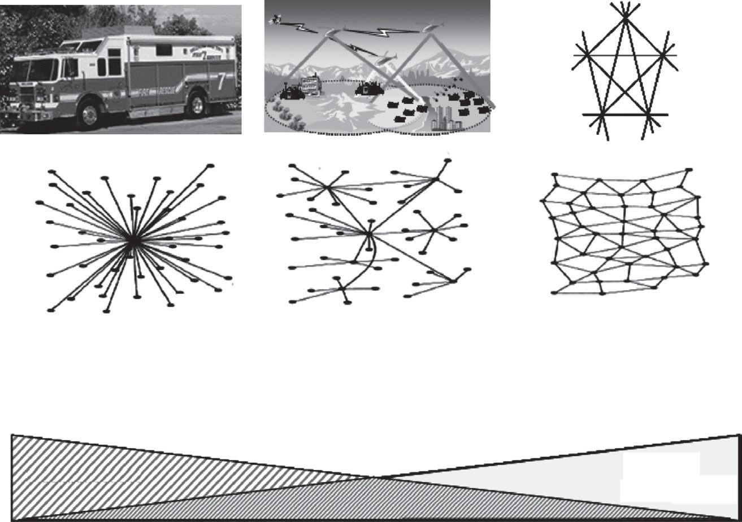Army/Reserves

Governors/Local

Centralized

**System**

* Assemblies
* Modules
* Parts

**Central Control**

Decentralized

**Systems of Systems**

* + - Family of Systems
    - System

**Mixed Levels of Control**

Distributed

**Enterprise Systems of Systems**

* Family of Systems
* Systems of Systems

Autonomy Diversity

No Clear Control

## PROBLEMS

* 1. Local college students drink a lot of coffee at the recently remodeled Café Java. The manager has gathered data about arrival times, coffee demand, and the service time using a single cashier. The relative frequency of the demand for certain coffee sizes during the 8:00–9:00 am hour (peak con- sumption period) of operation is shown in the table below:

**Demand Frequency *P*(*x*)**

0 8

Small 10

Medium 22

Large 10

**Cum.**

**Probability**

**Random Number Range**

Develop a DPG that you can use to simulate operations.

* 1. A restaurant manager has asked you to develop the data needed for the simulation of her operations. From her statements and your interviews with patrons, you determine that the inter-arrival time of patrons on aver- age is 2 minutes (closely approximating a Poisson process). The service times are uniformly distributed, with a minimum of 10 seconds and a maximum of 55 seconds. Develop the CPGs needed for the simulation.
     1. Arrival time process generator
     2. Service time process generator
  2. Consider a continuous random variable with the following PDF that rep- resents service time:

1 ,

*f* (*x*)   3

 0

for 2  *x*  5 otherwise

* + 1. Sketch the PDF.
    2. Develop a CPG for these service times using the ITM.
  1. Consider a continuous random variable with the following PDF that rep- resents service time:

2  *x* ,

for 2  *x*  4

*f* (*x*)   2

 0

otherwise

* + 1. Sketch the PDF.
    2. Develop a CPG for these service times using the ITM.
  1. The COTS PM is considering a refinement to the simulation model to study another possible change in the inventory policy of the active sonar geo- phones. The number of days the Navy has to wait from the time they place the order until the time the geophones arrive at the depot is not constant. The lead time (a random variable *X*) is described by the following probability:

*f* (*x*)  8*x*  4,



1  *x*  1 weeks

2

 0

1. Graph the function.

otherwise

1. Use the ITM to derive the CPG for the lead time to receive the geophones.
   1. Given the continuous probability distribution below, develop a CPG by using the ITM technique and graph the function in Excel:

 *x* ,

*f* (*x*)  18

 0

0  *x*  56 otherwise

* 1. To demonstrate the application of the exponential CPG, let’s take a situa- tion from queuing theory and simulate the arrival rate of customers enter- ing a system. Assume customers arrive at the Quick Mart for Squishies on average every 4 minutes (following an exponential distribution). Simulate this process using the exponential CPG. Using Excel, develop a histogram with 50 data points and verify that your CPG is indeed replicating the exponential behavior.
  2. As part of a business process reengineering study, you collected the follow- ing times for calls received at your IT support desk. You would like to build a simulation to investigate bottlenecks and the return on investment of new technology. Your IT department has provided you with the following inter- arrival times (in minutes). Using Crystal Ball or another statistical package, fit a continuous process distribution to the data for use in a simulation.

|  |  |  |  |
| --- | --- | --- | --- |
| **Inter-Arrival Times (min)** |  | | |
| 0.588814749 | 1.108568755 | 0.732264692 | 0.471302103 |
| 0.397494588 | 0.547610383 | 0.242657492 | 0.722365606 |
| 1.673683718 | 1.538859923 | 0.352512396 | 1.887436095 |
| 0.084404664 | 2.719185953 | 0.112583034 | 0.197749859 |
| 0.230179077 | 3.242295179 | 0.115828188 | 1.82730058 |
| 0.587504092 | 0.118464846 | 3.459217465 | 2.225006862 |
| 1.37812423 | 0.583542146 | 0.711006448 | 0.632092026 |
| 0.327181262 | 0.389833717 | 0.610918746 | 1.475870936 |

|  |  |  |  |
| --- | --- | --- | --- |
| **(Continued)** |  |  |  |
| **Inter-Arrival Times (min)** |  |  |  |
| 0.535358812 | 0.746621891 | 0.478771272 | 1.172587523 |
| 1.064741685 | 0.658668746 | 0.291238526 | 3.223637925 |
| 2.761979873 | 0.03681801 | 0.018324774 | 1.374153606 |
| 0.56351202 | 0.187436268 | 0.621802042 | 1.309829203 |
| 3.29436124 | 0.382481155 | 0.817091787 | 0.22914525 |
| 0.366030742 | 0.990546057 | 0.290123951 | 0.891470352 |
| 0.073726122 | 0.771284964 | 0.335684761 | 0.576193114 |
| 1.780062427 | 1.694452517 | 3.786707383 | 0.867377053 |
| 0.544917667 | 0.562536755 | 0.46974402 | 2.127784231 |
| 0.182478972 | 0.039699342 | 0.926288378 | 0.043291821 |
| 3.550765671 | 0.669752309 | 0.189516512 | 1.49132871 |
| 0.592049529 | 1.590598732 | 0.737572538 | 0.365648322 |
| 1.932861976 | 0.162172788 | 0.662148766 | 3.288387525 |
| 0.331807512 | 0.109502818 | 0.835056714 | 0.492974166 |
| 0.39967384 | 0.874628264 | 2.907609454 | 0.909592149 |
| 0.523997406 | 0.25855252 | 1.18275267 | 0.403250281 |
| 1.413733145 | 0.330339127 | 0.067442005 | 0.069066114 |

* + 1. Using the Kolmogorov–Smirnov (K–S) or some other goodness-of-fit statistic, how confident can we be that this data behaves according to the hypothesized distribution?
    2. Using histograms,* develop a DPG representative of this data.
    3. Under what circumstances is using a DPG preferable to a CPG? Give an example.
  1. You conducted a Crystal Ball simulation with project completion times, as shown below:

0.029

0.022

Probability

0.015

0.007

**Frequency Comparison**

Normal distribution Mean = 197.09

Std Dev = 14.31

Project duration

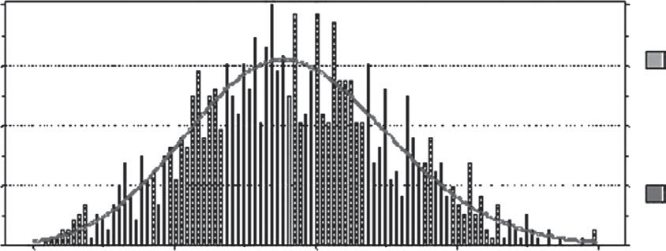0.000 160.00 180.00 200.00 220.00 240.00

* + 1. Your company bid this contract with the promise to complete the job within 185 days. What is the probability of completing this project in that time frame? (Show your work.)
    2. Develop a chart that would be of interest using the information provided.
    3. Explain your chart in simple terms.
* Typically, we use the *n*ö rule for determining bin sizes for histograms.
  1. Using the ITM, determine the CPG that will generate random variables with the following triangle distribution:

The sketch of this PDF:

f(x)

1/15

27 33 51

X (cubic feet × 100)

Determine the PDF equation.

* 1. Using the ITM, determine the CPGs that will generate random variables with the following triangle distribution:

The sketch of this PDF:

f(x)

1/2

1 2 5 X (seconds)

Determine the PDF equation.

* 1. To verify a proposed service time process generator, you use a stopwatch to time 30 transactions.
     1. Using Excel and bin sizes of 5 and 15, plot histograms from the data shown below. Qualitatively using these plots, does the uniform pro- cess generator (10,55) accurately reflect your observations?

|  |  |  |
| --- | --- | --- |
| 42 | 12 | 28 |
| 28 | 21 | 20 |
| 46 | 30 | 32 |
| 45 | 42 | 26 |
| 13 | 49 | 27 |
| 38 | 20 | 40 |
| 11 | 45 | 25 |
| 47 | 22 | 10 |
| 34 | 45 | 50 |
| 27 | 38 | 43 |

* + 1. What technique would you use to quantitatively assess (or hypoth- esize) whether this data behaves as a uniform distribution varying from 10 to 55?
  1. The manager of Café Java is trying to determine whether to hire another cashier for the morning coffee rush hour. Does she need one? Justify your answer using the simulation results obtained from five customers:

|  |  |  |  |  |  |  |  |  |  |
| --- | --- | --- | --- | --- | --- | --- | --- | --- | --- |
|  | **Inter-** | **Clock** | **At** | **Wait** |  | **Length** | **Service** | **Depart** | **Time in** |
| **Arrival** | **Time** | **Cashier** | **Time** |  | **of** | **Time** | **Time** | **System** |
| ***r*1** | **(min)** | **(min)** | **(min)** | **(min)** | ***r*2** | **Queue** | **(min)** | **(min)** | **(min)** |
| 0.25 |  |  |  |  | 0.70 |  | | | |
| 0.95 |  |  |  |  | 0.89 |
| 0.47 |  |  |  |  | 0.02 |
| 0.02 |  |  |  |  | 0.46 |
| 0.17 |  |  |  |  | 0.49 |

Use the following random number streams:

1st set: .25, .95, .47, .02, .17

2nd set: .70, .89, .02, .46, .49

Assume that the inter-arrival times are exponentially distributed, with a mean of 1/λ = 1.5 minutes per customer. The ordering, preparation, and money collecting (i.e., total service time) is an upward ramp function with a minimum of 15 seconds and a maximum of 1 minute.

* + 1. Develop the process generators.
    2. As the first step in designing a spreadsheet to study the problem in depth, manually simulate the arrival of five customers. (Hint: This is a basic single-server queuing system.)
    3. Determine the average waiting time, the average queue length, and the average time in the systems.
    4. Based on these limited results, do we need another cashier? Justify.
    5. How and why would you incorporate the demand for coffee into the simulation?
  1. The COTS PM for the Seawolf class attack submarine has asked you to examine their proposed inventory policy for passive sonar geophones (PSGs). The inventory policy must support the Navy’s diverse missions. The proposed inventory policy is to order 30 PSGs whenever the inven- tory drops below 16 at the east coast depot.

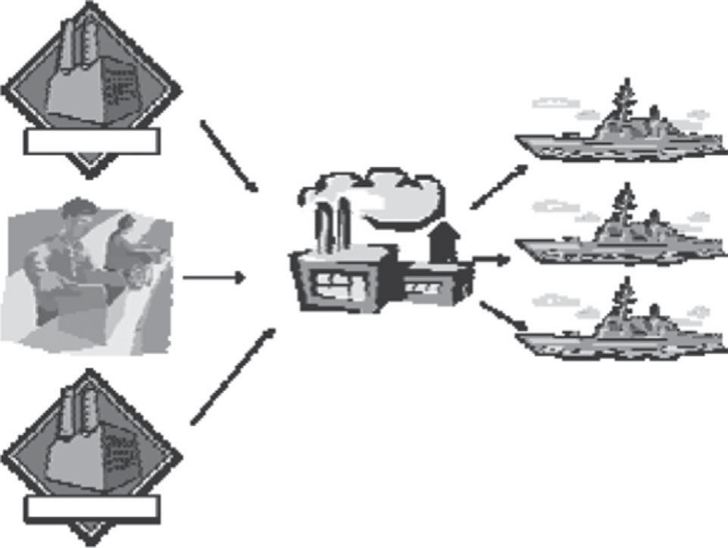

Manufacturing

**Logistics Depot**

**Navy Fleets**

Manufacturing

**Contract Manufacturers**

This new policy and your analysis are restricted to the following conditions:

* The Navy is prohibited from having more than one order in the system at any one time. They must wait until the initial order of 30 arrives at the depot and the inventory level drops below 16 before a special order is placed.
* The Navy operates its depots 10 hours per day, 7 days a week. The days on the system clock are in terms of working days. Since the depot operates 10 hours/day, 1/10 of a day is actually one working hour. This accounting method prevents orders from being processed when the depot is not open.
* The depot can place and receive an order any day of the week.
* You assume a starting inventory of 21 PSGs.

The COTS PM feels that the following three process generators can be used to accurately model the behavior of this supply chain:

Process generator #1

CPG for the inter-arrival time between demand orders:

*x*   5 ln(*r* )

6 1

where:

*x* = days between arrival of the PSGs

*r*1 = random number Process generator #2

**Number of PSGs**

**Number of Occurrences**

1 6

2 5

3 9

4 30

5 25

6 25

|  |  |  |  |
| --- | --- | --- | --- |
|  | | | **Random** |
| **Number** |  | **Cum.** | **Number** |
| **of PSGs** | ***P*(*x*)** | **Prob.** | **Range** |
| 1 |  | | |
| 2 |
| 3 |
| 4 |
| 5 |
| 6 |

Process generator #3 CPG for order lead time:

*Y* = –12.5 ln(*r*3)

where:

*Y* = number of days lead time

*r*3 = a random number

Use these process generators to simulate the proposed inventory policy of ordering 30 PSGs whenever the number of geophones in inventory drops below 16. Use the blank spaces in the following table to record the times, demands, inventory levels, and reorder points. Note that some of

the random numbers in the table may not be needed. The clock time must be recorded in the table for each event in the simulation. Process 11 cus- tomers through the system in your simulation. Assume that the first order arrives in the system at a clock time of 0 minutes.

|  |  |  |  |  |  |  |  |
| --- | --- | --- | --- | --- | --- | --- | --- |
| ***r*1** | **Days between Orders** | **Clock Time** | ***r*2** | **PSG**  **Demand** | ***r*3** | **Lead Time (Days)** | **Inventory Level** |
| N/A | N/A | 0 | 0.904 |  | 0.782 |  |  |
| 0.659 |  |  | 0.398 |  | 0.872 |  |  |
| 0.900 |  |  | 0.808 |  | 0.084 |  |  |
| 0.024 |  |  | 0.647 |  | 0.393 |  |  |
| 0.219 |  |  | 0.695 |  | 0.211 |  |  |
| 0.411 |  |  | 0.650 |  | 0.132 |  |  |
| 0.237 |  |  | 0.667 |  | 0.843 |  |  |
| 0.599 |  |  | 0.040 |  | 0.921 |  |  |
| 0.826 |  |  | 0.516 |  | 0.909 |  |  |
| 0.087 |  |  | 0.141 |  | 0.012 |  |  |
| 0.887 |  |  | 0.685 |  | 0.691 |  |  |

What is the average demand of PSGs per order?

* 1. Big Red, Inc., rents trucks on a weekly basis. Trucks are picked up and dropped off at one of five locations:

1. Enid, Oklahoma
2. Topeka, Kansas
3. Broken Bow, Nebraska
4. Goodland, Kansas
5. Amarillo, Texas

Management has developed the following “transition matrix,” which gives the probability of a truck being returned at each of the locations depending on the city where it was picked up:

**Return City**

|  |  |  |  |  |  |  |
| --- | --- | --- | --- | --- | --- | --- |
| **Pick-Up** | **Enid** | **Topeka** | **Broken Bow** | **Goodland** | **Amarillo** |  |
| **City** Enid | .3 | .35 | .2 | .1 | .05 |  |
| Topeka | .25 | .15 | .3 | .2 | .1 |  |
| Broken Bow | .05 | .1 | .2 | .3 | .35 |  |
| Goodland | .4 | .05 | .1 | .15 | .3 |  |
| Amarillo | .35 | .4 | .1 | .1 | .05 |  |

For example, if a truck is picked up in Goodland, there is a 30% chance that it will be returned in Amarillo.

Beginning with a truck in Broken Bow, Nebraska, simulate the rent- als and locations of a truck for a 20-week period. Start by developing a discrete random variable generator for each city. Use the random numbers given. From the simulation experiment, determine the percentage chance of a truck being returned in each city. Discuss how this simulation might be changed to yield more accurate results.

**Enid**

Enid Topeka Broken Bow Goodland

Amarillo

**Topeka**

Enid Topeka Broken Bow Goodland

Amarillo

**Broken Bow**

Enid Topeka Broken Bow Goodland

Amarillo

**Goodland**

Enid Topeka Broken Bow Goodland

Amarillo

**Amarillo**

Enid Topeka Broken Bow Goodland Amarillo

|  |  |  |  |  |  |  |  |
| --- | --- | --- | --- | --- | --- | --- | --- |
| **Week** | **Pickup** | ***r*** | **Return** | **Week** | **Pickup** | ***r*** | **Return** |
| 1 | Broken Bow | .45 |  | 11 |  | .03 |  |
| 2 |  | .69 |  | 12 |  | .47 |  |
| 3 |  | .33 |  | 13 |  | .06 |  |
| 4 |  | .69 |  | 14 |  | .55 |  |
| 5 |  | .88 |  | 15 |  | .86 |  |
| 6 |  | .16 |  | 16 |  | .25 |  |
| 7 |  | .7 |  | 17 |  | .63 |  |
| 8 |  | .7 |  | 18 |  | .18 |  |
| 9 |  | .07 |  | 19 |  | .63 |  |
| 10 |  | .37 |  | 20 |  | .18 |  |

**City**

Enid Topeka Broken Bow Goodland Amarillo

**Number of Returns**

What can we do to make this simulation more representative of an actual rental operation?

* 1. Gino Petralli is an enterprising businessman. He is in the process of start- ing up a pizzeria. Specifically, he needs to know if 10 tables in his dining area is enough. Further, he would like to ensure the average time a party must wait for a table is less than 2 minutes. Do a manual simulation of Gino’s Pizzeria to determine if the facility can meet Gino’s criteria with its current setup.

Assume there are 10 tables in the pizzeria and at the beginning of the simulation, 8 of the tables are occupied. The first table below shows the departure times of each group that is already in the pizzeria. The process generators for this problem are also shown below.

|  |  |  |
| --- | --- | --- |
| Group number | 1 2 3 4 5 6 7 | 8 |
| Departure time | 68 66 81 85 27 18 21 | 59 |

**119**

Simulation-Based Costing

|  |  |  |  |  |  |  |  |  |  |  |  |  |  |  |  |  |  |
| --- | --- | --- | --- | --- | --- | --- | --- | --- | --- | --- | --- | --- | --- | --- | --- | --- | --- |
|  | |  | **Time** |  |  |  |  | **Wait** |  | | | | | | | | |
| **Inter-** | **of** |  |  |  |  | **Time** |  | **No.** |  | **Time** | **Time** |  |  |  | **Total Time** |
| **Arrival** | **Arrival** |  | **No. in** | **Tables** | **Time** | **for** |  | **of Pizzas** | **Cook** | **into** | **Pizza** |  | **Eat** | **Depart** | **in** |
| **Group** | ***r*1** | **(min)** | **(min)** | ***r*2** | **Group** | **Avail.** | **Seated** | **Table** | ***r*3** | **Ordered** | **Time** | **Oven** | **Served** | ***r*4** | **Time** | **Time** | **Restaurant** |
| 9 | .191 |  |  | .204 |  |  |  |  | .806 |  |  |  |  | .959 |  |  |  |
| 10 | .655 |  |  | .313 |  |  |  |  | .478 |  |  |  |  | .302 |  |  |  |
| 11 | .513 |  |  | .982 |  |  |  |  | .596 |  |  |  |  | .593 |  |  |  |
| 12 | .474 |  |  | .246 |  |  |  |  | .322 |  |  |  |  | .938 |  |  |  |
| 13 | .638 |  |  | .019 |  |  |  |  | .019 |  |  |  |  | .285 |  |  |  |
| 14 | .439 |  |  | .791 |  |  |  |  | .154 |  |  |  |  | .564 |  |  |  |
| 15 | .227 |  |  | .346 |  |  |  |  | .217 |  |  |  |  | .389 |  |  |  |

**Interarrivals # in Group... Order Size...**

*x* = 5

0.10

*x* = 6

0.10

*x* = 2

0.20

*x* = 4

0.20

*x* = 3

0.40

**Consumption and**

**Conversation Time... Miscellaneous**

Inter-arrivals are exponentially distributed with a mean of 1/λ = 10 min/group. Thus, λ = 6 groups/hr. This results in the following process generator for inter-arrivals.

# of Pizzas

# in Group Ordered (*x*) p(*x*)

2 1 1.00

3 1 (or) 2 .60 (.40)

4 2 1.00

5 2 (or) 3 .20 (.80)

6 3(or) 4 .50 (.50)

**Cooking Time…**

The pizza oven is of the conveyor belt type. It takes 10 minutes to cook a pizza and pizzas must be spaced 2 minutes apart.

This process is uniformly distributed (*a*,*b*), where *a* = 10 and *b* = 50. The continuous process generator for a uniform distribution is

*x* = *r*4(50 – 10) + 10,

which generates “eat” times.

Note: Assume a 5-minute delay

between the time people are seated and the time their pizza(s) enters the oven.

**120**

Systems Life Cycle Costing

* 1. Your recent business-to-business (B2B) implementation of a Web-based inventory tracking system is a huge success with your customer. However, the equipment continues to have reliability issues. Currently, failures seem to be exponentially distributed, with a mean of 2 days. The duration of the equipment failures is distributed as follows:

|  |  |  |  |
| --- | --- | --- | --- |
| **Failure** | **Probability of Failure,** | **Cumulative** | **Random Number** |
| **(hours)** | ***P*(*x*)** | **Probability** | **Range (*r*2)** |
| 1 | .25 | .25 | 0 ≤ *r*2 < .25 |
| 2 | .60 | .85 | .25 ≤ *r*2 < .85 |
| 3 | .15 | 1.00 | .85 ≤ *r*2 ≤ 1.00 |

To determine the time between failures, use the following CPG:

Days until next failure = –2 ln(*r*1)

where:

*r*1 = a random number (0 ≤ *r*1 ≤ 1).

Simulate at least 1 month of business operations in Excel. Assuming that you lose $200/hr in business and another $500/hr in customer goodwill, determine the average cost per day and the average cost per equipment failure. Use the list below to develop the processes before conducting the simulation in Excel, Crystal Ball, or another software package:

* Draw a picture or a flowchart to help identify the processes
* Develop process generators
* Set up spreadsheet headings
* Develop simulation
* Capture output using a “what if” or “define forecast” table
* Postprocess the results
  + 1. What statistics could you obtain from this simulation that would be of interest to your management?
    2. What processes could you include to develop a more accurate model?
  1. A major airport authority used simulation in the planning to replace an international terminal at one of its airports. The early program plan was for a dual-level, 1.37 million square foot, 21 contact gates building with a cost estimate of $1.4 billion. The estimated project duration was 125 months. A value-planning workshop with 40 or so industry experts

was held over an intense 2-week period. This value-planning workshop looked at all aspects of the project; a subset of this group performed a risk analysis of the estimated duration and estimated cost. Below is a table of activities on the critical path of the network:

|  |  |  |  |  |
| --- | --- | --- | --- | --- |
|  | | **Month** |  |  |
| **Activity** | **Optimistic** | **Expected Value** | **Pessimistic** |
| Value planning | 0.50 | 0.50 | 0.50 |  |
| Planning | 2.0 | 6.0 | 8.0 |  |
| Award stage II design | 1.0 | 2.0 | 4.0 |  |
| Stage II | 10.0 | 16.0 | 20.0 |  |
| Value engineering | 0.25 | 0.25 | 0.25 |  |
| Project | 3.0 | 6.0 | 8.0 |  |
| Stage III design | 14.0 | 20.0 | 26.0 |  |
| Demo old control tower | 4.0 | 4.0 | 7.0 |  |
| New ticketing | 14.0 | 18.0 | 24.0 |  |
| New baggage hall | 6.0 | 8.0 | 10.0 |  |
| Construct departures and  arrivals | 16.0 | 18.5 | 20.0 |  |
| Fitout baggage | 6.0 | 8.0 | 10.0 |  |
| Fitout ticketing | 12.0 | 14.0 | 16.0 |  |
| Asbestos abatement main | 4.0 | 5.0 | 8.0 |  |
| Demolition main | 2.0 | 3.0 | 4.0 |  |
| Renovate main | 9.0 | 12.0 | 16.0 |  |
| Demolition ticketing | 10.0 | 12.0 | 16.0 |  |

The results from a Crystal Ball simulation are shown below:

0.031

0.02

Probability

0.01

0.00

**Project Duration**

Frequency Chart 1000 Trials Shown

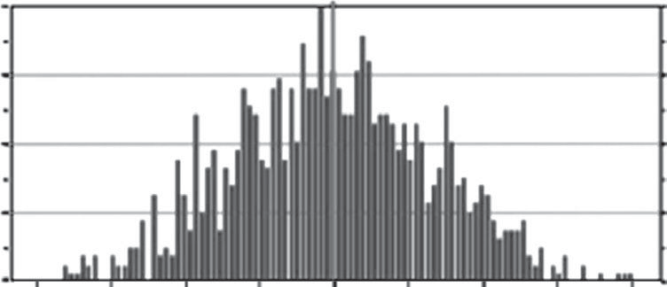31

23.2

Frequency

15.5

7.75

0.00140.00

147.50 155.00

162.50

0

170.00

Given that the mean project duration was 155 months, with a standard deviation of 7, complete the following table and plot the results in Excel:

**Duration**

125

145

155

165

**Probability of Completing in Less than Duration**

* 1. As part of a process reengineering study, you collected the following data for inter-arrival times:

|  |  |  |  |  |
| --- | --- | --- | --- | --- |
| 0.202693 | 0.777556 | 0.407303 | 0.016905 | 0.063665 |
| 0.014461 | 0.515572 | 0.718809 | 0.562519 | 0.068552 |
| 0.726741 | 0.827333 | 0.257001 | 0.52073 | 0.56361 |
| 0.763765 | 0.169967 | 0.864643 | 1.423221 | 0.357062 |
| 0.161565 | 0.535109 | 0.00114 | 0.571689 | 0.044286 |
| 0.244942 | 0.337265 | 0.144999 | 0.03313 | 0.018785 |
| 0.368699 | 0.434368 | 0.042632 | 0.240196 | 0.027319 |
| 0.163853 | 0.269635 | 0.339452 | 0.822752 | 0.231464 |
| 0.749167 | 0.301527 | 0.090666 | 0.464595 | 0.02154 |
| 0.04488 | 0.423597 | 1.197478 | 0.117271 | 0.145224 |
| 0.792627 | 0.710691 | 0.725581 | 0.29873 | 0.308896 |
| 0.070382 | 0.568303 | 0.197198 | 0.066977 | 0.543177 |
| 0.633093 | 0.318796 | 0.405549 | 0.423037 | 0.458229 |
| 0.163983 | 0.185042 | 0.082472 | 0.031344 | 0.356039 |
| 0.659358 | 0.570516 | 0.189155 | 1.217896 | 0.294747 |
| 0.743034 | 0.38452 | 0.356751 | 0.044138 | 0.83982 |
| 0.715777 | 0.37971 | 0.163473 | 0.722322 | 0.770268 |
| 0.698327 | 0.251889 | 0.188892 | 2.512673 | 0.996764 |
| 1.012138 | 0.256679 | 0.370203 | 0.23874 | 0.836308 |
| 0.023978 | 0.228313 | 0.569765 | 0.207689 | 0.083142 |

Using Crystal Ball or another statistical package, fit the data and show the best fit distribution and the appropriate K-S or other goodness-of-fit statistic value for this data.

* 1. You are an operations manager for the Greytown Credit Union, a small banking and lending institution. You have been tasked to construct a simulation model of a proposed single-server queuing system (a branch office) to analyze whether one teller will be sufficient.

Your boss told you that the credit union is planning to open a small sat- ellite branch office for the high density of customers located at the local military base. The satellite office will have one teller to handle deposits, cash checks, and answer customers’ questions. The office will not handle loan or credit card applications; customers must go to the main office for these services. Customer inter-arrival times are exponentially distributed, with an average inter-arrival time of 3 minutes. Withdrawal or deposit service time has the following PDF:

f(x)

1/2

1 5 x

The percentage of customers seeking to make a deposit is 30%; con- versely, the percentage seeking to make a withdrawal is 70%. Distribution of dollars withdrawn or deposited by customers is as follows:*

|  |  |  |  |
| --- | --- | --- | --- |
| **Money** | **Withdrawn** | **Money** | **Deposited** |
| **$** | ***P*($)** | **$** | ***P*($)** |
| 25 | .20 | 10 | .10 |
| 50 | .35 | 20 | .10 |
| 75 | .30 | 50 | .16 |
| 100 | .10 | 75 | .20 |
| 200 | .05 | 150 | .19 |
|  |  | 250 | .05 |
|  |  | 450 | .15 |
|  |  | 500 | .05 |

Develop the following:

* + 1. Problem formulation: Write a concise problem statement as you see it. What is your boss’ real expectation for the simulation?
    2. Specify performance criteria, decision rules, and critical system parameters:
       1. Draw a neat sketch of the system.
       2. Specify what parts of the environment you want to include and exclude. (What are the system boundaries?)
       3. List the statistics you want the model to produce. In other words, what results do you want the model to produce? These results should be important to you and your boss.
       4. Develop a flow chart of the simulation.
* An easy way to do this is to create one large VLOOKUP table and multiply *P*(withdrawn) by 0.7 and

*P*(deposited) by 0.3.

* + - 1. Outline on paper the column headings you would use in a spread- sheet simulation.
      2. Construct the process generators in your simulation. The data needed will directly support the columns headings you identified in (4) above.
    1. Construct the simulation in Excel or Crystal Ball.
  1. You have just recently accepted a job with a local defense contractor. Your starting salary is $65,000. You can save up to 8% and your employer will match 4% of your gross salary; you will invest in an S&P 500 fund. In 30 years, you would like to have $1 million (in today’s dollars) in a stock mutual fund and retire. Using historical inflation and stock market returns, develop a simulation model using Crystal Ball to assess the probability of achieving these results. Assume that you will receive, on average, a 2% raise in addition to inflation to account for promotions and bonuses. The follow- ing table contains the percent return (based on Standard and Poors 500) for the inflation-adjusted stock market returns and the inflation rate since 1951:

|  |  |  |  |  |  |
| --- | --- | --- | --- | --- | --- |
|  | **Stock Market** | **Inflation** |  | **Stock Market Average** | **Inflation** |
| **Year** | **Average (%)** | **(%)** | **Year** | **(%)** | **(%)** |
| 1951 | 16.46 | 7.90 | 1982 | 14.76 | 6.10 |
| 1952 | 11.78 | 2.20 | 1983 | 17.27 | 3.20 |
| 1953 | –6.62 | 0.80 | 1984 | 1.40 | 4.30 |
| 1954 | 45.02 | 0.50 | 1985 | 26.33 | 3.60 |
| 1955 | 26.40 | –0.40 | 1986 | 14.62 | 1.90 |
| 1956 | 2.62 | 1.50 | 1987 | 2.03 | 3.70 |
| 1957 | –14.31 | 3.60 | 1988 | 12.40 | 4.10 |
| 1958 | 38.06 | 2.70 | 1989 | 27.25 | 4.80 |
| 1959 | 8.48 | 0.80 | 1990 | –6.56 | 5.40 |
| 1960 | –2.97 | 1.60 | 1991 | 26.31 | 4.20 |
| 1961 | 23.13 | 1.00 | 1992 | 4.46 | 3.00 |
| 1962 | –11.81 | 1.10 | 1993 | 7.06 | 3.00 |
| 1963 | 18.89 | 1.20 | 1994 | –1.54 | 2.60 |
| 1964 | 12.97 | 1.30 | 1995 | 34.28 | 2.80 |
| 1965 | 9.06 | 1.70 | 1996 | 20.07 | 2.90 |
| 1966 | –13.09 | 2.90 | 1997 | 31.06 | 2.30 |
| 1967 | 20.09 | 2.90 | 1998 | 26.69 | 1.60 |
| 1968 | 7.66 | 4.20 | 1999 | 19.51 | 2.20 |
| 1969 | –11.36 | 5.40 | 2000 | –10.14 | 3.40 |
| 1970 | 0.10 | 5.90 | 2001 | –13.04 | 2.83 |
| 1971 | 10.79 | 4.30 | 2002 | –23.37 | 1.59 |
| 1972 | 15.63 | 3.30 | 2003 | 26.38 | 2.27 |
| 1973 | –17.37 | 6.20 | 2004 | 8.99 | 2.68 |
| 1974 | –29.72 | 11.00 | 2005 | 3.00 | 3.39 |
| 1975 | 31.55 | 9.10 | 2006 | 13.62 | 3.24 |

(*Continued*)

#### (Continued)

|  |  |  |  |  |  |
| --- | --- | --- | --- | --- | --- |
|  | **Stock**  **Market** | **Inflation** |  | **Stock**  **Market Average** | **Inflation** |
| **Year** | **Average (%)** | **(%)** | **Year** | **(%)** | **(%)** |
| 1976 | 19.17 | 5.80 | 2007 | 2.09 | 2.85 |
| 1977 | –11.52 | 6.50 | 2008 | –34.99 | 3.70 |
| 1978 | 1.06 | 7.70 |  |  |  |
| 1979 | 12.31 | 11.30 |  |  |  |
| 1980 | 25.77 | 13.50 |  |  |  |
| 1981 | –9.73 | 10.40 |  |  |  |

Write a brief paragraph describing the results of your simulation. Discuss your investment strategy and the probability of success. Use out- put figures from Crystal Ball or similar software to justify your strategy.

* 1. Your company is bidding to design and install new multi-million-dollar radar systems at the Leeds, United Kingdom, airport.

This will be a 3-year contract based on the following cash flows.

* All values are in then-year or actual dollars.
* You will be paid upon delivery and certification of the system. (Remember, this will be in 2014 so you must account for inflation.)
* Year 0: Start-up costs are estimated to be between $8 and $10 mil- lion. (Assume this varies uniformly.) These costs include refurbishing your factory, investment in capital equipment, and other normal project start-up expenses. You will fund this work with existing cash reserves.
* You will borrow at 7% the expenses for Years 1 and 2, to be paid back at the end of the project.
* Year 1: These expenses are estimated to be $8 million, mainly for research and development and preliminary design. Because R&D is a highly uncertain process, assume this varies according to a normal distribution, with a standard deviation of $1.5 million.
* Year 2: Expenses at the end of the second year are of concern. During the second year you will award subcontracts and start integration. You are concerned about the reliability of your subcontractors and their ability to adhere to their bid price. You estimate that expenses could vary uniformly between $11 and $14 million, according to a uniform distribution.
* Year 3: The last year of the contract will be devoted to testing, installa- tion, and customer acceptance. The airport authority has a poor track record of working within the contract guidance. Thus, you think costs for the last year could vary between $13 and $17 million, leaning heav- ily toward the high end, and thus you model using an up-ramp (fit with the triangular function and set the expected = maximum value).

Conduct a simulation using Crystal Ball or another software package to develop your bid price. Assume an inflation value of 3% and a profit of 25%. Develop a plot of the year 3 payout versus probability along with a one-paragraph recommendation to present to management. Remember that others are bidding on this project and it is key to keeping your Leeds facility operational.

F=?

E0 E1 E2 E3

* 1. As vice president of engineering, you are responsible for many projects. Your company has recently bid on a major avionics upgrade for the U.S. Air Force under a fixed price contract. The proposal group in your com- pany developed a preliminary design configuration, as follows:

**Electronic Package Hierarchy**

Wafer

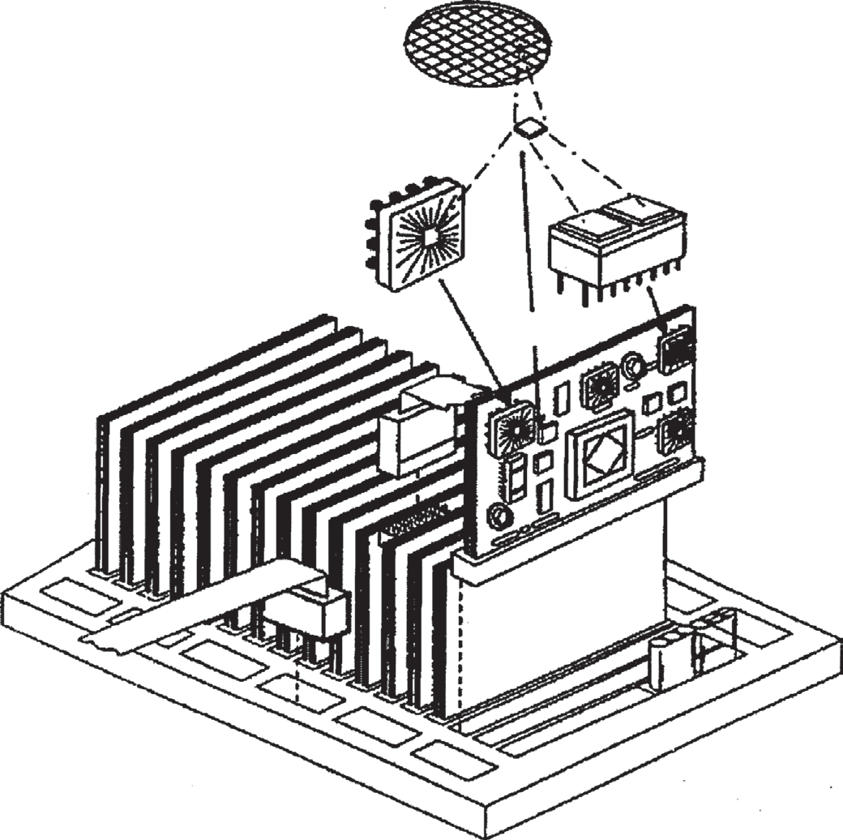IC Components, MEMS

First Level Package Single or Multi Chip Module

PCB Board Level

System Level

Hardware: electronic box 12˝ x 16˝ x 10˝ box 9 Circuit cards plus motherboard Wiring harness

Fan

Readout displays Software

(*Continued*)

#### (Continued)

20,000 source lines of code Systems engineering Systems requirements study Technical integration

Logistics technical documents

Assuming a January 1 award date, the PM has developed the following project management schedule:

**Task** Software Development Design and Manufacturing Test and Integration Milestone Review

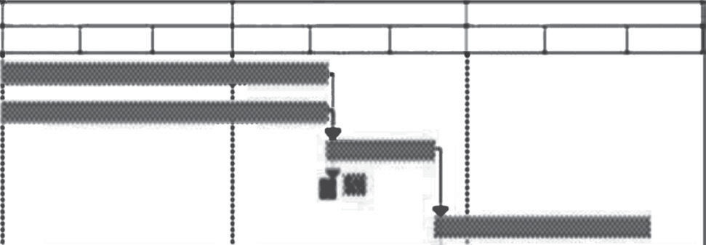

1st Quarter 2nd Quarter 3rd Quarter

Jan Feb Mar Apr May Jun Jul Aug Sep

Field Testing System Delivery

Upon review of this simplified schedule, you express your concern to both the PM and the divisional vice president about meeting the 180 calendar days allotted for delivery of the system with the current staff. Your major concerns are software development and systems testing. With follow-on systems scheduled for bid during this and the next fiscal year, delivery of this system on time and within budget is critical. Since time drives cost, you must have an accurate estimate of the total project dura- tion and assess the risk of various project durations.

You are trying to develop a more quantifiable and defensible methodol- ogy for estimating these projects for your company. Simulation seems to be the best tool for assessing risk for project delivery times. You would like to make this part of the normal estimating process for your division. Because of the visibility of this project, you decide to pursue simulation as an analytical tool to assess risk for the senior leadership of the company. After careful research, you develop the following data, based on histori- cal data and expert solicitation in support of a simulation for this project:

**Item Distributiona Crystal Ball Fit Notes**

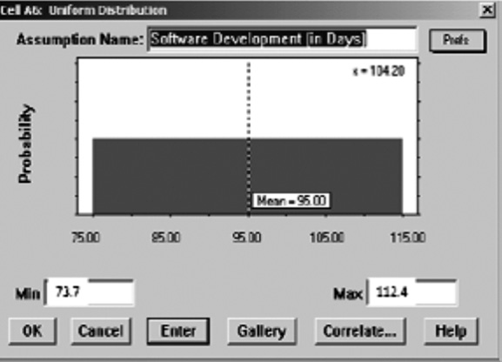Software development

Uniform from 74 to 112

days

Based on the COCOMO model for a 35-person team, assuming semidetached and embedded for the limits.

#### (Continued)

**Item Distributiona Crystal Ball Fit Notes**

Design and manufacturing

Systems testing and integration

Normal, with a mean of 90 and a standard deviation of 15 days

Triangular function with 20 days minimum, peak at 30 days, and a maximum of 60 days

Uses many currently existing systems; small standard deviation. Usually outsourced and have little control over delivery. Plan for 25 engineers initially to be on this task. We estimate that for design and manufacturing for every additional five engineers applied to the task, the mean and standard deviation will decrease by 10% (i.e., 90, 81,

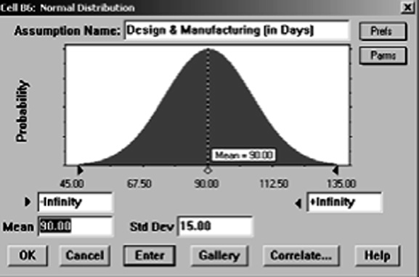72.9, etc.).

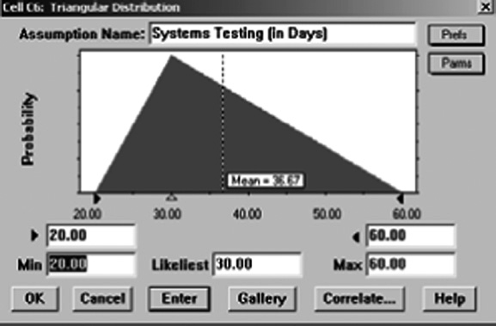Greater potential for variation of greater than 30 days based on historical results. Plan for 10 engineers initially on this task.

Additional engineers will probably reduce the maximum value.

Assume five more engineers decreases maximum value 10%.

Field testing 60 days fixed NA Specified not to exceed in contract.

a Calendar days were used to simplify the analysis.

Now re-create the following plot along with another meaningful plot for management. This plot shows the probability of completion for 35-, 40-, 45-, and 50-person software development teams:

230

220

Total Project Days

210

200

190

180

30

35 40 45 50 55

Probability of Completion 50%

90%

95%

Write a two-page executive summary on how best to achieve the 180- day stated objective. Assume that you cannot dedicate more than 100 engineers to this program. If you cannot reach the 180-day goal with 100 engineers, how much risk are you willing to assume?

Note that the spreadsheet model for software development time using the basic COCOMO model produced the following:

**COCOMO Model**

|  |  |  |  |  |
| --- | --- | --- | --- | --- |
| a factor | 3 | **Software Development Team Size** | **Project Time Minimum** | |
| b factor | 1.12 | 35 | 73.7 Days | |
| Lines of Code | 20,000 | 40 | 64.5 Days | |
| EAF Factor | 1 | 45 | 57.3 Days | |
| 50 | | | 51.6 | Days |
| Effort Minimum | 86.0Man/Months |  |  | |
| a factor | 3.6 | **Software Development Team Size** | **Project Time Maximum** | |
| b factor | 1.2 | 35 | 112.4 Days | |
| Lines of Code | 20,000 | 40 | 98.3 Days | |
| EAF Factor | 1 | 45 | 87.4 Days | |
| 50 | | | 78.6 | Days |

Effort Maximum 131.1Man/Months

5.24 You are in charge of costing and developing the schedule for a new sat- ellite radome for a third-world country to support its emerging wireless communications business. You need a rough first-order estimate to apply for the United Nations Development Program funding. As a first step, you develop the following work breakdown structure:

0.0

1.0

Integration and Testing

Site Software Development

Radome

Design and Analysis

Project Management

5.0

4.0

3.0

2.0

Satellite Radome

Project management (1.0) will be a concurrent activity for all other activities. Design and analysis (2.0) must be completed before the actual physical construction (3.0) and the software (4.0) is developed. These last two will be parallel activities. Integration and testing (5.0) can occur only after the radome is constructed and the software developed. After integration and testing, you will turn over the facility to the phone com- pany for operations. (Hint: This will describe the PERT diagram for your simulation.)

The local currency is euros. Everything will be built with U.S. parts and labor, but you will be paid in euros.

The following table lists the behavior of each of the program elements. You have developed cost and duration relationships for each of these major elements.

|  |  |  |
| --- | --- | --- |
| **Task** | **Duration** | **Cost ($)** |
| Project management | Will last for the whole project | 8% of project cost |
| Design and analysis | Varies uniformly between 5 and 7 months | $50,000 per month |
| Radome construction | Varies uniformly between 3 and 5 months | Fixed cost bid of $2M |
| Site software development | Ramp up between 4 and 6 months | $80,000 per month |
| Integration and testing | Varies uniformly between 2 and 3 months | $35,000 per month |

Project Management



Site Software

Radome Construction

Integration and Testing

Design and Analysis

Develop two plots of time versus probability of completion and total cost in dollars, ignoring inflation. Then develop your bid price in euros. Assume you will receive 25% upfront and 75% upon project delivery. Use a profit of 20% for this project.

## APPENDIX 5A

**CONTINUOUS PROCESS GENERATOR FORMULAS**

Terms:

*X* = the random variable being generated

*r* = a uniform (0,1) random number

λ = the arrival or service rate associated with an exponential random variable (expressed in units per time period, such as cars per hour, customers per minute, etc.)

*x* = *a* + *r* (*b* − *a*) *p*(*x*)

*a*

*x*

*b*

**UNIFORM [*a,b*]**

*h*

*X*

**Exponential [***l****b*]**

*h* = 2

*b* − *a*

*x* = *a* +

*x*   ln(1 *r*) *or X*   ln(*r*)

● 

**UPWARD RAMP [*a,b*]**

*p*(*x*) *h*

2*r*(*b* − *a*)

*h*

*a x b*

for 0 ≤ *r* ≤ 1 *X*

2

*h* =

*b* − *a*

**DOWNWARD RAMP [*a,b*]**

*p*(*x*) *h*

*a*

*x*

*b*

*x* = *b* − (*b* − *a*)2 (1 − *r*) for 0 ≤ *r* ≤ 1 *X*

**TRIANGLE [*a,b,c*]**

*p*(*x*)

2 *h*

*h* =

*c – a*

**Area** *= Area of left triangle =h* (*b – a*)

2

*x = a + r*(*b – a*)(*c – a*) for 0 ≤ *r* ≤ *AREA*

*x = c –*

(1 *– r*)(*c – a*)(*c – b*)

for *Area* ≤ *r* ≤ 1

*a b c x X*

## REFERENCES

Department of Defense (DoD). 2005. Accessed April 20, 2005, [http://www.education.dmso.](http://www.education.dmso/) mil/ms_primer.asp?a=s4&b=view&c1=272

Gove, R. 2007. “Development of an Integration Ontology for Systems Operational Effectiveness.” Master’s of science thesis. Stevens Institute of Technology.

Gove, R., B. Sauser, and J. Ramirez-Marquez. 2008. “Integration Maturity Metrics: Development of an Integration Readiness Level.” White paper. Stevens Institute of Technology.

Mankins, John C. 1995. “Technology Readiness Levels.” White paper. Accessed July 22, 2007, <http://www.hq.nasa.gov/office/codeq/trl/trl.pdf>

National Aeronautics & Space Administration (NASA). 2008. Accessed June 25, 2009, http:// sbir.nasa.gov/SBIR/sbirsttr2008/solicitation/forms/appendix_B.pdf

Sauser, Brian J., Eric Forbes, Michael Long, and Suzanne E. McGrory. 2009. “Defining an Integration Readiness Level for Defense Acquisition.” International Symposium of the International Council on Systems Engineering (INCOSE), Singapore, July 20–23.

# Costing of Complex Systems

6

## INTRODUCTION

Developing a cost estimate using PCEs or analogies based on past systems can be tricky. Analysts who attempt to develop such estimates find that the sum of the most likely costs of the components of a system in development does not equal the most likely cost of the entire system, because costs, software, complexity, and so forth do not scale linearly. The same holds true when scaling systems up to SoS and enterprises. Any cost engineer will tell you that we can cost hardware and software separately with some confidence; however, when we integrate and develop inter- faces, we simply do not know how to estimate these costs, much less scale to the larger, software-centric systems. This is the challenge of costing systems.

## ISSUES SURROUNDING COMPLEX SYSTEMS

Figure 6.1 contains a common plot used to demonstrate how cost committed and cost incurred vary over a typical system’s life cycle. The figure clearly shows the impor- tance of upfront systems engineering and managing requirements.

From an LCC perspective, it is even more critical when developing products and committing funds that experience is key because we simply do not have the tech- niques to estimate costs. The top-down tools we use to estimate costs early in the product development cycle are gross rules of thumb at best. When you combine this with requirements creep, unstable funding, etc., cost estimates of +100% are expected.

Referring to the product life cycle model presented in Chapter 1, the techniques for estimating systems costs vary depending on where we are in the life cycle: conceptual exploration; component advanced development; systems integration and preliminary design; systems demonstration, test, and evaluation; production; or operations and disposal. For example, early in conceptual exploration, the only technique might be some type of parametric cost estimation technique, such as the constructive systems engineering cost model (COSYSMO). As we move further in the product develop- ment cycle (e.g., at the end of preliminary design), we estimate using a bottom-up approach or engineering build of the system. Finally, as we enter production, we modify our engineering bottom-up model to more accurately reflect the final design elements of hardware, software, and interfaces/integration. Table 6.1 was modified from a commercial vendor and demonstrates that very early in the product develop- ment cycle we simply do not know enough about the system to accurately develop costs. Unfortunately, this is when budgets are allocated, bids developed, etc. For

**135**

100%

Cost Committed

Cost Incurred

80%

60%

Cost

40%

20%

0%

Conceptual

Detailed

Construction

Use,

Time

& Preliminary Design & or Refinement

Design Integration Production & Disposal

**FIGURE 6.1** Cost committed versus cost incurred.

LCC to become more accurate, we must use software and other formal engineering tools earlier in the design process.

## SYSTEMS ENGINEERING AND MANAGEMENT COSTS

* + 1. **HARDWARE COSTS**

If we use a hierarchal approach (an SoS or enterprise is composed of systems, systems are composed of subsystems, and subsystems are composed of components), any of these levels will be the building block of a bottom-up estimate. In its simplest form, hardware can be separated into physical components (which comprise the building blocks) plus the labor for estimating purposes. We can think of this as levels of our WBS. Note that developing an LCC for any component of a system is basically devel- oping your WBS using phases of the product life cycle and assigning hardware, soft- ware, etc., for every phase.

You can use these categories as a way to classify costs. Unfortunately, depending on where you are in the product life cycle, you will need to adjust costs to account for technology maturity, which might include TRLs, SRLs, learning curve issues, and so forth.

As you transition from a top-down cost estimating relationship such as COSYSMO, you can use rough relations to estimate these costs over the product life cycle and refine them as the design becomes more final. The model presented must evolve as you move further down the life cycle.

Costing of Complex Systems **137**

#### TABLE 6.1

**Cost and Schedule Estimates as a Function of Technical Baseline Work Products**

**Baseline Created**

**Technical Work Products from Which Estimates Are Developed**

**Methodologies Used to Develop Cost Estimates**

Customer Customer requirements

* Capabilities
* Characteristics CONOPS

System System requirements Preliminary architecture

Top down

* + - * Based on number/complexity of requirements
      * Based on number/complexity of scenarios
      * Based on number/complexity of external interfaces

Analogous

* + - * Estimates based on complexity of technical work products compared to similar complexity of similar projects

*Estimates are based on experience and historical data with a ±75% accuracy*

Top down

* + - * Based on number/complexity of requirements
      * Based on number/complexity of scenarios
      * Based on technology maturity
      * Based on architecture complexity Analogous
      * Estimate based on complexity of technical work products against known projects

Bottom up

* + - * Estimates based on architecture

*Estimates are based on experience and formal design and SE tools with a ±50% accuracy*

Component (hardware, software, and processes)

Design, testing, and production

Component requirements

* + - * Hardware and software Systems architecture
      * Document all hardware, software, processes, and interfaces

Test architecture System into production Hardware, software, and processes

Design and test strategy Service agreements

Bottom up

* + - * Estimates based on architecture, technologies selected, testing plan, etc.

*Estimates are based on formal design (WBS, COCOMO, COSYSMO, function point, etc.) and SE tools with a ±10% accuracy*

Bottom up

* + - * Estimates based on detailed design, test schedules, implementation details, and other technical work products
      * Delivered solution architecture

*Estimates are detailed bottom up, based on all technical work products*

*Source:* Modified from Barker, 2008.

* + 1. **SOFTWARE COSTS**

Since software dominates most complex systems, Chapter 7 is devoted solely to tra- ditional software costing methods and include the COCOMO and function point analysis. The COnstructive COst MOdel or COCOMO family of models presented is probably the most widely used software estimation models in the world. Both of these techniques can be classed as analogy methods.

* + 1. **INTERFACES AND INTEGRATION AT THE SYSTEM LEVEL**

No overarching methodology exists for costing the integration of hardware and soft- ware and developing the interfaces. Interfaces and integration challenges are the key reason why the costs of systems scale nonlinearly. We know from the past failures of the DoD, NASA, and other developers of large SoS problems that we do not know how to estimate their costs.

* + 1. **SYSTEMS ENGINEERING/PROJECT MANAGEMENT COSTS**

One area that has received significant attention because it is often underfunded and has been connected to major cost overruns is systems engineering and project man- agement (SE/PM). Figure 6.2 shows some of the SE/PM functions that comprise this category. Stem et al. (2006), of the RAND Corporation, reported that the average SE/PM costs for major aircraft programs increased from 8% of the total develop- ment costs in the 1960s to about 16% in the 1990s. The SE/PM components are sig- nificant for controlling costs, schedule, and quality during product design. However, what are the SE/PM concerns postproduction? They also are significant for upgrades and supportability issues.

According to Stem et al. (2006), SE/PM costs for most large defense programs are split roughly 50/50, and, as shown in Figure 6.3, these costs can be significant. Unfortunately, COSYSMO only provides a technique for estimating systems engi- neering costs during the development phase. We are in the process of trying to identify quantitative means for estimating project management costs, which will be necessary for SBC to evolve.

The COCOMO family of models (shown in Figure 4.3) develops cost estimates that cover only the work conducted between the beginning of the concept explora- tion phase and the end of the integration and test phase. Costs and schedules of other phases (e.g., requirement phase) must be estimated separately. Estimates with significant variation from other than an ideal development (i.e., poor management, programming skill level, etc.) should be conducted using the intermediate of detailed version of the model.

The COSYSMO is a model that can help people reason about the economic impli- cations of systems engineering on projects. Similar to its predecessor, COCOMO III, it was developed at the University of Southern California as a research proj- ect with the help of BAE Systems, General Dynamics, Lockheed Martin, Northrop Grumman, Raytheon, and SAIC. COSYSMO follows a parametric modeling approach used to estimate the quantity of systems engineering labor, in terms of

**Program Management Functions**

**ILS functions**

**Non-ILS functions**

**Systems Engineering Functions**

LS demonstration and evaluation ILS planning and management, 3%

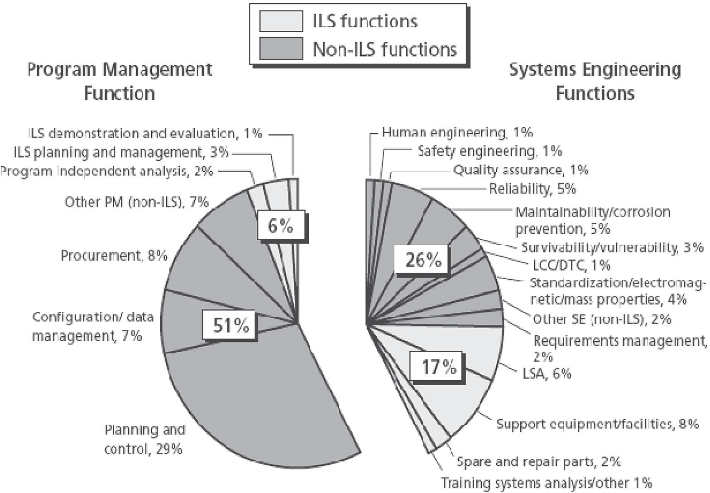

, 1%

Program independent analysis, 2%

Other PM (non-ILS), 7%

Human engineering, 1%

Safety engineering,

1%

ance, ity, 5%

Quality assur 1%

Reliabil

Procurement, 8%

Configuration/ data

management, 7%

Planning and

control, 29%

51%

6%

26%

17%

Maintainability/corrosion prevention, 5%

Survivability/vulnerability, 3%

LCC/DTC, 1%

Standardization/electromag- netic/mass properties, 4% Other SE (non-ILS), 2%

Requirements management, 2%

LSA, 6%

Support equipment/facilities, 8%

Spare and repair parts, 2%

**139**

Costing of Complex Systems

Training systems analysis/other, 1%

**FIGURE 6.2** SE/PM as a function of integrated logistics support (ILS) for a typical Air Force program. (Modified from Stem, David E., Michael Boito, and Obaid Younossi. 2006. *Systems Engineering and Program Management: Trends and Costs for Aircraft and Guided Weapons Programs*. Santa Monica, CA: RAND Corporation.)

35

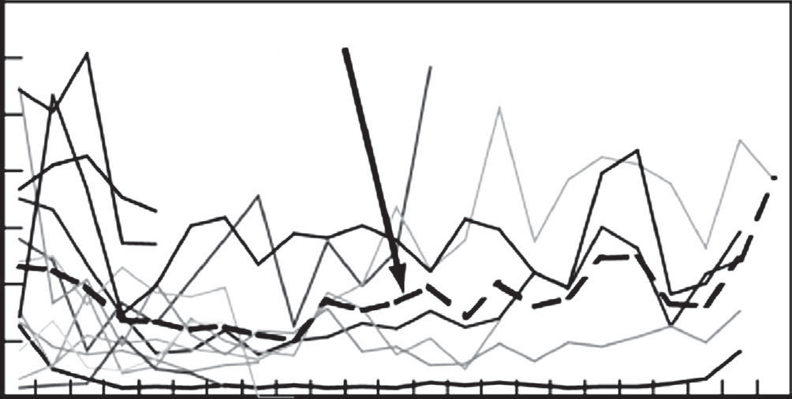

Average SE/PM Percentage Across Programs

30

25

SE/PM Percentage

20

15

10

5

0 1 2 3 4 5 6 7 8 9 10 11 12 13 14 15 16 17 18 19 20 21 22 23

Lot Number

**FIGURE 6.3** Average systems engineering and project management percent of total costs for 22 major Air Force programs. (Modified from Stem, David E., Michael Boito, and Obaid Younossi. 2006. *Systems Engineering and Program Management: Trends and Costs for Aircraft and Guided Weapons Programs*. Santa Monica, CA: RAND Corporation.)

person-months, required for the conceptualization, design, test, and deployment of large-scale software and hardware projects. User objectives include the ability to make proposal estimates, investment decisions, budget planning, project tracking, tradeoffs, risk management, strategy planning, and process improvement measure- ment. (See Valerdi [2005, 2006] for more details.)

Each parameter in the COSYSMO algorithm is part of the cost estimating rela- tionship (CER) defined by systems engineering experts. COSYSMO is typically expressed as

  *E* 14

PMNS  *A* *e*,*k* *e*,*k*  *n*,*k* *n*,*k*  *d* ,*k* *d* ,*k* 

*EM j*

(6.1)

*k*  *j*1

where:

PMNS = effort in person-months (nominal schedule)

*A* = calibration constant derived from historical project data

*E* = diseconomies of scale

*k* = {REQ, IF, ALG, SCN}

*w*k = weight for “easy,” “nominal,” or “difficult” size driver

Φk = quantity of “*k*” size driver

EM = effort multiplier for the *j*th cost driver; the geometric product results in an overall effort adjustment factor to the nominal effort

The size of the system is the weighted sum of the system requirements (REQ), system interfaces (IF), algorithms (ALG), and operational scenario (SCN) parameters and represents the additive part of the model. The EM factor is the product of the 14 effort multipliers and represents the multiplicative part of the model, as shown in Table 6.2.

#### TABLE 6.2

**Rating Scale Values for Cost Drivers**

|  |  |  |  |  |  |  |
| --- | --- | --- | --- | --- | --- | --- |
|  | Very  Low | Low | Nominal | High | Very  High | Extra  High |
| Requirements understanding | 1.85 | 1.36 | 1.00 | 0.77 | 0.60 |  |
| Architecture understanding | 1.62 | 1.27 | 1.00 | 0.81 | 0.65 |  |
| Level of service requirements | 0.62 | 0.79 | 1.00 | 1.32 | 1.74 |  |
| Migration complexity |  |  | 1.00 | 1.24 | 1.54 | 1.92 |
| Technology risk | 0.70 | 0.84 | 1.00 | 1.32 | 1.74 |  |
| Documentation | 0.82 | 0.91 | 1.00 | 1.13 | 1.28 |  |
| # and diversity of  installation/platforms |  |  | 1.00 | 1.23 | 1.51 | 1.86 |
| # of recursive levels in the design | 0.80 | 0.89 | 1.00 | 1.21 | 1.46 |  |
| Stakeholder team cohesion | 1.50 | 1.22 | 1.00 | 0.81 | 0.66 |  |
| Personnel/team  capability | 1.48 | 1.22 | 1.00 | 0.81 | 0.66 |  |
| Personnel  experience/continuity | 1.46 | 1.21 | 1.00 | 0.82 | 0.67 |  |
| Process capability | 1.46 | 1.21 | 1.00 | 0.88 | 0.77 | 0.68 |
| Multisite coordination | 1.33 | 1.15 | 1.00 | 0.90 | 0.80 | 0.72 |
| Tool support | 1.34 | 1.16 | 1.00 | 0.85 | 0.73 |  |

*Source:* Valerdi, R. 2006. “Academic Cosysmo User Manual—A Practical Guide for Industry and Government.” Version 1.1. MIT Lean Aerospace Initiative.

Intermediate COCOMO is designed to estimate the software effort derived from an analysis of software requirements and the design, implementation, and testing of software. COSYSMO estimates the system engineering effort associated with the development of the software system concept, overall software system design, and implementation and test—not the actual software development costs. Intermediate COCOMO estimates of the software effort will surely account for the additional effort required by further testing of the software system. The COSYSMO effort will account for additional test development and management since the systems engi- neers are required to perform additional validation and verification of the system (Valerdi, 2006). Case Study 6.1 demonstrates the use of COCOMO and COSYSMO to estimate the cost of a software-centric system.

Obviously, this type of approach has shortcomings that would be inherent in any top-down model developed early in the life cycle:

* The model is developed from historical data; unless you have significant experience in that domain, you should not use the model.
* Engineers estimate from the bottom up, or an engineering build.
* Requirements should not be used for estimating. No direct correlation exists between requirements and effort. COSYSMO recognizes this implicitly by distinguishing between pure and equivalent requirements.

#### Case Study 6.1: Development Costs for the AgriClean Environmental Monitor*

The marketing and research and development departments identified a need for a wireless sensor that detects and reports very small changes in temperature, humidity, and acidity. The sensor was specially designed to withstand natural ele- ments and be waterproof. The marketing department recognized an opportunity to develop this product into a system of sensors that could monitor waste levels in agricultural ponds and waste runoff points. They developed their prototype (AgriClean) with the expectation that it would be transitioned into the company’s medium-scale product line monitoring system called Watchman, which monitors and measures waste levels for various environmental hazards.

COSYSMO was used to estimate the systems engineering costs of the AgriClean.

The table below shows the categories and ratings assigned to all drivers:

|  |  |  |  |  |
| --- | --- | --- | --- | --- |
| **Size Drivers** | **Easy** | **Medium** | **Hard** | **Total Driver** |
| No. of system requirements | 5 | 1 | 0 |  |
| Weights | 0.5 | 1 | 5 | 3.5 |
| No. of system  interfaces | 2 | 2 | 1 |  |
| Weights | 1.7 | 4.3 | 9.8 | 21.8 |
| No. of algorithms | 7 | 4 | 0 |  |
| Weights | 3.4 | 6.5 | 18.2 | 49.8 |
| No. of operational  scenarios | 0 | 0 | 0 | 0 |
| Weights | 9.8 | 22.8 | 47.4 | 75.1 |

It was estimated that for the software needed to implement the technology transi- tion strategies, there would be 5 easy, 1 medium, and 0 hard requirements. As specified by Equation 6.1, the number of easy requirements was multiplied by the weight for an easy requirement. The same was done for the medium and hard requirements. Then the three weighted values were added together. This was repeated for the other size drivers and then all weighted values were summed, resulting in a total size driver of 75.1.

Twelve of fourteen cost drivers were considered. The software written was pri- marily internal, so level of service requirements would not be needed. Because the software did not originate from a previously existing system, migration complexity was not a factor either. For each cost driver, a subjective determination was made of its level of understanding of that factor based on characterizations provided in the COSYSMO model. Each rating from VL (very low) to VH (very high) was given a weight, also provided by the model. The following table shows drivers, the level

* Modified from Sweeton, Julie E. 2009. “Comparison of Life Cycle Costs between Two Technology Transition Approaches.” EM 620 Project.

of understanding, and the associated weight. The multiplied weights result in a total cost driver of .230155.

|  |  |  |
| --- | --- | --- |
|  | **Level of** |  |
| **Cost Drivers** | **Understanding** | **Weight** |
| Requirements understanding | H | 0.77 |
| Architecture understanding | VH | 0.65 |
| Technology risk | VL | 0.7 |
| Documentation | VL | 0.82 |
| No. and diversity of installation/platforms | Na | 1 |
| No. of recursive levels in the design | N | 1 |
| Stakeholder team cohesion | L | 1.22 |
| Personnel/team capability | H | 0.81 |
| Personnel experience/continuity | VH | 0.67 |
| Process capability | L | 1.21 |
| Multisite coordination | N | 1 |
| Tool support | N | 1 |
| *a N=Nominal* |  | 0.230155 |

The work in person-months is found by multiplying the size driver by the cost driver. The historical constant, A, as well as the diseconomies of scale exponent, E, were not considered; therefore, they were set to 1. Then, the cost was found by multiplying by the average monthly rate of $16,000.

Person-months = Size driver * Cost driver 17.28466 = 75.1 * 0.230155

With a total cost of 17.28 * 16,000 = $276,555

The following table shows each recommendation and its cost, taking into account work done in each of the 2 years—the original targeted duration. Appropriate pay rates are used for the personnel involved.

#### Non-Software Development and Fixed Cost Related Strategies

|  |  |  |
| --- | --- | --- |
| **Recommended Technology Transition Strategy** | **Cost** | **Costing Technique** |
| Strategic planning | $16,000 | Historical data |
| Support for separate budget | $4100 | Historical data |
| Technology transition agreement | $24,500 | Historical data |
| Cross-pollinate personnel | $13,000 | Historical data |
| Buy materials earlier | 0 | No cost |
| Metrics support, COTS products | $15,000 | Historical data |
| Support for gated reviews |  |  |
| (lab manager salary + cost of process) | $224,000 | Historical data, COSYSMO |
| Relationship manager’s salary | $82,000 | Historical data |
| TOTAL | $378,600 |  |

The total cost of developing AgriClean is the sum of the costs of the soft- ware development-related strategies, which include the development and system engineering activities, and the costs of the management-related and fixed cost strategies.

Therefore, we calculate the cost to integrate AgriClean into the Watchman proj- ect as follows:

|  |  |
| --- | --- |
| COCOMO | $377,640 |
| COSYSMO | $276,555 |
| Management-related/  fixed cost strategies | $378,600 |
| Total cost | $1,032,795 |

## FROM REQUIREMENTS TO ARCHITECTURES

From a set a system requirements or CONOPs, a functional description is developed in which the system-level requirements or “whats” are translated to “hows” using tools such as functional block diagrams. This functional hierarchy process and inter- dependencies are shown in Figure 6.4. The functional description provides the basis for either a physical architecture or a WBS (see Figure 6.5), or a cost breakdown structure (CBS). Note that the WBS in Figure 6.5 was developed using physical cat- egories and is applicable for only one phase of the product life cycle. This process is applicable to new systems as well as those that are being reengineered.

|  |  |  |  |  |
| --- | --- | --- | --- | --- |
|  | | System Requirement |  | |
|  | **Requirements Hierarchy** | | |  |
| Derived Requirement 1 |  | Derived Requirement 2 |  | Derived Requirement 3 |

**FIGURE 6.4** Role of functional and physical views of a system. (From Stevens Institute of Technology. 2009. “SYS 650 System Architecture and Design.” Course notes.)

“Basis of”

“Allocated to”

System

**Physical Hierarchy**

Component 2

Sub- Function 2

**Functional Hierarchy**

System Function

Component 3

Component 1

Sub- Function 3

Sub- Function 1

SOFTWARE INTENSIVE SYSTEM WBS

1 2 3 4 5

SOFTWARE INTENSIVE SYSTEM PRIME MISSION PRODUCT APPLICATIONS S/W

BUILD 1

CSCI 1…n

CSCI TO CSCI INTEG. AND CHKOUT

BUILD 2…n

CSCI 1…n

CSCI TO CSCI INTEG. AND CHKOUT APPLICATIONS S/W INTEG., ASSEMBLY, TEST, & CHKOUT

SYSTEM S/W

BUILD 1

CSCI 1…n

CSCI TO CSCI INTEG. AND CHKOUT BUILD 2…n

CSCI 1…n

CSCI TO CSCI INTEG. AND CHKOUT

SYSTEM S/W INTEG. ASSEMBLY, TEST AND CHECKOUT INTEG., ASSEMBLY, TEST AND CHECKOUT

HW/SW INTEGRATION

SYSTEMS ENGINEERING/PROGRAM MANAGEMENT SYSTEM TEST AND EVALUATION

TRAINING DATA

PECULIAR SUPPORT EQUIPMENT COMMON SUPPORT EQUIPMENT INITIAL SPARES AND REPAIR PARTS

**FIGURE 6.5** Sample WBS. (From Department of Defense (DoD). 2005. “Work Breakdown Structure for Defense Material Items.”)

## SUMMARY

Costing systems is complex and consists of a variety of techniques, including analogies, PCEs, and detailed bottom-up modeling. There is probably no one-size- fits-all solution and certainty no substitution for experience. Readiness levels show promise with additional research to provide insight into developing immature technologies.

In the evaluation and reengineering of existing systems, the functional analy- sis serves as a basis for developing the WBS or CBS, leading to the collection of costs by functional area (Sage and Rouse, 2009). Unfortunately, if you can develop architectures or a WBS, you have a well-understood system suitable for realistic cost estimates. You then have enough detail that PCE-type techniques are not really applicable.

Until we can quantify integration costs, we will not be able to conduct meaningful bottom-up analysis. Estimates will continue to be based on PCE or analogies.

## QUESTIONS

* 1. If we define system cost as equal to hardware + software + interface/ integration + support, which of these is the most difficult to ascertain early in the product life cycle? For which element is it the most difficult to determine the recurring costs?
  2. During the concept exploration phase, 70–75% of the costs are typically committed. When you consider requirements creep, cost variances of

±75%, TRLs of some components of less than 3, etc., budgeting during concept exploration and advanced development allows for at best rough order of magnitude estimates. How can we develop more accurate esti- mates early during the product life cycle when funds typically are pro- grammed and expectations set?

* 1. Below are bids from two actual software-centric systems. These systems consist of a sensor network, data processing, some data mining, and ulti- mately storage.

|  |  |  |  |
| --- | --- | --- | --- |
| **Project 1** |  | **Project 2** |  |
| Management | $7,731,153 | Management leadership | $4,483,465 |
| Systems engineering | $3,619,772 | Overhead | $15,943,536 |
| Software | $7,183,903 | Comments processing | $1,993,215 |
| Hardware | $500,355 | Software development | $4,569,854 |
| Integration | $6,937,304 | Simulation | $11,369,329 |
| I&T | $7,062,878 | Software overhead | $3,086,863 |
| Training | $1,695,175 | Contract data  requirements list | $4,415,556 |
| Travel | $2,142,724 | Systems engineering | $3,070,027 |
| EIS | $1,174,913 | Integration & test | $9,900,734 |
| Prop | $491,848 | Installations | $8,475,736 |
|  |  | Travel | $2,828,208 |
| Total | $38,540,025 | Total | $70,136,523 |

Can you see any “rules of thumb” for project management, systems engi- neering, integration and testing, or other areas?

## PROBLEM

6.1 Many companies use analogies early in the development process to esti- mate total project costs. For example, one large IT services provider uses the following rules of thumb when calculating total project costs:

**Percent of Total**

**Project Cost Cost Category**

8% Project management

15% Systems engineering

40% Development

26% Testing and evaluation

11% Installation

Your engineers and estimating department have calculated the following development costs for an IT solution:

* Software: $7,183,903
* Hardware: $500,355
* Integration: $6,937,304

Using the information from the table, develop the total project costs. How does this compare with the total costs for Project 1 of Question 6.3? What are the main differences?

## REFERENCES

Barker, Bruce. April, 2008. Personal Communication.

Department of Defense (DoD). 2005. “Work Breakdown Structure for Defense Material Items” (MIL-HDBK-881A, DoD handbook). Accessed July 30, 2005, http://www.acq. osd.mil/pm/currentpolicy/wbs/MIL_HDBK-881A/MILHDBK881A/WebHelp3/MIL- HDBK-881A%20FOR%20PUBLICATION%20FINAL%2009AUG05.pdf

Sage, Andrew P., and William B. Rouse. 2009. “Cost Management.” In *Handbook of Systems Engineering,* 2nd ed., edited by Benjamin S. Blanchard, chapter 6. New York: John Wiley & Sons.

Stem, David E., Michael Boito, and Obaid Younossi. 2006. *Systems Engineering and Program Management: Trends and Costs for Aircraft and Guided Weapons Programs*. Santa Monica, CA: RAND Corporation.

Stevens Institute of Technology. 2009. “SYS 650 System Architecture and Design.” Course notes.

Sweeton, Julie E. 2009. “Comparison of Life Cycle Costs between Two Technology Transition Approaches.” EM 620 Project.

Valerdi, Ricardo. 2005. “The Constructive Systems Engineering Costing Model (COSYSMO).” Dissertation submitted in partial fulfillment of the requirements for the degree of doctor of philosophy, University of Southern California.

Valerdi, Ricardo. 2006. “Academic COSYSMO User Manual—A Practical Guide for Industry and Government.” Version 1.1. MIT Lean Aerospace Initiative.

## BIBLIOGRAPHY

University of Southern California. January 2008. Modified from <http://sunset.usc.edu/publica-> tions/TECHRPTS/2005/usccse2005-509/usccse2005-509.pdf

# Software-Intensive Systems

7

## 7.1 INTRODUCTION

Almost every aspect of modern society is controlled by software. One need look no further than the defense industry to see how dramatic and pervasive software has become. Consider the following military examples:

* In the early 1970s, the F4 fighter had no digital computer or software.
* In the late 1970s, the F16A fighter had 50 digital processors and 135,000 lines of code (135 KLOC).
* In the late 1980s, the F16D fighter had 300 digital processors and 236 KLOC.
* In the late 1990s, the B-2 bomber had more than 200 digital processors and 5000 KLOC.
* The Future Combat Systems (FCS) have between 16,000 and 50,000 KLOC.

Software requirements (the percentage of functionality provided by software) have grown from less than 10% in the 1980s to 80% currently.

Software is also redefining the consumer’s world. Microprocessors embedded in today’s automobiles require software to run, permitting major improvements in performance, safety, reliability, maintainability, and fuel economy. According to Elektrobit (2008), today’s high-end automobiles contain up to 70 electronic control units that control the vehicle’s major functions. The average car in 1990 had 1 mil- lion lines of code; in 2010, the average car is expected to have up to 100 million lines of code, with software and electronics contributing to greater than one-third the cost of the car. Most complex systems (e.g., airplanes, watches, clocks, TVs) have seen a growth in software costs similar to that shown in Figure 7.1. New devices in the consumer electronics sector have dramatically changed how we play and manage music, how we conduct our personal computing, and even how we manage our daily activities. As software becomes more deeply embedded in most goods and services, creating reliable and robust software will become an even more important challenge. Despite the pervasive use of software, and partly because of its relative immaturity especially with regard to integrating complex hardware and software applications, understanding the economics of software presents an extraordinary challenge.

As engineers, we know how to estimate hardware costs: we simply add up the cost of the components. However, software and integration/interfaces continue to be a challenge in costing complex systems. This chapter was written to expose readers to the myriad of software cost estimating methods. As you will see, historical analysis dominates software cost estimation.

**149**

Hardware

Software

Time

Cost

**FIGURE 7.1** Growth of hardware and software costs for most complex systems.

If we view software costing from an LCC perspective, from Figure 7.2 we see that maintenance accounts for a significant percentage of the total costs. Even though the values presented in the figure are decades old, and significant advances have been made in software engineering tools, increased complexity and more software reuse makes these numbers still roughly representative of the problem with software main- tenance. The high cost of software maintenance is linked to the difficulty of reading and understanding programming code, particularly software written by others. Code reading has been estimated to account for more than 50% of the effort expended in software maintenance (von Mayrhauser and Vans, 1995).

## SOFTWARE ESTIMATING TECHNIQUES

* + 1. **OVERVIEW**

Figure 7.3 lists various techniques for estimating software development time, resources, and costs. Most techniques are from a combination of experience and historical results. In Chapter 1 we classed these types of LCC techniques as either PCE or analogy, or some combination.

Probably the most important tool in developing a software (or any) cost estimate is a functional representation that captures all the elements in the life cycle, includ- ing (DoD, 2005):

* + - * A product-oriented family tree composed of hardware, software, services, data, and facilities. The family tree results from systems engineering efforts during the acquisition of a defense materiel item.
      * A WBS that displays and defines the product, or products, to be developed and/or produced. It relates the elements of work to be accomplished to each

other and to the end product. A WBS can be expressed down to any level of interest. However, the top three levels are as far as any program or contract need go unless the items identified are high cost or high risk. Then, and only then, is it important to take the work breakdown structure to a lower level of definition.

95

Software Maintenance/Software Engineering Development Costs

90

85

80

75 McKee (1984)

70 Zelkowitz et al. (1979)

65

Moad (1990)

Erlikh (2000)

Eastwood (1993)

60 Port (1988) Huff (1990)

55 Lientz & Swanson (1981) 50

1975

1980

1985

1990

Year

1995

2000

**FIGURE 7.2** Maintenance cost of software. (Modified from Koskinen, Jussi. 2009. “Software Maintenance Costs,” Information Technology Research Institute, ELTIS-project, University of Jyväskylä, Finland. Accessed June 9, 2009, <http://www.cs.jyu.fi/~koskinen/smcosts.htm)>



Hybrid

Statistical

Mathematical

Tools

Algorithmic

Expertise-Based

**FIGURE 7.3** Software estimation techniques. (Modified from IBM. 2008. Accessed November 18, 2008, <http://www.ibm.com/developerworks/rational/library/jun07/temnenco/index.html)>

* + 1. **EXPERTISE BASED AND HYBRID**

Most models are a mix of expertise based and hybrid because of the subjective nature of many of the inputs and algorithms. Expertise is nothing more than subjective human estimating combined with simple heuristics. One large defense contractor uses expertise and an algorithm to estimate software costs:

1. Estimate the number of function points based on requirements, such as projects.
2. Use intermediate COCOMO to estimate the resources required.
3. Multiply the software development time by 175% to estimate costs.

This is one example of an experienced-based algorithm combined with a math- ematical model to produce a hybrid technique. Many companies use rules of thumb with hybrid techniques to estimate software development costs, as demonstrated in Example 7.1.

* + 1. **ALGORITHMIC**

The original COCOMO is an algorithm-based model developed by Boehm (1981) and is used to predict the effort and schedule for a software product development. The model is based on inputs relating to the size of the software and a number of cost drivers that affect productivity COCOMO and drew on a study of about 60 projects at TRW with software ranging in size from 2000 to 100,000 lines of code. Most companies use a modified version of one of the COCOMO family of models to estimate software development times and efforts.

**EXAMPLE 7.1**

One major services company uses application development costs to estimate total project costs and other cost categories. They multiply the application development costs by 2.5 to determine the total project cost. Then they use the following percentages to determine the cost elements:

* Project management = 8% × total project cost
* Systems engineering = 15% × total project cost
* Application development = 40% × total project cost
* Testing = 26% × total project cost
* Service delivery/fielding = 11% × total project cost

Obviously, this type of expertise-based model is based on considerable experience and is critical to developing rough order of magnitude estimates early in the product life cycle.

The original COCOMO consists of a hierarchy of three increasingly detailed ver- sions (NASA, 2008):

1. Basic COCOMO computes software development effort (and cost) as a function of program is good for quick, early, rough order of magnitude esti- mates of software costs.
2. Intermediate COCOMO computes software development effort as a func- tion of program size and a set of “cost drivers” that include subjective assessment of product, hardware, personnel, and project attributes.
3. Detailed COCOMO incorporates all characteristics of the intermediate ver- sion with an assessment of the cost drivers’ impact on each step (analysis, design, etc.) of the software engineering process.

The COCOMO family of models uses either thousand-delivered source instruc- tions (KDSI) or KLOC as a unit of measure for software size. Note that code created by applications should not be included. Also, when using COCOMO you should not include commented DSI/LOC when making estimates but should include declara- tions. The literature often interchanges these terms when discussing COCOMO. The main difference between DSI and LOC is that a single LOC may contain several DSI. Only basic COCOMO uses DSI, whereas follow-on versions use source lines of code, or SLOC.

Use of DSI/LOC to estimate software can present problems, mainly with the ease of programming of higher level languages. Imagine two applications that provide the same exact functionality, with one written in C and the other written with a higher level language such as Java. The same functionality would require many more lines of C code than Java.

The most commonly used measure of source code program length is the number of LOC (Fenton, 1997). We use NCLOC to represent a noncommented source line of code. NCLOC is also sometimes referred to as effective lines of code (ELOC). NCLOC is therefore a measure of the uncommented length. Thus, by measuring NCLOC and CLOC separately, we can define:

Total length (LOC) = NCLOC + CLOC (7.1)

The commented length is also a valid measure, depending on whether line docu- mentation is considered to be a part of the programming effort. CLOC is used to rep- resent a commented source line of code (Fenton, 1997). LOC/KLOC is the primary input in determining software development costs.

#### Original or Basic COCOMO Model

The basic COCOMO, which is also referred to as COCOMO 81, is a static model that utilizes a nonlinear single valued input equation to compute software develop- ment effort (and cost) as a function of software program size. The main input into the model is estimated KDSI. The model takes the following form:

*E* = *aS*b (7.2)

where: *E* = effort in person-months

*S* = size of the software development in KDSI

*a*, *b* = values dependent on the development mode, where

|  |  |  |
| --- | --- | --- |
| organic: | *a* = 2.4, | *b* = 1.05 |
| semidetached: | *a* = 3.0, | *b* = 1.12 |
| embedded: | *a* = 3.6, | *b* = 1.20 |

The basic model also presents an equation for estimating the development sched- ule (time to develop, or TDEV) of the project in months:

TDEV= *cE*d (7.3)

Factors *c* and *d* also depend on the development mode, where

|  |  |  |
| --- | --- | --- |
| organic: | *c* = 2.5, | *d* = 0.38 |
| semidetached: | *c* = 2.5, | *d* = 0.35 |
| embedded: | *c* = 2.5, | *d* = 0.32 |

Examples 7.2 and 7.3 demonstrated how these equations are used.

Boehm and his colleagues at the University of Southern California have defined three development modes:

*Organic mode*. Relatively simple projects in which small teams work to a set of informal requirements (e.g., thermal transfer program developed for a heat transfer group).

*Semidetached mode*. An intermediate project in which mixed teams must work to a set of rigid and less than rigid requirements (e.g., a transaction processing system with fixed requirements for terminal hardware and software).

*Embedded mode*. A project that must operated within a tight set of constraints (e.g., flight control software for aircraft).

The more detailed descriptions in the text that follows were modified from NASA (2008).

**EXAMPLE 7.2**

A large transportation and distribution company is planning to develop a new computer program to keep track of high-value inventory items. An initial study determined that the size of the program will be roughly 32,000 DSI. You have an experienced team of developers who know the domain. Using the basic COCOMO and the organic mode, you determine the following:

Effort: 2.4 * (32)1.05 = 91 staff-months (SM)

Productivity: 32,000 DSI/91 SM = 352 DSI/SM ≈ 18 DSI/day ≈ 2 DSI/hr

Development time = 2.5 * (91).38 = 13.8 months ≈ 14 months

* + - * 1. *Organic Mode*

In the organic mode, the project is developed in a familiar, stable environment and the product is similar to previously developed products. The product is rela- tively small and requires little innovation. Most people connected with the project have extensive experience working with related systems within the organization and therefore can usefully contribute to the project in its early stages without generat- ing a great deal of project communication overhead. An organic mode project is relatively relaxed about the way the software meets its requirements and interface specifications. If a situation arises in which an exact correspondence of the software product to the original requirements would cause an extensive rework, the project team can generally negotiate a modification of the specifications that can be devel- oped more easily.

* + - * 1. *Semidetached Mode*

In this mode, the project’s characteristics are intermediate between organic and embedded. “Intermediate” may mean either of two things:

An intermediate level of project characteristics.

A mixture of the organic and embedded mode characteristics.

Therefore, in an semidetached mode project:

* All team members may have an intermediate level of experience with related systems.
* The team may have a wide mixture of experienced and inexperienced people.
* Team members may have experience related to some aspects of the system under development, but not others.
* The size of a product generally extends up to 300 KDSI.
  + - * 1. *Embedded Mode*

In this development mode, the project is characterized by tight, inflexible constraints and interface requirements. The product must operate within a strongly coupled complex of hardware, software, regulations, and operational procedures. With an embedded mode project, you do not generally have the option of negotiating easier software changes and fixes by modifying the requirements and interface specifica- tions. The project therefore requires more effort to accommodate changes and fixes. The embedded mode project is generally charting its way through unknown territory to a greater extent than the organic mode project. This type of project uses a much smaller team of analysts in the early stages, because a large number of people would get swamped in communication overhead.

Once you complete the product design, your best strategy is to bring in a very large team of programmers to perform detailed design, coding, and unit testing in parallel. Otherwise, the project will take much longer to complete. This strategy leads to the higher peaks often seen in the personnel curves of embedded mode projects and to the greater amount of effort consumed compared to an organic mode project working to the same total development schedule.

* + - * 1. *Phase Distribution of Effort and Schedule for Organic Mode*

After estimating the effort and schedule of a project, we need to determine how to distribute them among different project phases. This distribution varies as a function of the product size rather than the number of developers. Larger software projects require relatively more time and effort to perform integration and test activities, but they are able to compress the programming portion of the program by having more people programming components in parallel (NASA, 2008). Smaller software projects have a more uniform, flat distribution of labor throughout the development cycle and have relatively more resources devoted to the phases other than integration and testing.

Using Tables 7.1 and 7.2, we can calculate the distribution of the effort and schedule among different phases of an organic mode software product. Example 7.3 demonstrates how these tables are used. Then, using the same method as in Example 7.3, we can cal- culate the number of the personnel required for each phase. Tables 7.3 and 7.4 present the percentage distribution of the basic software effort and schedule within the develop- ment phases of a semidetached mode product. Tables 7.5 and 7.6 present the percentage distribution of the basic software effort and schedule within the development phases of an embedded mode product. Note that if you include the plans and requirements phase, the total will exceed 100%. These tables separate these two entities.

#### TABLE 7.1

**Phase Distribution of Effort: Organic Mode**

|  |  |  |  |  |
| --- | --- | --- | --- | --- |
|  | **Small** | **Intermediate** | **Medium** | **Large** |
| **Phase** | **(2 KDSI)** | **(8 KDSI)** | **(32 KDSI)** | **(128 KDSI)** |
| Plans and requirements | 6% | 6% | 6% | 6% |
| Product design | 16 | 16 | 16 | 16 |
| Detailed design | 26 | 25 | 24 | 23 |
| Code and unit test | 42 | 40 | 38 | 36 |
| Integration and test | 16 | 19 | 22 | 25 |
| Total | 100 | 100 | 100 | 100 |

#### TABLE 7.2

**Phase Distribution of Schedule: Organic Mode**

|  |  |  |  |  |
| --- | --- | --- | --- | --- |
|  | **Small** | **Intermediate** | **Medium** | **Large** |
| **Phase** | **(2 KDSI)** | **(8 KDSI)** | **(32 KDSI)** | **(128 KDSI)** |
| Plans and requirements | 10% | 11% | 12% | 13% |
| Product design | 19 | 19 | 19 | 19 |
| Detailed design &  code and unit test | 63 | 59 | 55 | 51 |
| Integration and test | 18 | 22 | 26 | 30 |
| Total | 100 | 100 | 100 | 100 |

**EXAMPLE 7.3**

Using Table 7.2, we can calculate the number of programmers needed for the detailed design and code and unit test phase of Example 7.1:

Programming effort = 91 SM Development time = 13.8 SM

Programming schedule = (0.55) (13.8) = 7.6 months

Average staffing = 91 staff-months/7.6 months ≈ 12 full-time equivalent (FTE) software programmers

#### TABLE 7.3

**Phase Distribution of Effort: Semidetached Mode**

|  |  |  |  |  |
| --- | --- | --- | --- | --- |
|  | **Small** | **Intermediate** | **Medium** | **Large** |
| **Phase** | **(2 KDSI)** | **(8 KDSI)** | **(32 KDSI)** | **(128 KDSI)** |
| Plans and requirements | 7% | 7% | 7% | 7% |
| Product design | 17 | 17 | 17 | 17 |
| Detailed design | 27 | 26 | 25 | 24 |
| Code and unit test | 37 | 35 | 33 | 31 |
| Integration and test | 19 | 22 | 25 | 28 |
| Total | 100 | 100 | 100 | 100 |

#### TABLE 7.4

**Phase Distribution of Schedule: Semidetached Mode**

|  |  |  |  |  |
| --- | --- | --- | --- | --- |
|  | **Small** | **Intermediate** | **Medium** | **Large** |
| **Phase** | **(2 KDSI)** | **(8 KDSI)** | **(32 KDSI)** | **(128 KDSI)** |
| Plans and requirements | 16% | 18% | 20% | 22% |
| Product design | 24 | 25 | 26 | 27 |
| Detailed design & code  and unit test | 56 | 52 | 48 | 44 |
| Integration and test | 20 | 23 | 26 | 29 |
| Total | 100 | 100 | 100 | 100 |

Comparing Tables 7.1 through 7.6, we can see some differences between the effort and schedule distribution of the products developed in different modes. The main differences are (NASA, 2008):

* The embedded mode project consumes considerably more effort in the integration and test phase. This results from the need to follow and verify software requirements and interface specifications more carefully in the embedded and semidetached modes.

#### TABLE 7.5

**Phase Distribution of Effort: Embedded Mode**

|  |  |  |  |  |
| --- | --- | --- | --- | --- |
|  | **Small** | **Intermediate** | **Medium** | **Large** |
| **Phase** | **(2 KDSI)** | **(8 KDSI)** | **(32 KDSI)** | **(128 KDSI)** |
| Plans and requirements | 8% | 8% | 8% | 8% |
| Product design | 18 | 18 | 18 | 18 |
| Detailed design | 28 | 27 | 26 | 25 |
| Code and unit test | 32 | 30 | 28 | 26 |
| Integration and test | 22 | 25 | 28 | 31 |
| Total | 100 | 100 | 100 | 100 |

#### TABLE 7.6

**Phase Distribution of Schedule: Embedded Mode**

|  |  |  |  |  |
| --- | --- | --- | --- | --- |
|  | **Small** | **Intermediate** | **Medium** | **Large** |
| **Phase** | **(2 KDSI)** | **(8 KDSI)** | **(32 KDSI)** | **(128 KDSI)** |
| Plans and requirements | 24% | 28% | 32% | 36% |
| Product design | 30 | 32 | 34 | 36 |
| Detailed design &  code and unit test | 48 | 44 | 40 | 36 |
| Integration and test | 22 | 24 | 26 | 28 |
| Total | 100 | 100 | 100 | 100 |

* The embedded mode project consumes proportionally less effort in the code and unit test phase. This is because of the proportionally higher effort required for the other development phases.
* The embedded mode project consumes considerably more schedule in both the plans and requirement phase and the product design phase. This is because of the project’s need for more thorough, validated requirements and design specifications and the greater need to perform these phases with a relatively small number of people.
* The embedded mode project consumes considerably less schedule in the pro- gramming phase. This results from the strategy of employing a great many peo- ple programming in parallel in order to reduce the project’s overall schedule.

The basic COCOMO model was developed when 100,000 lines of code was con- sidered a large program and few computer-aided software engineering (CASE) tools existed. We typically write codes in excess of 1,000 KLOC for most applications and they typically require significantly more integration. Thus, these algorithms were not developed for large codes, languages such as Java and C++, and the extensive num- ber of CASE tools that exist today. Conversely, applications today must be interoper- able among many other platforms and require significant integration effort. Many

companies have developed their own internal effort adjustment factors (EAFs) for use with COCOMO. One large defense contractor uses intermediate COCOMO with an EAF of 1.75 because most of their work is defense related, which means it has significant reporting and security requirements and entails a significant amount of integration with a large focus on COTS.

#### Intermediate COCOMO

Intermediate COCOMO takes basic COCOMO as a starting point and then accounts for personnel, product, computer, and project attributes. The intermediate COCOMO model computes effort as a function of program size and a set of cost drivers (Pressman, 1997). The intermediate COCOMO equation is

*E* = *a* * KLOCb * EAF (7.4)

The *a* and *b* factors for the intermediate COCOMO model are the same as for basic COCOMO. The EAF is calculated using 15 cost drivers (Boehm, 2000). The cost drivers are grouped into four categories: (1) product, (2) computer, (3) personnel, and (4) project. Each cost driver is rated on a six-point ordinal scale ranging from low to high importance. Based on the rating, an effort multiplier is determined using Table 7.7 (Boehm, 1981). The product of all effort multipliers is the EAF. Thus, the correct mathematical expression is

15

*E*  *aSb* *EAF*

1

(7.5)

There are two reasons why the intermediate model produces better results than the basic model. First, it has more fidelity because it considers the effect of more cost drivers. Second, it is advertised as applicable for use for systems that can be divided into “components.” DSI value and cost drivers can be chosen for individual compo- nents rather than the system as a whole. COCOMO can estimate the staffing, cost, and duration of each of the components, allowing you to experiment with different development strategies, to find the plan that best suits your needs and resources. Note that if all of the cost drivers are rated as nominal, which means that that factor has no effect on overall EAF, the intermediate model reduces to the basic model.

#### Advanced COCOMO

The advanced or detailed model differs from the intermediate model in that it uses different EAFs for each phase of a project. This phase dependency yields better esti- mates than the intermediate model. The four phases used in the detailed COCOMO model are (1) requirements planning and product design (RPD), (2) detailed design (DD), (3) code and unit test (CUT), and (4) integration and test (I&T). The RPD phase includes the beginning stages of product design and planning. The DD phase is calculated for a more detailed level of design. The CUT includes coding activities as well as individual unit testing. Last, I&T is the final stage of testing. All compo- nents are put together and the system is tested as a whole.

#### TABLE 7.7

**Software Development Effort Multipliers**

|  |  |  |  |  |  |  |
| --- | --- | --- | --- | --- | --- | --- |
| **Cost Driver** | **Very Low** | **Low** | **Nominal** | **High** | **Very High** | **Extra High** |
| Analyst capability (ACAP) | 1.46 | 1.19 | 1.00 | 0.86 | 0.71 | — |
| Application experience  (AEXP) | 1.29 | 1.13 | 1.00 | 0.91 | 0.82 | — |
| Product complexity  (CPLX) | 0.70 | 0.85 | 1.00 | 1.15 | 1.30 | 1.65 |
| Database size (DATA) | — | 0.94 | 1.00 | 1.08 | 1.16 | — |
| Language experience  (LEXP) | 1.14 | 1.07 | 1.00 | 0.95 | — | — |
| Modem programming  practices (MODP) | 1.24 | 1.10 | 1.00 | 0.91 | 0.82 | — |
| Programmer capability  (PCAP) | 1.42 | 1.17 | 1.00 | 0.86 | 0.70 | — |
| Required software  reliability (RELY) | 0.75 | 0.88 | 1.00 | 1.15 | 1.40 | — |
| Required development  schedule (SCED) | 1.23 | 1.08 | 1.00 | 1.04 | 1.10 | — |
| Main storage constraint  (STOR) | — | — | 1.00 | 1.06 | 1.21 | 1.56 |
| Execution time constraint  (TIME) | — | — | 1.00 | 1.11 | 1.30 | 1.66 |
| Use of software tools  (TOOL) | 1.24 | 1.10 | 1.00 | 0.91 | 0.83 | — |
| Computer turnaround  time (TURN) | — | 0.87 | 1.00 | 1.07 | 1.15 | — |
| Virtual machine  experience (VEXP) | 1.21 | 1.10 | 1.00 | 0.90 | — | — |
| Virtual machine volatility  (VIRT) | — | 0.87 | 1.00 | 1.15 | 1.30 | — |

*Note:* Appendix 7A contains descriptions of these factors.

#### Function Points

In the late 1970s, IBM felt the need to develop a language-independent approach to estimating software development effort. It tasked one of its employees, Allan Albrecht, with this task. The result was the function point (FP) technique. FPs mea- sure size in terms of the amount of functionality in a system. Function point analysis is a structured technique for classifying components of a system. This method is used to break down systems into smaller components so that they can be best under- stood and analyzed. FP analysis provides a structured technique for problem solving. FPs are computed by first calculating an unadjusted function point (UFP). Counts are made for the following categories (Fenton, 1997):

* External inputs: Items provided by the user that describe distinct applica- tion-oriented data (such as file names and menu selections)
* External outputs: Items provided to the user that generate distinct applica- tion-oriented data (such as reports and messages, rather than the individual components of these)
* External inquiries: Interactive inputs requiring a response
* External files: Machine-readable interfaces to other systems
* Internal files: Logical master files in the system

Once this data has been collected, a complexity rating is associated with each count, according to Table 7.8.

Each count is multiplied by its corresponding complexity weight and the results are summed to provide the UFP. The adjusted FP count is calculated by multiplying the UFP by a technical complexity factor (TCF). Components of the TCF are listed in Table 7.9.

#### TABLE 7.8

**Function Point Complexity Weighting Factors**

|  |  |  |  |
| --- | --- | --- | --- |
| **Item** | **Simple** | **Average** | **Complex** |
| External inputs | 3 | 4 | 6 |
| External outputs | 4 | 5 | 7 |
| External inquiries | 3 | 4 | 6 |
| External files | 7 | 10 | 15 |
| Internal files | 5 | 7 | 10 |
|  |  |  |  |

#### TABLE 7.9

**Components of the Technical Complexity Factor**

**Factor Description**

F1 Reliable backup and recovery

F2 Data communications

F3 Distributed functions

F4 Performance

F5 Heavily used configuration

F6 Online data entry

F7 Operational ease

F8 Online update

F9 Complex interface

F10 Complex processing

F11 Reusability

F12 Installation ease

F13 Multiple sites

F14 Facilitate change

Each component is rated from 0 to 5, where 0 means the component has no influ- ence on the system and 5 means the component is essential (Pressman, 1997). The TCF can then be calculated as follows:

TCF = 0.65 + SUM(Fi)/100 (7.6)

The factor varies from 0.65 (if each Fi is set to 0) to 1.35 (if each Fi is set to 5) (Fenton, 1997). The final function point calculation is

FP = UFP × TCF (7.7)

With Table 7.10, one can use function points to convert to SLOC.

Most companies use some version of COCOMO and/or historical algorithms to convert SLOC to person-months of effort. Example 7.4 demonstrates how FPs and COCOMO can be used to estimate software development resources for a complex system.

#### TABLE 7.10

**Number of SLOC per Function Point as a Function of Programming Language**

**Source Statement per FP**

|  |  |  |  |
| --- | --- | --- | --- |
| **Language** | **Low** | **Mean** | **High** |
| First generation | 220 | 320 | 500 |
| Basic assembly | 200 | 320 | 450 |
| Macro assembly | 130 | 213 | 300 |
| C | 60 | 128 | 170 |
| Basic (interpreted) | 70 | 128 | 165 |
| Second generation | 55 | 107 | 165 |
| Fortran | 75 | 107 | 160 |
| Cobol | 65 | 107 | 170 |
| Pascal | 50 | 91 | 125 |
| Ada 83 | 60 | 71 | 80 |
| Lisp | 25 | 64 | 80 |
| Quick Basic | 38 | 58 | 90 |
| C++ | 30 | 53 | 125 |
| Ada 9X | 28 | 49 | 110 |
| Visual Basic (Windows) | 20 | 32 | 37 |
| SQL | 7 | 12 | 15 |

*Source:* Modified from Jones, C. 1996. “Programming Languages Table.” Software Productivity Research. <http://www.spr.com/library/langtbl.htm>

* + 1. **MATHEMATICAL AND STATISTICAL**

Cost models provide direct estimates of effort. These models typically have a pri- mary cost factor, such as size, and a number of secondary adjustment factors or cost drivers. Cost drivers are characteristics of the project, process, products, or resources that influence effort. Cost drivers are used to adjust the preliminary estimate pro- vided by the primary cost factor (Fenton, 1997).

**EXAMPLE 7.4**

Consider the context diagram for an ATM system:

Response

Response

Log-in/

Request

Response

Log-in/

Response

Request

Log-in/

Request

Transaction

Log-in/

Service

Request

Response

Response

Fill up w/Cash

Diagnostic

Transaction

**ATM System**

Request

Response

Transaction

Deposits

Retrieve

Request

Log-in/

Service

Diagnostic

Response

Request

Reports

Fraud/Break-in

Response

Transaction

Request

Function points have been estimated for the architecture, along with complexity ratings:

UFP = 37 + 49 + 38 + 59 + 53 = 236

**Unfriendly Customer**

**Bank Management**

**CIRRUS**

**Network**

**HW Maint.**

**PLUS**

**Network**

**ATM Servicers**

**NYCE**

**Network**

**ATM Admin.**

**Customer**

**Account DB**

**Another Bank’s Customer**

**Credit Card Customer**

**XYZ Bank Customer**

|  |  |  |  |  |
| --- | --- | --- | --- | --- |
| **Item** | **Simple** | **Average** | **Complex** | **Total** |
| External inputs | 3*3 | 4*4 | 2*6 | 37 |
| External outputs | 2*4 | 2*5 | 3*7 | 49 |
| External inquiries | 2*3 | 2*4 | 4*6 | 38 |
| External files | 2*7 | 3*10 | 1*15 | 59 |
| Internal files | 3*5 | 4*7 | 1*10 | 53 |

|  |  |
| --- | --- |
| Reliable backup and recovery | 5 |
| Data communications | 5 |
| Distributed functions | 5 |
| Performance | 3 |
| Heavily used configuration | 5 |
| Online data entry | 1 |
| Operational ease | 5 |
| Online update | 4 |
| Complex interface | 5 |
| Complex processing | 1 |
| Reusability | 5 |
| Installation ease | 2 |
| Multiple sites | 5 |
| Facilitate change | 3 |
| Total | 49 |

A typical cost model is derived using regression analysis on data collected from past software projects. Effort is plotted against the primary cost factor for a series of projects. The line of best fit is then calculated among the data points. If the primary cost factor were a perfect predictor of effort, then every point on the graph would lie on the line of best fit. In reality, however, there is usually a significant residual error. It is therefore necessary to identify the factors that cause variation between predicted and actual effort. These parameters are added to the model as cost drivers (Fenton, 1997).

We now need to compute the technical complexity factors for this problem:

Thus, FP = 236 * (0.65 + 49/100) = 236 * 1.14 = 269 function points. Assuming that this application will be programmed in C (see Table 7.10), this will produce about 34 KLOC. We can now use COCOMO to estimate software development resources and time.

(From Stevens Institute of Technology, 2009, “SYS 650 Systems Architecture and Design” Course notes.)

The overall structure of regression-based models takes the following form:

*E* = *A* + *B S*C

where *A*, *B*, and *C* are empirically derived constants, *E* is effort in person-months, and *S* is the primary input (typically either LOC or FP) (Pressman, 1997).

The following are examples of cost models that use LOC as a primary input (Pressman, 1997):

*E* = 5.2 × (KLOC)0.91 Walston–Felix model

*E* = 5.5 + 0.73 × (KLOC)1.16 Bailey–Basili model

*E* = 3.2 × (KLOC)1.05 COCOMO basic model

*E* = 5.288 × (KLOC)1.047 Doty model for KLOC > 9

Cost models that use FP as a primary input include (Pressman, 1997):

*E* = –12.39 + 0.0545 FP Albrecht and Gaffney model

*E* = 60.62 × 7.728 × 10–8 FP3 Kemerer model

*E* = 585.7 + 15.12 FP Matson, Barnett, and Mellichamp model

## 7.3 SUMMARY

Relative to systems, estimating software is mature, with most companies having their own PCE applicable to their domains, processes, etc. The biggest challenge is converting requirements to LOCs. Numerous models and techniques are published in the open literature to convert an LOC-type measure to some type of development effort. However,

* Software cost estimation models are not a substitute for a detailed estimate by a subject matter expert.
* Software estimation models highly depend on the user’s experience in the application domain, analysis ability, and understanding of the requirements.
* Like any cost estimate, developing the elements to be cost is equally critical to the process and accuracy of making the estimate.

Software is redefining the consumer’s world. In actuality, most companies under- stand their products and capabilities and do a good job at estimating software devel- opment costs. Beyond requirements creep, the main contributor to cost overruns can be attributed to integration and the associated scalability challenges.

## QUESTIONS

* 1. Assume that software is a significant component of your system. Can you give some reasons why software maintenance might account for 70% or more of the TOC? Can you provide other examples where 70% does not seem reasonable?
  2. Many organizations have developed their own versions of COCOMO. For example, REVIC, developed by the Air Force in 1992, uses quantitative metrics for the effort multipliers in intermediate COCOMO. An example from REVIC is shown below for a project application experience:

|  |  |
| --- | --- |
| Very low: Less than 4 months | 1.29 |
| Low: 1 year | 1.13 |
| Nominal: 3 years | 1.00 |
| High: 6 years | 0.91 |
| Very high: Greater than 12 years | 0.82 |

Is this a significant improvement? What other classes would you add to the effort multipliers listed in Appendix 7A to improve the capability and accuracy?

* 1. Conduct a Web search to research how major investments in software affect the profit and loss of a business. For example, how do a business’ depreciated investments in software affect a financial statement? Should leasing versus buying be considered? Refer to the categories used in the after-tax cash flow analysis described in Chapter 3.

## PROBLEMS

* 1. You estimate that your software will have 75,000 DSI to achieve the desired functionality. Using basic COCOMO, develop plots of effort and development time versus for organic, semidetached, and embedded. Vary the size of the software from 60,000 to 80,000 DSI.
  2. Develop a general spreadsheet implementation of intermediate COCOMO. You should include a percent software reusability as part of your general model. Also, input labor and overhead rates to get a total cost model. This model should be general enough to be used as a first-cut software- estimating tool. The VLOOKUP function in Excel could be a great help in developing a general model.
  3. You are developing a new IT application that must operate within a strongly coupled complex environment of hardware, software, and opera- tional procedures. You are in charge of estimating the development and installation costs of the data collection system. Given the following infor- mation, estimate the total cost of the system:
     1. The system will consist of the following components:
        1. Three COTS servers at $9000 each
        2. Two COTS sensors at $13,000 each
        3. 10 KLOC to integrate the systems
     2. Your company uses the following rules of thumb when estimating costs:
        1. The total project cost is estimated to be 2½ times the application development costs, which is allocated based on project manage- ment (8%), systems engineering (15%), development (40%), test (28%), and services delivery (11%).
        2. Engineering costs are billed at $18,000 per month.
        3. Software COTS integration is best estimated using the embedded mode and the organic COCOMO, with an effort adjustment factor of 1.33.
  4. You are costing a custom business-to-business (B2B) implementation of a web-based inventory tracker for a new customer. The owners would like you to implement this system at 10 stores, with a central backup at the corporate headquarters. You are bidding the job for 3 years along with training and hardware and software support. You will be paid upon delivery and acceptance of the system. Your customer wants an annual hardware and software maintenance estimate for consideration. Key assumptions include
* Ignore the time value of money: few will consider the time value of money for this type of problem
* Hardware support: 5%, 10%, and 15%* per year (years 1, 2, and 3) of the total hardware bid cost
* Software support: 2.5% of the total software cost for years 1, 2, and 3
* Training: 2% of total cost (not including profit); one-time cost at year 0
* Hardware bid cost: actual cost plus 20%
* Software: values from basic COCOMO, organic mode, increased by a factor of 25% for all new code
* Normally, you use 8 and 15% for program management and systems engineering costs, respectively, of the total development costs (i.e., exclusive of training and support costs)
* Software programming, integration, and test and evaluation costs are

$12,000 per professional staff month (PSM) (this includes all over- head costs)

Consider the three basic components of any system: hardware, software, and interfaces. Your senior manager has given you the following basic rules for estimating costs.

***Hardware***

|  |  |  |
| --- | --- | --- |
| **Item** | **Number** | **Cost/Number** |
| Central server | 1 | $4000 |
| Single point of sell (POS) registers | 12 | $900 |
| Printer | 12 | $600 |
| Bar code scanner | 12 | $100 |
| Surge/battery | 12 | $125 |
| Infrastructure (wiring, setup, etc.) | 11 | $1500 |
| Miscellaneous (cables, start-up  supplies, etc.) | 12 | $300 |
| Monthly connect charges | 11*36 | $40 |

You should allow for two extra sets (hardware, printer, scanners, and surge/battery) as spares.

***Software***

Past experience has shown you that you can reuse about 50 KLOC and you will need to write about 1.2 KDSI for these types of applications. Since you have a lot of experience in these types of applications, use the organic mode for estimating the development time of the new code. Assume the existing code has a value of $25,000.

* Assume these percentages include inflation, increased labor costs, etc. These are used to convert to actual dollars.

***Integration***

Your best methodology for estimating the integration development time is experience. Using the following projects, extrapolate interface development and testing and evaluation (T&E) for your B2B systems. A simple linear regres- sion model using Excel is probably suitable given the number of data points:

|  |  |  |
| --- | --- | --- |
| **Number of Single POS Systems** | **Integration Coding Time** | **T&E Time** |
| 4 | .2 PSM | 1 PSM |
| 15 | 1.3 PSM | 2 PSM |
| 10 | .8 PSM | 1 PSM |
| 17 | 1.1 PSM | 1.5 PSM |

Use 25% profit based on the total project cost. Develop an estimate of this project using Excel. Your model should be robust so that you can conduct meaningful sensitivity analysis.

## APPENDIX 7A

**EFFORT MULTIPLIERS FOR THE INTERMEDIATE COCOMO MODEL (BOEHM, 2000)**

#### Required Software Reliability (RELY)

This is the measure of the extent to which the software must perform its intended func- tion over a period of time. If the effect of a software failure is only slight inconvenience, then RELY is very low. If a failure would risk human life, then RELY is very high.

#### Database Size (DATA)

This measure attempts to capture the effect of large data requirements on product development. The rating is determined by calculating D/P, the ratio of bytes in the database to SLOC in the program. In other words, DATA is capturing the effort needed to assemble the data required to complete testing of the program through IOC.

#### Product Complexity (CPLX)

Complexity is divided into five areas: (1) control operations, (2) computational opera- tions, (3) device-dependent operations, (4) data management operations, and (5) user interface management operations.

#### Developed for Reusability (RUSE)

This cost driver accounts for the additional effort needed to construct components intended for reuse on current or future projects.

#### Documentation Match to Life Cycle Needs (DOCU)

Several software cost models have a cost driver for the level of required documenta- tion. In COCOMO II, the rating scale for the DOCU cost driver is evaluated in terms of the suitability of the project’s documentation to its life cycle needs.

#### Execution Time Constraint (TIME)

This is a measure of the execution time constraint imposed on a software system. The rating is expressed in terms of the percentage of available execution time expected to be used by the system or subsystem consuming the execution time resource.

#### Main Storage Constraint (STOR)

This rating represents the degree of main storage constraint imposed on a software system or subsystem.

#### Platform Volatility (PVOL)

“Platform” is used here to mean the complexity of hardware and software (OS, DBMS, etc.) that the software product calls on to perform its tasks. If the software to be developed is an operating system, then the platform is the computer hardware. If a database management system is to be developed, then the platform is the hardware and the operating system. If a network text browser is to be developed, then the plat- form is the network, computer hardware, the operating system, and the distributed information repositories. The platform includes any compilers or assemblers sup- porting the development of the software system. This rating ranges from low, where there is a major change every 12 months, to very high, where there is a major change every 2 weeks.

#### Analyst Capability (ACAP)

Analysts are personnel who work on requirements, high-level design, and detailed design. The major attributes that should be considered in this rating are analysis and design ability, efficiency and thoroughness, and the ability to communicate and cooperate.

#### Programmer Capability (PCAP)

Current trends continue to emphasize the importance of highly capable analysts. However, the increasing role of complex COTS packages, and the significant produc- tivity leverage associated with programmers’ ability to deal with these COTS pack- ages, indicates a trend toward higher importance of programmer capability as well. Evaluation should be based on the capability of the programmers as a team rather than as individuals. Major factors that should be considered in the rating are ability, efficiency and thoroughness, and the ability to communicate and cooperate.

#### Personnel Continuity (PCON)

The rating scale for PCON is in terms of the project’s annual personnel turnover: from 3% (very high continuity) to 48% (very low continuity).

#### Applications Experience (APEX)

The rating for this cost driver (formerly labeled AEXP) is dependent on the level of applications experience of the project team developing the software system or subsystem. The ratings are defined in terms of the project team’s equivalent level of experience with this type of application.

#### Language and Tool Experience (LTEX)

This is a measure of the level of programming language and software tool experience of the project team developing the software system or subsystem. Software develop- ment includes the use of tools that perform requirements and design representation and analysis, configuration management, document extraction, library management, program style and formatting, consistency checking, planning and control, etc. In addition to experience in the project’s programming language, experience on the project’s supporting tool set also affects development effort.

#### Platform Experience (PLEX)

The post-architecture model broadens the productivity influence of platform expe- rience, PLEX (formerly labeled PEXP), by recognizing the importance of under- standing the use of more powerful platforms, including more graphic user interface, database, networking, and distributed middleware capabilities.

#### Use of Software Tools (TOOL)

Software tools have improved significantly since the projects of the 1970s that were used to calibrate the 1981 version of COCOMO. The tool rating ranges from simple edit and code (very low) to integrated life cycle management tools (very high). A nominal TOOL rating in COCOMO 81 is equivalent to a very low TOOL rating in COCOMO

1. An emerging extension of COCOMO II is in the process of elaborating the TOOL rating scale and breaking out the effects of TOOL capability, maturity, and integration.

#### Multisite Development (SITE)

Given the increasing frequency of multisite developments, and indications that multisite development effects are significant, the SITE cost driver has been added in COCOMO II. Determining the cost driver rating involves the assessment and judgment-based averaging of two factors: site collocation (from fully collocated to international distribution) and communication support (from surface mail and some phone access to full interactive multimedia).

#### Required Development Schedule (SCED)

This rating measures the schedule constraint imposed on the project team develop- ing the software. The ratings are defined in terms of the percentage of schedule stretch-out or acceleration with respect to a nominal schedule for a project requiring a given amount of effort.

## REFERENCES

Boehm, Barry. 1981. *Software Engineering Economics*. Upper Saddle River, NJ: Prentice Hall. Boehm, Barry, et al. 2000. *Software Cost Estimation with COCOMO II.* Upper Saddle River,

NJ: Prentice Hall.

Department of Defense (DoD). 2005. “Work Breakdown Structure for Defense Material Items” (MIL-HDBK-881A, DoD handbook). Accessed July 20, 2005, http://www.acq. osd.mil/pm/currentpolicy/wbs/MIL_HDBK-881A/MILHDBK881A/WebHelp3/MIL- HDBK-881A%20FOR%20PUBLICATION%20FINAL%2009AUG05.pdf

Eastwood, A. 1993. “Firm Fires Shots at Legacy Systems.” *Computing Canada* 19 (2): 17.

Elektrobit. 2008. Accessed June 8, 2008, [http://www.elektrobit.com/index.php?id=597&](http://www.elektrobit.com/index.php?id=597) news_id=110&archive

Erlikh, L. 2000. “Leveraging Legacy System Dollars for E-Business.” IEEE. IT Pro, May/ June 17–23.

Fenton, N. E., and S. L. Pfleeger. 1997. *Software Metrics: A Rigorous and Practical Approach*.

Boston, MA: International Thomson Computer Press.

Huff, S. 1990. “Information Systems Maintenance.” *The Business Quarterly* 55: 30–32.

IBM. 2008. Accessed November 18, 2008, <http://www.ibm.com/developerworks/rational/> library/jun07/temnenco/index.html

Jones, C. 1996. “Programming Languages Table.” Software Productivity Research. http:// [www.spr.com/library/langtbl.htm](http://www.spr.com/library/langtbl.htm)

Koskinen, Jussi. 2009. “Software Maintenance Costs,” Information Technology Research Institute, ELTIS-project, University of Jyväskylä, Finland. Accessed June 9, 2009, <http://www.cs.jyu.fi/~koskinen/smcosts.htm>

Lientz, B. P., and E. Swanson. 1981. “Problems in Application Software Maintenance.”

*Communications of the ACM* 24 (11): 763–769.

McKee, J. 1984. “Maintenance as a Function of Design.” *Proceedings of the AFIPS National Computer Conference*, 187–193.

Moad, J. 1990. “Maintaining the Competitive Edge.” *Datamation* 61–62.

National Aeronautics & Space Administration (NASA). 2008. “Cost Estimating Handbook.” [www.nasa.gov/ceh_2008/2008.htm](http://www.nasa.gov/ceh_2008/2008.htm)

Port, O. 1988. “The Software Trap—Automate or Else.” *Business Week* 3051 (9): 142–154. Pressman, R. S. 1997. *Software Engineering A Practitioner’s Approach*. New York: McGraw-

Hill.

von Mayrhauser, A., and A. M. Vans. 1995. “Program Understanding: Models and Experiments.”

*Advances in Computers* 40: 2–36.

Zelkowitz, M., A. Shaw, and J. Gannon, J. 1979. *Principles of Software Engineering and Design*. Upper Saddle River, NJ: Prentice Hall.

## BIBLIOGRAPHY

Jones, T. Capers. 2007. *Estimating Software Costs: Bringing Realism to Estimating*. New York: McGraw-Hill.

Jorgenson, Dale W., and Charles W. Wessner, eds. 2006. “Measuring and Sustaining the New Economy, Software, Growth, and the Future of the U.S. Economy: Report of a Symposium Committee on Software, Growth, and the Future of the U.S Economy, Committee on Measuring and Sustaining the New Economy.” National Research Council. <http://www.nap.edu/catalog/11587.html>

Park, Robert E. 1995. “A Manager’s Checklist for Validating Software Cost and Schedule Estimates,” Special report, CMU/SEI-95-SR-004. Software Engineering Institute, Carnegie Mellon University.

Venugopalan, Nandini. 2008. “An Overview of Function Point Analysis.” Accessed February 4, 2008, <http://www.devshed.com/c/a/Practices/An-Overview-of-Function-Point-Analysis/>

# 8 Parametric Cost Estimating

## 8.1 INTRODUCTION

“The origins of parametric cost estimating (PCE) date back to World War II. The war caused a demand for military aircraft in numbers and models that far exceeded anything the aircraft industry had manufactured before. While there had been some rudimentary work from time to time to develop parametric techniques for predict- ing cost, there was no widespread use of any cost estimating technique beyond a laborious buildup of labor-hours and materials” (DoD, 1995). PCE for planning and strategizing system cost issues is a critical element and finds applicability in both bottom-up and top-down estimating.

PCE utilizes cost estimating relationships (CERs) and associated mathematical algorithms, logic, and processes to establish cost estimates. For example, detailed cost estimates for manufacturing and testing of an end item (e.g., a hardware assem- bly) can be developed using precise industrial engineering standards and analysis. Performed in this manner, the cost estimating process is laborious and time consum- ing. However, if, as history has demonstrated, that test (as the dependent variance) has normally been valued at about 25% of the manufacturing value (the independent variable), then a detailed test estimate need not be performed and can simply be computed at the 25% level (DoD, 1995). Figure 8.1 shows a process that can be used for developing CER for PCE. Like any mathematical model, it should be used only for the range described by the “relationship” data.

The following definitions were taken from NASA (2004) and the DoD (1995):

**Parametric cost estimate:** Estimate derived from statistical correlation of historic system costs with performance and/or physical attributes of the system.

**Parametric cost model:** A mathematical representation of parametric cost estimat- ing relationships that provides a logical and predictable correlation between the physical or functional characteristics of a system and the resultant cost of the system. A parametric cost model is an estimating system compris- ing CERs and other parametric estimating functions, (e.g., cost/quantity relationships, inflation factors, staff skills, schedules, etc.). Parametric cost models yield product or service costs at designated levels and may provide a departmentalized breakdown of generic cost elements. A parametric cost model provides a logical and repeatable relationship between input vari- ables and resultant costs.

**Cost estimating relationship:** An algorithm relating the cost of an element to physical or functional characteristics of that cost element or a separate cost element, or relating the cost of one cost element to the cost of another

**173**

**Data Evaluation and Normalization**

* Unit Cost/Quantity
* Constant Year $
* Escalation

**Data Collection**

* Company Databases
* References
* Contractors
* DoD, NASA. Other Government



**Data Analysis and**

**Correlation**

* R2
* Data Plots
* Data Subsets
* Dimensional Analysis
* Software

Update

**CER Database**

**Validation, Verification, Certification**

**Select CER(s)**

C = aX+ by

**Regression and Curvefit**

C = aX

C = aXb

C = aX+ b

**Test Relationships**

Var

**Selection of**

**Variables**

* Rational Dependent Variables
* Interdependencies

**FIGURE 8.1** Process for determining parametric cost estimates. (Modified from Department of Defense (DoD). 1995. “Parametric Cost Estimating Handbook,” Joint Government/ Industry Initiative.)

element. A CER can be a functional relationship between one variable and another and may represent a statistical relationship between some well-de- fined program element and some specific cost. Many costs can be related to other costs or non-cost variables in some fashion, but not all such relation- ships can be turned into a CER.

**Cost estimating relationships:** A mathematical expression that describes, for pred- icative purposes, the cost of an item or activity as a function of one or more independent variables.

Table 8.1 shows typical relationships that could be used to develop CERs (DoD, 1995). To develop CERs we need (DoD, 1995):

* + Reliable historical cost, schedule, and technical data or a set of data points
  + WBS, WBS dictionary, product tree, and/or physical architecture
  + Analysis to determine significant cost drivers
  + Knowledge of basic statistics and software

#### TABLE 8.1

**Sample CER Relationships**

**Product Independent Variable**

Construction Floor space, roof surface area, wall surface area Gears Net weight, percent of scrap, inches of teeth cut,

harness, envelope

Trucks Empty weight, gross weight, horsepower, number of

driving axles, loaded cruising speed Passenger car Curb weight, wheel base, passenger space,

horsepower

Turbine engine Dry weight, maximum thrust, cruise thrust, specific

fuel consumption, bypass ratio, inlet temperature

Reciprocating engine

Dry weight, piston displacement, compression ratio, horsepower

Sheet metal Net weight, percent of scrap, number of holes

drilled, number of rivets placed, inches of welding, volume of envelope

Aircraft Empty weight, speed, useful load, wing area, power,

landing speed

Diesel locomotive Horsepower, weight, cruising speed, maximum load

on standard grade at standard speed

Note that data for CERs can be obtained from a multitude of sources: basic account- ing records, cost reports, subject matter experts, historical databases, other orga- nizations, open literature, technical databases, contracts, and cost proposals. See Examples 8.1–8.3 for sample CER problems.

**EXAMPLE 8.1**

Historical information on construction waste disposal costs has been input into a computer with statistical software. The statistical package generated the following CER equation:

C = 200 + 275D10 + 325D30 + 0.75M

where:

C = cost (in dollars) to dispose of construction waste

D10, D30 = number of 10-cubic-yard or 30-cubic-yard rolls off dumpsters

M = number of miles between waste location and waste disposal facility

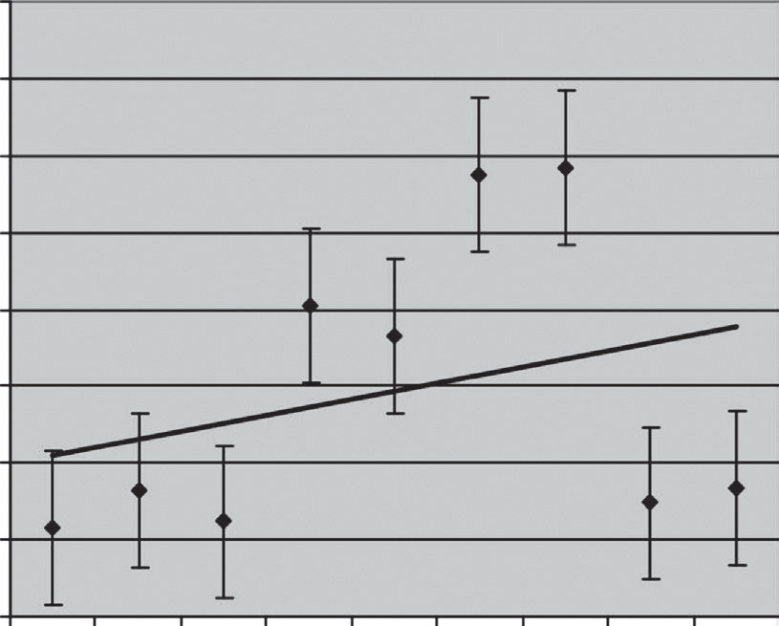

**EXAMPLE 8.2**

Many systems have consumables that we often ignore when developing life cycle costs. Take, for example, the CER for radar consumables shown here:

$80.00

$70.00

$60.00

$50.00

$40.00

$30.00

$20.00

$10.00

$-

y = 2.07x + 19.04

1997 1998 1999 2000 2001 2002 2003 2005 2006

Year

The radar’s consumables in this case include all of the internal cable assem- blies, low-cost power supplies, and other various low-cost components that fail. The resulting CER for the radar is

*y* = 2.07*x* + 19.04

Note that these values are in actual or then-year dollars. This relationship covers only the O&S costs for consumable components and piece parts. It does not include consumables such as fuel, lubricants, corrosion treatment solutions, etc. Even for a low-maintenance item such as radar, there can be significant hidden costs.

$/FH

**EXAMPLE 8.3**

A bridge is to be constructed to span a distance of 3000 feet across a shallow river, as shown below. A preliminary study concluded that a series of equal- span simple trusses is most suitable. It is estimated that the two end piers, A and B, will cost $400,000 each. The remaining piers, which will be located in water, can be constructed anywhere in the crossing at a cost of $800,000 per pier. Each bridge truss of length *L* (feet) costs 80 times *L*2.

L L L L L

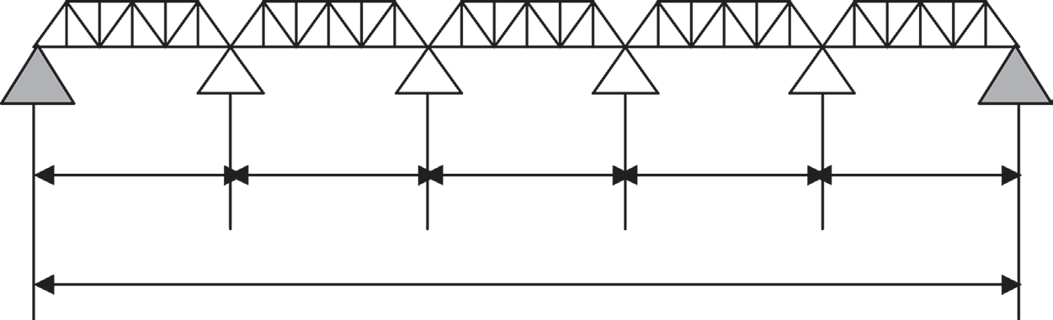

3000 Feet

A B

Thus, the number of interior piers, *n*, is given by

*n*  3000  1

*L*

and the expected cost of the bridge, *C*, becomes

*C* = 2(400,000) + *n*(800,000) + (*n* + 1)8*L*2

 800, 000 

3000  1

 800, 000 

3000

 80*L*2

*L L*

The figure below shows a plot of interior truss length as a function of cost.

This would be a useful CER for a planning report.

$240,000,000

$220,000,000

$200,000,000

Total Bridge Cost, $

$180,000,000

$160,000,000

$140,000,000

$120,000,000

$100,000,000

$80,000,000

**Cost as a Function of Truss Length**

300

400

500 600 700 800

900

1000

Interior Truss Length, ft

Inflation, %

## ROLE OF STATISTICS

Modern software from Excel®, SPSS®, SAS®, and other sources makes sophisti- cated analysis of data very simple. For example, consider the regression analysis in Example 8.4. When you plot an *x*-*y* scatter plot in Excel, by simply right-clicking your mouse on one of the data points you can add a trend line with an *R*2 to the plot. We will not review simple, multiple, and curvilinear regression and other predic- tive modeling techniques. Even complicated techniques such as neural networks, genetic algorithms, etc., can now be used easily to develop CERs, provided the modeler understands the limitations. The biggest challenge is understanding the goodness of fit for the data and the validity of the equations even for statistically significant models.



**EXAMPLE 8.4**

From the data given in Problem 5.21 develop a CER for inflation (1951–2008) and plot the results using Excel.

14

**Inflation 1951–2008**

12

10

8

Inflation (%)

Linear (Inflation (%))

6

4

y = 0.0091x – 14.056 R2= 0.0029

2

1950

–2

0

1960

1970

1980

1990

2000

2010

Year

Of interest is how the CER would change if we used only the information from 1951 to 1980, or only the data since 1992.

## SOME CERS OF INTEREST

* + 1. **LEARNING CURVES**

Learning curves and expressions such as “experience curve,” “cost improvement curve,” “progress curve,” “progress function,” “start-up curve,” “improvement curves,” “progress functions,” or “efficiency curve” are often used interchange- ably and are based on the concept that resources required to produce each addi- tional unit decline as the total number of units produced increases (NASA, 2004). The term *learning curve* is used when referring to an individual’s or organiza- tion’s performance as knowledge or insight is gained. The learning curve concept is used primarily for repetitive and labor-intensive tasks and finds most of its utility in manufacturing. In most practical applications, learning curve analysis is used to predict the cost of making the *n*th unit given the time and cost of making the first unit. This CER’s data are gathered under the “design and implementa- tion” phase of the life cycle costing process. It uses historical data, by definition, to calculate a cumulative average cost for producing an item. A consistency in improvement converts to a constant percentage reduction in time required over successively doubled quantities of units produced. This constant percentage by which the costs of the doubled quantities decrease is called the *rate of learning* (FAA, 2008).

Other terms that are used interchangeably with learning curve are experience curve and cost improvement curve. The difference between these terms is in what measurement they define. The learning curve describes the reduction in the number of hours a job requires as workers learn their jobs. The experience curve, by con- trast, applies not only to labor-intensive situations, but also to process-oriented ones (NetMBA, 2008). It covers value-added costs (including administration, marketing, and distribution) that are also reduced by a constant and predictable percentage. The cost improvement curve applies these reductions across multiple processes to reduce recurring costs over and above labor charges.

The learning curve principle is predicated on three commonly accepted observa- tions. The first observation states that the amount of time needed to perform a task decreases the more times the task is repeated. Second, the amount of improvement decreases as the number of units manufactured increases. And third, the rate of improvement is consistent enough to allow prediction of future data. The mathemati- cal model that represents these premises is attributed to Wright (1936).

The generally accepted learning curve graph is shown in Figure 8.2. It represents the concept that the more units of a product that are manufactured, the less time it takes to make an individual unit. Workers on the first line improve their skills and reduce the time to perform those skills at an exponentially decreasing rate.

Most learning curves range from around 70 to 100%. Below 70% probably indi- cates that the workers are in a job they are not capable of doing. A 100% learning curve indicates that no more knowledge is to be gained. This will occur over time if the product being made is never improved on or reworked.

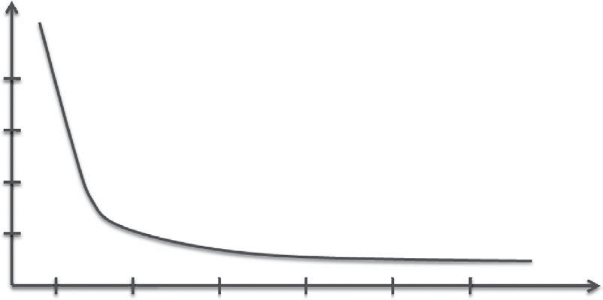

Cumulative Average Unit

Unit of Production

**FIGURE 8.2** Generally accepted learning curve graph.

* + 1. **WRIGHT’S METHOD**

Wright’s (1936) model was the first CER and was originally defined as the unit curve theory. It calculates the cost to produce the *n*th unit given the cost to produce the first unit and the value for a decreasing slope that contains the learning rate.

The learning curve unit function is defined as follows:

*y*n = *an*b (8.1)

where:

*y*n = the time (or cost) per unit to produce the *n*th unit

*n* = the number of units produced

*a* = time (or cost) required to produce the first unit

*b* = slope of the function, which is negative because time (or cost) decreases as production goes up (log of the learning rate/log of 2)

Taking the log of both sides reduces this equation to a straight line (*y* = *mx* + *b*). This gives the analyst a simple visual ability to determine future predictions for *n*+ additional units. The formula looks like this:

log *y*n = *b* * log *n* + log *a* (8.2)

If we used an example with a learning rate of 85% and time to produce the first unit of 60 hours, we could determine the time to produce the seventh unit with the following calculations, based on Equation 8.1:

*b* = log (.85)/log (2) = –.07058/.301 = –.234

*y*7 = 60 * 7–.234

*y*7 = 38.05 hours to produce the seventh unit

Cumulative total hours (or cost) is then computed by multiplying both sides of the cumulative average equation by the *n*th unit number:

*ny* = *an*1+b (8.3)

#### TABLE 8.2

**Effects of Learning When Doubling the Lot Size**

|  |  |
| --- | --- |
| **Total (Cumulative)** | **Average Time/Unit** |
| 60 | 60 |
| 102 | 51 |
| 173.4 | 43.4 |
| 294.8 | 36.8 |

Thus, the equation for cumulative total labor hours from the above example is

*ny* = 60*n*1–.234 = 60*n*.766

Cumulative total labor hours = 60 * (7).766 = 60 * 4.4396 = 266.38 total hours for 7 units (Martin, 2008).

Table 8.2 shows total cumulative hours and average labor hours when the lot size is successively doubled. Note that the above calculations fall roughly where you would expect for 7 units (38.05 hours/266.38 hours).

## SUMMARY AND CONCLUSIONS

CERs/PCEs are easy to use and common throughout the cost estimating indus- try. Most software analysis tools use these simple mathematical relationships and bottom-up estimating techniques. In applying good judgment in the use of CERs, we must remain mindful of their strengths and weaknesses, including (DoD, 1995):

Strengths

* One of the principal strengths of CERs is that they are quick and easy to use. Given a CER equation and the required input data, one can gener- ally turn out an estimate quickly.
* A CER can be used with limited system information. Consequently, CERs are especially useful in the RDT&E phase of a program.
* A CER is an excellent (statistically sound) predictor if derived from a sound database, and it can be relied on to produce quality estimates.

Weaknesses

* CERs are sometimes too simplistic to forecast costs. Generally, if one has detailed information, the detail may be reliably used for estimates. If available, another estimating approach may be selected rather than a CER.
* Problems with the database may mean that a particular CER should not be used. Although the analyst developing a CER should validate that CER, it is the responsibility of any user to validate the CER by reviewing the source documentation. Read what the CER is supposed

to estimate, what data were used to build that CER, how old the data are, how they were normalized, etc. Never use a cost model without reviewing its source documentation.

Analysts must be diligent when using CERs/PCEs and remember that the under- lying conditions from which the relationships were developed can change, especially due to technology. When using a CER, we need to make sure the factors in the fore- cast are applied only for the range of data used in its development.

## QUESTIONS

* 1. Qualitatively develop a simple CER for a home computer system.
  2. Consider the figure and data shown below. Can you explain why cost/unit prices increase 50 to 100% when the number produced drops by a factor of 5?

**DOD’s Project Unit Cost for the F22 Prices before and after Restructuring**

Move T1 Down

Shift in learning curve

(cost improvement) to move more rapidly to economic production

Production

Unit Cost

Low-rate Full-rate

Units Unit Units Unit

Estimates Cost Cost

Before restructuring Restructured without initiatives

76 $142.6

70 $200.3

362 $102.8

368 $128.0

QTY/Time

Restructured with initiatives

70 $200.8

368 $92.4

## PROBLEMS

* 1. Consider the following data collected for software development as a func- tion of KLOC (thousands of lines of code):
     1. Using Excel, develop a CER using regression analysis for software development in staff-months.
     2. Develop a plot of your regression model and the results, as predicted by the semidetached mode, using basic COCOMO (constructive cost model). Can you develop a CER using basic COCOMO?

|  |  |
| --- | --- |
| **KLOC** | **Staff-Months** |
| 7 | 80 |
| 13 | 106 |
| 56 | 581 |
| 100 | 682 |
| 115 | 854 |
| 220 | 939 |

* 1. A review of several projects for production rates versus LOCs is shown in the table below. Use Excel to develop a plot of the various data sources. Then, develop a linear regression of the data and make a prediction for a 5,000,000 LOC project. What is *R*2 for your regression model? Based on your *R*2 value, do you have confidence in this prediction?

**Project Size Average**

**Lines per Developer per Day**

10,000 LOC 22

100,000 LOC 17

1,000,000 LOC 12

10,000,000 LOC 10

* 1. Your company has used the basic COCOMO model in the semidetached mode with an EAF (error adjustment factor) of 1.75 to estimate software for your line of data acquisition systems. You suspect there is a better PCE and want to develop a more accurate model. Data for all of the proj- ects are shown below. Can you recommend a better model?

|  |  |
| --- | --- |
| **KLOC** | **Effort (PSM)** |
| 12.5 | 96.5 |
| 23 | 160.8 |
| 87 | 624.5 |
| 63 | 528.2 |
| 47 | 313.3 |
| 50 | 335.8 |
| 10 | 79.1 |
| 7 | 55.7 |

* 1. Your company manufactures specialty ammunition for the U.S. Army. You are bidding on a new contract for similar ammunition. You review historical data and find out that you have manufactured this type of ammunition four times, with the following results:

Lot 1 = 256,000 units @ 853 units/hour

Lot 2 = 332,000 units @ 938 units/hour

Lot 3 = 361,760 units @ 952 units/hour

Lot 4 = 207,000 units @ 690 units/hour

You need to develop a CER using this data. The lot size will be 500,000 units. Should you be concerned about how lot size affects the production rate?

* 1. Problem 5.21 contains a plot of inflation as a function of stock market returns. You believe that when inflation is low, typically stock market returns are higher. Using Excel, fit a linear regression model for your CER for inflation as a function of stock market return. On the basis of *R*2 and a plot of the data, is a linear model appropriate? Develop a plot with

the trend line, regression equation, *R*2, and the data. Ensure that the axes are labeled and the plot appropriately titled.

* 1. As the owner of a small security firm, you use CERs to develop most of your cost estimates. The contract on which you are bidding is the largest in your company’s history and will involve about 20 sensors. Below are your historical records on installing these types of sensors.

**Number of Sensors**

**Integration and Installation**

**Man-Hours/Sensor**

2 12.4

5 16.6

5 14.6

9 27.7

9 28.3

11 42.9

15 77.6

Using Excel, fit a linear regression model for your CER. Looking at *R*2

and the plot of the data, is a linear model appropriate?

## REFERENCES

Department of Defense (DoD). 1995. “Parametric Cost Estimating Handbook,” Joint Government/Industry Initiative.

FAA. 2008. “The Learning Curve.” In *FAA Pricing Handbook*, chapter 18. Accessed December 2008, <http://fast.faa.gov/pricing/98-30c18.htm#18.3>

Martin, James R. 2008. “The Learning Curve or Experience Curve.” Accessed December 2008, <http://maaw.info/LearningCurveSummary.htm>

National Aeronautics & Space Administration (NASA). 2008. “Cost Estimating Handbook.” [www.nasa.gov/ceh_2008/2008.htm](http://www.nasa.gov/ceh_2008/2008.htm)

NetMBA. 2008. Strategic Management: The Experience Curve.” Accessed December 2008, <http://www.netmba.com/strategy/experience-curve/>

Wright, T. P. 1936. “Factors Affecting the Cost of Airplanes.” Presented at the Aircraft Operations Session, Fourth Annual Meeting.

## BIBLIOGRAPHY

Griffis, Fletcher H., and John V. Farr. 1999. *Construction Planning for Engineers*. New York: McGraw-Hill.

# Cost as an Independent Variable

9

## INTRODUCTION

Cost as an independent variable (CAIV) is a formal methodology for reducing TOC while maintaining performance and schedule objectives. It involves developing, set- ting, and refining cost objectives in a systematic method while meeting owner/user requirements. CAIV entails setting aggressive, realistic cost objectives for acquir- ing systems and managing program risks to obtain those objectives. Cost objectives must balance against market and budget realities with projected out-year resources, taking into account existing technologies as well as the high-confidence matricula- tion of new technologies (Kaye et al., 2000). In essence, the CAIV concept means that, once the system performance and objective costs are decided (on the basis of cost/performance tradeoffs), then the acquisition process will make cost more of a constraint, and less of a variable, while obtaining the needed capability of the system. Figure 9.1 shows this graphically.

CAIV is founded on two primary principles. First, TOC are constrained. Unfortunately, this is all too often limited to development and production costs. Whereas some programs do obtain additional funding when needed, such funding is often at the expense of other business units, other programs, or future moderniza- tion. Second, “trade space” is the foundation for smart decisions. Trade space is the range of alternatives available to the buyers. It is four-dimensional, comprising performance, TOC, schedule, and risk impacts (Kaye et al., 2000). Many of the methods presented, such as service-based costing (SBC), can be used for this trade space analysis.

The process of implementing a CAIV program includes

* Setting realistic cost objectives early in a program
* Devising appropriate metrics for tracking progress in setting and achieving cost objectives
* Managing risks to achieve cost, schedule, and performance objectives

For CAIV to be effective we need to conduct meaningful trade space analysis that includes

* Tradeoff performance considerations
* LCC considerations
* The role of risk
* Incentives for achieving cost objectives

**185**

Max price will pay

Solution Set

Becomes Cost Prohibitive

Trade Space

Cost

Marginal Performance Many Requirements not Met

Performance Threshold

Risk Reserve

All Requirements Met or Exceeded

Min expected price

**FIGURE 9.1** CAIV

Performance

representation. (Modified from Kaye, M. A., M.

S. Sobota,

D. R. Graham, and A. L. Gotwald. 2000. “Cost as an Independent Variable: Principles and Implementation.” *Acquisition Review Quarterly* Fall. Accessed January 2008, http:// [www.dau.mil/pubs/arq/2000arq/kaye.pdf)](http://www.dau.mil/pubs/arq/2000arq/kaye.pdf))

* Innovative acquisition strategies
* Appropriate metrics and processes This analysis usually assumes
* Stable requirements and funding
* True competition exists
* Creative contracting
* The right amount of oversight
* A product team organized correctly

As with any business process, to fully implement a strategy and assess its effec- tiveness, we must

* Develop a CAIV plan
* Establish a CAIV process
* Select and collect metrics
* Train teams
* Determine key performance parameters (KPPs)
* Determine cost goals
* Estimate TOC
* Identify cost drivers
* Perform meaningful trade analysis
* Adjust architecture for cost/performance issues
* Deploy cost reduction incentives through creative contracting

## CAIV EVOLUTION THROUGH THE LIFE CYCLE*

CAIV should be initiated at the beginning of a program and evolve through the life cycle. As an LCC program management methodology, the application of CAIV var- ies between each acquisition phase or systems process as performance requirements, initially established as a range between required thresholds and desired objectives, narrow as a program migrates toward production (NASA, 2008).

Our product life cycle model includes six steps (Figure 9.2):

* + 1. Conceptual exploration
    2. Component advanced development
    3. Systems integration/preliminary design
    4. Systems demonstration, test, and evaluation
    5. Production
    6. Operation, support, and disposal

Below is a discussion of CAIV throughout our product life cycle.

* + 1. **CONCEPTUAL EXPLORATION**

During this phase, CAIV supports the analysis of alternatives (AoA) by focusing on technical performance requirements versus cost drivers. CERs based on historical analysis or high-resolution models can play a useful role in these trade space studies. At the end of this phase, the requirements are established with threshold and objec- tive ranges, funding is assigned for development, and a support strategy is proposed to minimize downstream costs.

*Requirements*. Stakeholders utilize mission effectiveness and cost performance analyses as key elements of the AoA. When the preferred approach is identified, customers employ mission effectiveness analysis and CAIV principles to set initial requirements based on the best estimates of TOC. This is not trivial because until the system architecture is developing, estimating the LCC costs is impossible. Typical O&S contribute to a significant majority of the TOC for any system.

*Partnering*. The buyers typically lead the requirements definition efforts and should have organizational support once a development team is assigned.

*TOC focus*. During the conceptual exploration phase, integrated product teams (IPTs) focus on the LCC aspects of a program by developing and recommending an O&S strategy that will optimize the elements of reliability, maintainability, and sustainability. TOC focus recognizes that the majority of LCC is in the O&S phase and focuses the analysis on this issue.

*Risk-based management*. A significant amount of buyer involvement is needed to support the developer in gaining an early understanding of potential risks and alter- natives. In preparation for preliminary design review (PDR), the acquisition strategy must identify the key risk areas within the proposed solution. These will become integrated into the CAIV strategy and, ultimately, the request for proposals (RFP).

* Much of this section was modified from Kaye et al. (2000). “Cost as an Independent Variable: Principles and Implementation.” *Acquisition Review Quarterly*, Fall. Accessed January 2008, <http://www.dau.mil/pubs/arq/2000arq/kaye.pdf>

*Measurement*. Objective TOC should be set in the requirements documents. Although this is becoming more common, in reality this is not the case simply because the system must be architected before the requirements can be determined. The requirements “owner” should estimate which requirements are likely to be cost drivers and, for each such driver, track whether adequate TOC insight has been gained. For that reason, it is essential that buyers (i.e., users, government, etc.) work with the development team to best estimate TOC.

* + 1. **COMPONENT ADVANCED DEVELOPMENT, SYSTEMS INTEGRATION PRELIMINARY DESIGN**

Maximum leverage for CAIV efforts exists in these phases because system design has not yet been finalized and trade space studies can be conducted. Also, significant funding has not been obligated for the system (see Figure 1.2).

*Requirements*. The IPTs use CAIV to define TOC impacts and conduct trade studies focused on design, particularly as influenced by O&S. Tradeoff data enable buyers to refine requirements.

*Partnering*. Using CAIV, the team should baseline expectations through the fol- lowing steps (Kaye et al., 2000):

* + - * Identify common and unilateral objectives to ensure concerted, focused effort.
      * Define all interdependencies and organize, plan, and commit to act to meet them.
      * Central to this aspect is analysis of the developer’s network, critical path, and integrated master plan (IMP). Based on this analysis, the owner should build his own IMP to ensure owner actions meet timelines expected by the developer and do not give any cause for developer claims.
      * Generate a unified risk-handling plan.
      * Develop a concept of operations (CONOPS) to define management and working-level interaction, metrics, etc.

*TOC focus*. With a funded and manned program, adequate effort can now be expended to identify TOC and risk impacts from design and O&S trade studies.

*Risk-based management*. The team should generate a unified risk mitigation plan to address high- and moderate-risk areas. The plan should consolidate previous risk analyses, brainstorm other concerns, prioritize risks, allocate risk-handling respon- sibilities, outline a risk mitigation plan, and regularly review status. Implementation may include provisions in acquisition strategies, contracts, or parallel efforts. At a minimum, the contract should require the developer to conduct trade space studies to mitigate risk.

*Measurement*. The team must continue to track TOC estimates versus objectives. In addition, requirements “owners” should continue to track degree of insight to TOC impact for each identified cost driver. The team should track risk drawdown per the handling plans, with metrics tied to specific risk reduction accomplishments. Use of TPMs can be very effective for such efforts.

* + 1. **SYSTEMS DEMONSTRATION, TEST, AND EVALUATION**

Early in this phase, fixing requirements limits the ability of CAIV to generate fur- ther substantial cost savings. However, focusing on production and O&S may still yield benefits.

*Requirements*. The IPT uses CAIV to ensure requirements are met at a mini- mum TOC. Note that a configuration control board (CCB) should be established as requirements change in order to manage costs. A process similar to the one shown in Figure 9.2 can be used for configuration management.

*Partnering*. The same principles of teaming apply as applied in the early phases. Creative contracting for all phases of the life cycle is a key element of CAIV. The developer must be incentivized to reduce costs.

*TOC focus*. Tradeoff studies will focus on production and O&S impacts on TOC and risk. A mature testing and evaluation of components and prototypes should enable more accurate estimates of O&S impacts on TOC.

*Risk-based management*. The contract again must require trade studies to iden- tify the trade space, although the ability to make substantive changes decreases as the design matures. As shown in Figure 1.2, more costs have been obligated the further along in the product life cycle. The team should employ the same type of risk program definition as described in the concept exploration phase.

*Measurement*. The team continues to track TOC estimates to TOC objectives and risk drawdown through TPMs. In addition, the contractor earned value met- rics, in conjunction with the IMP and integrated master schedule (IMS), provide an accurate status for completion of development as well as visibility to any poten- tial problems before they get out of hand. Data from prototype and component builds and testing will support production cost estimates. The team will have deter- mined the availability and visibility of such metrics during their partnering sessions (NASA, 2008).

Disapproved

Approve

Report Result to Affordability IPT

Present to User & Cost Performance IPT

Engineering/ Contract Change Approved

Program Analysis Team Review

Concurrent CCB/ Affordability Team Review

Receive CAIV

Engineering/ Contract Change Proposal

|  |  |  |
| --- | --- | --- |
| Present to Management IPT | | |
| d |  |  |
|  | |

Disapproved

**Note:** Configuration Control Board (CCB)

**FIGURE 9.2** Flowchart illustrating how CAIV can be used for changes in requirements/ design. (From Gaddis, Don. 1998. “Implementation of Cost as an Independent Variable: An AIM-9x Case Study,” Master’s thesis, Naval Postgraduate School.)

* + 1. **PRODUCTION**

In this phase, CAIV can generate some TOC savings through production improve- ments prior to delivery of finished systems to the user.

*Requirements*. The IPT ensures continued ability to meet baseline requirements while adapting to the requirements evolutions that drive system modifications.

*Partnering*. Although some partners may have changed from earlier phases (espe- cially if major modifications are in process), the same principles apply.

*TOC focus*. With an eye on reducing immediate costs, developers are given incen- tives in production contracts to streamline manufacturing processes to reduce the cost of producing systems. Additionally, all members of the product development team, especially maintainers, work to ensure proposed sustainment processes and practices, maximize system availability, and minimize cost.

*Risk-based management*. For steady state systems, teams should focus on risks that may upset the steady state. Risk occurs in all phases of acquisition. Constantly moni- tor and reexamine risk to ensure old risks are managed and new risks are identified. *Measurement*. As in previous phases, a well-functioning earned value measure- ment process provides the product team with the necessary information to assess

program progress and status.

* + 1. **OPERATION, SUPPORT, AND DISPOSAL**

For fielded systems, the TOCprocessisprimaryinidentifyingcost-savingopportunities, but the CAIV process really starts all over again in support of system modifications.

## CAIV METRICS

The metrics detailed in Table 9.1 can be used to ascertain whether a strong CAIV program is in place.

## DESIGN TO COST VERSUS CAIV

* + 1. **INTRODUCTION**

Design to cost (DTC) and CAIV are often used interchangeably but are very dif- ferent. DTC is a management technique for controlling cost by “designing to speci- fied goals.” During the development of a piece of hardware, financial incentives or awards are paid to the developer under DTC provisions when contractual goals are met. The two components of DTC are

* + - 1. Design to unit production cost (DTUPC)—This effort uses incentives and/ or awards to achieve unit production cost goals specified in the contract, through creative engineering and cost control techniques.
      2. Design to operating and support cost (DTOSC)—This effort uses incen- tives and/or awards to develop a unit design that will achieve operating and support goals specified in the contract (Gille, 1988).

#### TABLE 9.1

**Examples of CAIV Metrics and Features**

Are cost objectives defined and consistent with programmed requirements and projected fiscal resources?

Is the owner/stakeholder managing to achieve cost objectives?

Are developers managing to achieve cost objectives?

Out-year resources identified?

Production and O&S cost objectives included in the RFP?

Key tradeoff issues addressed (e.g., in CONOPS/AoA)? Requirements are stable

Cost performance IPT functioning, tradeoff space

identified in program baseline and RFP?

Risks to achieve cost objectives identified and program steps to address these defined? (risk plan)

Incentives for achieving LCC objectives included in the RFP and contract? (% relative total contract dollars; period of performance tied to life cycle cost target profile) Mechanism for developer suggestions to reduce production and operations and support costs in place? (value engineering clause)

Allocation of cost objectives provided to IPTs and key suppliers

Measurement and estimation of reliability and maintainability LCC

Robust developer incentives plan in place?

Provide appropriate tools for cost/performance tradeoffs (including incentives) and participate in cost/ performance tradeoff process (hierarchy IPT structure; award fee flow down to IPT members)

Identify and implement new technologies and manufacturing processes that can reduce costs Identify procedural/process impediments to cost reduction measures

Establish strong relationship with vendor base, including sound incentives structure

*Source:* Modified from Kaye, M. A., M. S. Sobota, D. R. Graham, and A. L. Gotwald. 2000. “Cost as an Independent Variable: Principles and Implementation.” *Acquisition Review Quarterly*, Fall. Accessed January 2008, <http://www.dau.mil/pubs/arq/2000arq/kaye.pdf>

Advocates of CAIV argue that it is more than a methodology, but a philosophy, with IPTs driving the process and developers involved in setting cost goals and the ability to do requirements trades. Most important, the developer/owner team works in a partnership with contractual incentives to reduce costs; whereas DTC is more of a rigid process, with the owner setting the costs and the contracting agents involved

in the decision processes. There is an important distinction between the two, but both have the same goal—cost is a key business driver.

In the mid-1970s, the DoD started using DTC, a program based on cost as a dependable variable throughout the LCC of the program. By the mid-1990s, a big shift occurred as a process for cost performance trades allowing day-to-day interac- tion between requirements and the acquisition communities and the use of IPTs was necessary. CAIV arose from that need.

* + 1. **OVERVIEW OF DESIGN TO COST**

The purpose of DTC is to stimulate creativity in the design of a system in order to control the cost of its production and/or operation. Creativity is stimulated through the use of incentives and awards.

The goal of the DTC program is to attain a proper balance among development, production, and O&S costs while providing the customer with the desired capabili- ties, satisfying operational requirements on schedule and within cost.

Sometimes DTC programs become fixated on the wrong metrics, such as the average unit procurement costs. Although the idea is to identify cost drivers for the specific system early in the life of that acquisition program and to consider ways to keep those costs under control, developers often place the greatest emphasis on production costs rather than the total LCC of the program. However, because the developer has a greater interest in the near-term problems and costs, incentives for spending development funds to reduce production and O&S costs are not as strong as the near-term requirements.

#### DTC Roles and Responsibilities

The two oversight groups within the DTC program are the DTC board and the DTC managers. The roles and responsibilities within each are defined to ensure personnel are clearly instructed on the DTC process. The DTC manager is oversees the DTC activities: writing, reviewing, and approving documents such as waiver requests. The DTC board reviews, analyzes, and recommends approval or disapproval of the DTC packages, when applicable.

#### Impact of LCC in the Program

Overall, DTC optimizes the use of the critical life cycle acquisition functions and database management procedures, reports progress against cost targets, and takes appropriate action to achieve a realistic balance between cost targets and system performance requirements. This approach helps ensure that cost-effec- tive systems are developed within the cost, performance, and time frameworks. These costs include development costs, production costs, O&S costs, and dis- posal costs.

The crucial importance of DTC as a system parameter prompts a more aggressive approach to contracting for cost. During the early phases of a system’s development, achieving a proper balance of cost, performance, readiness, supportability, and schedule that is best characterized by unstable requirements and funding requires continual communication between the owner and the developer. In some cases

these program parameters will be in conflict and will require compromise. The buyer’s management agency is the authority for guiding these decisions because it is ultimately responsible for the final product. Consequently, during the course of a contract, particularly where cost is critical and the cost risk is high, provisions are included to obtain guidance from the buyer. This is accomplished through appropri- ate contracting vehicles to update priorities and to clarify what is an acceptable mix of product characteristics.

Cost is a major consideration during the selection of subsystems and major com- ponents for the production of an end item. The DTC process uses relevant LCC elements to the extent that they discriminate between design choices. Later in the acquisition cycle, DTC is used as the means to compare current estimates against targets and to encourage cost reduction initiatives when a target breach appears imminent.

Ensuring cost visibility in the design tradeoff process is an essential function of DTC; still, there are other essential ingredients to the success of the DTC plan: cost issues, high-quality cost analysis, concise and timely cost information, and rapid communication among designers and decision makers. The level of effort should be commensurate with the risk involved in meeting cost targets and the benefits derived.

#### Elements of DTC Program

The DTC elements include

* + - * + Planning, identifying cost drivers, developing cost targets, and conduct- ing tradeoff studies to determine the most cost-effective alternatives. In response to cost objectives, the WBS principles shall be identified for col- lection and establishment of DTC targets.
        + Describing how DTC is accomplished in relation to management structure, processes, procedures, and contract schedules.
        + Monitoring cost targets, documenting progress, developing action plans, and resolving problems.
        + Implementing feedback techniques, during the design process, to control relevant LCC.
        + Employing existing cost analysis methodologies and data sources, and providing justification for developing new methodology and data sources when necessary.
        + Reviewing DTC status and future plans in all design and program reviews.
        + Documenting ground rules, assumptions, and methodology used in estimat- ing DTC targets, estimates, and LCC.

#### DTC Plan

The DTC plan originates from the developer’s DTC program planning to ensure that a high degree of confidence exists. It also includes monitoring techniques to ensure timely and effective execution of the DTC program; in addition to an action plan in case of an imminent need to breach a cost threshold.

Another section of the DTC plan is the DTC implementation plan, a dynamic document subject to revision and change as the system evolves. It provides the inte- grated program plan for the time-phased activities required to accomplish a specific set of DTC objectives.

#### Cost Controls (Goals)

The execution of an effective cost control strategy is critical to the DTC process. The objective should be to achieve an affordable product that is acceptable in terms of performance, readiness, effectiveness, supportability, and schedule. When there is conflict between cost-effective choices and affordable choices for design alterna- tives, then cost-effectiveness may be sacrificed to the practical considerations of the funding available to the owner program office. The application of cost targets (goals) is an important issue in that it requires the developer and owner interaction to deter- mine proper timing and magnitude of the cost targets.

Major cost drivers must also be identified early in the program because they may account for approximately 80% of the cost. High-risk areas must be identified and reduced to acceptable levels because they affect the reliability of the forecasted pro- gram cost and control plan. Examples of areas to consider are schedules, quantities, design changes resulting from high-cost or excessive component failures, test activi- ties, inadequate tailoring of specifications, new technologies, and increased mission capability.

#### DTC Trade Space Studies

Trade space or tradeoff studies are not unique to CAIV, but are necessary for DTC programs to determine which alternatives provide the best combination of cost, per- formance, and supportability within the time constraints imposed by acquisition and deployment schedules.

The trade space studies should be developed to address major cost drivers not covered in other engineering trade space studies. These studies should include a discussion of the schedule, levels of effort, and means and depth of detail of results reporting. They should be updated as new tradeoffs are developed and as the results of the trade studies are completed. Ground rules, assumptions, and methodology used to estimate the alternatives must also be documented. The DTC tradeoff studies must also consider the development and maintenance cost of software.

The trade space studies include information for the decision-making process regarding cost targets, performance, and cost-effectiveness. The studies identify the preferred alternatives measured against potential conflicts from issues of cost targets versus performance, supportability, schedule, and LCC effectiveness.

#### Provide Incentives and Awards

Incentives and awards target mainly the developers but should also include the owners and their representatives. Incentives are scheduled payments made when contracted goals are achieved or when creative contracting is employed. Awards, as opposed to incentives, are payable based on a subjective evaluation of developer performance in achieving owner goals that are readily measurable. Remember that DTC treats cost as a key design factor, equal in importance to risk, performance, and schedule.

#### Establish Metrics

DTC does not have a formal metrics program. However, it includes guidelines to develop and maintain trend analysis reports, cost initiatives, action plans, quarterly reports and reviews, LCC and goal tracking, milestone reviews, and unit production cost determination.

Trend analysis—or the evaluation of cost tracking information to identify adverse trends in terms of LCC, cost targets, and/or the individual allocated cost subtar- gets—must be implemented. Identified problem areas must be analyzed for interim action. Once implemented, the interim actions become cost initiatives.

Each cost initiative must include background, action taken to date, action planned, and the current assessment regarding successful completion. Periodic progress on efforts to rectify a cost threshold breach, as identified in a DTC action plan, should be reported immediately.

A DTC program must include an action plan that identifies the specific effort necessary to control costs and to get the projected costs back to an acceptable level. The elements to include are cost to implement, schedule, risk, and benefits of action plan.

The developer must periodically (usually quarterly) report progress in meeting the cost targets or, if targets have not yet been established, report the status of the present estimates compared to the baseline estimates. Electronic mail is considered a timely means of submitting the DTC status report for programs where the risk of meeting cost targets is high. The final periodic report shall contain, with supporting rationale, the developer’s proposed cost targets for the next phase.

Another metric is that of LCC and goal tracking—a comparison of the current status versus target and current status versus the previously reported status. For LCC, this comparison shall be the current LCC estimate versus the baseline LCC estimate and previous LCC estimates to illustrate LCC trends. For cost targets, this comparison must be in terms of total targets and any allocated subtargets, whenever the cost targets or the baseline LCC estimate is changed, to include an explanation and a quantitative substantiation for the change.

Formal DTC milestone reviews must be held periodically between the program office and the developer’s DTC personnel. Care should be taken in spacing these reviews to ensure that enough new design information is available to warrant the expense of preparing for and attending these meetings. Additionally, all formal project status reviews, PDRs, and critical design reviews (CDRs) shall include a review of the DTC program and an assessment of its effectiveness in controlling cost. These reviews provide the best opportunity for the owner to ensure the con- tinued effectiveness of the developer’s engineering cost control effort.

The determination of the unit production cost prior to development of an item serves as a metric to guide design and control costs. The unit product cost is the cost to the owner to acquire a production item based on a stated level of production.

#### Implementing Risk Management

For DTC, risk management is defined as a qualitative assessment of the chances of failing to achieve a design that is affordable to procure, operate, and support and that is acceptable in terms of performance, readiness, supportability, and

schedule. Cost risk is directly proportional to technical risk and estimating uncer- tainty. As result, a cost reduction effort shall be implemented to have a specified quantitative target and a threshold higher or lower, as the case may be for the specific item.

* + 1. **ROLE OF CAIV AND DTC**

CAIV is touted as a methodology for reducing TOC and improving performance. It involves developing, setting, and refining aggressive unit production cost objectives and O&S cost objectives while meeting requirements. Critical elements for CAIV success include investing in the training of key personnel and making sure the CAIV process is followed and understood.

CAIV is applicable to all programs and throughout all acquisition phases includ- ing modifications and upgrades in the O&S phase. However, the greatest effect of CAIV on program requirements, TOC, schedule, and performance is at the begin- ning of the program’s life.

CAIV means the owner and requirements communities work the requirements, cost, performance, and schedule tradeoffs first, using a small number of KPPs, with the production unit cost as a real, independent, input variable. These initial perfor- mance and cost estimates should be refined as the program progresses. It is essential to involve the user community in the tradeoff process from the beginning to achieve the best outcome for all parties involved. But, like any good investment, applying CAIV is not free. One must invest resources in the tradeoff analyses performed dur- ing the upfront concept exploration phase.

All participants in the acquisition system are expected to recognize the reality of fiscal constraints and to view cost as an independent variable. Cost, in this con- text, refers to LCC, which should be treated as equally important to performance and schedule in program decisions. To institutionalize this principle, program managers must consider developing a formal CAIV plan as part of the acquisition strategy.

#### CAIV Plan

The implementation steps in a CAIV plan will depend on the type of system and its current stage in the acquisition framework. In general, however, a CAIV plan would include the following elements: set cost goals, establish cost performance integrated product teams, perform tradeoff studies, provide incentives, and estab- lish metrics.

#### Set Cost Goals

The CAIV plan includes cost goals for unit production and operating and support. The unit production cost goal is established for a specified quantity of systems and a specified peak production rate. The O&S cost goal is an annual cost per deployable unit or individual system. The goals should be challenging but realistically achiev- able. The goals in the CAIV plan might be the same as the cost goals in the acquisi- tion program baseline, or possibly more aggressive.

Aggressive goals means taking full advantage of the cost savings possible through the application of all tools, such as COTS products, competition via an open systems approach, single process initiative, military specifications reform, etc. It is important to establish goals for unit procurement cost and O&S cost drivers as early as possible and include these goals in the acquisition documents.

An approach should be outlined for setting and achieving aggressive unit cost and O&S cost goals. Tradeoff studies and affordability analyses are major inputs to set- ting aggressive cost goals. Cost targets should be set for all milestones.

#### Establish Cost Performance Integrated Product Team

The CAIV plan should establish a cost performance integrated product team (CPIPT), which most likely would receive considerable support from the system developer. Although led by the program manager, the CAIV process requires collaboration with other acquisition and logistics organizations as well as the user. CAIV relies on partnering among the war fighter, acquisition, sustainment, and industry com- munities. It takes the involvement of the entire owner/developer team to achieve maximum benefit. The developer should strive for strong trust and teaming among all parties in order to meet the system needs.

The CAIV plan should establish the CPIPT before the PDR. The CPIPT includes the users as well as acquisition, test, logistics, and program office personnel. It moni- tors the CAIV implementation and oversees the trade studies.

#### Perform Tradeoff Studies

The best time to reduce TOC and the program schedule is early in the acqui- sition process (see Figure 1.2). Continuous cost/schedule/performance tradeoff analyses help program managers accomplish cost and schedule reductions. Also, analyses should be broad enough that all costs are considered during the early decisions on system design alternatives. Cost, risk, schedule, and performance may be traded off within the trade space. The developer should jointly coordi- nate all tradeoff decisions; but validated KPPs may not be traded off without the owner’s approval.

The CAIV plan should show the timing, content, and approach of the specific trade studies to be used to establish realistic and aggressive cost targets and KPPs. These studies should be performed in a team environment consisting of the require- ments community, users, and developers. The studies should address both produc- tion and O&S costs.

Supporting studies need to focus on establishing the critical few mission require- ments and the associated unit cost and LCC targets. The objective of these studies is to obtain an acceptable balance of the lowest cost versus an acceptable set of require- ments. This is the critical new element of CAIV: making trades of requirements to achieve lower costs.

O&S costs are essentially “locked in” as a result of the requirements/cost/perfor- mance tradeoff studies. In order to support setting O&S cost targets, tradeoffs should specifically examine interactions between unit costs, logistics footprint, infrastruc- ture response time, and readiness posture. Over time, as the system design matures, the trade studies become more refined and specialized.

The results of the tradeoff studies should be structured to support timely inputs into the overall program acquisition plans. The CAIV plan should clearly indicate the input points in the schedule and show the timing and coordination of both the operational requirements documents (ORD) and the project milestones RFP. The RFP should also contain incentives and metrics. The CAIV plan will explain how unit cost and O&S cost targets, KPPs, and CONOPS will be aligned throughout all documents. Unit production and O&S cost goals should be identical throughout all documents in order to align team efforts.

#### Provide Incentives

The elements of the acquisition strategy should describe incentives to the developer that directly support, or are at least complementary to, the CAIV plan. Such incen- tives might include award fees, sharing of cost savings, or other (positive or negative) incentives.

The post-concept exploration RFP package should address and include developer and government incentives to meet unit cost and O&S cost objectives. Price credibil- ity, the extent to which the developer has thought through acquisition and ownership costs and can document its plans, should be a primary evaluation factor. Unit price commitment curves (UPCCs) should be considered for early production lots; their inclusion in source selection for systems demonstration and later phases should also be discussed. Competition, award fees, warranties, and “carrot and stick” incentive approaches should be included as appropriate.

The developer should review the use of incentives to achieve CAIV and schedule objectives. As an example, incentives might stress upfront investments to minimize production costs, operating and support costs, and/or cycle time, where applicable. Also, “shared savings” programs should be reviewed as a creative method to encour- age the generation of cost- and schedule-saving ideas throughout all phases of the life cycle. The developer needs the encouragement of the end users to accept risks associated with aggressive cost objectives.

Effective top-level management will motivate developers at every level to per- form as desired by clearly identifying objectives and by fostering a positive “can do” attitude from top to bottom. Promotion policies, awards, and other formal recogni- tion are important in providing feedback that jobs have indeed been done well. This fosters an environment that promotes goal setting, teamwork, and recognition of accomplishments from the management chain.

#### Establish Metrics

The CAIV plan should address how metrics will be established to track progress and achievement of unit production and O&S cost goals. The plan identifies how progress toward achieving the goals will be monitored and reported. It describes how cost estimates will be updated and refined over time and compared to the original cost goals. The plan identifies specific organizational responsibilities and specifies related major events where progress toward achieving goals will be assessed.

Metrics should be established to track achievement of unit production and O&S cost goals. These metrics will relate directly to program objectives and act as the gauge by which incentives are awarded. The metric system focuses on accomplish- ments and reward-oriented categories. Each metric should be simple to understand and use existing reporting mechanisms. Cost-effective data collection is a key to success.

CAIV metrics include both unit production price for early production lots and unit production price developed over the buy period. Additionally, O&S-related met- rics should be established and tracked. The O&S metrics may include reasonable parameters as well as a model to track these O&S costs. These initial metrics should be established by completion of the concept exploration phase. The ability to set and reach cost objectives will largely depend on early tradeoffs in performance versus costs. In many cases, metrics and observables will reflect the degree to which a program is structured for success. Some examples of metrics include, but are not limited to:

* + - * + Identification of the cost baselines for comparison of progress. A prime example of this would be separate identification of development, unit pro- curement, and operating costs for the system being replaced. A secondary (less desirable) would be identification of initial program estimates for these same cost parameters.
        + Identification of cost goals relative to the identified baselines.
        + Identification of how progress toward achieving the goals will be measured and how it will be monitored and reported.
        + Assignment of responsibility for efforts intended to achieve each goal.
        + Identification of allocations among cost elements expected to contribute toward achievement of overall goals (e.g., manpower reductions have a goal of certain reductions, and within those certain operational aspects, such as maintenance, are certain subgoals).
        + Identification of events/times at which progress toward achieving goals, and reviews of goals, will be evaluated (presumably major milestones).

As part of the reduction of total ownership costs (R-TOC) program, the R-TOC working group developed templates that could be used as guidelines in the develop- ment of CAIV implementation plans. Use of these templates is optional.

From the CAIV working group report, Table 9.2 contains examples of illustrative cost factors and indicators that can contribute to assessing cost objective achieve- ments. It is interesting to point out that factors that seem to be obvious, such as work- ing with a simple design, have a huge impact on cost.

#### CAIV Templates

Numerous CAIV implementation scenarios exist, depending on the type of system and its current stage in the system life cycle. CAIV templates have been developed

#### TABLE 9.2

**Illustrative Factors and Indicators in Reducing TOC Risks**

**Factors Indicators**

Design simplification (mission/complexity) Mission simulation complete

80% solution analysis complete Mature manufacturing processes (cost/yield) Scalable process demonstrated

Statistical process controls in place Technology (cost trends, cost/performance) Product available

Market prices established Effective integration (errors/redesign) 100% 3D product model exists

Test articles available Software available

COTS (cost/performance) Mature systems Stable provider

DoD prototype Integration verified

Elimination of unnecessary business practices

Low-cost business processes employed

to meet the most common scenarios. These templates are organized around three stages of a program’s life cycle:

1. New start and modification and upgrade programs
2. Programs entering or in the system demonstration, test, and evaluation phases
3. Programs at or beyond the production stage

Table 9.3 presents activities for new start programs using evolutionary acquisition and can be used as guidance in modification and upgrade programs.

#### Implementing Risk Management

The CAIV plan should include a series of demonstrations during concept advanced development and early system demonstration, test, and evaluation to prove out the program’s approaches to aggressive cost target implementation. These will include demonstrations of innovative performance features and of critical manufacturing processes and their maturity; for example, yield improvement. Additionally, the plan should address the assessment and development, if needed, of the models neces- sary to track and predict cost and performance based on demonstrated subsystem parameters.

* + 1. **DIFFERENCES BETWEEN DTC AND CAIV**

DTC and CAIV differ in five major areas: (1) concept focus, (2) costs tradeoffs, (3) trading off performance requirements, (4) reducing life cycle cost, and (5) incentives with these differences summarized in Table 9.4.

#### TABLE 9.3

**Evolutionary Acquisition Template**



Identify, monitor and manage technologies for following blocks

M

Design sustainment strategy considering initial and following blocks

L

Fund follow-on blocks if simultaneously in development

K

Fully fund each block

J

Prepare Test and Evaluation Master Plan (TEMP) consistent with the time-phased requirements for the block under development

I

Employ CAIV to refine requirements

H

Maintain open system in anticipation of follow-on increments — (SEMP)

G

Prepare contracting plan consistent with incremental approach — update as necessary

F

Plan for independent technology assessment

E

Identify key technologies

D

Develop increments based on mature technologies

C

Develop Evolutionary Approach

B

Develop time-phased Operational Requirement Document (ORD)

A

and Support

Operations

Development

Production &

Demonstration

System

Development &

Concept &

Technology

Development

Activity

Action

C

B

Milestone: A

*Source:* Modified from DOD, 2002 EA Templates, Accessed November 2010, <http://ve.ida.org/rtoc/> open/pdf/EA_Template_V6_020701.pdf

#### TABLE 9.4

**Differences between DTC and CAIV**

**DTC CAIV**

Concept focus Minimize development and production for performance level

Performance and schedule versus cost

Spent development funds LCC as a whole

Cost tradeoff PM CPITP jointly with PM

Performance tradeoff Recommended quarterly or

enough progress

Continuous assessment

LCC Procurement Early acquisition for production and O&S cost savings

Incentives & awards Developer Owner/owner Developer/developer

#### Concept Focus

In the opinion of most, the biggest difference between DTC and CAIV is in the focus of the two concepts:

* + - * 1. Under DTC, the focus tends to be on designing the system to minimize LCC for a particular performance level; whereas under CAIV, performance and schedule can be traded to achieve TOC goals.
        2. Under DTC, although LCC is of concern, little or no attention is given to reducing postproduction O&S costs because the incentive to spend those development funds is great; therefore, attention to near-term requirements often takes precedence.

#### Costs Tradeoffs

Another key difference between DTC and CAIV is in the use of the CPIPT to recom- mend tradeoffs. Under DTC, the developer is ultimately responsible for making deci- sions regarding trades to reduce production costs. For the most part, the developer determines which tradeoff studies are necessary and approved. Under CAIV, the users are intimately involved in making trade recommendations as a result of their participation on the CPIPT. Early in the life of the program, the developer establishes a CPIPT, with representatives from the three primary communities involved in the business (i.e., user, industry, and acquisition). The CPIPT recommends cost objec- tives for each of the acquisition phases, evaluates the progress being made toward achieving those cost objectives, and, when appropriate, develops recommendations for the tradeoffs between performance parameters and costs in order to stay within the cost objectives.

#### Trading Off Performance Requirements

If concept focus is the biggest difference between DTC and CAIV, then the most significant difference shall be that the CAIV’s philosophy calls for the establishment of a process wherein the developer and owner partner have continuous and honest dialog about trading off performance requirements to stay within established fiscal LCC constraints.

Although DTC establishes metrics for reviewing the program progress against performance, risk, cost, and schedule on a quarterly basis, cost is the main driver. These reviews are more a recommendation than a mandated activity. Still, all formal project status reviews, PDRs, and CDRs are defined to include a review of the DTC program and an assessment of its effectiveness in controlling cost.

In CAIV, the developer provides an honest consideration at each milestone deci- sion point, addressing specific ongoing actions to actively manage the total LCC of the program. The owner sets aggressive cost objectives and then, at each milestone, reports on the progress made toward achieving the objectives.

With regard to the concept that cost containment is as important as performance and schedule under the CAIV philosophy, there is the recognition, along with author- ity, that it may be necessary to trade off some elements of performance parameters in

order to stay within the previously established cost objectives. DTC assigns authority without such recognition.

For CAIV, trading off performance parameters does not mean that the system being acquired will fail to satisfy the user community’s operational requirement, but that a specific way of achieving that requirement may not be possible. The opera- tional requirement must be stated in terms of overall system performance capability rather than in a detailed set of performance parameters. The key should be that the required performance capability be established and that the owner and developer both be allowed certain flexibility to achieve that capability.

#### Reducing LCC

Under CAIV, there is specific recognition that the best time to reduce LCC is early in the acquisition process; for example, it makes sense for the buyer to spend develop- ment funds in order to save a greater amount in production costs and/or O&S costs when the program transitions to later phases.

This recognition is not necessarily present in the DTC program because of the focus on procurement and to a lesser extent O&S costs.

#### Incentives

DTC provides no incentives for the developer to control costs for the production phase, because most of the time those involved in development have moved on when it is time to start production. The incentives and awards were for the developer, based on the contract vehicle used for the specific program.

With CAIV, the story is different because there are fees and incentives establishing motivation for both owner and developer to control those future costs. For the devel- oper, the incentives come from the users and managers accepting risk associated with setting aggressive cost targets, and promotion policies recognizing and rewarding not only “major success stories” but also “best efforts.” This does not mean that all will be recognized, just that those who work hard in a risky environment must be recognized for both: successes and attempts at success. For the developer, the type of contract vehicle used by the owners that includes an award fee has become a great success.

* + 1. **SUMMARY OF DTC AS RELATED TO CAIV**

Although traditionally five main areas have been identified to pinpoint the differ- ences between DTC and CAIV, in reality, these two ideologies are not much differ- ent at all. The focus of both programs is concern with managing the TOC.

Of course the DTC program focuses mainly on the developers, instructing them on the way to manage the contract and, as a result, assigning them the major respon- sibility and consequences for the success or failure of the program. The CAIV is a more participative effort, where the ultimate responsibility lies in a partnership between the owner and developer. This requires an owner’s active participation in all aspects of the program life cycle rather than only monitoring and judging the accomplishments or failures of the developer.

Trading off performance requirements happens under either program. In DTC, creativity is rewarded when using a simple solution to meet the requirement. For

CAIV, there is no questioning when a determination of performance must be traded off for the whole of the program’s benefit.

## SUMMARY

Like Six Sigma, Total Quality Management, etc., CAIV is more of a philosophy that focuses on fixing costs in the trade space. Few programs can truly fix costs, especially within the federal government. For example, the Government Accounting Office (2008) analyzed the 72 largest defense-related acquisitions and reported “none of them had proceeded through system development meeting the best practices stan- dards for mature technologies, stable design, or mature production processes by criti- cal junctures of the program, each of which are essential for achieving planned cost, schedule, and performance outcomes.” However, if the IPTs are empowered to use CAIV to define TOC impacts and conduct trade studies focused on design, particu- larly as influenced by O&S, meaningful tradeoff analysis can be conducted through- out the life cycle.

## QUESTIONS

* 1. The figure below was developed using simulation to visually represent risk as a function of cost and performance. (The three lines represent probability of completion.)
     1. Can you develop a similar plot of cost versus time showing risk?
     2. The cost-versus-performance curves are exponential. Do you think this is representative of reality?
     3. How would technology affect the slope of the lines?
     4. How would technology maturity/immaturity affect the shape of the curves?
  2. How would you implement a process similar to the one shown in Figure 9.2 for a system of systems or an enterprise?

Cost

All Requirements Met or Exceeded

50%, 90%, 95%

Marginal Performance/Many Requirements Not Met

Performance

Minimum Expected Cost

Becomes Cost Prohibitive

## REFERENCES

Department of Defense (DoD). 2002, July 3. DoD EA templates. Accessed November 2010, <http://ve.ida.org/rtoc/open/pdf/EA.Template_V6_020701.pdf>

Gaddis, Don. 1998. “Implementation of Cost as an Independent Variable: An AIM-9x Case Study,” Master’s thesis, Naval Postgraduate School.

Gille, Warren H., Jr. 1988. “DTIC DTC Handbook.” U.S. Army Troop Support Command. Government Accounting Office (GAO). 2008. “Assessments of Selected Weapons

Programs,” GAO-08-467SP.

Kaye, M. A., M. S. Sobota, D. R. Graham, and A. L. Gotwald. 2000. “Cost as an Independent Variable: Principles and Implementation.” *Acquisition Review Quarterly* Fall. Accessed January 2008, <http://www.dau.mil/pubs/arq/2000arq/kaye.pdf>

National Aeronautics & Space Administration (NASA). 2008. “Cost Estimating Handbook.” [www.nasa.gov/ceh_2008/2008.htm](http://www.nasa.gov/ceh_2008/2008.htm)

## BIBLIOGRAPHY

ARMY Publishing. Accessed January 2008, <http://www.usapa.army.mil/USAPA_PUB_> pubrange_P.asp

Department of Defense (DoD). “Defense Acquisition Management Policies and Procedures.” DoDI 5000.2, February 23, 1991.

Department of Defense (DoD). DoD 5000 Defense Acquisition Guidebook, chapter 3.

Accessed January 2008, https://akss.dau.mil/dag/Guidebook/IG_c3.2.4.asp Department of Defense (DoD). DoD issuances. Accessed January 2008, <http://www.dtic.mil/>

whs/directives/corres/dir.html

Departmentof Defense(DoD).“Reductionof Total Ownership Program, CAIVand Evolutionary Acquisition.” Accessed January 2008, <http://ve.ida.org/rtoc/open/caiv.html>

Gates, James. 2006. “Cost as an Independent Variable.” Teaching notes. Defense Acquisition University.

Land, Gerald J. 1997. “Differences in Philosophy—Design to Cost vs. Cost as an Independent Variable.” *Program Manager* March–April.

Military Standard 337. “Design to Cost.” DOD, Accessed January 2008. http://www.every- spec.com/MIL-STD/MIL-STD+(0300+-+0499)/

# Costing and Managing Off-the-Shelf Systems

10

## INTRODUCTION

Expanding the use of preexisting hardware and software items for new products offers owners and developers opportunities for reduced development cycle times, faster cycle time for new technology, potentially lower LCC, greater reliability and availability, and support from a more diverse industrial base. The use of preexisting items or those designed for other applications (we will call these off-the-shelf sys- tems) permeates all aspects of modern new product development. Off-the-shelf and open source are the mantras for developing complex, software-centric systems in the global economy of the 21st century.

Using preexisting commercially available items in complex systems is not new. Most systems being developed today use some “preexisting” or “developed else- where” elements, such as hardware, software, operating systems, etc. What is new is the availability of more complex systems, not just components that because of modern industry-defined standards are readily adapted to complex systems, SoS, and enterprises. The extent to which individual systems use preexisting items varies. Some developers integrate a few preexisting items, especially for largely custom- built applications. Still other developers serve mainly as lead system integrators, building systems that are integrated from multiple preexisting items purchased from different vendors. No single set of rules covers this broad range of possibilities.

The following definitions are provided:

A *commercial off-the-shelf (COTS)* component is an item bought from a third- party supplier and integrated into a larger system. Some examples are subroutines, subsystems, components, libraries, databases, and embedded systems. It might be an application, an application generator, or a frame- work in which applications are addressed by parameter choices or by plug- ins. COTS components are sold, leased, or licensed for a fee, which may include vendor support for fixing defects. What characterizes COTS com- ponents is that they already exist and can be used to build a new system by means of integration and without needing to be modified. The COTS com- ponent vendor has a ready-built component and is supplying and supporting the nearly identical component for numerous customers. The term COTS often includes GOTS (government off-the-shelf) or MOTS (military off- the-shelf) NDIs (nondevelopmental items), where no source code is avail- able. Figure 10.1 illustrates the difference between COTS solution systems and COTS-intensive solutions.

**207**

Tailored Enterprise Solution

One substantial product tailored to meet the customer requirements

Spectrum of COTS Used Systems

COTS-Intensive Enterprise

Multiple products from different vendors integrated to provide an enterprise wide solution

**Characteristics**

* Tailored solution
* Typically vendor maintained
* Significant risk to customer
* Easy to estimate development costs/ difficult to estimate LCC

**Characteristics**

* Less risk to customer
* End user maintained
* Integration challenges
* Increased complexity
* Difficult to estimate development costs/more difficult to estimate LCC

**FIGURE 10.1** Difference between a unique systems solution and a COTS-intensive prod- uct. (Modified from Federal Aviation Administration, 2000. “Lessons Learned in Developing Commercial Off-the-Shelf (COTS) Intensive Software Systems,” Software Engineering Resource Center.)

A *contractor or developer* is a company or institution that is under contract to the owner and from whom a program manager expects to receive a deliv- ered system as specified in a contract. A contractor may also be a vendor (DoD, 2000).

A *GOTS* product is typically developed by the technical staff of the govern- ment agency for which it is created. It is sometimes developed by an exter- nal entity, but with funding and specifications from the agency. Because agencies can directly control all aspects of GOTS products, these are gener- ally preferred for government purposes because they are recyclable.

*“Open source* describes a broad general type of software license that makes source code available to the general public with relaxed or non-existent copy- right restrictions. The principles, as stated, say absolutely nothing about trade- mark or patent use and require absolutely no cooperation to ensure that any common audit or release regime applies to any derived works. It is an explicit ‘feature’ of open source that it may put no restrictions on either the use nor redistribution nor the organization or user whatsoever” (Wikipedia, 2008b).

*Outsourcing*, also commonly referred to as global sourcing or offshoring by industry professionals, is made up of two words—“out” and “sourcing.” Sourcing refers to a number of procurement practices aimed at finding, evaluating, and engaging suppliers of goods and services. Sourcing can be fulfilled by various departments coordinating within the same organiza- tion or by involving external parties. Thus, outsourcing refers to the act of transferring work, responsibilities, and decision rights to another entity. Outsourcing is normally conducted with an external party—i.e., external to the unit conducting the sourcing; hence, the word “out.” A group within an organization can outsource some work to another group, and an organiza- tion can outsource work to another organization or person who is external to it (Power et al., 2006).

A *MOTS* (either *modified or modifiable off-the-shelf* or *military off-the-shelf*, depending on the context) product is “typically a COTS product whose source code can be modified. The product may be customized by the pur- chaser, by the vendor, or by another party to meet the requirements of the customer. In the military context, MOTS refers to an off-the-shelf prod- uct that is developed or customized by a commercial vendor to respond to specific military requirements. Because a MOTS product is adapted for a specific purpose, it can be purchased and used immediately. However, since MOTS software specifications are written by external sources, gov- ernment agencies are sometimes leery of these products, because they fear that future changes to the product will not be in their control” (Enterprise Linux, 2009).

*Reengineering* is the process of examining and altering an existing system to reconstitute it in a new form. This may include reverse engineering (analyz- ing a system and producing a representation at a higher level of abstraction, such as design from code), forward engineering (using software products derived from an existing system, together with new requirements, to pro- duce a new system), and translation (transforming source code from one language to another or from one version of a language to another).

*Software reuse* is the principle of using preexisting software in multiple appli- cations; for example, by deriving application-specific object classes from general-purpose object classes, or using existing class libraries or frame- works for common application functions. Reuse is one of the goals of object technology.

*Spiral development* or the *spiral model* is a software development process that combines elements of both design and prototyping-in-stages in an effort to combine the advantages of top-down and bottom-up concepts. Also known as the spiral life cycle model, it is a systems development method used in information technology (IT). This model of development combines the features of the prototyping model and the waterfall model. The spiral model is intended for large, expensive, and complicated projects (Wikipedia, 2009).

*Technology refreshment* is the periodic replacement of COTS components (e.g., processors, displays, computer operating systems, commercially available software within larger DoD systems) to ensure continued supportability of that system through an indefinite service life.

Regardless of which of the above approaches or products are used, all are envi- sioned as a cost-effective means of developing a new system. Unfortunately, costing these products means interfacing with existing systems. Little research has been conducted on costing these products, and thus we do not have a true understanding of the cost savings.

Because of the rapid pace of technology change, the traditional trial-and-error maturing process of technology-intensive systems is often bypassed for the sake of better and more economical performance. Spiral development has become a com- mon approach. Rapid technology insertion using off-the-shelf products poses some

Performance Requirements

*COTS*

*Based Systems*

Technology Performance

Time Gap

*Conventional Technology Development*

Technology Maturity

Gap

Technology Idea

Insertion

Technology Improvement

Mature Technology

Time

**FIGURE 10.2** A comparison of rapid technology insertion and conventional methods of developing equipment. (Modified from Schulz, Armin P., Don P. Clausing, Ernst Fricke, and Herbert Negele. 2000. “Development and Integration of Winning Technologies as Key to Competitive Advantage.” *Systems Engineering* 3 (4): 180–211.)

unique problems from both a systems integration and a field operational perspective. As shown in Figure 10.2, the increased performance, provided sooner, is often at the expense of mature technology. Integration of these immature COTS systems is becoming a key business driver for many vendors in lieu of equipment develop- ment. In this regard, the role of a systems integrator will continue to evolve from providing platform-specific products, systems, and system elements to providing a clearly defined functionality or a solution based on some COTS, MOTS, GOTS, open source, or other components.

Driven by shrinking budgets and the continuing exponential growth of technol- ogy products in the commercial arena, owners and developers are increasingly turn- ing to COTS sources for components and subsystems as the basis for advanced but affordable systems. Historically, critical capabilities needed to respond to evolving (mainly military) threats resulted in large budgets for high-performance systems. Acquisition of these systems drove the development and evolution of a wide range of underlying technologies. In particular, government investments in military and space applications were the primary source of R&D funding that spurred develop- ment of computing technologies across the board. Since the early 1990s, government investments in technology have been significantly curtailed. By contrast, commer- cial investments in these technologies have continued to dramatically increase. Today, commercial spending on R&D far outpaces that of the government, and prac- tically all advancements in electronics, computing, and other information processing areas result from investments from commercial sources. To build the most capable and affordable systems, it is now necessary for the large system buyers (especially government) to establish processes, rules, and philosophies to exploit commercial sources of technology. In many cases this requires that the buyers and developers

adopt new methods and procedures that optimize the use of and long-term support of systems built primarily from commercial products and technologies.

The use of COTS presents new challenges for those other than government buy- ers to include the designers of large network-centric systems (airplanes, automo- biles, etc.). The rapid pace of technology and product evolution combined with strong demand for products have resulted in extremely short product lifetimes and con- stantly improving performance with decreasing costs. This short product lifetime coupled with the difficulty of obtaining product design data can result in system supportability issues shortly after production.

Products based mainly on COTS will inevitably encounter problems or issues associated with supportability. This lack of support comes in a variety of forms throughout the life of the system, including

* Short production runs
* Difficulty procuring equivalent replacement parts
* Lack of documentation and knowledge management
* Lack of hardware repair parts and facilities for fielded products
* Lack of vendor support for fixes or updates for earlier software versions
* Standards migration

Anyone who owns a personal computer has dealt with most of these issues.

All of these support issues result in rapid obsolescence that must be dealt with throughout the product life cycle. Technology refreshment is the process of periodic replacement of selected system elements before support and obsolescence issues can make O&S (operations and support) costs prohibitive. This process must coexist with the normal process of periodic functional upgrades required to address changing threat and mission requirements. A well-planned technology management program requires balancing functional requirements and obsolescence into cost-effective upgrades.

## COTS

COTS offers the promises of rapid development and shared risk development costs with other customers. Yet these promises have not been realized because of the tech- nical risk and the unrealistic expectations of lower cost, higher reliability, immature sourcing strategies, increased project complexity, and most importantly integration challenges and costs.

Several types of COTS products can be considered for reuse. Some, like the hard- ware examples below, are relatively easy to integrate, whereas others, such as soft- ware, are challenging:

* + - Infrastructure—libraries, networking components
    - Application support—database server, application server, web server
    - Customizable application/software
    - Services—weather reports, maps, GIS, reference information
    - Embedded systems—device controllers
    - Hardware—displays, keyboards (Lieberman, 2006)

Since the mid-1990s, most buyers of large systems have made a strong push for COTS-based products. It is hoped that this will reduce costs, make systems flexible/scal- able, allow incorporation of new technology, and reduce the development time. “Shifting to a paradigm in which systems are built primarily of components that are available commercially offers the opportunity to lower costs by sharing them with other users” [Software Engineering Institute (SEI), 2007]. Table 10.1 lists the various levels of COTS products. Table 10.2 lists some of the disadvantages and advantages of using COTS.

The biggest advantages to implementing COTS can be realized when combining the use of products with an open systems approach. “Open systems emphasize: (1) the use of interface standards and (2) the use of implementations that conform to those standards” (SEI, 2007). This approach maximizes the ability to make COTS interchangeable in the architecture, thus allowing the program to reap the benefits of competition and to take advantage of technology upgrades. COTS is especially appro- priate for horizontal reuse (math routines, user interfaces, graphics, databases, etc.).

Note that COTS does not equal open systems and many COTS products do not conform to standards. Defining and managing interfaces is the key. Also, an open systems approach requires work early in the development life cycle to identify and select standards, make certain that the standards work for the applications, and find compliant products. COTS, open source, etc., along with smart buyers, are all needed to minimize LCC.

One consequence of the rapid-fire technology evolution seen in technology-cen- tric industries is the pace of product introduction and consequent short lifetimes. These short product lifetimes are driven directly by the continuing cost reductions resulting from technology evolution, which erodes the cost competitiveness of prod- ucts very quickly after their introduction. Indeed, the life of many computer-related products is less than a year. The product development cycle in some cases can be as short as a few months.

#### TABLE 10.1

**Levels of COTS Usage**

**Level Definition of “Commercial Systems”**

1. Buy it from a manufacturer—domestic or foreign—and use it as is
2. Buy it from a manufacturer and make minor modifications (e.g., paint it green)
3. Buy if from a manufacturer and make significant modifications (e.g., add armor, radios, etc.)
4. Have the manufacturer make significant modifications before you buy it
5. Have a manufacturer gut an existing product and replace most of the parts
6. Have a manufacturer modify a commercial prototype product and replace most of the parts
7. Have a manufacturer assemble a collection of components and independently qualified in different systems
8. The product does not yet exist but requires commercial development and utilizes commercial plans or processes

*Source:* Modified from Defense System Board. 2009. “Buying Commercial: Gaining the Cost/Schedule Benefits for Defense Systems.” Task Force on Integrating Commercial Systems into the DoD, Effectively and Efficiently.

#### TABLE 10.2

**Advantages and Disadvantages of COTS and Custom Components/Software**

**Advantages Disadvantages**

**COTS**

Immediately available Licensing, intellectual property procurement delays

Avoids expensive development Up-front licensing fees

Avoids expensive maintenance Recurring maintenance fees

Predictable license fees and performance Reliability often unknown or inadequate; scale difficult

to change

Rich functionality Too-rich functionality, compromises usability and performance

Broadly used, mature technologies Constraints on functionality and efficiency

Frequent upgrades often anticipate organization’s needs

No control over upgrades and maintenance

Dedicated support organization Dependence on vendor

Hardware/software independence Integration not always possible; incompatibilities

among vendors

Tracks technology needs Synchronizing multiple-vendor upgrades

**Custom**

Complete freedom Development expensive and unpredictable

Smaller, often simpler Available data unpredictable

Often better performance Maintenance expensive Control of development and enhancements Portability often expensive Control of reliability tradeoffs Drains expert resources

*Source:* Modified from Castro, Lymari. 2008, October. “The Risks and Costs of COTS-Based Software Development.” EM 620 Project, and Boehm, B., and C. Abts. 1996. “COTS Integration: Plug and Pray?” *Computer*, January: 135–138.

One unavoidable consequence of fast-paced product development is short product support lifetimes. Most commercial vendors are unwilling to commit resources to sup- port their products for extended periods after the sale. In most cases, commercial and industrial users replace equipment on a regular basis to achieve the cost savings offered by newer products. This makes determining the downstream O&S costs difficult.

When designing COTS-intensive systems, your primary objective is to achieve a system design that is as independent of the underlying implementation as possible, thus reducing development costs. This goal starts with the development of system requirements specifications, where care should be taken to avoid specifying imple- mentation-level detail as part of a functional requirement. Requirements documents, whether at the system, subsystem, or component level, should describe the system in terms of functional requirements and avoid anticipating design choices within the functional description. As much design latitude as possible should be delegated to the implementers and then properly documented in design descriptions. The spec- ification should allow for, and even anticipate, a wide range of implementations.

Carefully structured requirements will allow for future technology refreshment exe- cution with minimal costs.

Designing systems around widely used commercial standards is a practice called open systems design. Selection of a proper set of commercial standards is a critical aspect of the system design and can be a major determinate of the system through LCC. Open system design principles allow for interchangeability of components from multiple vendors and foster the highly competitive market environment that ensures the availability of low-cost products and ready supply. Open systems can dramatically reduce the costs of product improvement programs, development, and downstream O&S costs.

Compared to custom designs, COTS components come with limited documenta- tion. Because of standards and interchangeability of parts from multiple vendors, there is no commercial demand for full design documents for COTS components other than that required for proper interfaces and user data. Therefore, the vendor is the only source of bug fixes, repairs, and spare parts. The role of the vendor is critical beyond parts selection and the acquisition phase of development. When developing an LCC model, increased COTS often translates to increased documentation costs.

The following suggestions can be helpful for evaluating commercial items (DoD, 2000):

* To develop the skills needed
  + Employ outside experts to support COTS evaluation activities.
  + Train the stakeholders (both developers and buyers) on how to evaluate commercial items.
  + Repeat this training as personnel or the nature of the commercial items being evaluated changes.
  + Select a developer who has past experience in integrating commer- cial items.
* To conduct evaluations
  + Decide in advance what information you want to gain from the evalua- tion of a commercial item.
  + Select evaluation techniques based on the type of information required and the importance of the selection to the program.
  + Unless it is impractical, evaluate potential commercial items in a sys- tem test bed.
  + Consider both the capabilities of the commercial item and the business practices of the vendor.
  + Take into account the business motivations of the vendors.
  + Understand the vendor’s strategy and talk to other buyers.
  + Understand where you stand in relation to the vendor’s other customers.
* Budget for repeated evaluations throughout the program’s life cycle.
  + 1. **HARDWARE-CENTRIC COTS**

Table 10.3 lists general criteria for selecting vendors to ensure support and minimize LCC. Selecting the right COTS components can dramatically reduce development

#### TABLE 10.3

**Assessment and Evaluation Methodology for Hardware COTS Insertion**

**Assessment and Evaluation System Elements—Vendors, Technologies, and Products**

**Supplier Evaluation Product Evaluation Technology Evaluation**

**Supplier**

**Supplier Capability Experience Quality Usability Logistics Support Cost Standards Maturity**

1. Financial strength Credit line Research budget

**215**

Costing and Managing Off-the-Shelf Systems

% of revenues to R&D

1. Facilities Manufacturing facility

Test and Integration facility Computing/ modeling and simulation capability Design and development capability Surge capacity

1. History of providing products for application within DoD
2. History of providing product support for applications within DoD
3. Supplier

production maturity

1. Experience with supplier/ vendor
2. Product

availability Performance history

Field

data-based MTBF MTTR

1. Built In Test Coverage Probability of success Frequency Report failures

Log failures Fault group size

Adaptability:

1. Extent of ruggedization necessary
2. Environment testing conducted: temperature, humidity, shock & vibration, pressure
3. Availability of support tools
4. Availability of software support tools: drivers, compilers, debuggers
5. Availability of interface options
6. Data rights Training data availability Technical document availability
7. Supply chain compatibility
8. Lead times Delivery Procurement
9. Formal

configuration management process

1. Item cost
2. Lot size pricing Lot size variation/range Delivery timing Modifications to lot sizes, delivery times, and the item itself
3. Support

agreement costs

1. Warranty costs
2. Training cost
3. Training data cost
4. Technical

documentation cost

1. Market size of products based on associated standards
2. Any proprietary technology used in product
3. Any proprietary standards used in product
4. Any proprietary interfaces
5. Interchangeability in terms of technologies
6. When was the technology introduced?
7. What is the anticipated supported life of the technology?

(*Continued*)

#### TABLE 10.3 (CONTINUED)

**Assessment and Evaluation Methodology for Hardware COTS Insertion**

**Assessment and Evaluation System Elements—Vendors, Technologies, and Products**

**Supplier Evaluation Product Evaluation Technology Evaluation**

**Supplier**

**Supplier Capability Experience Quality Usability Logistics Support Cost Standards Maturity**

1. Staffing quality

% degreed engineers

% with advanced degrees

1. Organizational structure Formal quality and reliability function Product support function

Help desk Certification ISO

SEI

1. Market share
2. Key strategic industrial partners
3. References
4. Preferred

provider list

1. Product

warranty

1. Product

safety analysis Process History Certification

1. Interchangeability Hazardous Materials Flexibility
2. Potential for growth
3. Product change frequency
4. Product maturity Obsolescence
5. Customer support Response time Customer support center (level/staffing/ times)

Training support Installation support

1. Product shelf life

On-board spares perspective Production inventory perspective

1. Development cost
2. Disposal cost
3. Recurring

environmental costs

6. Number of suppliers supporting the technology

3. Is the

technology scalable/alive?

*Source:* Verma, Dinesh. 2002. “Crusader Program: Technology Refreshment and Obsolescence Avoidance Strategy.” Research Proposal Presented to UDLP.

**216**

Systems Life Cycle Costing

and O&S costs. The wrong COTS components can lead to unplanned integration and fielding costs.

There are many suggested techniques, but no clear solutions for integrating COTS components. Some techniques, such as simulation and prototyping, are typical of larger programs, where integration of multiple components is conducted. In these cases, the integrator is not concerned about the source of the component, but only with getting it to function in the system.

* + 1. **SOFTWARE-CENTRIC COTS**

The costs associated with software development have come to dominate most sys- tem development costs. In COTS-based software development, many hidden costs are associated with the various activities of the component’s life cycle, including licensing, royalties, training, pre-integration assessment and evaluation, post-inte- gration certification of compliance with mission-critical requirements, and costs associated with incompatibilities with other software or hardware components. The initial integration costs of COTS products typically occur during the assessment of candidate COTS components, tailoring, and the development and testing of glue code.

The most significant variables that influence the LCC of COTS-based systems are the following (in order of impact):

* + - * COTS component integration that needs to be synchronized within a release
      * Technology refresh and renewal cycle times
      * Maintenance workload glue code for glue code updates
      * Maintenance workload to reconfigure updated COTS packages
      * Keeping track of new COTS package releases, also called market watch
      * Product evaluation workload during maintenance phase
      * Maintenance workload to update databases
      * Maintenance to migrate to new systems
      * License costs

COTS buyers tend to ignore the longer term maintenance costs associated with software and look only at the upfront costs, such as those associated with func- tionality, training, and purchase cost. But the true costs of COTS software become apparent during the maintenance phase of the system’s life cycle. Maintenance costs can easily equal or exceed the costs of custom-developed applications, and dealing with new releases that incorporate bug fixes and repairs can become a challenge in an already-implemented system. During maintenance, COTS products undergo a technology refresh and renewal cycle. Maintainers decide whether to upgrade the COTS products or retain old versions. If they choose to retain the old version of the COTS, they will eventually reach the point where the vendor no longer provides sup- port for that version. If the customer decides to upgrade, they must synchronize the associated update with their release cycle (and with product updates other vendors are making, in the case of a system comprising multiple COTS components). In the case of an upgrade, customers must also consider upgrading the glue code.

A COTS component upgrade or refresh can represent a major life cycle issue when upgrading a mission-critical operational system without disrupting its normal operations. The greater the number of COTS components in the system, the greater the number of version releases, each one potentially coming out at different times. The issue becomes when to upgrade the system. If the COTS product is not upgraded after a given period of time, the vendor will stop maintaining the product version. If the customer decides to freeze the current configuration for a certain number of years and then replace the entire system, it faces the risk of continuing to operate with an unsupported component or paying the vendor a premium to continue provid- ing support for that version of the product.

The major sources of added costs in maintaining systems containing COTS soft- ware components compared with custom-developed components are as follows:

* + - * *Licensing*. Maintenance license fees can increase the overall costs of main- taining a COTS-based system, especially if the vendor increases the price per license over time. Custom-developed systems do not have licensing fees. In COTS-based systems, the risk of project cancellation increases if the price per license becomes so high that the customer cannot afford it and assesses that it is cheaper to start over using custom components instead of COTS components.
      * *Evaluation of new releases*. A major source of cost is associated with COTS component volatility (i.e., the frequency with which vendors release new versions of the product and the significance of the changes in those versions: minor upgrades vs. new releases). Contrary to custom-developed software, COTS components are controlled by the vendor. The timing and content of releases is at the discretion of the vendor. The customer must invest great effort to evaluate and understand the implications of an upgrade. Sometimes the evaluation process necessitates a test bed to rep- licate the deployed system configurations of software and hardware. This requires a large analysis effort. This need for a test bed, and all the analysis involved in making the decision of whether to upgrade, is unique to systems with COTS components.
      * *Defects*. Defects tend to be more problematic for COTS-intensive systems than for custom code. After documenting and confirming the existence of a defect, the next step is finding the source within the system. In COTS- based systems it is more difficult to pinpoint the source of the problem. It can be difficult to determine if the defect is coming from the COTS com- ponent or from other custom-developed software. Also, if the defect is in the COTS component, the vendor may not be able to re-create it because the hardware/software configuration may be different. All of this can take time and effort, which translates into additional costs. In custom-developed systems, debugging can follow the path through the code without running into component boundaries.
      * *Vendor support*. Vendor support is often used in maintenance to fix defects quickly, provide assistance with the latest product upgrades, or make adjust- ments to the COTS component in the presence of other product upgrades.

The support may range from a 24/7 call service to dedicated on-site staff- ing. If a defect is found that is caused by the COTS component, it is the vendor who must fix the problem. If a new release of the COTS component has new features or interfaces, the vendor’s support may be required to integrate the component into the current system. This support may include some tailoring by the vendor to get the component to work with the existing system architecture. Finally, if a vendor has gone out of business, support may be unavailable.

* + - * *Software upgrades*. After a new version of a COTS component has been evaluated, the installation of the component into the system may have a ripple effect. Due to new functionalities in the component, the system may require changes to custom code or to glue code between components, or tailoring of other COTS components. With custom-developed code mainte- nance, only the fixes and enhancements that are needed are implemented, which minimizes the ripple effects of upgrades.
      * *Hardware upgrades*. Sometimes software component upgrades require new hardware as well, which increases the costs of maintaining the COTS com- ponent, because the customer must be up to date with the required hardware in order to obtain the most benefit of the new functionalities of the COTS product. In a custom maintenance upgrade, hardware performance is con- sidered part of the upgrade activity. Because only the required features are implemented, there is minimal impact to hardware performance.
      * *Disabling new features*. When upgrading the COTS component, new fea- tures may need to be disabled for security or performance reasons. This adds cost in the form of additional tailoring of the COTS product. This may require finding out how to disable new features or develop a custom code to hide or disable the new features. Disabling new features is not characteristic of custom systems.
      * *Early maintenance*. Because COTS components continue to evolve in the marketplace, upgrades may begin before the system is deployed, partic- ularly if the development spans several years. If the components are not upgraded, much of the system may reach the end of its life before the system is delivered.
      * *Market watch*. Customers may incur additional maintenance costs if they decide to establish a market watch as a risk mitigation activity in case the vendor goes out of business. Market watch is a continuous task in which COTS software capabilities and quality are evaluated during the main- tenance phase. Establishing a market watch allows the customer to make informed decisions about purchasing the COTS component source code or a different component to plan for the event of having an unsupported COTS component if the vendor goes out of business. This activity is not necessary when using custom-developed software.
      * *Continuous funding*. Systems that use COTS components require a more stable funding base. When budgets get tight in a project, funding for main- tenance is most often affected. With a custom system, enhancement can be delayed until funding is obtained. The consequences of delaying the

funding in a COTS-based system are that licenses may expire, bug fixes and upgrades may become unavailable, or vendors may go out of business with no resources to exercise a market watch.

* + 1. **INTEGRATION COSTS**

The number of COTS components in a system has a large impact on development and O&S costs. For example, the maintenance costs for a single COTS component go down over time as the experience gained by the system maintainers increases, thus improving productivity. The increase in productivity can outpace the increased effort required to maintain the system as the COTS product matures and evolves in divergent directions. However, there is a break-even point with the number of installed COTS software components, *n*, where the costs increase disproportion- ately to the number of COTS products, regardless of the increased productivity. The factors already discussed contribute to the COTS diseconomies in Figure 10.3. For example, the COTS licensing issue is more complex when dealing with more COTS components. A COTS-intensive system presents multiple licensing strategies, differ- ent renewal periods, and different license cost structures. Upgrades can be a difficult task when dealing with multiple COTS components. The number of possible inter- actions between components increases exponentially as the number of components increases. Identifying defects is made more difficult by the complex interactions of many components.

The only estimating tool in the open literature is the COCOTS model, which is an abbreviation of the longer phrase Constructive COTS model. COCOTS is actually

*n* + x

*n* + 2

COTS Maintenance Diseconomies

n

*n* + 1

COTS Maintenance Economies

COTS LCC

3

2

1

Time COTS Saving

**FIGURE 10.3** COTS economies versus diseconomies. (Modified from Clark, Betsy and Clark, Brad. 2007. “Added Sources of Costs in Maintaining COTS-Intensive Systems.” *Cross Talk, The Journal of Defense Software Engineering*.)

an amalgam of four related submodels, each addressing individually what we have identified as the four primary sources of COTS software integration costs. These are costs due to the effort needed to perform (1) candidate COTS component assessment,

(2) COTS component tailoring, (3) the development and testing of any integration or glue code needed to plug a COTS component into a larger system, and (4) increased system-level programming due to volatility in incorporated COTS components (University of Southern California, 2008).

## GOTS

Government off-the-shelf (GOTS) is a term for software and hardware products that are typically developed by the technical staff of the government agency for which it is created. It is sometimes developed by an external entity, but with funding and speci- fication from the agency. Because agencies can directly control all aspects of GOTS products, these are generally preferred for government purposes. (Wikipedia, 2008a)

Many government organizations have developed libraries of software to promote reuse. Unfortunately, these GOTS items are often not used or are lost because of evolving standards (e.g., ADA), stovepipe development, and mainly poor knowledge management.

## SOFTWARE REUSE

The perceived benefits of software reuse were one of the paybacks that the Department of Defense hoped to realize in their effort to implement the ADA programming lan- guage as a standard in the 1980s and 1990s. The other goals were reliability, main- tainability, and standardization. However, for many reasons, these goals were never realized and the mandate was abandoned in 1997. This is just one example of how regulation and processes can decrease productivity and innovation and ultimately lead to higher LCC.

As envisioned by the government, software reuse was to be effective across a broad community, achieving what could be defined as systematic software reuse. “Systematic software reuse is a promising means to reduce development cycle time and cost, improve software quality, and leverage existing effort by constructing and applying multiuse assets like architectures, patterns, components, and frame- works” (Schmidt, 2006). The challenges to achieving systematic software reuse fall into two distinct areas: organizational processes and individual programming practices.

The software manufacturing reuse reference model (RRM) provides a good understanding of the technical and nontechnical elements or activities that are nec- essary to establish software reuse practices in an organization:

Technical activities consist of: (1) technologies (tools) that support reuse include: case tools and software standards, e.g., CORBA, DCOM, and COTS; and (2) software devel- opment with reuse processes (technical procedures) include: domain modeling, product- line approach, common architecture, quality control, and best development practices.

Non-technical activities (non-technical procedures) include: management of reuse pro- gram, market place, financing and marketing forecast, and training. (Rine, 2008)

Part of an organization’s reuse program must include establishing a library of code that can be categorized and easily retrieved for reuse. This is just one of the upfront administrative costs that an organization must consider for future ROI for these types of knowledge management investments.

One area where software reuse had taken hold is in the development of middle- ware; in particular, middleware that isolates operating system specifics from the application:

Based on the case studies and survey results, we also confirm that the leading indicators of software reuse capability are: product-line approach, architecture which standardizes interfaces and data formats, common software architecture across the product-line, design for manufacturing approach, domain engineering, management which understands reuse issues, software reuse advocate(s) in senior management, state-of-the-art tools and methods, precedence of reusing high level software artifacts such as requirements and design versus just code reuse, and trace end-user require- ments to the components that support them. (Rine, 2008)

For users of systems that incorporate reuse software, very little will change with respect to LCC for logistical support of the system. Some of the areas that could be impacted, positively or negatively, are initial development costs because of increased documentation, scheduled maintenance/overhaul, and lease costs. Repair and sched- uled maintenance/overhaul cost impacts depend on who will provide this support. If it is the reuse software vendor or vendors, there could be additional cost and a concern for lack of support. Lease costs, interpreted here as license costs, for the reuse software could place a burden on the logistics chain to ensure that they are paid over the years to guarantee continued legal use of a product. Depending on how the contract is writ- ten when reuse is executed, a typical government program office may deal with these issues for the life of the system or they could become the responsibility of the imple- menting organization. It is typical that development/procurement and O & S costs are split in this manner.

* + 1. **LCC ASSOCIATED WITH SOFTWARE REUSE**

As noted above, tools that support reuse and standards are a necessity. The costs associated with these tools include procurement, integration, training, and admin- istration, including updates, and must be considered in an LCC model. These costs can vary significantly depending on what tools are currently in place and whether the existing tools meet the reuse needs or the development environment needs to be completely retooled.

Education of the entire software development life cycle team on this new approach is key. This is an upfront and ongoing cost as the organization adopts reuse tech- niques and to maintain these techniques as personnel or processes change.

Supporting the corporate assets to maintain the software reuse library is a cost that is not specific to a program. This could be a challenge if the corporation does

not have a model for “taxing” programs. However, larger corporations could likely adapt the model they use for the overhead costs for programs that typically include computing resources. The challenge is the cost/benefit tradeoff that must be made early in the decision-making process of whether software reuse is a good alternative or not.

* + 1. **COST REDUCTIONS ACHIEVED WITH SOFTWARE REUSE**

Certainly the goal of reuse is to reduce development time and costs. An organiza- tion that successfully meets the challenge of implementing a culture of software reuse will achieve this goal, but it will not be immediate and it will not be pervasive. Some products will still require standard software development practices. In spite of the fact that software reuse has been a goal of many programs for approximately 20 years, the lack of metrics and documented case studies that can be translated between companies and programs means that there are no hard numbers on the per- centage of savings that can be achieved through reuse.

Because of the rapid pace of technology change, the traditional trial-and-error maturing process of technology-intensive systems is often bypassed for the sake of better and more economical performance for many architectures. Rapid technology insertion using off-the-shelf products poses some unique problems, from both a sys- tems integration and a field operational perspective. As shown in Figure 10.2, the increased performance, provided sooner, is often at the expense of mature technology. Integration of these immature COTS systems is becoming a key business driver for many vendors in lieu of equipment development. In this regard, the role of a systems integrator (e.g., IBM, Lockheed Martin, Boeing, and others that market their services as systems integrators) will continue to evolve from providing platform-specific prod- ucts, systems, and system elements to providing a clearly defined functionality or a solution based on COTS, MOTS, GOTS, open source, or other components.

Some literature exists concerning costing software reuse. At best, rules of thumb exist. For example, reusing software takes about 20% of the effort of new develop- ment. Although rewriting software for reuse takes an extra 50% effort, some believe that this number is substantially higher. The cost is probably application specific and is greatly affected by the number of external function points. For systems requiring substantial integration, reusing software might cost more than developing new code. In some instances, writing new code could produce a tenfold ROI (e.g., with the right use of the code, documented properly, or with little integration).

## OPEN SOURCE

Open source describes a broad general type of software license that makes source code available to the general public with relaxed or non-existent copyright restric- tions. The principles, as stated, say absolutely nothing about trademark or patent use and require absolutely no cooperation to ensure that any common audit or release regime applies to any derived works. It is an explicit “feature” of open source that it may put no restrictions on either the use or distribution by any organization or user. (Wikipedia, 2008b)

Open source does not just mean access to the source code. The distribution terms of open source software must comply with the following criteria (Coar, 2006):

* + - *Free redistribution*. The license shall not restrict any party from selling or giving away the software as a component of an aggregate software distribu- tion containing programs from several different sources. The license shall not require a royalty or other fee for such sale.
    - *Source code*. The program must include source code and must allow distri- bution in source code as well as compiled form. If some form of a product is not distributed with source code, there must be a well-publicized means of obtaining the source code for no more than a reasonable reproduction cost, preferably downloading via the Internet without charge. The source code must be the preferred form in which a programmer would modify the program. Deliberately obfuscated source code is not allowed. The output of intermediate forms, such as a preprocessor or translator, is not allowed.
    - *Derived works*. The license must allow modifications and derived works and must allow them to be distributed under the same terms as the license of the original software.
    - *Integrity of the author’s source code*. The license may restrict source code from being distributed in modified form only if the license allows the dis- tribution of “patch files” with the source code for the purpose of modifying the program at build time. The license must explicitly permit distribution of software built from modified source code. The license may require derived works to carry a different name or version number from the origi- nal software.
    - *No discrimination against persons or groups*. The license must not dis- criminate against any person or group of persons.
    - *No discrimination against fields of endeavor*. The license must not restrict anyone from making use of the program in a specific field of endeavor. For example, it may not restrict the program from being used in a business or for genetic research.
    - *Distribution of license*. The rights attached to the program must apply to all to whom the program is redistributed, without the need for execution of an additional license by those parties.
    - *License must not be specific to a product*. The rights attached to the pro- gram must not depend on the program being part of a particular software distribution. If the program is extracted from that distribution and used or distributed within the terms of the program’s license, all parties to whom the program is redistributed should have the same rights as those that are granted in conjunction with the original software distribution.
    - *License must not restrict other software.* The license must not place restric- tions on other software that is distributed along with the licensed software. For example, the license must not insist that all other programs distributed on the same medium must be open source software.
    - *License must be technology neutral*. No provision of the license may be predicated on any individual technology or style of interface.

The open source model touts unrestricted access to the source code to execute or modify at will as well as support from an ad hoc collection of developers and other users. However, to be accepted, this model must produce software that meets or exceeds the reliability and performance of its proprietary competitors.

The obvious attraction of open source is that it is perceived as being free, but nothing could be further from the truth. The savings from the lack of license fees must be balanced with the costs of training, support, and maintenance. The big- gest advantage of no license fees is the zero cost to scale, meaning that fees do not increase proportional to the number of systems running the software. This can result in huge savings for large companies.

Support is an area that is hard to categorize and cost. Proprietary product support can be costly and can increase as a vendor supports a company’s particular version. Open source support is essentially a network of people on the Internet, who can pro- vide timely but conflicting responses.

## SUMMARY

If you group GOTS, MOTS, and software reuse broadly as off-the-shelf products, many challenges arise in recycling preexisting systems. Lieberman (2006) presents a discussion of these challenges. When evaluating off-the-shelf software the decisions about developing your own versus buying/reuse are complicated. Table 10.4 presents categories that could be used to determine whether or not to procure off-the-shelf systems. Table 10.5 presents some unique challenges of integrating and supporting COTS-based software products.

The challenge of vendor modifications can be dealt with only through commu- nication and planning with the vendor. A suggestion is to make the vendor part of the development team instead of merely a supplier. The cost of upgrades and new releases must be factored into the LCC of the system.

Vendor entanglement can be addressed through the use of an open architecture and open standards. This is easy to say, but it is very challenging. Once a product is incorpo- rated into a system, the tendency is to “customize” it for the application. Once a product is customized, typically by the vendor for COTS or GOTS, the system is locked in to that vendor for future modifications to the product. From a costing standpoint, entanglement prevents the system from taking advantage of the benefits of competition with respect to COTS and from moving to potentially less costly open source software.

Finally, deployment complexity can be addressed through good testing, documen- tation, and training. Users should receive a “system,” and the development process should shield them from the intricacies of any reuse products in the system. Costs incurred may include rewrite of documentation for reuse components, to incorporate this information into system manuals.

To reduce the LCC of COTS-based development, it is important not only to look at the functional capabilities of the COTS component but also to understand

**226**

Systems Life Cycle Costing

#### TABLE 10.4

**Software Integration Activities for COTS-Based Development and Custom Development over Time**

**COTS Assessment/Selection Criteria**

**Vendor Evaluation Product Evaluation Technology Evaluation**

|  |  |  |  |  |  |  |  |  |  |
| --- | --- | --- | --- | --- | --- | --- | --- | --- | --- |
| **Supplier** | **Supplier** |  | | | | | | | |
| **Capability** | **Experience** |  | **Quality** | **Usability** | **Logistics Support** | **Cost** |  | **Standards** | **Maturity** |
| Financial | Other |  | Quality | Interchangeability: | Rate of changes of the | Cost of the |  | How much of | When was the |
| stability | customer |  | assurance | What is the | product | software product |  | the software | technology the |
| Financial | experience |  | practices | obsolescence | Does the vendor allow | Subscription or |  | contains | software uses |
| credit | in several |  | Product | impact? | for product | upgrades on an |  | proprietary | introduced |
| assessment | of the |  | functionality | Number of vendors | customization? | individual basis |  | technology? | (1.0 or 1.X)? |
| Stock and | vendors |  | Quality of | who have | Product availability | Cost for |  | What | What is the |
| mutual fund | products |  | documentation | competing | Support agreement | modifications |  | commercial | anticipated |
| assessment | within the |  |  | products | terms | Support agreement |  | standards are | supported life |
| Market share/ | DoD |  |  | Upward/downward | Technical support for | costs |  | used? | of the |
| direction | History of |  |  | compatibility | integration | Number of |  |  | software? |
| Availability of software support  skills | support periods for products |  |  | Ease of installation | Response time Updates to bugs Support availability of  previous releases | upgrades expected |  |  | Is the product in its mainstream use or at its  tail end? |

*Source:* Modified from Lombardo, Anthony. 2008. “Evaluating COTS Software.” SDOE 620 Project, Stevens Institute of Technology.

#### TABLE 10.5

**Challenges of Integrating COTS Products**

**Challenge Description**

Sensitivity to vendor modifications and release schedules

Vendors control the functional road map and release schedule for their products; consequently, customers must be prepared to deal with new releases, patches, and functional changes.

Vendor lock-in (entanglement) Unless they’re extremely careful in developing their system

architectures, customers can become tightly dependent on a particular vendor’s product or component (e.g., billing engines).

Deployment complexity for installation and configuration

Installation of COTS components can involve significant deployment and configuration issues, which must be considered early in the product selection process.

the market direction, to determine when it is time to upgrade or change vendors in order to maintain a strong position in the market. Also, understanding the long- term costs of using COTS components during the initial product selection allows budgeting for the LCC of the project, because no unexpected fees will be discov- ered later during the operational phase of the product. All of these points show the importance of developing a cost estimation tool for the full LCC of COTS-based development.

Many of the risks associated with COTS integration can be attributed to poor ini- tial program planning and tracking. If the technology risks associated with COTS- based software development are underestimated, it can lead to longer schedules delays, higher development costs, and higher maintenance costs. Applying risk miti- gation strategies while dealing with COTS-based software development can mini- mize the risks and LCC of using COTS components.

No silver bullets exist for dealing with COTS, COTS insertion, GOTS, MOTS, etc. Although their use can bring significant benefits, they can be attained only by understanding and addressing the challenges of buying COTS or in-house develop- ment. It must also be emphasized that the risks associated with system development do not disappear and usually increase as the number of COTS systems increases. In summary, no matter how much of a system is comprised of COTS, the system must still be integrated, tested, sustained, and retired.

## QUESTIONS

* 1. Consider the technology cycle times shown in the figure below.
     1. Discuss the challenges of producing a system with leading edge technology while conducting systems integration and meaningful independent testing.
     2. Military systems often take 15 years or longer from conception to fielding. Discuss the use of modularity as a key performance param- eter for assessing platform designs.

***Technology Cycle Times***

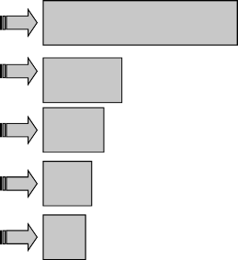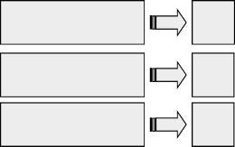

**Baseline Systems Infrastructure Acquisitions**

**5–8 yrs**

**3–5 yrs**

**1–3**

**Proactive Spirals — Opportunities Driven**

**.5–2**

**.5–1**

**Improvised Explosive Devices**

**Disruptive Technology**

**?**

**.01–1**

**.01–1**

**?**

**Reactive Spirals — Threat Driven**

**IT Software**

**IT Hardware**

**Communications**

**Sensors**

**C4 ISR**

**Infrastructure**

**Mechanical Systems/Weapon**

**Materials/Platforms**

**Primary Structural**

**10–15 yrs**

**15–30 yrs**

**Components**

**Systems**

* 1. Please answer and/or discuss the following questions:

**Component Level Solutions**

* + 1. Does your organization have a software reuse process?
    2. Does your organization have a formal software library?
    3. How do you handle similar yet new development?
    4. How do you cost the integration of existing code?
    5. Do you have any experience in the integration of existing code?

## PROBLEMS

* 1. A small software company that develops math libraries sees an opportu- nity to sell the library components for reuse in other commercial prod- ucts, such as e-commerce web sites, banking systems, etc. They identify three products to target for a pilot effort: (1) a compound interest calcula- tor, (2) a mortgage payment reduction calculator, and (3) an exponential calculation function for cryptographic use. If the pilot is successful, they plan to launch a larger software reuse effort.

Market projections show that these three products could have sales of 10 per month. Assume that the price of the products will be the same.

Initial development of the software will require two developers/program- mers for a period of 4 months for each reuse component. The developers/pro- grammers work 40 hours per week and earn $100 per hour with benefits.

Training the developers/programmers in reuse practices will require 1 week of training per person at a cost of $2000 plus salary. (This 1 week is considered to be part of the 4 months of development time.)

Establishment of a reuse database to catalog the reuse components will require start-up costs for a server ($900) and database software ($800). A database administrator will establish and manage this system. Because the database is initially small, the administrator will spend 80 hours over the 4-month period to establish the database and then 2 hours per week in maintenance. The database administrator earns $90 per hour. The data- base administrator will require 1 week of training at a cost of $3000.

Given that the products will not be ready for market until 4 months after project initiation, how much must the company charge for the prod- ucts to achieve an ROI for the start-up and maintenance costs for this effort within 12 months? Is this a reasonable cost for this product? What can the company do to achieve a faster ROI? Use a cash flow diagram to represent the data.

* 1. A company needs to implement a web server. The first alternative is the Windows IIS and the second is a Linux server with Apache. The com- pany has always used Microsoft products, so the system administrators are trained on these products exclusively.

Microsoft implementation

* + - Product cost: Windows Web Server 2008, $469.00 annual license (Internet-facing web server only)
    - Training: $4795 for intense 7-day course
    - Cost of personnel time: $100 per hour
    - Support: MS Software Assurance, updates and support, 25% of license cost annually

Red Hat Linux/Apache implementation

* + - License costs: Red Hat Enterprise Linux, standard subscription, $799 annual license
    - Training: Red Hat Linux systems administration, 4 days, $2498; Apache and secure web server administration, 4 days, $2398
    - Cost of personnel time: $100 per hour
    - Support: Updates and 12x5 and web support included

Initially, three administrators are trained for each system. Turnover will result in one additional administrator being trained each year. A course day is 8 hours.

Assume all costs will not be affected by inflation; compare the two alternatives over 3 years of each implementation. Would your answer change if the company web server was a critical asset for the company to conduct its business? Why or why not?

## REFERENCES

Boehm, B., and C. Abts. 1996. “COTS Integration: Plug and Pray?” *Computer*, January: 135–138.

Castro, Lymari. 2008, October. “The Risks and Costs of COTS-Based Software Development.” EM 620 Project.

Clark, Betsy, and Clark, Brad. 2007. “Added Sources of Costs in Maintaining COTS-Intensive Systems.” *CrossTalk, The Journal of Defense Software Engineering*. June.

Coar, Ken. 2006, July 7. “Open Source Initiative.” Accessed May 20, 2008, http://www.open- source.org/docs/osd

Defense System Board. 2009. “Buying Commercial: Gaining the Cost/Schedule Benefits for Defense Systems.” Task Force on Integrating Commercial Systems into the DoD, Effectively and Efficiently.

Department of Defense (DoD). 2000, June 26. “Commercial Item Acquisition: Considerations and Lessons Learned.”

Enterprise Linux. 2009. Accessed December 7, 2009, [http://searchenterpriselinux.techtarget.](http://searchenterpriselinux.techtarget/) com/sDefinition/0,,sid39_gci789218,00.html

Federal Aviation Administration. 2000, October 2. Lessons Learned in Developing Commercial off-the-Shelf (COTS) Intensive Software Systems, Software Engineering Resource Center.

Lieberman, BenjaminA. 2006. “COTS Product Integration:AnArchitecturalApproach.”Accessed April 20, 2008, <http://www.ibm.com/developerworks/library/ar-cotsint/index.html>

Lombardo, Anthony. 2008. “Evaluating COTS Software.” SDOE 620 Project, Stevens Institute of Technology.

Power, M., K. Desouza, and C. Bonifazi. 2006. *The Outsourcing Handbook: How to Implement a Successful Outsourcing Process*. Philadelphia, PA: Kogan Page.

Rine, David C., and Nader Nada. 2008. “Software Reuse Manufacturing Reference Model: Development and Validation.” George Mason University. Accessed May 20, 2008, <http://www.gmu.edu/depts/survey/rrmpaper1.html>

Software Engineering Institute. 2007, January 11. “COTS and Open Systems—An Overview.” Accessed April 25, 2008, <http://www.sei.cmu.edu/str/descriptions/cots.html#ndi>

Schmidt, Douglas C. 2006, September 28. “Why Software Reuse Has Failed and How to Make It Work for You.” Accessed April 25, 2008, <http://www.cs.wustl.edu/~schmidt/> reuse-lessons.html

Schulz, Armin P., Don P. Clausing, Ernst Fricke, and Herbert Negele. 2000. “Development and Integration of Winning Technologies as Key to Competitive Advantage.” *Systems Engineering* 3 (4): 180–211.

University of Southern California. 2008. COCOTS model description. Accessed June 2, 2008, <http://sunset.usc.edu/research/COCOTS/index.html>

Verma, Dinesh. 2002. “Crusader Program: Technology Refreshment and Obsolescence Avoidance Strategy.” Research Proposal Presented to UDLP.

Wikipedia. 2008a. Accessed January 24, 2008, <http://en.wikipedia.org/wiki/Government_off-> the-shelf

Wikipedia. 2008b. Accessed January 24, 2008, <http://en.wikipedia.org/wiki/Open_source> Wikipedia. 2009. Accessed December 8, 2009, <http://en.wikipedia.org/wiki/Spiral_model>

## BIBLIOGRAPHY

Carney, David J. 1999. *Quotations from Chairman David (A Little Red Book of Truths to Enlighten and Guide on the Long March toward the COTS Revolution)*. Prepared for SEI Joint Program Office, Software Engineering Institute. Fort Belvoir, VA: DTIC.

Seeley, Rich. 2008. Accessed May 20, 2008, <http://searchsoa.techtarget.com/news/> article/0,289142,sid26_gci1312507,00.html

# 11 Cost of Quality

## INTRODUCTION

The fields of quality management and reliability widely recognize that the later a defect or failure is found in the system development or manufacturing process, the more costly it is to resolve and the more catastrophic the defect or failure can be to either the customer or the system objectives. Most approaches to process and qual- ity improvement have roots in the post-World War II work by pioneers in the field of quality control, such as Deming, Juran, Taguchi, and Shewhart. The following is a partial list of informal and formal process improvement methodologies that have gained popularity over time:

* + - Benchmarking
    - Business Process Improvement
    - Business Process Reengineering
    - Capability Maturity Model® Integration (CMMI)/Capability Maturity Model
    - Goal–question–metric
    - Hoshin Kanri
    - ISO 9000
    - Just In Time manufacturing
    - Lean manufacturing
    - Performance improvement
    - Process management
    - Process improvement and management
    - Six Sigma
    - Theory of Constraints
    - Total Quality Management
    - Trillium Model
    - Twelve leverage points

Today’s highly competitive business environment, in both the commercial and defense industries, requires companies to strive to provide goods and services bet- ter, cheaper, and faster than their competitors. To that end, most large to mid-size companies have process improvement initiatives as a core component to doing business. The two most well known of these process improvement methodologies are Six Sigma and CMMI. Motorola developed the former in the mid-1980s and the Software Engineering Institute developed the latter. This chapter provides an over- view of the cost of quality (CoQ) and its significance to these methodologies. For most small to mid-sized companies, embarking on any process improvement effort involves a steep initial cost. It is therefore imperative to understand and account for the CoQ as it relates to these efforts.

**231**

*Realized Total Cost of Quality = Prevention and Inspection Costs + Internal and External Failure Costs*



Cost

Low

Quality

*Prevention and Inspection Costs*

*Internal and External Failure Costs*

High

**FIGURE 11.1** The elements of the total cost of quality. (Modified from American Institute of Architects. 2008. Accessed August 29, 2008, <http://www.aia.org/> nwsltr_pm.cfm?pagename=pm_a_20050722_quality)

In the construction industry, quality is often discussed in terms of the “1-10-100 rule.”* This widely used rule of thumb suggests that a quality problem costing $100 to resolve in the field would have cost only $10 to correct if discovered during in- house design review and only $1 to prevent in the first place. Most contractors will tell you “the rule is about right.”

Many books have been written on costing quality. Philosophies such as Lean and Six Sigma dominate the quality industry. Figure 11.1 generalizes the issues associ- ated with the realized cost of quality. The challenge is not so much trading off pre- vention versus failures but “how much quality” is enough for your product. Banking and space systems are examples of where you cannot have enough quality. However, say you are developing a product for which cost compared to its competitor is the key market driver. How much quality is needed? How many sales are lost because of quality versus gained because of the low price?

As shown in Figure 11.1, four elements must be considered when developing the total cost of quality:

* 1. Prevention costs: The costs of all activities specifically designed to prevent service deficiencies or defects in project deliverables. Examples include quality system design and implementation, quality planning at the project level, quality training and education, consultant evaluation, and quality sys- tem audits.
  2. Inspection costs: The costs required to measure, evaluate, or audit services or project deliverables to identify deficiencies and determine whether client requirements are being met. Examples of inspection costs include design

* This rule was apparently first published in *Total Quality Project Management for the Design Firm* by David Burstein and Frank Stasioski, 1994, p. 265, John Wiley & Sons, but the term and the concept existed for many years prior to its publication*.*

reviews, drawing checks, calculation checks, specification reviews, and peer reviews.

* 1. Internal failure costs: The costs required to evaluate and correct identified deficiencies in services or project deliverables before completion. These costs primarily include redesign and other rework of project deliverables to correct deficiencies before the documents are released to the client or the field.
  2. External failure costs: The costs of evaluating and correcting deficiencies in services or project deliverables after the documents are released to the client or the field. Examples of external failure costs certainly include rede- sign activities and other rework of project deliverables to correct deficien- cies. However, external failure also involves costs associated with client dissatisfaction, client defection, liability claims, legal expenses, and so on.
     1. **DEFINITION OF THE COST OF QUALITY (COQ)\***

The CoQ has two main components:

* + - 1. The cost of poor quality (CoPQ): Internal and external costs resulting from failing to meet requirements. Internal costs relate to defects found prior to delivery to external customers. External costs relate to defects found after delivery to customers.
      2. The cost of good quality (CoGQ): Costs for investing in the prevention of defects and ensuring conformance to requirements and the costs for apprais- ing a product or service for defects or conformance to requirements.

Table 11.1 provides examples for both categories. Example 11.1 demonstrates how the CoQ can affect costs.

The CoQ can permeate all aspects of a life cycle. Many of the costs are obvi- ous and not systemic, such as rejects, rework, warranty, returns, recalls, and waste. However, the not-so-obvious costs related mainly to schedule overruns and errors are significant.

The cost of quality is twofold: costs derived from the savings in eliminating the CoPQ and costs expended from the CoGQ. The total quality costs are the sum of these costs. Because many of these costs are hidden, it can be difficult to get an accu- rate measure of the cause-and-effect impact to the bottom line. It is difficult to relate future savings to a measure taken early on in the development life cycle of a product, system, or service. Effort must be expended in accurately assessing, modeling, and collecting long-term data to determine true effectiveness.

In simple terms, the more dollars spent on appraisal and preventive costs, the less costs incurred from defects, or the cost of poor quality. CoGQ can be considered quality controlling costs and COPQ considered quality failure costs. A traditional model of a cost–quality curve is shown in Figure 11.1 (bathtub-shaped curve). With

* The iSixSigma website at [www.isixsigma.com](http://www.isixsigma.com/) is a good open source reference for articles on CoQ and Six Sigma.

#### TABLE 11.1

**CoPQ and CoGQ Costs**

**CoPQ CoGQ**

Internal Failure Costs

External Failure Costs

Appraisal Costs Preventive Costs

Rework Poor market image

Quality planning Inspection

Schedule delays

Customer calls Supplier/COTS

evaluations

Field testing

Redesign Liability Training Process

improvement

Waste Warranty Metrics Audits

Failure analysis Reduction in

sales

Design for reliability

System implementation

Regression testing

Environmental costs

Reviews/meeting Automate testing

Downtime Penalty fees Planning Modeling and simulation

**EXAMPLE 11.1**

A printed circuit board (PCB) company spent $5 million to improve the quality of their manufacturing equipment and processes. This produced a decrease in average rework costs and reserves that were set aside for warranty work from $5 to $2 per PCB. Last year the company sold 75,000 PCBs. Assuming they can amortize the $5 million over 3 years (ignore depreciation) and sales will remain constant, was this investment warranted? Assume an MARR (minimum accept- able rate of return) of 15%.

or PMT(.15,3,5000000) = $2,232,855.11

The cost of quality is ($5 – $2) * $75,000 * 3 = $675,000. Thus, from a purely economic perspective, this is a bad investment. However, the company must also consider other factors (lost customers, reputation, etc.) when making such decisions.

highly defective products, prevention and appraisal costs are low, but failure costs are high. As zero defects are approached, failure costs are low, but prevention and appraisal costs are high. For optimum quality costs, the objective is to be between these extremes, at the bottom of the curve. This is commonly known in economics as the law of diminishing returns—that there is some optimum economic quality

level that, if exceeded, would bring minimal benefit. However, some industry experts believe that spending on prevention can always be justified and that the optimum quality level actually exists at the zero defect level (Schiffauerova and Thomson, 2006). Some of these opposing concepts and methodologies will be reviewed in the following section. Primarily, the concept represented by the bathtub curve is the tra- ditional prevention–appraisal–failure approach developed by Armand Feigenbaum in 1943, also known as the P-A-F classification.

## SIX SIGMA

Although Six Sigma describes quantitatively how a process is performing, it is primar- ily utilized in manufacturing rather than system or software development. To achieve Six Sigma, a process must not produce more than 3.4 defects per million opportunities (DPMO). A Six Sigma defect is defined as anything outside of customer specifications. A Six Sigma opportunity is then the total quantity of chances for a defect to occur.

The fundamental objective of the Six Sigma methodology is the implementation of a measurement-based strategy. This strategy focuses on process improvement and variation reduction through the application of Six Sigma improvement projects. Six Sigma sub-methodologies include DMAIC (define, measure, analyze, improve, and control) and DMADV (define, measure, analyze, design, and verify). The DMAIC process identifies existing processes that are falling below specifications and imple- ments incremental improvement. The DMADV process is used for new processes or products that can start at Six Sigma levels.

Figure 11.2 represents the Six Sigma approach to the CoQ concept. Quality is believed to be built into the process, services, and products. Six Sigma, through better

**Traditional Management View**

Defect Level

0%

Prevention

**The Six Sigma Philosophy** and Appraisal

Costs

2σ

3σ

4σ

Failure Costs

Failure Costs

Prevention and Appraisal Costs

Costs

Defect Level 0%

Costs

**FIGURE 11.2** Six Sigma cost-to-defect-level curve. (Modified from Buthmann, Arne. 2007, May 2. “Cost of Quality: Not Only Failure Costs.” iSixSigma.com. Accessed September 19, 2008, <http://europe.isixsigma.com/library/content/c070502a.asp)>

business processes, can obtain lower prevention and appraisal costs. As the sigma level increases, the costs of quality become proportionally smaller. Furthermore, according to Six Sigma, the cost of quality as a percentage of sales will decrease as the process improves.

## CMMI

Capability Maturity Model Integration (CMMI) was developed by the Software Engineering Institute at Carnegie Mellon University and provides organizations with a framework for effective processes management and process improvement. Although mainly used in the realm of software-centric systems, the methodology is generic enough for use in other industries as a guide to process improvement across a project, a division, or an entire organization. CMMI, as a framework, supports the integra- tion of traditionally separate organizational functions by setting process improvement goals and priorities, provides guidance for quality processes, and provides a point of reference for appraising current processes through the baselining of current process performance. CMMI utilizes mechanisms such as Statistical Process Control (SPC) to baseline process performance and implement improvements in a quantifiable manner. CMMI best practices enable organizations to do the following (Mishler and

Sisti, 1984):

* + - More explicitly link management and engineering activities to their busi- ness objectives
    - Expand the scope of and visibility into the product life cycle and engineering activities to ensure that the product or service meets customer expectations
    - Incorporate lessons learned from additional areas of best practice (e.g., measurement, risk management, and supplier management)
    - Implement more robust high-maturity practices
    - Address additional organizational functions critical to their products and services
    - More fully comply with relevant International Organization for Standardization (ISO) standards

## GENERIC COST OF QUALITY MODELS

The cost of quality is now widely considered to mean the costs incurred in the design, implementation, operation, and maintenance of a quality management system; the costs of resources needed for continuous improvement; the costs of system, product, or service failures; and all other non-value-added items that are necessary to achieve quality.

Although the P-A-F model is fairly ubiquitous, other models have also gained support. The models can be categorized into four groups: P-A-F or Crosby’s Model, opportunity cost models, process cost models, and the ABC (activity-based costing) model. P-A-F represents the traditional tradeoff model between failure costs and prevention and appraisal costs. Although similar to P-A-F, Crosby’s Model defines quality as conformance to customer requirements. Quality is the sum of the price of

conformance and the price of nonconformance. It follows along the lines of the Six Sigma philosophy in doing things right the first time (the price of conformance) and the waste of doing things wrong (the price of nonconformance).

The opportunity cost model attempts to address the more intangible costs of, for instance, profits not earned due to lost customers. These intangible costs can only be estimated. Under this model, opportunity losses can be broken down into three components: poor service, underutilized capacity, and inadequate material handling. This model expresses the total CoQ as the revenue and profit lost.

The process cost model represents quality systems that focus on process as opposed to products and services. It represents the process cost as the total cost of conformance and nonconformance for a particular process. Costs can be measured at any individual step of the process. The model also allows for a determination of when high nonconformance costs demonstrate the need for increased expenditures on prevention tasks. It also allows for complexity. Although others have made sim- plifications, this particular model is not widely used.

The ABC methodology assigns an organization’s resource costs through activi- ties to the products and services provided to its customers. It is generally used as a tool for understanding product and customer cost and profitability. The ABC model traces resource costs to their related activities, assigning indirect or overhead costs to specific activities to determine value-added and non-value-added items. It identifies activities in an organization and assigns the cost of each activity resource to all prod- ucts and services according to the actual consumption by each; it transforms indirect costs (overhead) into direct costs. This contrasts with traditional accounting systems, which do not lend themselves to analyzing activity-based quality measures and thus categorize costs in terms of cost accounts and related categories of expenses.

**11.4.1 COST OF QUALITY FROM A SOFTWARE PERSPECTIVE**

From the perspective of the cost of software quality (CoSQ), the general industry consensus is that the software sector is not as mature as other industries in estab- lishing software quality cost models. This is due to several factors. The software industry and the technology it utilizes is constantly changing, making the collection, assessment, and analysis of historical databases difficult. This is especially true for the defense industry, where software-centric systems have a much longer life cycle than those in the commercial world. There are also no tangible, physical components to measure and analyze. This makes realizing and justifying a cost benefit for CoSQ difficult to verify. All sources acknowledge the difficulties of collecting activity- based labor costs from an existing accounting system versus implementing a less accurate quality system to collect data.

Several articles that addressed the issues of modeling for CoSQ are worth read- ing. In particular, two authors recognized the lack of maturity in modeling software quality costs. All three recommended utilizing a modified P-A-F model for the cost of poor quality and the cost of good quality. The differences in these individual assessments primarily lie in the level of detail specified.

Mandeville (1990), in his assessment of the software cost of quality, maps spe- cific software measures and activities to preventive costs, appraisal costs, and failure

costs. Quality costs for software are defined as the conformance to specifications/ requirements and the cost of noncompliance. Mandeville supplies a list of preven- tion costs for software. This list consists of the cost of training, tools, methods, stan- dards/policies/procedures, consulting, quality planning, prevention meetings, fast prototyping, quality data gathering and analysis, and root cause analysis. All of the prevention activities allow a software organization to be in a position of doing things right from the start, a battle cry from both the CMMI and Six Sigma communities. It also provides a basis for historical collection and analysis for baselining perfor- mance over time and from one effort to the next. These are all process improvement activities that lend themselves well to the area of software development—they indi- cate how well the CoGQ activities performed. Did the project receive a 100% award fee? Did the project provide lessons learned for the next job?

Mandeville also outlines the appraisal-related costs, represented in the following activities: review of requirement specifications; review of design specifications; review of component and model specifications; the review, walk-through, or inspection of code; the testing process and independent verification and validation; and product audits. Of course, the cost of noncompliance is a failure cost. Although software does not contain physical moving parts that wear out and fail, it certainly does contain inherent defects. Mandeville identifies a partial list of failure costs: to fix an error, to fix or re-review documentation, to regression test, to reinspect a module of code and officially release to production, lab and computing resources, and to expedite fixes. He asserts that it is imperative to show management the cost of defects and defect resolution by perform- ing an ROI. He acknowledges the relationship to process improvement and the need for root cause analysis to determine which types of defects are the most costly (later in the life cycle rather than where the defect was inserted) and thus need to be resolved first rather than just at the frequency at which the defect occurs. Although the concept is discussed, the difficulty of assessing the ROI is not completely addressed.

Demirors et al. (2000) assert that process improvement in the area of software typically leaves out the cost of quality in the calculations. These authors describe a case study on the utilization of CoSQ as a motivating factor for software improve- ment in a public software development organization. They discuss the CoSQ for two projects. The primary intention of this effort is to create, calculate, and use CoSQ as a catalyst for software process improvement. The authors conclude that the quality of the software product could potentially vary significantly despite the process utilized. They recommend that organizations carefully select their pilot projects for process improvement initiatives. They also recommend that the current models be extended in terms of the cost breakdown of the components of cost cat- egories (prevention, appraisal, internal and external failures) and that field should validate these models’ experiments. These are not necessarily. Their conclusion touches on the difficulty of determining if cost benefits are realized at some future point in time for a project or for an organization.

## CONCLUSIONS

Determining the benefit or effectiveness of activities that drive the cost of quality in the long term is problematic. Especially in the defense industry, project time frames

are extremely long term and may or may not include development spirals (i.e., future development work). In this environment, how can you verify and validate the cost benefit? Process improvement initiatives require historical data and the capability to determine if this particular baseline is applicable to other efforts. Research for this chapter did not uncover any assessments that clearly demonstrated the industry has found the answer.

## QUESTIONS

* 1. The return on quality can be defined as the profit increase divided by the cost of the quality improvement program. From an LCC perspective, is the metric appropriate?
  2. Engineers have tried to quantify CoQ in order to determine ROI. One of the key elements of CoQ is poor market image (see Table 11.1). Can you think of examples in the automotive industry where consumers are will- ing to pay more for what are perceived as higher quality cars? Can you offer counterexamples in either the automotive or another industry where consumer practices are solely cost driven?

## PROBLEMS

* 1. Your company modifies high-end computers for use as servers for robotic manufacturing devices. You occasionally have problems with hardware failures that are in excess of what you feel is normal. Ignoring the cost of lost business because of these failures, you determine that the following costs are applicable:

|  |  |
| --- | --- |
| Rework costs | $500/server |
| Appraisal costs | $5000 |
| Supplier product  testing | $4000 |
| Product quality  audits | $1000 |
| Process maturity  evaluation | $2000 |
| Causal analysis  and reporting | $2000 |
| Design corrective  action | $10,000 |
| Cost to implement | $50/server |

What is the break-even point in terms of sales if you need to invest in identifying the cause of these failures?

* 1. Your company has two manufacturing sites that produce electronic com- ponents. One has a scrap rate of 12% of the 10,000 manufactured per year. The other plant has a scrap rate of 5% of the 7500 manufactured per year.

A product quality audit reveals that the semiautomated pick-and-place machine (vs. the fully automated machine) is contributing to these scrap rate differentials. It costs $20 for each scrapped component. Ignoring depreciation and assuming that the machine has a life of 5 years, what is the maximum amount you should invest in an upgrade to the semiauto- matic machine? Assume production levels will remain constant.

* 1. Your HVAC system initially had many reliability and maintainability issues. Last year you invested $3 million in redesign and subsequently saw a sales increase of 100,000 units that you believe were based solely on quality improvements. If the new HVAC unit sells for $1100 and you expect this unit to be in your sales portfolio for 2 more years, was it worth the investment? Use an MARR of 15% and assume you have a 50% profit in each system.

## REFERENCES

American Institute of Architects. 2008. Accessed August 29, 2008, <http://www.aia.org/> nwsltr_pm.cfm?pagename=pm_a_20050722_quality

Buthmann, Arne. 2007, May 2. “Cost of Quality: Not Only Failure Costs.” iSixSigma.com. Accessed September 19, 2008, <http://europe.isixsigma.com/library/content/c070502a.asp> Demirors, O., O. Yildiz, and A. Selcuk Guceglioglu. 2000. “Using Cost of Software Quality for a Process Improvement Initiative.” Proceedings of the 26th Euromicro Conference. 2: 286–

291. <http://ieeexplore.ieee.org/stamp/stamp.jsp?arnumber=874440&isnumber=18916> Mandeville, W. A. 1990. “Software Costs of Quality.” *IEEE Journal on Selected Areas in*

*Communications* 8 (2): 315–318. <http://ieeexplore.ieee.org/stamp/stamp.jsp?arnumber>

=46887&isnumber=1775

Mishler, J., and F. Sisti. 1984. “Defining Acquisition Measures: The Integrated Software Acquisition Measurement Project (ISAM).” Software Engineering Institute, Carnegie Mellon University, Pittsburgh, PA.

Schiffauerova, A., and V. Thomson. 2006. “A Review of Research on Cost of Quality Models and Best Practices.” *International Journal of Quality and Reliability Management* 23 (4).

## BIBLIOGRAPHY

Capell, P. 2004. “Benefits of Improvement Efforts.” Special report, CMU/SEI-2004-SR-

010. <http://www.sei.cmu.edu/pub/documents/04.reports/pdf/04sr010.pdf> Crosby, Philip B. 1980. “Quality Is Free.” New York: New American Library.

Karg, L. M., and A. Beckhaus. 2007. “Modeling Software Quality Costs by Adapting Established Methodologies of Mature Industries.” 2007 IEEE International Conference on Industrial Engineering and Engineering Management, 267–271, December 2–4. <http://ieeexplore.ieee.org/stamp/stamp.jsp?arnumber=4419193&isnumber=4419131>

Reitzig, R., D. Goldenson, D. Gibson, and D. Cavanaugh. 2007, March. “Calculating CMMI- Based ROI: Why, When, What, How?” 19th Annual SEPG Conference.

Schiffauerova, A., and V. Thomson. 2006. “Managing Cost of Quality: Insight into Industry Practice.” *The TQM Magazine* 18 (5): 542–550.

Wang, Pei-xin, and Chun-hua Chen. 2007. “Improvement and Application of Quality Profit Analysis Model.” School of Management, Harbin Institute of Technology, IEEE.

Williams, A., A. Van der Wiele, and B. G. Dale. 1999. “Quality Costing: A Management Review.” *International Journal of Management Reviews* 1 (4): 441–460.

# Project Management’s Role in Life Cycle Costing

12

## INTRODUCTION

Formal project/program management (PM) is essential for planning, controlling, and communications that, when properly executed, support time and cost estimates. As shown in Figure 12.1, PM techniques are needed throughout the life cycle to develop detailed estimates and then properly track the project. Figure 12.2 demonstrates how requirements map to WBS (work breakdown structure) elements, which ultimately feed a master schedule. This WBS can be used at any point in the life cycle to cap- ture how, what, and when the activities in a project from which costs are developed should be accomplished.

Much of the literature concerning scheduling and project management concepts focuses on the mechanics of PM (networks, critical path method [CPM], etc.) and not on how to translate requirements to elements of a WBS and estimate activity duration. Project scheduling, controlling, and management concepts have more of an impact if they are implemented early in the planning and design stages of a project, which is when one has the most control over the project’s cost and duration (see Figure 1.2). For example, the ultimate decision to even have a project hap- pens in the beginning. As planning proceeds, decisions are made that determine the characteristics of the project, such as size of the facility, the technology to be used in the facility, and the quality of the facility. As the project moves to design, further decisions nail down cost and schedule. The developer is left to influence only the cost and scheduling aspects of the project. Managing labor and equipment productivity, smart buying, and the use of good project management practices can accomplish this. Effective project management concepts must be applied early in project planning and continue throughout its life cycle.

## BASICS OF NETWORKS

Simply put, time is money, and the duration of a project has a direct bearing on its cost. Because the estimated duration of any project is determined by a schedule and the activities coordinated by that schedule, project planning is an important element of any engineering/technology project.

Much of the current thinking equates scheduling to a network. Although this is not necessarily true, let us examine the concept. A *network* is a diagram of activities joined in interconnected links that reflect relationships between complex interrelated tasks. It is used to determine the overall duration of a project, to learn about the project, to perform “what if” analyses, and to analyze and settle issues. Some people

**241**



**Inputs**

1. WBS
2. Resource requirements
3. Resource rates
4. Activity duration estimates
5. Estimating publications
6. Historical information
7. Risks
8. Architectures
9. Requirements



**Tools and Techniques**

1. Analogous estimating
2. Parametric modeling
3. Bottom-up estimating
4. Simulation Based Costing
5. Other cost estimating methods
6. LCC Estimate
7. Integrated product teams



**Outputs**

1. Cost estimates
2. Supporting detail
3. Cost management plan
4. Integrated master plan

**FIGURE 12.1** Role of PM in cost estimating. (Modified from Defense Acquisition University. 2003. “U.S. Department of Defense Extension to: A Guide to the Project Management Body of Knowledge.” PMBOK® Guide. 1st ed. Version 1.0.)

**Requirement**

**WBS Elements**

**SOW Task**

.

11 *n*

1110 .Wing

1000 Air Vehicle

1100 Airframe

Wing

1100 Airframe

1000 Air Vehicle

System Specification

3.1 Air Vehicle (WBS 1000) design, develop, produce and verify, complete air vehicles, defined as airframe propulsion, avionics and other installed equipment.

**Integrated Master Plan**

|  |  |  |  |  |  |  |  |  |  |  |  |
| --- | --- | --- | --- | --- | --- | --- | --- | --- | --- | --- | --- |
| Management Plan | Events | | | | | | Accomplishment Criteria | | | | |
| 1. Preliminary Design 2. Review | PDR |  |  | |  |  | 1. a. Duty Cycle Defined  b. Preliminary Analysis Complete | | | | |
|  |  |  | |  |  |
| **Integrated Master Schedule** | | | | | | | | | |  | |
|  | | | | 19XX | | | | 19XY | 19XZ | |  |
| Program Events | | | |  | | | | PDR | CDR | |
| Detailed Tasks   1. Preliminary Design Complete 2. Duty Cycle Defined | | | |  | | | |  |  | |

**FIGURE 12.2** Role of WBS in developing an integrated master schedule. (From Defense Acquisition University. 2001. “Scheduling Guide for Program Managers.” Fort Belvoir, VA: Defense Systems Management College Press.)

claim that a network can integrate cost and schedule but, as desirable as this is to cost and schedule management, it rarely occurs in practice—even with the advent of tools such as Microsoft® Project.*

Basically, there are two types of networks. The first is the “activity-on-arrow” net- work. In this type, the arrows represent activities and the nodes represent events. This is predominantly taught in most management science and project management courses. The second is the “activity-on-node” or precedence network. In this type of network, the nodes represent activities and the arrows represent only interrelationships. Modern project planning software uses activity-on-node networks. Both network types have

* Microsoft® Project is a registered trademark of Microsoft Corporation.

been used in CPM and in PERT (program evaluation and review technique). However, most software is moving toward supporting only the precedence-type networks.

CPM and PERT were developed independently in the late 1950s. CPM was devel- oped by Morgan Walker of E.I. Dupont and James E. Kelly, then with Remington Rand Univac Corporation. The goal of the research that ultimately led to CPM was to reduce time for the construction and maintenance of manufacturing plants. CPM is a deterministic method that assumes that at least one path through the network (the “critical path”) determines the project duration. PERT was developed by a research team consisting of the U.S. Navy Special Projects Office and the consulting firm of Booz, Allen, and Hamilton for planning and control of the production of the Polaris submarine in the late 1950s. PERT is a stochastic technique that assumes one path determines the duration of the project. It is based on the assumption that the duration of a single activity can be described by a probability density function. The duration of the project is computed by the sum of the “expected” durations of each activity on the critical path. Then, because of a specific statistical theorem (the central limit theorem), the duration of the project can be shown to follow a bell-shaped (normal) distribution, uniquely defined by the parameters computed from the individual activ- ity parameters (Stevens, 1990).

One other networking technique coming into favor with the advent of faster and more powerful microcomputers is simulation networks. By assuming specific distri- butions for individual activities, networks can be repeatedly computed using random influences, the outcomes plotted, and the overall duration distribution approximated. Most modern PM software contains this capability.

You must remember that a network is not a schedule. The network is used to develop scheduling data. Once the data are developed, you may produce a schedule in the form of a table or bar chart.

Networks are the cornerstones of any type of program or project planning. In the civil engineering profession, the PERT/CPM network is the primary tool for plan- ning (choosing which method or procedure should be used), scheduling (timing of the procedures), and controlling (monitoring the procedures). The terms PERT and CPM are used interchangeably and together because they have become common ter- minology for networks in engineering and management when referring to the whole networking technology. We shall use the term CPM unless stochastic time duration is introduced.

A project has been identified as a collection of activities, interrelated logically or sequentially, that have a finite scope. Projects related to civil engineering planning are typically nonrepetitive and not conducted at the same site. A CPM network con- sists of the logical relationships between the activities that make up a project. There are two types of CPM networks. The first is the arrow diagramming method (ADM), also called the activity-on-arrow method. The second is the precedence diagram- ming method (PDM). The PDM is increasing in popularity primarily due to some of the newer features of some of the CPM software packages. Primavera* and Microsoft Project use only PDM networks. However, most texts use ADM networks to teach the basics of networks.

* Primavera® is a registered trademark of Microsoft Corporation.
  + 1. **DEVELOPMENT OF THE ADM NETWORk**

The basic building block in a project network is the activity. In an ADM network, an arrow (as shown in Figure 12.3) represents that activity. The beginning and end- points of activities are called *events*. These events are typically referred to as nodes in the network and are represented by the circles shown in Figure 12.3.

All CPM networks follow this set of basic rules:

* + - 1. The network must have one starting node (without a predecessor) and one ending node (without a successor), representative of project initiation and completion, respectively.
      2. Before any activity can begin, all activities preceding that activity must be complete.
      3. Any two events can be connected by only one activity.

Often a *dummy* activity must be introduced to correct problems of false depen- dency and to satisfy the three basic CPM rules. Loops are prevented by dummy arrows (represented by a dashed line from activity 60 to 61 in the diagram in Example 12.1). Dummy activities are also a tool that permits logic restrictions. A dummy arrow shows dependence only. It implies no duration. The number of dummy arrows in a network should be minimized. Figure 12.3 demonstrates the use of dummy activities.

Each activity is uniquely identified by its *i*,*j* number. In an ADM, this determines the activity’s relationship within the network. All computer software packages use the *i*,*j* number as the activity identifier. It must be unique. Two activities with the same *i*,*j* number form a loop, causing an error in the network.

Generally speaking, the network is made up of several “paths” that consist of activities that must be performed sequentially. For instance, the path of “remove ceiling grids, existing cabling,” “install cable trays,” “fiber optic backbone and rout- ers,” “local area networks,” “connect and test,” “install new ceiling grids” follows logically in the diagram of Example 12.1.

In a PDM network, a node or event (Figure 12.4) represents the activity. Here are some PDM network development guidelines:

1. Unlike ADM, the PDM activity is identified by a node number. This num- ber has nothing to do with the logical dependencies of the network. It is merely an identifier.

Earliest Start of Activity

Earliest Finish of Activity

Activity Name i Activity Duration



j

Latest Start of Activity

Latest Finish of Activity

**FIGURE 12.3** Basic elements of an ADM network.

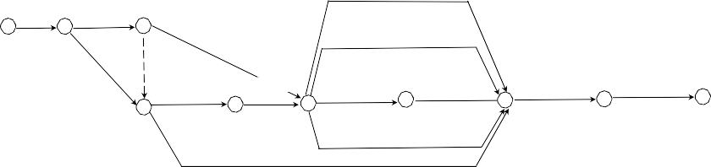

**EXAMPLE 12.1**

Here we see the relationships for an ADM network without durations for the installation of a telecommunications system. Note that this final network was developed after careful review of the drawings. Several drafts were prepared before the final drawing was complete. This diagram looks much different from when it was first drafted.

Obtain

Building

Install

Install, Test New File Servers

58 Permits 59 Networks 60

Temporary

Order Cable Trays, Work Space Outlets

61

Order Routers, Cabling, etc.

Remove Ceiling

Grids, Existing Install Cable Cabling 63 Trays

0.625 Coax for Cable TV Backbone

10 Based T Finer Optic Backbone Local Area

Connect and Test All Install New Ceiling

Telecommunication

70

and Routers 72

Networks

80

Systems

Grids and Panels

82

84

Install Work Space Outlets

New Telephone System and Panel

Early Start of Activity

Early Finish of Activity

Activity



Activity Number

Duration

Number Duration

Latest Start of Activity

**FIGURE 12.4** Basic elements of a PDM network.

Latest Finish of Activity

1. In working with various software packages, you must describe each activ- ity’s predecessor and its successor explicitly.
2. There are no dummy arrows in a PDM network.
   * 1. **CPM CALCULATIONS**

Although most complex networks are computed using computer software, you should have some understanding of how those calculations are made. This does not mean that an engineer should waste time calculating network data by hand, unless software is not available. The following steps are necessary to perform CPM calculations:

* + - 1. Estimate activity durations.
      2. Perform a forward pass.

Determine Quantities

Determine Number of Crews

Determine Production Rate

Initial Duration

Technology, Site Characteristics, Learning, etc.

Estimate Downtime

Modify Time

Activity Duration

**FIGURE 12.5** Activity duration estimation algorithm.

* + - 1. Perform a backward pass.
      2. Compute the total float.
      3. Compute the free float.

The most difficult aspect of scheduling is estimating an activity’s duration. It is similar and needed to estimate the cost of an activity. You must know the estima- tion methods to be used, the resources available, the quantities involved, and, most important, the production rate. Those subjects are discussed in great detail in Part III of Problem 12.13. From a practical point of view, most planners will use handbooks or PCEs. Figure 12.5 shows the general algorithm for developing the durations of activities.

The bar chart is probably the most often used project management tool. Numerous forms of the bar chart exist for conveying information. The bar (or Gantt) chart can be very effective for conveying a simple schedule. Figure 12.6 is a Gantt chart for a hazardous waste problem. This chart was produced using Microsoft Project.

## WORK BREAKDOWN STRUCTURE

Most projects are broken down into subelements. This must be done, at least implic- itly, on all but the smallest projects, to schedule the activities. The WBS is used to assign responsibilities, for management control on major complex projects, and to

|  |  |  |  |
| --- | --- | --- | --- |
| **ID** | **Task Name** | **3rd Quarter 1st Quarter**  Jul Sep Nov Jan Mar May | **3rd Quarter 1st Quarter 3rd Quarter**  Jul Sep Nov Jan Mar May Jul Sep Nov |
| 1 | Develop Info for Pub |  |  |
| 2 | Hold Public Hearings |  |  |
| 3 | Develop Draft P&S |  |  |
| 4 | Contract Stakeholders |  |  |
| 5 | Obtain Permits |  |  |
| 6 | Order Equip for Facility |  |  |
| 7 | Procure and Prep Land |  |  |
| 8 | Construct Facility |  |  |
| 9 | Approval of Ops Proced |  |  |
| 10 | Install & Staff |  |  |

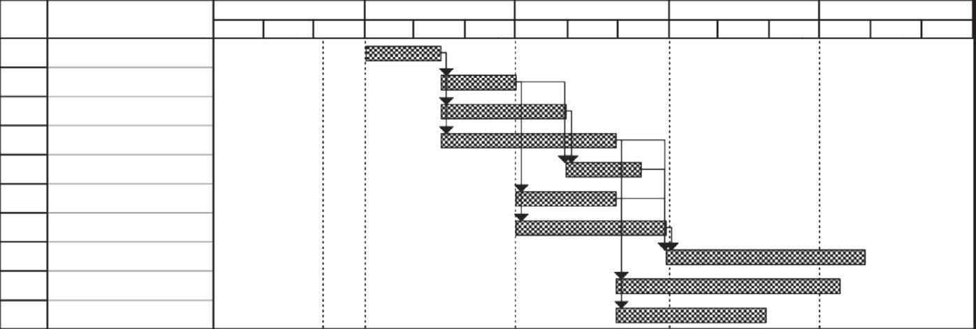**FIGURE 12.6** Gantt chart of a hazardous waste incineration facility.

develop activities for project scheduling. It is also used in the planning stage to iden- tify tasks and subtasks. For smaller projects, use the WBS for cost accounting and the assignment of responsibilities. Example 12.2 shows how a WBS can be related to an organizational, functional, and contract management perspective. There are no hard and fast rules as to the level of detail that goes into developing a WBS. Some PMs (who should be developing the WBS) prefer to see a physical representation, whereas others prefer a more holistic representation and develop the WBS in phases in accordance with some product development cycle, with a functional representa- tion for each phase.

**EXAMPLE 12.2**

Develop a generic WBS, relating system design to the WBS.

## PROGRESS MEASUREMENT

Numerous methods are available to measure work in progress of an activity. Some depend on judgment; some may be calculated analytically. We discuss seven methods used to assess performance or measure work. With this many available methods, you must be cognizant of the potential for abuse.

*Method 1: Units completed.* This assumes that the activity is basically linearly scheduled. If an activity consists of the installation of 800 linear feet of cable and 400 linear feet has been installed, then the progress is 400/800 = 0.5, or 50% complete.

*Method 2: Incremental milestones.* This method depends on heuristics based on experience. If the activity is one of those presented here, then the prog- ress may be estimated as:

*Method 3: Start/finish.* Some activities may have a duration shorter than the reporting period. In that case, it may go to 100% in the period and its prog- ress measured accordingly.

#### TABLE 12.1

**Weights and Quantities for a Small Steel Building**

|  |  |  |  |  |  |  |
| --- | --- | --- | --- | --- | --- | --- |
| **Wt.** | **Subtask** | **u/m** | **Quan/**  **Total** | **Equiv/stl**  **ton** | **Quantity/**  **to date** | **Earned/**  **Tons** |
| 0.02 | Fdn bolts | each | 200 | 10.4 | 200.0 | 10.4 |
| 0.02 | Shim | % | 100 | 10.4 | 100.0 | 10.4 |
| 0.05 | Shakeout | % | 100 | 26.0 | 100.0 | 26.0 |
| 0.06 | Columns | each | 84 | 31.2 | 74.0 | 27.5 |
| 0.10 | Beams | each | 859 | 52.0 | 0.0 | 0.0 |
| 0.11 | Cross-braces | each | 837 | 57.2 | 0.0 | 0.0 |
| 0.20 | Girts & sag rods | bay | 38 | 104.0 | 0.0 | 0.0 |
| 0.09 | Plumb & align | % | 100 | 46.8 | 5.0 | 2.3 |
| 0.30 | Connections | each | 2977 | 156.0 | 74.0 | 3.9 |
| 0.05 | Punchlist | % | 100 | 26.0 | 0.0 | 0.0 |
| 1.00 | STEEL |  | TON |  | 520.0 | 80.5 |

*Method 4: Supervisor opinion.* Painting, dewatering, constructing support facilities, installing architectural trim, and landscaping are candidates for this approach.

*Method 5: Cost ratio.* Project management, quality assurance, contract admin- istration, and project controls are candidates for this approach. This is not a good measurement for physical activities that require actual work.

Percent complete = Actual cost or work-hours to date (12.1) Forecast at completion

*Method 6: Weighted or equivalent units.* Material weights or some similar unit can be used to measure progress. This is illustrated by the data in Table 12.1.

*Method 7: Earned value.* Most agencies and contractors prefer the earned value method of progress measurement. This method uses man-hours or dollars as a way to weigh the value of one activity with respect to the others. It has nothing to do with the actual consumption of man-hours or dollars on a project. To perform an earned value analysis on a project, first you must find the percent complete of each activity. This may be done using methods 1 through 6. The percent complete is then multiplied by the budget in man-hours, man-days, or dollars for that activity. That gives the earned value for that activity and is often referred to as the budgeted cost of work performed (BCWP) for that activity. The earned value for the project is given by:

Percent Complete = Earned work-hours or dollars all accounts (12.2) Budgeted work-hours or dollars all accounts

* + 1. **EVALUATION OF CPM**

The following terms are gaining acceptance in earned value assessment progress assessment of networks:

* + - 1. Budgeted cost of work scheduled (BCWS)
      2. Budgeted cost of work performed (earned value amount) (BCWP)
      3. Actual cost of work performed (ACWP)

The terms are used to calculate various indicators of program performance: Schedule Variance (SV) = BCWS – BCWP (12.3)

Schedule Performance Index (SPI) = BCWP (12.4)

BCWS

Cost Variance (CV) = ACWP – BCWP (12.5)

Cost Performance Index (CPI) = BCWP (12.6)

ACWP

Figures 12.7 and 12.8 show numerical values of those indicators that can be inter- preted differently. Figure 12.7 shows that BCWS, BCWP, and ACWP can be used to reflect various degrees of completion over the life of a project. A time plot of these performance indicators can be useful to identify when projects are starting to fall behind schedule, having problems with cost overruns, and so forth. Example 12.3 demonstrates the basics of earned value assessment. Figure 12.8 shows how values of CPI and SPI can be related to schedule and budget. CPI and SPI can be calculated for a single activity, a group of activities, or a whole project or program. However, SPI may not be a good schedule performance indicator.

% Complete

Milestone B

Milestone A

BCWS

BCWP

ACWP

Time

**FIGURE 12.7** Performance measurement parameters.

(CPI = 1)



Behind Schedule under Budget

Behind Schedule over Budget

**FIGURE 12.8** Meanings of CPI and SPI.

**EXAMPLE 12.3**

As a subcontractor on a telecommunications revitalization project, the prime vendor has asked for a progress update. You have decided to calculate SV, SPI, CV, and CPI as performance indicators. Your cost accounting section and proj- ect manager have provided you with the following information:

*Note:* Asterisks indicate the critical path for this project.

Ahead of Schedule under Budget

(SPI = 1)

Ahead of Schedule over Budget

|  |  |  |  |  |  |
| --- | --- | --- | --- | --- | --- |
| **Activity Number** | **Description** | **Total Cost Forecast** | **Percent Complete** | **Cost to Date— Actual** | **Cost to Date— Forecast** |
| 58,59* | Building permits | $2000.00 | 100.00% | $1253.75 | $2000.00 |
| 59,60* | Temp networks | $25,000.00 | 100.00% | $26,497.83 | $25,000.00 |
| 59,61 | Order cable  trays | $8000.00 | 100.00% | $7907.27 | $8000.00 |
| 60,70 | Order routers,  cabling | $10,000.00 | 100.00% | $9017.32 | $10,000.00 |
| 61,63* | Remove  ceilings | $18,000.00 | 100.00% | $11,427.49 | $18,000.00 |
| 63,70* | Install cable  trays | $28,000.00 | 100.00% | $19,743.19 | $28,000.00 |
| 70,80* | New servers | $20,000.00 | 70.00% | $11,271.25 | $14,000.00 |
| 70,80 | Cable TV | $10,000.00 | 10.00% | $793.21 | $1000.00 |
| 70,72 | Backbone &  routers | $20,000.00 | 5.00% | $327.19 | $1000.00 |
| 72,80 | LANs | $17,500.00 | 0.00% | $ — | $ — |
| 80,82* | Connect & test | $15,000.00 | 0.00% | $ — | $ — |
| 82,84* | New ceilings | $20,000.00 | 0.00% | $ — | $ — |
|  | Total as of  2/28/08 | $193,500.00 |  | $88,238.50 | $107,000.00 |

**SOLUTION**

You need three pieces of information to obtain the desired performance indica- tors: BCWS, BCWP, and ACWP. BCWS is simply the total cost forecast; BCWP is the cost-to-date forecast; and ACWP is the actual costs to date. Thus,

SV = BCWS – BCWP = $193,00 - $107,000 = $86,500

SPI  BCWP  $107,000  0.55

BCWS $193,500

CV = ACWP – BCWP = $88,238.50 – $107,000 = –$18,761.50

*CPI*  *BCWP*  $107,000  1.2

*ACWP* $88,238.50

From Figure 12.8, we see that a CPI > 1 and SPI < 1 indicate that the job is behind schedule but under budget. Although this analysis does not provide an absolute answer as to what is wrong with the project, it provides an indication that management should look into the performance. This pattern probably means the contractor is using an insufficient level of effort to maintain the schedule

## SIMULATION OF NETWORKS

Stochastic simulation is a technique by which a computer is used to simulate the actions of a system. Systems can generally be depicted as mathematical or logical models about which specific assumptions are made. If the model is simple enough, it may be solved explicitly. However, most complex, real-world problems cannot be solved explicitly. Thus, we use simulation to evaluate the model numerically and then gather data to estimate the true characteristics of the model. A network must be treated as a system of activities.

Simulation allows much more flexibility than PERT. You can assign almost any uncertain attribute of a project as a random variable, then simulate the actions of nature, collect data from the model, and predict the characteristics of the system.

The theory behind simulation is simple. Each activity in the network is assumed to be an independent random variable that behaves according to some known distri- bution. In simulating a network, we assume that the duration of each activity follows a probability distribution rather than being a single point estimate. The simulation process will randomly select the duration to add for each activity, using random numbers selected from a uniform distribution. Many of the problems contained in Chapter 5 are simulations of networks.

## SUMMARY

Resources include labor, equipment, material, subcontractors, money, workspace, and anything else needed to execute a project. Resources determine the duration and

the cost of a project. They should be viewed as the independent variables of project management. The production rate of driving resources determines the duration of an activity. Similarly, the costs associated with driving resources are fixed regardless of the duration of an activity. If a specified amount of driving resources will complete an activity in a specific period, doubling that resource, from a purely theoretical point of view, should halve the duration, but the cost should remain the same.

Non-driving resources do not determine the duration of an activity. The cost of a non-driving resource may or may not vary with time. The purchase price of installed material should be the same regardless of the installation duration. However, the cost of a night watchman will increase as the duration of the activity requiring a night watchman increases.

Resource allocation and resource leveling are best accomplished using a com- puter. Any but the most trivial networks are difficult if not impossible to level by hand. You should note, however, that field supervisors are usually adept at estab- lishing crew sizes and managing crews efficiently regardless of any early network gyrations. Therefore, resource leveling is most useful in preliminary planning. Prior to implementation, an experienced project manager should evaluate any computer solution to resource allocation or leveling.

## QUESTION

12.1 Referring to Figure 6.2, we can see that project management and systems engineering are divided into two distinct categories. What management tasks are missing from the figure?

## PROBLEMS

* 1. A local municipality has issued a request for proposals to conduct a fea- sibility study to design, implement, and sustain a recycling program in a small town. As PM, you need to develop a bar chart to assign responsibil- ity and maintain a project schedule. You develop the following activities, precedence relationships, durations, and responsible individuals:

|  |  |  |  |  |
| --- | --- | --- | --- | --- |
| **Activity** | **Description** | **Immediate Predecessors** | **Duration (Weeks)** | **Responsible Organization** |
| A | Review RFP | None | 1 | Legal & PM |
| B | Analysis of community  waste stream | A | 2 | Environmental  department |
| C | Design of collection  routes | B | 2 | Engineering  department |
| D | Investigate regulations | A | 2 | Legal |
| E | Preliminary design of  WTF | C | 2 | Engineering  department |
| F | Integrate design | C, D, E | 2 | PM |
| G | Review by legal and ownership | F | 1 | All |

Develop a bar chart to help you manage this project.

* 1. Risk assessment is the primary justification for the extra effort needed to generate a PERT network. For example, given µ = 38 months and σ2 = 5 for the construction of a coal-fired power plant:
     1. When will the power plant come on-line with a 90% probability?
     2. The utility company would like to apply for a permit to operate the facility three years after award of the contract. What is the probability the plant will be on-line on time?
  2. Find the schedule and cost variances for a project that has an actual cost at month 16 of $540,000, a scheduled cost of $523,000, and an earned value of $535,000. What do the results tell you?
  3. A sales project at month 5 had an actual cost of $34,000, a planned cost of $42,000, and a value completed of $39,000. Calculate the CPI and SPI and explain the message they give the program manager.
  4. A construction project at day 70 has actual costs of $78,000 and a scheduled cost of $84,000. The work package manager estimates a value completed of $81,000. Calculate SV, CV, CPI, and SPI. What does this tell you?
  5. Given a project planned to cost $12,000 but actual cost to date is $10,000, and the project is only 70% complete, calculate the variances. Should the customer be happy?
  6. A project to build a new taxiway at Culpepper Airport is 5 days behind at day 65. It had a planned cost of $735,000 for this point in time, but the actual cost so far is only $550,000. Estimate the variances. What do they say about the health of the project? Reestimate with an actual cost to date of $750,000.
  7. You plan to manufacture a PCB in China using a contractor manufac- turer with a proven history of delivering products on time. Because of the cheap labor, you can manufacture the chips using through-hole technol- ogy much cheaper than using surface-mount technology and can also cut the delivery time from 90 to 60 calendar days. The software will be based on your current operating system. However, some major upgrades will be needed. Your primary software contractor in India will accomplish the changes. By focusing on the major upgrades, you can also reduce the delivery time for the software upgrades to 60 calendar days. Your own in-house staff will be responsible for integration and quality control. Because the software and the PBC are contract items, you must carefully monitor the integration phase.

After consulting with your team, you develop the following schedule based on a January 1 start date. Assume that all working days are calen- dar days:

|  |  |  |  |
| --- | --- | --- | --- |
|  | | **Immediate** | **Duration** |
| **Activity** | **Description** | **Predecessor** | **(calendar days)** |
| 1 | Software development | — | 60 |
| 2 | PCB design and manufacturing | — | 60 |

(*Continued*)

#### (Continued)

|  |  |  |  |
| --- | --- | --- | --- |
|  |  | **Immediate** | **Duration** |
| **Activity** | **Description** | **Predecessor** | **(calendar days)** |
| 3 | Develop performance and validation plan | — | 45 |
| 4 | Subsystem testing | 1,2,3 | 15 |
| 5 | System testing | 4 | 15 |
| 6 | Product documentation | 3 | 45 |
| 7 | Validate system performance | 6 | 15 |
| 8 | Conduct reliability testing | 5 | 30 |
| 9 | New product announcement | — | 0 |
| 10 | Marketing campaign | 9 | 135 |
| 11 | Delivery of voice system | 8,10 | 0 |

Using a Gantt chart, determine whether you can meet the July 1 deadline.

* 1. You have just decided to open your own land development consulting firm. To secure financing from the bank, you must present a plan for when you expect some type of income from your firm. You sit down with your banker and develop this plan of things that must be accomplished prior to starting your first job. Estimated duration and precedence relationships for these activities are included the table:

|  |  |  |  |  |  |
| --- | --- | --- | --- | --- | --- |
| **Activity** | **Description** | **Immediate Predecessor** | **Most Optimistic** | **Most Likely** | **Most Pessimistic** |
| A | Purchase land | — | 30 | 60 | 90 |
| B | Hire staff | A | 9 | 25 | 32 |
| C | Obtain permits | A | 2 | 10 | 18 |
| D | Obtain business license | A | 20 | 45 | 52 |
| E | Site preparation | C, D | 3 | 4 | 11 |
| F | Construct office | E | 21 | 25 | 41 |
| G | Paving and landscaping | F | 9 | 12 | 15 |
| H | Testing, design, and  survey equipment | B, G | 25 | 30 | 41 |
| I | Test equipment | H | 11 | 12 | 16 |

* + 1. Draw the PERT diagram and determine the expected duration and the critical path.
    2. Using simulation, assume the time required to complete a path is nor- mally distributed. Determine the probability of being able to start your first job within 180 days.
    3. To provide an allowance for unforeseen problems, you want to present your banker with an operations start time based on a 95% confidence. How many days from receipt of the loan will you tell the banker to expect you to start your first job?
  1. Assume that operations on a work package were expected to cost $1500 to complete. They were originally scheduled to have been finished today. At this point, however, we have actually expended $1350, and we estimate that we have completed two-thirds of the work. What are the cost and schedule variances? Calculate CPI, SPI, and EAC. Interpret the results. (What does it all mean?)
  2. Consider this diagram:

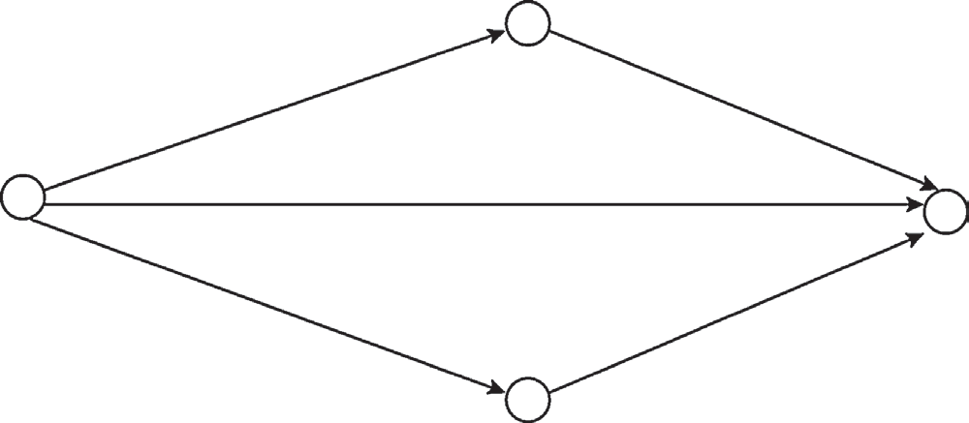

20

A(3,6)

B(5,10)

10

C(8,12)

30

D(6,8) E(2,6)

25

where each activity in the network has a probabilistic duration defined by a uniform distribution as:

f(x)

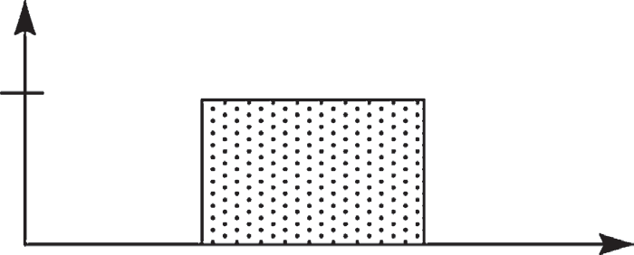

Uniform Distribution

a (Most

optimistic)

x

1/(b – a)

b (Most

pessimistic)

where *a* and *b* are shown on the network. Using simulation, deter- mine the critical tasks and expected project completion time for each simulation.

* 1. Consider the B2B implementation of the web-based inventory tracking system described in Problem 7.4. Additional information relevant to this project:
     1. Assume that the project consists of six phases: system design, hard- ware development, software development (conducted concurrently with hardware), integration, training, and fielding.
     2. Table 7.1 will provide a rough estimate of the software development time as a percentage of the total development time.
     3. Hardware should be broken into, at a minimum, two high-level tasks: collect requirements and procure software. These will be mainly COTS systems requiring no modifications. One engineer

will be assigned full time to monitor this task. This will allow for procurement of the hardware near the end of the software development.

* + 1. Assume that you can install two systems per day with a crew of two engineers and that training will last 1 week and be conducted by one engineer.
    2. Assume the plans and requirements values from Table 7.1 are also representative of the systems design for the total system.
    3. Use the regression analysis from Problem 7.4 to determine the sys- tems integration time.
    4. Your company uses historical results for project management and sys- tems engineering of 8 and 15%, respectively.

Using this information, you need to

1. Develop a WBS for this project.
2. Develop a Gantt chart from the WBS, showing the schedule. (Hint: Use the phase distribution schedules presented in Chapter 7 to allo- cate software development time.)
3. Address only the development costs (i.e., year 0 costs) when allocat- ing resources to the tasks in Microsoft Project.

Use a tool such as Microsoft Project to allocate the budget to the activi- ties. Are there any activities that are not described above that should be in your WBS?

* 1. In November 2008, your employer (Ace Builders) is awarded a con- tract for the renovation of Buccaneer Stadium to house the New York Neapolitans. The construction must start on January 14, 2009, and must be completed within 15 months. Liquidated damages (penalty clause) of

$250,000 per day of delay beyond March 31, 2010, are written into the contract. On the other hand, Ace will receive an early completion bonus of $100,000 per day for each workday the project is completed before March 31, 2010.

To meet this aggressive schedule, the project will require around-the- clock construction crews, detailed project management, good construc- tion weather, and some modern construction techniques.

The project will begin with mobilizing equipment, preparing a stag- ing area, and some minor demolition work—activities that are expected to last approximately 8 weeks. Once the site is ready and all equipment mobilized, the work can start simultaneously on both the structure and the playing field.

The work in the field involves excavation for installation of new sub- surface irrigation, drainage, and heating facilities, which lasts approxi- mately 8 weeks. This activity is followed by actual installation of water and drain pipes, valves, heating and control circuits, etc. Installation of

the subsurface facilities (14 weeks) is followed by filling of the playing field and track. Only with the completion of the backfill material needed for the drainage systems (4 weeks) can the installation of the artificial playing turf take place, an activity that consumes 6 weeks.

The work on the structure itself starts with excavation and founda- tion preparation (4 weeks) followed by the pouring of concrete footings (6 weeks). Next comes the pouring of supports for box seats, façade, and luxury boxes (10 weeks), followed by erecting the precast concrete façade and the luxury boxes (16 weeks). Finish work on the boxes will be accomplished over the next 5 weeks. The roof must be erected on a steel structure that takes approximately 4 weeks to install. Prefabrication of the work will also take 4 weeks. Once the roof is erected, work can start simultaneously on the lights (5 weeks) and the scoreboard (4 weeks). The date on which the project is scheduled to start falls on a Monday. The contractor has bid this job with 5-day workweeks.

#### Part I

Jim Brown, the president of Ace Builders, calls a planning meeting in which he expresses great satisfaction at obtaining the $350,000,000 contract and reveals that the company could earn a gross profit of

$20,000,000 on the project. He is confident that the project can be completed on time with an allowance for the usual delays anticipated in such a large contract.

Develop a high-level Gantt chart in MS Project for presentation to the board of directors of Ace Builders. The board has expressed concerns about the exposure to risk from such an aggressive schedule. Using infor- mation from the preparation of the bid, you develop the following gross- level activities for this project:

#### High-Level Activities, Precedence Relationships, and Durations for the New Home of the Neapolitans

|  |  |  |  |
| --- | --- | --- | --- |
| **ID** | **Task Name** | **Duration** | **Predecessors** |
| 1 | Stadium construction project | 62 wks |  |
| 2 | Staging area, mobilization | 8 wks |  |
| 3 | Playing field | 32 wks |  |
| 4 | Excavation | 8 wks | 2 |
| 5 | Drainage, etc. | 14 wks | 4 |
| 6 | Fill | 4 wks | 5 |
| 7 | Install sod | 6 wks | 6 |
| 8 | Stadium structure | 54 wks |  |
| 9 | Excavation—façade, roof, boxes | 4 wks | 2 |
| 10 | Pour footings | 8 wks | 8 |
| 11 | Pour supports | 10 wks | 10 |
|  |  |  | (*Continued*) |

**(Continued)**

|  |  |  |  |
| --- | --- | --- | --- |
| **ID** | **Task Name** | **Duration** | **Predecessors** |
| 12 | Erect facades, boxes | 16 wks | 11 |
| 13 | Finish boxes and façade | 5 wks | 12 |
| 14 | Painting | 4 wks | 10 |
| 15 | Dressing rooms, offices, etc., | 8 wks | 14 |
| 16 | Prefab roof | 4 wks | 15 |
| 17 | Erect roof | 4 wks | 13, 16 |
| 18 | Scoreboard | 5 wks | 15 |
| 19 | New seats | 3 wks | 13 |
| 20 | Lights | 7 wks | 15 |
| 21 | Wiring, HVAC | 4 wks | 15, 16, 18, 20 |
| 22 | Exterior infrastructure improve | 6 wks | 17 |
| 23 | Punch list and demob | 3 wks | 22 |

Highlight the critical path and other key pieces of information.

#### Part II

Bonnie Green, chief estimator, agrees that in a normal year only slight delays might develop due to a labor shortage. However, she points out that for such a large project, the company will need to use unionized employ- ees and that the construction industry labor agreements with New York City will expire October 30, 2009. Past experience and current construc- tion activity in the surrounding area indicate that any union tradesman would support a strike against the city. Because this is a public project, she estimates a 50% chance that they would strike this project to gain the attention of the national media.

Jim Brown inquires about the prospective length of a strike. Bonnie figures that such a strike would last at least 4 weeks. Jim is not pleased with these prospects. However, he is pleased when he realizes that only major construction (steel and concrete—Tasks 9, 10, 11, 12, 16, and 17) would be affected. He would be far enough along in the job that he could subcontract to nonunion shops minor activities such as the scoreboard, lighting, playing field, dressing rooms, and sod.

Jack White, vice president for operations, comments that May 2008 had been extremely cold and wet. This factor had not been taken into con- sideration during earlier estimates. Any work on the playing field would have to stop during an extended wet period.

Clearly, the possibility of a strike or of cold, wet weather introduces probability into the planning process and, more important, may result in a significant unfavorable change to the completion date, which could lead to penalties, etc. With this new information, Mr. Brown can no longer rely on the best-case completion date estimate, because that analysis was

based on assuming that each task began as soon as its predecessor task or tasks were completed and that the nature and duration of each task was known and invariant.

At the end of the planning meeting, Jim Brown asks the project man- agement team to study two options:

* + 1. In the event of a 4-week strike, how much of the $20 million in profit would Ace lose? What would be the new completion date?
    2. If the weather is indeed cold and wet (assume May time frame), should this be a major planning issue for construction of the playing field? (Justify your answer with numbers.)

As a member of the project management team, your task is to analyze the options and produce a two-page report summarizing your results.

#### Part III

Now it is December 10, 2009. Ace Builders did not face any problems with a strike or bad weather. Up-to-date information for the stadium proj- ect is given in the following table:

#### Project Status as of December 10, 2009a

|  |  |  |  |  |  |
| --- | --- | --- | --- | --- | --- |
| **Tasks** | **%**  **Complete** | **Bid Price** | **Actual**  **Expenses** | **Duration**  **(weeks)** | **Actual** |
| Staging area, mobilization, demolition | 100 | $6,500,000 | $7,500,000 | 8 | 8.5 |
| Excavation—field | 100 | $75,000 | $75,000 | 8 | 8 |
| Subsurface drainage | 100 | $370,000 | $270,000 | 14 | 10 |
| Fill material for field | 100 | $50,000 | $50,000 | 4 | 2 |
| Installation of turf | 0 | $100,000 | $0 | 6 | 0 |
| Excavation—façade, roof  supports, and boxes | 100 | $1,000,000 | $1,000,000 | 4 | 5 |
| Pouring concrete footings | 100 | $18,500,000 | $18,500,000 | 6 | 6 |
| Pouring box, roof, and  facade supports | 100 | $59,500,000 | $53,500,000 | 10 | 11 |
| Erecting precast concrete  façade and boxes | 75 | $75,000,000 | $57,250,000 | 16 | 13 |
| Finishing boxes and new  façade | 0 | $30,000,000 | $0 | 5 | 0 |
| Painting | 10 | $5,000,000 | $500,000 | 4 | 0.5 |
| Dressing rooms, offices,  concession | 10 | $12,000,000 | $1,200,000 | 8 | 1 |
| Prefabricating the  retractable roof | 90 | $10,000,000 | $9,500,000 | 4 | 4 |
| Erecting the roof | 10 | $5,250,000 | $550,000 | 4 | 0.5 |

(*Continued*)

|  |  |  |  |  |  |
| --- | --- | --- | --- | --- | --- |
| **(Continued)** |  |  |  |  |  |
| **Tasks** | **%**  **Complete** | **Bid Price** | **Actual Expenses** | **Duration (weeks)** | **Actual** |
| Scoreboard | 75 | $10,000,000 | $7,250,000 | 5 | 3 |
| New seats | 10 | $32,000,000 | $3,200,000 | 3 | 0.5 |
| Lights and other facilities | 5 | $40,000,000 | $2,000,000 | 7 | 0.1 |
| Wiring, HVAC | 15 | $20,000,000 | $3,000,000 | 4 | 1 |
| Exterior infrastructure | 5 | $19,655,000 | $982,750 | 6 | 0.1 |
| improvements |  |  |  |  |  |
| Punch list and | 0 | $5,000,000 | $0 | 3 | 0 |
| demobilization |  |  |  |  |  |
| Total |  | $350,000,000 | $166,327,750 |  |  |

a All precedence relationships should be strictly followed.

You must develop a status report for Mr. Brown using standard evaluation “figures of merit,” such as BCWS, ACWP, BCWP, EAC, and the perfor- mance SPI and CPI indices.

By updating your schedule regularly and then comparing it to your original plan, you can easily tell which tasks are slipping, have been delayed, or are starting or finishing early. You can easily track the prog- ress of the project using Microsoft Project.

There is a project evaluation meeting next week. You will make a pre- sentation there about the current status of the project. You will also talk about what you have done so far.

*Deliverables for Project Evaluation Meeting*

1. Analyze the current schedule status of the project using Excel. Calculate the SPI. Is the project ahead of, on, or behind schedule?
2. Analyze the current cost status of the project. Calculate the CPI. Is the project under, on, or over budget?
3. Write a two-page executive summary on the general status of the project. Use figures and statistics to back up your assessment.

#### Part IV

The following are data and sample calculations for erecting the precast concrete facade and boxes:

**Task**

**%**

**Complete Bid Price**

**Actual Expenses**

**Duration**

**(weeks) Actual**

Erecting precast concrete façade and boxes

75 $75,000,000 $57,250,000 16 13

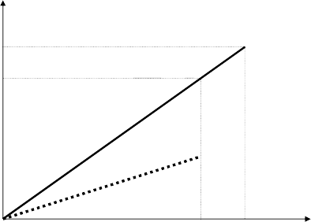Dollars

$75M

$60.9MM

0 13 16

Time (weeks)

BCWS = 13/16($75M) = $60.9M (for 100%, we use actual bid price for BCWS)

ACWP = $57.25M BCWP = 0.75 × $75M = $56.3M

SV = BCWP – BCWS = 56.3 – 60.9 = –$6M CV = BCWP – ACWP = 56.3 – 57.3 = –$1M

Estimate at completion (EAC) = ACWP + (Remaining earned value/CPI)

= 57.3 + (75 – 56.3)/0.98

= $76.4M

SPI = BCWP/BCWS = 56.3/60.9 = 0.92 CPI = BCWP/ACWP = 56.3/57.3 = 0.98

## REFERENCES

Callahan, M. T., D. G. Quackenbush, and J. E. Rowings. 1992. *Construction Project Scheduling*.

New York: McGraw-Hill.

Defense Acquisition University. 2001. “Scheduling Guide for Program Managers.” Fort Belvoir, VA: Defense Systems Management College Press.

Defense Acquisition University. 2003. “U.S. Department of Defense Extension to: A Guide to the Project Management Body of Knowledge.” PMBOK® Guide. 1st ed. Version 1.0.

Department of Defense. 1998. “Work Breakdown Structures for Defense Material Systems.” MIL-HDBK-881. 2 January.

Hinze, J*.* 1993. *Construction Contracts*. New York: McGraw-Hill.

Primavera Systems, Inc. 1996. *P3: Primavera Project Planner*® *Planning and Control Guide*.

Bala Cynwyd, PA: Primavera Systems, Inc.

Spinner, M. P. 1997. *Project Management Principles and Practices*. Upper Saddle River, NJ: Prentice Hall.

Stevens, J. D. 1990. *Techniques for Construction Network Scheduling*. New York: McGraw-Hill.

## BIBLIOGRAPHY

Griffis, Fletcher H., and John V. Farr. 1999. *Construction Planning for Engineers*. New York: McGraw-Hill.

# Appendix A: Abbreviations and Acronyms

**ABC:** Activity-based costing

**ACWP:** Actual cost of work performed **ADM:** Arrow diagramming method **AoA:** Analysis of alternatives

**APR:** Annual percentage rate **B2B:** Business to business **BCR:** Benefit–cost ratio

**BCWP:** Budgeted cost of work performed **BCWS:** Budgeted cost of work scheduled **CAIV:** Cost as an independent variable **CCB:** Configuration control board

**CDF:** Cumulative distribution function

**CDR:** Concepts design review, critical design review

**CER:** Cost estimating relationship **CLOC:** Commented lines of code **CLT:** Central limit theorem

**CMMI:** Capability maturity model integration

**CoGQ:** Cost of good quality **CoPQ:** Cost of poor quality **CoQ:** Cost of quality

**CoSQ:** Cost of software quality

**COCOMO:** Constructive cost model

**COCOMO II:** Constructive cost model version II **COCOTS:** Constructive commercial-off-the-shelf model **CONOPS:** Concept of operations

**COPROMO:** Constructive productivity model

**COPSEMO:** Constructive phased schedule estimation model

**COQUALMO:** Constructive quality model

**CORADMO:** Constructive rapid application development model **COSOSIMO:** Constructive system-of-systems cost model **COSYSMO:** Constructive systems engineering cost model **COTS:** Commercial off-the-shelf

**CPG:** Continuous process generator

**CPI:** Consumer price index, cost performance index **CPIPT:** Cost performance integrated product team **CPM:** Critical path method

**CRL:** Cost readiness level, commercialization readiness level

**263**

**CTS:** Central train station

**CV:** Conventional carrier or cost variance

**CVN:** Nuclear carrier

**DCOM:** Distributed component objective model **DMADV:** Define, measure, analyze, design, and verify **DMAIC:** Define, measure, analyze, improve, and control **DoD:** Department of Defense

**DoDAF:** Department of Defense architectural framework

**DPMO:** Defects per million opportunities

**DPG:** Discrete process generator

**DSCA:** Defense support to civil authorities

**DSI:** Delivered source instructions

**DTC:** Design to cost

**DTOSC:** Design to operating and support costs

**EAC:** Estimate at completion **EAF:** Error adjustment factor **EAV:** Equivalent annual value **ELOC:** Effective lines of code **FCFS:** First come, first serve **FCS:** Future combat system **FD:** Finite difference

**FE:** Finite element

**FEMA:** Federal Emergency Management Agency

**FFP:** Firm fixed price

**FP:** Function points

**FTE:** Full-time equivalent

**GAAP:** Generally accepted accounting principles

**GAO:** Government Accounting Office **GIS:** Geographic information systems **GOTS:** Government off-the-shelf **GPS:** Global positioning system **GPL:** General public license

**HVAC:** Heating, ventilation, and air conditioning

**HW:** Hardware

**ILS:** Integrated logistics system **IMP:** Integrated master plan **IMS:** Integrated master schedule **IPT:** Integrated product teams **IRL:** Integration readiness level **IRR:** Internal rate of return **JIT:** Just In Time

**IT:** Information technology

**ITM:** Inverse transformation method

**K–S:** Kolmogorov–Smirnov

**KDSI:** Thousand of delivered source lines on instructions

**KLOC:** Thousands of lines of code

Appendix A: Abbreviations and Acronyms **265**

**KPP:** Key performance parameters

**LCC:** Life cycle costs

**LCCA:** Life cycle cost analysis

**LCID:** Large construction and industrial debris

**LOC:** Lines of code **LOGPACS:** Logistic packages **M&S:** Modeling and simulation

**MACRS:** Modified accelerated cost recovery system **MARR:** Minimum attractive or acceptable rate of return **MBA:** Master of business administration

**MOTS:** Modifiable or military off-the-shelf **MPTs:** Methods, processes, and tools **MRL:** Manufacturing readiness level **MRTS:** Major regional train station

**MSL:** Mean sea level

**MSW:** Municipal solid waste

**NASA:** National Aeronautics and Space Administration

**NCLOC:** Non-commented lines of code **NGO:** Non-government organizations **NPV:** Net present value

**NPW:** Net present worth

**NCF:** Net cash flow

**NTS:** Neighborhood train station

**O&S:** Operations and support/sustainment **ORCA:** Orlando Regional Corridor Association **ORD:** Operational requirements document **OSS:** Open source software

**OV:** Operational view

**P-A-F:** Prevention-against-failure

**PCB:** Printed circuit board

**PCE:** Parametric cost estimating/estimate **PDF:** Probability distribution function **PDM:** Precedence diagramming method **PDR:** Program design review

**PERT:** Program evaluation and review technique

**PM:** Program/project management **PSG:** Passive sonar geophones **R&D:** Research and development

**RDT&E:** Research, development, testing, and evaluation

**R-TOC:** Reduction of total ownership costs

**RFP:** Request for proposal **ROI:** Return on investment **RRW:** Relative risk weighting

**S/E M:** Systems/engineering management **SE/PM:** Systems engineering/project management **SBC:** Simulation-based costing

**SE:** Systems engineering

**SEI:** Software Engineering Institute

**SF:** Square foot

**SLOC:** Source lines of code

**SM:** Staff-month

**SOA:** Service-oriented architecture

**SoS:** System of systems

**SPC:** Statistical process control **SPI:** Scheduled performance index **SRL:** System readiness level

**SV:** Systems view, schedule variance

**SW:** Software

**T&E:** Test and evaluation

**TCF:** Technical complexity factor

**TDEV:** Time to develop

**TOC:** Total ownership costs **TRL:** Technical readiness level **UFP:** Unadjusted function point

**UFC:** Unadjusted function point count **UML:** Unified Modeling Language **UPCCs:** Unit price commitment curves **V&V:** Verification and validation

**VV&A:** Validation, verification, and accreditation

**WBS:** Work breakdown structure

# Appendix B: Excel®* Tutorial to Support Economic Analysis

and Simulation-Based Costing†

## INTRODUCTION

Microsoft Excel is a spreadsheet software program that allows the user to organize and perform mathematical functions on numerical data. Excel consists of organiza- tional units called “workbooks.” A standard workbook contains worksheets that per- form calculations, store and organize data, present graphics, and perform a plethora of mathematical and statistical functions. A worksheet in turn is comprised of cells whose function is to store data or a formula that performs a calculation. Since its inception in the 1980s, Excel has rapidly gained importance among the engineering community because many engineering tasks can be organized and solved easily and efficiently within the framework of a spreadsheet. Excel is now much more than just an electronic medium of organizing data; it solves high-level mathematical, statis- tical, and financial problems, requiring optimization techniques, simulation capa- bilities, and the means to generate reports. When developers use the capabilities provided by Visual Basic, they can easily automate processes and define functions. It is the tool of choice for economic analysis, estimation, and management.

The intent of this appendix is to acquaint the student with the Excel features that are widely used in engineering economics and simulation-based costing (SBC). This book deals primarily with Excel 2007.

## EXCEL 2007 BASICS

* + 1. **EXCEL BASICS**

Before moving on to discussion of the financial functions and applications of Excel in engineering economics, it is worthwhile to review some of the basics of Excel.

The *ribbon*, which is a new feature in MS Office 2007 products, is a tool intended to provide convenient access to the most commonly used features of the program. The ribbon replaces the menus and toolbars found in earlier versions of Excel (1997– 2003) and consists of a strip of tabs above the work area. Clicking on each tab displays a series of related functions. The default ribbon tab is the Home tab, which pro- vides the user with basic formatting options. The ribbon is also “context sensitive,”*

* Microsoft Excel® is a registered trademark of Microsoft Corporation.

† Primary author of this appendix is Dr. Anirban Ganguly, Lecturer, School of Systems and Enterprises, Stevens Institute of Technology, Hoboken, New Jersey.

**267**

allowing additional tabs to appear when required. For example, when a graph or chart is selected, an additional tab called Chart Tools will appear on the ribbon to aid the user in customization. However, when the user clicks outside the graph or chart, the corresponding tab disappears. Figure B.1 provides a snapshot of the ribbon.

The *active cell* (also known as the *current cell*) in Excel can be defined as the cell that has been selected using the mouse or the keyboard. The active cell is iden- tified by its heavy border. All information, including mathematical and financial functions, is entered into the active cell. Figure B.2 shows an example of an active cell.

An active cell can contain any of the following: labels, numbers, or formulas. A label can be defined as one or more text or alphanumeric characters and words. If the first character entered in an active cell is not a number or a formula, Excel treats the cell contents as a label by default. Typing an apostrophe before the first character can convert a number or even a formula to a label. In fact, any mathematical formula can be converted to a label by inserting an apostrophe before the first character, which is always an equals sign (=). This feature is particularly useful in situations where the applied mathematical or financial calculations are required to be shown as a label. Furthermore, if the first character of an active cell is an equals sign, the cell automatically treats the entry as a formula (or an equation) and tries to arrive at a solution based on the referenced cells or worksheets. Finally, if a number is entered

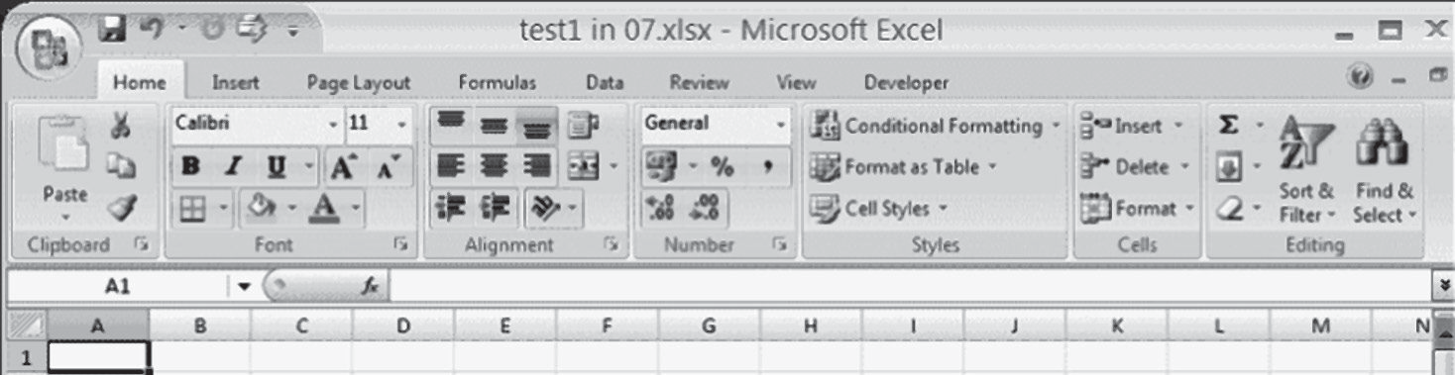

Excel 2007 Ribbon

**FIGURE B.1** Excel 2007 ribbon.

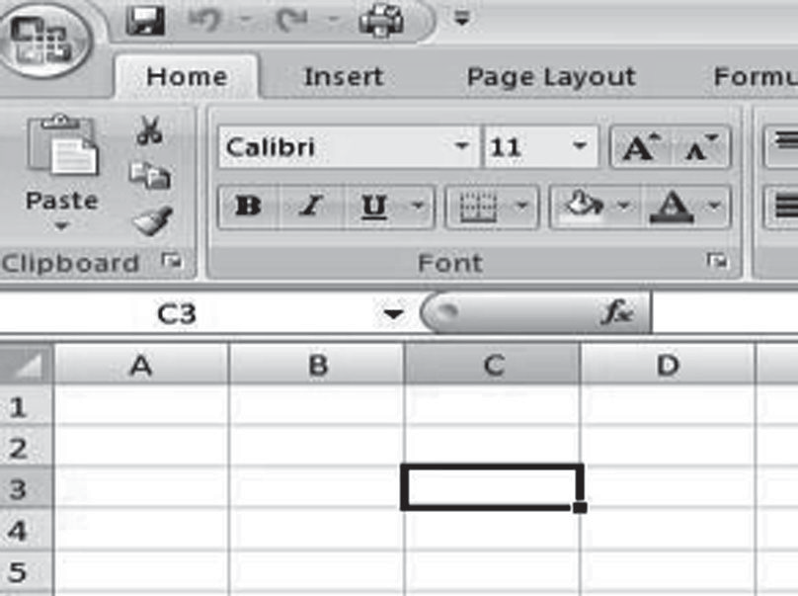

Active cell

**FIGURE B.2** Active cell in Excel 2007.

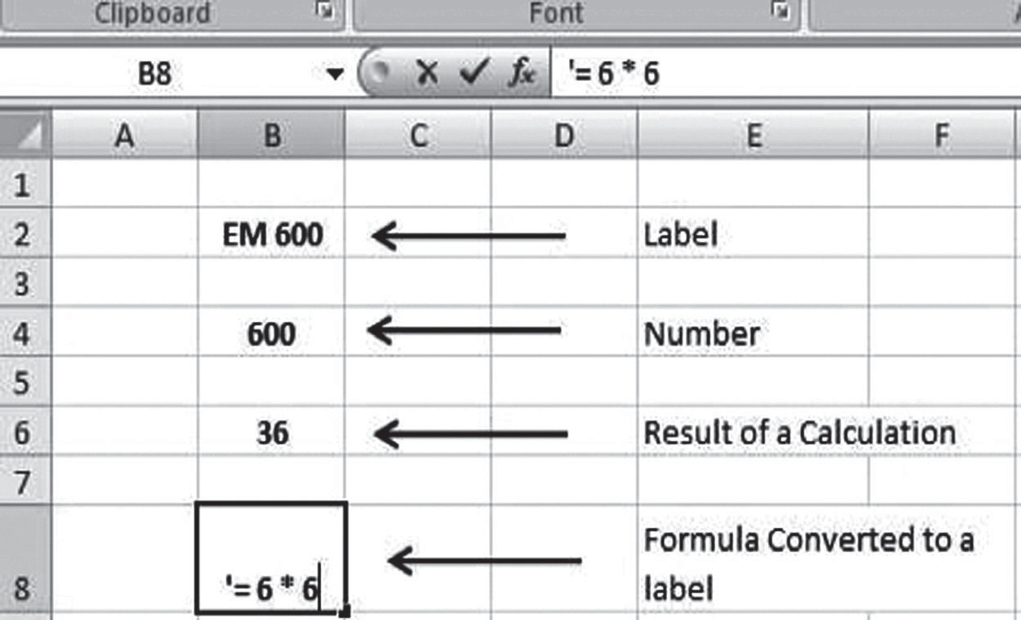

The symbol [‘] used to convert formula into labels of the

The result of the calculation

The details of the calculation

**FIGURE B.3** Labels, numbers, and formulas.

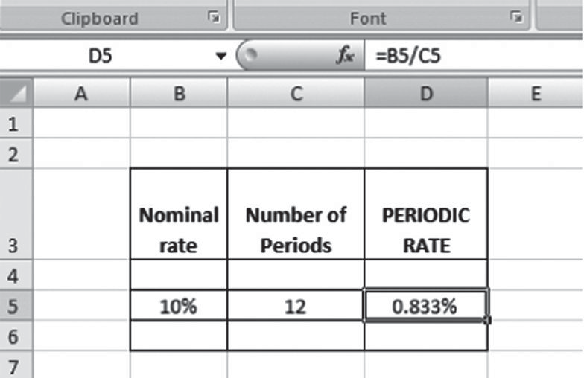

The formula bar and the result of the calculation

**FIGURE B.4** Using cell addresses as variables in a formula.

in an active cell, it is treated as a numerical value and is shown in the active cell. Figure B.3 further clarifies these ideas.

When a formula is entered in an active cell, Excel initially displays the characters that are typed, but as soon as the Enter key is pressed, the contents of the cell revert to the numerical result of the equation rather than the equation itself. However, the formula that was entered in the active cell is stored in the cell; you can use the F2 key to view the formula in the active cell as well as to perform subsequent edits to it. Figure B.4 illustrates this point. The primary advantage of using Excel for formulas (apart from its ability to solve complex problems relatively easily and quickly) is the ability to use cell addresses as variables in formulas (Larsen, 2008).

Figure B.4 depicts an elementary engineering economic problem. Suppose an investor pays a nominal rate of 10% and the number of compounding periods avail- able to the investor is 12. Thus, the periodic rate for the investor in question will

amount to 10%/12 = 0.833% per period. In Figure B.4, this calculation is performed using cell references and addresses. The output cell (D5) contains the formula B5/ C5, as indicated on the formula bar, and the result is displayed in the active cell, D5. Thus, using cell addresses spares the user from having to re-input the values in the output cell. This is particularly useful when working with a large data set.

Furthermore, the cell addressing feature can be useful in cases of repetitive calcu- lations. You can use either the keyboard or the left mouse button to drag the source range of cells to the destination range of cells. With the *fill handle* feature, a formula and cell addresses can be copied into a range of cells rather than being inserted indi- vidually. Additionally, the fill handle serves to fill up a series with certain incremen- tal values, both linear as well as nonlinear. One can use this feature for time series analysis and forecasting of financial data.

* + 1. **SOME BASIC FUNCTIONS**

A function is a built-in formula in Excel that has a name and arguments in parenthe- ses. At the time of its inception, Excel handled business functions only but gradually transitioned to include many additional functions that are useful to engineers (Larsen, 2008). For example, the average and sum of a particular set of data can be easily cal- culated using the built-in Average() and Sum() functions, respectively. Excel includes other common statistical functions such as standard deviation [STDEV()] and corre- lation [CORREL()], along with financial functions such as calculating present worth [NPV()] and internal rate of return [IRR()]. The entire set of built-in functions is available in the Formulas tab in the Excel 2007 ribbon, shown in Figure B.5.

Clicking on the Insert Function tab in the Formulas tab enables the user to choose and insert one of the built-in functions. However, for the purpose of this tutorial, this discussion will be restricted to a few basic functions. We will discuss the following built-in functions:

* + - * SUM: Adds all cells in the argument
      * AVERAGE: Calculates the average of the cells in the argument
      * MIN: Finds the minimum value
      * MAX: Finds the maximum value
      * COUNT: Finds the number of cells that contain a numerical value within a range of the argument
      * ABS: Returns the absolute value of any numerical expression

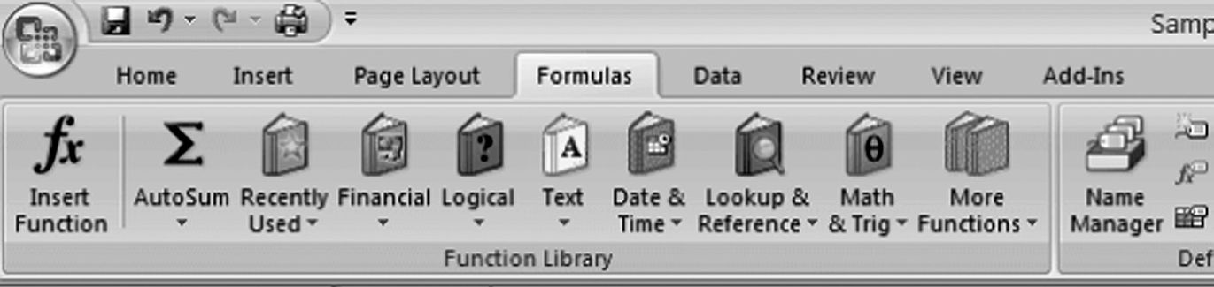

**FIGURE B.5** Built-in functions of Excel 2007.

The SUM function in Excel was created to speed up the process of adding together many values in a spreadsheet. With the SUM function, the user does not have to change equations when values change. Excel can sum values across both rows and columns. Constants, cell references, and other formulas can also be added to the SUM function if required. There is also a method to sum values in noncontiguous blocks without having to manually type in the formula. To add together the values in the four corners of a data table, type in =SUM (then hold down the control key (Ctrl) and left-click the mouse (without letting up on the Ctrl key) on each of the four corners. This will provide the user with the sum of the values located in the four corners of any particular table.

The AVERAGE function in Excel helps the user determine the average (mean) of a range of data. The AVERAGE function has all of the capabilities and properties of the SUM function. Averages can be performed down columns, across rows, for an entire table, in noncontiguous ranges and cells, for formulas, and for constants. Just like in the SUM function, spaces and text have no effect on the AVERAGE function. The AVERAGE function can also be accessed by clicking the Insert Function button within the Formulas tab.

Other basic built-in functions of Excel include MAX, MIN, COUNT, and ABS. MAX and MIN calculate the maximum and minimum values, respectively, from a range of values. COUNT determines the number of cells in the data range. Finally, ABS determines the absolute value of any numerical expression. This is particularly useful when dealing with ratios.

Let us briefly discuss relative, absolute, and mixed references. Addressing cells by just their column and row labels (such as “A1”) is called *relative referencing*. When a formula contains relative referencing and it is copied from one cell to another, Excel does not create an exact copy of the formula but rather changes cell addresses relative to the row and column to which it is moved. For example, if a simple addition formula in cell C1 “= (A1 + B1)” is copied to cell C2, the formula would change to “=(A2 + B2)” to reflect the new row. To prevent Excel from automatically making this change, the user must perform *absolute referenc- ing*, which is accomplished by placing dollar signs “$” within the cell addresses in the formula. Thus, using absolute referencing, the formula in cell C1 of the previous example would now read “=($A$1+$B$1)” if the value of cell C2 should be the sum of cells A1 and B1 instead of A2 and B2 (which is the Excel default through rela- tive referencing). With absolute referencing, the column and row of both cells are absolute and do not change when copied. Finally, in situations where only a par- ticular row or column is fixed, *mixed referencing* can be used. For example, in the formula “=(A$1+$B2)”, the row of cell A1 is fixed and the column of cell B2 is fixed. Therefore, mixed referencing enables the user to fix particular rows or columns according to convenience. Finally, the value from a cell in another worksheet could also be used within the same workbook in a formula. For example, the value of cell A1 in the current worksheet and cell A2 in the second worksheet can be added using the format “sheetname!celladdress”. The formula for this example would be “=A1+Sheet2!A2”, where the value of cell A1 in the current worksheet is added to the value of cell A2 in the worksheet named “Sheet2”. This is a handy tool when performing an after-tax analysis problem because data from multiple worksheets

are often required to be interlinked in calculations as part of the process to arrive at the after-tax cash flow.

You need to be familiar with the basics of simulation and DPGs presented in Chapter 5 to complete this tutorial. This tutorial is to be used with the Excel file “Tutor.xls” and the “VLOOKUP” and “HLOOKUP” worksheets.

You learned about creating DPGs in the statistics lectures for this class. You can use VLOOKUP and HLOOKUP in your spreadsheets to access a DPG value in simulations. This tutorial will focus mainly on VLOOKUP. If you can master VLOOKUP, HLOOKUP should be an easy transition for you. The only difference between the two functions is the orientation of the data on the spreadsheet: in a VLOOKUP table the data are presented vertically, whereas in an HLOOKUP table the data are presented horizontally.

The spreadsheet process differs from the manual process. VLOOKUP needs only the lower bound in order to return a discrete process. The VLOOKUP function looks like this:

=VLOOKUP(Value To Lookup, Table Used, Row Number Returned)

The HLOOKUP function works in the same way as VLOOKUP except it looks up values down columns instead of across rows. Click on the See HLOOKUP Function button to see the same lookup table and burger generator formatted as a horizontal lookup table. As you can see, there is little to be gained by using HLOOKUP versus VLOOKUP.

* + 1. **RECORDING SIMULATION RUN DATA USING EXCEL**

Rather than develop an Excel macro or push the F9 key numerous times, you can use the following Excel function to initiate and record the results of each simulation run in a table. The function in Excel is called a What-If Table. It can be found under the Data pull-down window of the Windows version of Excel. To accomplish this:

* + - * Within your Excel spreadsheet, establish the upper-left corner cell of your What-If Table by using the = key and then referencing the output cell from one iteration of your spreadsheet simulation. This output cell from your simulation should be the average value of W or Wq.
      * Define the size of the table (width and height) by clicking on the upper-left corner of the table (the output cell from the step above) and dragging across the rows and columns to the lower-right corner of your table.
      * With this table still highlighted from the step above, select Data from the pull-down window and then Table.
      * Column input cell: Click on an empty cell outside the table. (This function is not used, but a cell needs to be entered in order to use this function—our random numbers make this option necessary.)
      * Row input cell: Click on another empty cell outside the table.
      * Select OK and watch your output appear (as if by magic). Depending on the size of your table, it may take seconds or minutes to complete the table.

As an example, let us say that we develop a table in our spreadsheet that looks like the following:

|  |  |  |  |  |  |  |
| --- | --- | --- | --- | --- | --- | --- |
| W | 1 | 2 | 3 | 4 | 5 | 6 |
| 1 |  |  |  |  |  |  |
| 2 |  |  |  |  |  |  |
| 3 |  |  |  |  |  |  |
| 4 |  |  |  |  |  |  |
| 5 |  |  |  |  |  |  |

The upper-left corner cell will be the output of your simulation run, linking this What-If table to your simulation spreadsheet. The 1, 2, 3, etc. establishes a two- dimensional array in which to store your simulation run results. Each cell is an out- put (W) from a single iteration of your simulation. Once you click OK, the computer will run 30 iterations of your simulation (because of your 6 × 5 matrix), placing the results in the 30 empty cells above. These results are used to determine the mean and standard deviation for the simulation.

Table B.1 contains numerous Excel functions of interest to anyone doing spread- sheet modeling.

## GRAPHING WITH EXCEL*

One of the highlights of MS Excel is its ability to generate graphs based on data sets and data ranges. Charts allow the user to present information contained in the worksheet in a graphic format. Excel offers many types of charts, including column, line, pie, bar, area, and scatter. However, since the majority of engineering econom- ics problems concern primarily scatter plots and line graphs, this section will be restricted to just those. Consult the user’s manual provided with Excel or one of the many self-help books for further reference. The available charts in Excel 2007 are located under the Insert tab on the Excel ribbon, as shown in Figure B.6.

Line charts in Excel are often used to plot variations in financial and other engi- neering data over time. Additionally, they can be used to forecast a value over a certain time period. This is especially true when making time value forecasts of a cash flow and bonds. Similar to most graphs, a line diagram consists of a horizontal and a vertical axis, with the time on the *x* axis and the variable on the *y* axis. Line graph options are located under the Insert tab on the Excel ribbon, as shown in Figure B.7.

As seen from Figure B.7, Excel provides various forms of line charts. Line dia- grams display lines through a set of data points, with or without data markers, and the data series in line charts can be stacked. Unlike scatter charts, line charts can even be displayed with a 3D visual effect.

Scatter diagrams are one of the most widely used graphs in the domain of business and engineering. Scatter charts represent the relationship between pairs of variables and are commonly used for displaying and comparing numeric values, such as scientific,

* Some of the text in this section is taken from <http://office.microsoft.com/en-us/Excel/HA01054> 8401033.aspx

#### TABLE B.1

**Useful Excel Functions**

**Mathematical**

EXP(*x*) *e* raised to the *x*th power

INT(*x*) Returns the integer portion of *x;* in this function, *x* is simply truncated, not rounded off

LN(*x*) The log base *e* of *x*

LOG(*x*) The log base 10 of *x*

RAND A random number between 0 and 1

ROUND(*x,n*) Rounds off the number in cell *x* to *n* decimal places

SQRT(*x*) The positive square root of the number in cell *x*

**Statistical**

AVERAGE(list) The average (mean) of all numeric values in the list CONFIDENCE(α,SDev,*n*) Confidence interval for a population mean COUNT(list) The number of non-blank cells in the list EXPONDIST(*x*,λ,cum) The exponential distribution

INTERCEPT(*x,y*) The *y* intercept of a regression line through a known *x* and *y*

MAX(list) The largest numeric or last date value in the list

MEDIAN(list) The median of values in the list

MIN(list) The smallest numeric or earliest date value in the list NORMDIST(*x*,mean,SDev) The standard cumulative normal distribution function NORMSINV(prob) The inverse of the standard cumulative normal distribution function POISSON(*n*,mean, cum) The Poisson probability distribution

SLOPE(*x,y*) The slope of a regression line through a known *x* and *y* STDEV(list) The population standard deviation of all non-blank values in the list SUM(list) The total of all numeric values in the list

**Cells and Tables**

HLOOKUP(*x*,block,row) A horizontal search of a data table where the index values are located in

the first row of the block of cells; searches for *x* in the index row; returns the corresponding value from the desired row

VLOOKUP(*x*,block,column) A vertical search of a data table where the index values are located in the

first column of the block of cells; searches for *x* (or for the value of the expression *x*) in the index column; when it finds the value, it returns the corresponding value from the desired column

**Logical**

IF(c,t,f) Evaluates expression c and returns t if it is true or f if it is false CHOOSE(*x*,list) Returns element from the list in the position specified by the numeric value *x*

**Date & Time**

NOW Returns the date and time serial number for the current system date and time

TODAY Returns the date number for the current system date

DAY(*n*) Returns the day of the month

MONTH(*n*) Returns the month in number form

YEAR(*n*) Returns the year (in years since 1900)

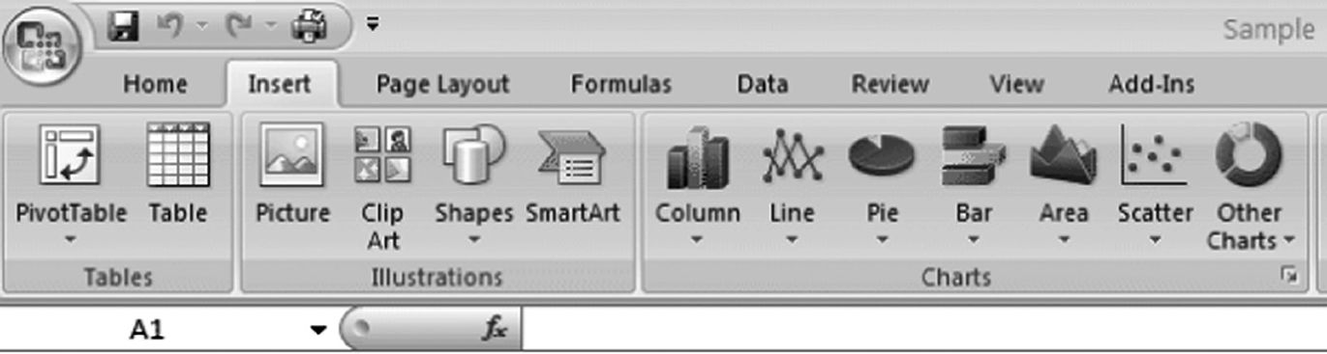

**FIGURE B.6** Location of available charts in Excel.

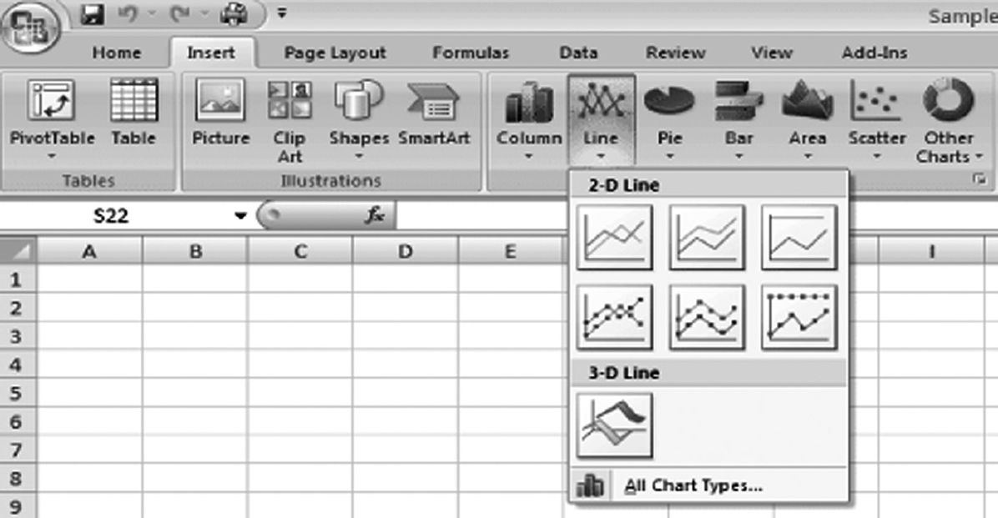

**FIGURE B.7** Line graph in Excel 2007.

statistical, and engineering data. A scatter diagram allows a convenient visual represen- tation of a pair-wise relationship. It can be used effectively to display worksheet data that includes pairs or grouped sets of values and to depict correlations between large sets of data and hence compare them in the process. The *x-y* scatter diagram tab (Scatter tab) is located under the Insert tab on the Excel ribbon, as shown in Figure B.8.

Scatter charts can be displayed with or without lines to connect the data points, and connecting lines can be displayed with or without data markers *(data marker: A bar, area, dot, slice, or other symbol in a chart that represents a single data point or value that originates from a worksheet cell. Related data markers in a chart con- stitute a data series.)*. A scatter chart has two value axes, showing one set of numeri- cal data along the *x* axis and another along the *y* axis. It combines these values into single data points and displays them in uneven intervals, or clusters. Additionally, the *x* axis of a scatter chart can display only numeric data, and the scaling option of the axis can be changed if needed to achieve greater flexibility.

The steps required to create a line or scatter diagram are listed below:

1. Arrange the data so that the *x* values are in the first row or column of your worksheet and the *y* values are in adjacent rows or columns.
2. Select the range of *x* and *y* values that must be plotted.

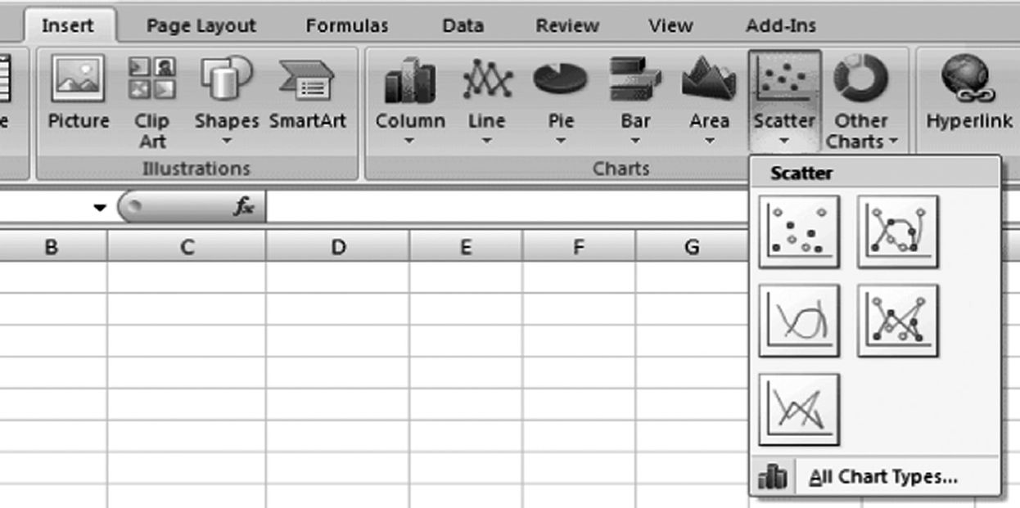

**FIGURE B.8** Scatter diagram in Excel 2007.

1. Click on the Insert menu from the Excel 2007 ribbon.
2. Select Scatter or Line from the list of available charts.
3. In the Chart menu, click the chart subtype you want to use.
4. Click Next and continue to complete the chart.
5. Format the graph according to the requirements and convenience.

One feature that is especially applicable for developing PCEs is to plot the data in an *x-y* scatter. You can then right-click on the plot line on the graph and check Add Trend Line from the dialog box. Excel will conduct a linear regression of those data points and display the equation of the line on the graph.

## MANAGING YOUR WORKSHEET AND WORKBOOK

A properly formatted worksheet not only allows the data to be more organized visu- ally, but also aids the reader in deciphering information more quickly. This section deals with a few basic formatting commands in Excel and provides a brief overview of their utility and functions. You should be familiar with the following basic format- ting functions in Excel:

* *Wrapping text in a cell.* This feature is used to wrap a label when it is too large to fit into a particular cell. For example, if the label for a cell is “Time Value of Money,” it may require more space than what is allocated by default in the active cell. Wrapping the text allows it to not be displayed across multiple rows on the sheet, thereby making it more visually compli- ant. The text wrapping command is located within the Alignment group, which in turn is located under the Home tab in the ribbon.
* *Formatting numbers.* The Number group on the Home tab provides the user with a plethora of numeric formats. The most commonly used formats for engineering economics are general, numbers, currency, accountancy, and percentages. Additionally, the user can specify the number of significant

digits to be displayed and round the number to the desired number of deci- mal places.

* *Merging and centering cells.* One of the more useful features of Excel is that it allows the user to merge a set of cells to accommodate a large text label. Once the cells are merged, they are then treated as a single cell for further calculation. One common use of this feature is to create a common heading for several columns in a table (Larsen, 2008).

## INTEREST RATES, TIME VALUE OF MONEY, AND IRR

Spreadsheets have become one of the principal tools for solving engineering eco- nomics problems along with making decisions based on engineering economics. The major advantages of using Excel for economic analysis are that it not only allows easy what-if calculations in a variety of decision-making situations, but also provides more powerful annuity factors than its tabulated counterpart, thereby considerably reducing the margin for error (Eschenbach, 2003). Other advantages of using spread- sheets include the ability to more easily construct a year-by-year cash flow table, easier calculation of time value of money and sensitivity analysis, and a more com- prehensive analysis of depreciation of assets and after-tax analysis. The subsequent sections of this appendix cover in detail the various ways that Excel spreadsheets can be applied to solve engineering economics problems.

It should be mentioned that a clear knowledge regarding the compounding period, the different types of interest, and how they are used in calculation are important in determining a financing decision or a project (see Chapter 2). For example, the bor- rower on a monthly basis generally repays a certain amount of money loaned from the bank, but most financial institutions use quarterly compounding for their savings account. However, because the interest rates are interrelated, knowing one can help you determine the others (Larsen, 2008). Excel’s time value of money functions can be used to determine and interchange the types of interest rates to handle a variety of options, including the ones stated above.

The interest rate per compounding period is called a periodic interest rate (see Chapter 2 for a discussion of *i*per). It depends on the compounding period and is determined by dividing the interest rate by the number of compounding periods. The nominal rate of interest can be defined as the rate of interest before the adjustment of inflation.* It can also be stated as the periodic rate multiplied by the number of compounding periods. When you work with the various economic analysis func- tions in Excel, use the terminology and equations shown in Chapter 2. All functions require that you use the appropriate interest rates, but the descriptions in Excel can be confusing. Use Equations 2.2 and 2.3 for the annual effective and periodic inter- est rates.

The effective annual interest rate (also called effective rate, or *i*eff; see Equation 2.2) can be defined as an investment annual rate of interest when compounding occurs more often than once a year.† In other words, it can be stated as the rate that produces

* <http://en.wikipedia.org/wiki/Nominal_interest_rate>

† <http://www.investopedia.com/terms/e/effectiveinterest.asp>

the same end-of-year value with a single interest payment as would be produced by more frequent periodic interest payments. Microsoft Excel has a built-in finan- cial function called EFFECT() that incorporates this and calculates the effective rate, given the nominal rate and the number of compounding periods, as shown in Examples B.1 and B.2 and Figure B.9.

Microsoft Excel 2007 has built-in functions that allow the user to toggle between the nominal and the effective annual interest rate. In other words, if the user is provided with the effective annual interest rate, he or she can use Excel’s built-in function to calculate the nominal annual interest rate from the given data. The built-in financial functions that can be used in this situation are EFFECT() and NOMINAL().

The NOMINAL() built-in function should be used only to convert an effective annual interest rate to the corresponding nominal rate. *It should not be used to determine the nominal rate from the periodic rate.* Users are advised to multiply the periodic rate by the number of compounding periods in order to arrive at the nominal rate. Furthermore, users should download the Excel Analysis Toolpack, available as an add-in, to successfully perform a variety of statistical and financial analyses.

The basic constitution of engineering economics comprises interest rates and the time value of money. Excel’s time-value-of-money functions allow the user to deter- mine the effect of interest rates on money as it moves through any specified time period (Larsen, 2008). The functions are available in the Financial functions list (located under the Formulas tab in the ribbon), as shown in Figure B.9.

Excel’s built-in financial functions help the engineering manager understand and calculate the present worth, annual worth, and future worth of any capital project, thereby facilitating more effective and efficient project selection. Additionally, a

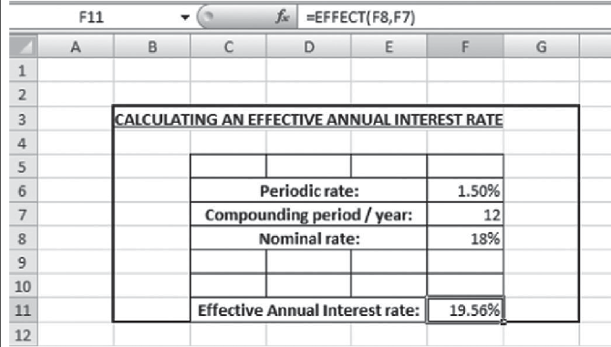

**EXAMPLE B.1**

What is the Effective Annual Interest rate for a financing opportunity that offers an interest of 1.50 % compounded monthly?

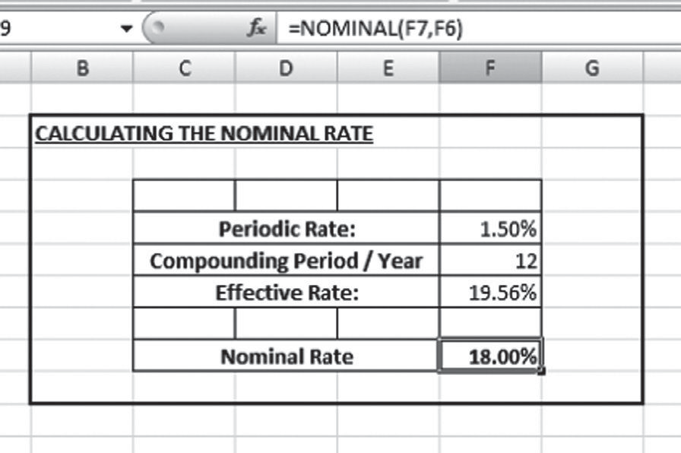

**EXAMPLE B.2**

What is the Nominal Annual Interest rate for a financing opportunity that offers an Effective Annual Interest Rate of 19.56%?

**Answer:**

comprehensive knowledge about determining the time value of money through the use of spreadsheets can substantially aid the engineering manager in making deci- sions regarding the worth of machinery or equipment after a certain time period, the cost effectiveness of any particular project, and the potential future benefit of any capital project. Time value of money can also be used to make decisions regarding a car or a house loan as well as repaying education loans. The following discussion provides further detail about the calculation of time value of money using Excel’s financial functions.

The net present value (NPV) of an investment is the total value of each of the cash flows for the investment represented in terms of today’s dollars.* In other words, NPV compares the value of a dollar today to the value of that same dollar in the future, taking inflation and returns into account.† NPV calculations make use of the discount rate, as will be shown later in this section. If the NPV of a prospective project is positive, it should be accepted. However, if the NPV is negative, the project should be rejected.

The NPV of capital projects can be calculated using the NPV() function in Excel. The NPV is similar to the PV (present value) function, which is also available in Excel (under financial functions). Unlike the variable NPV cash flow values, PV cash

* <http://www-personal.umich.edu/~kathrynd/UsingExcelsFinancialWizard.pdf>

† <http://www.investopedia.com/terms/n/npv.asp>

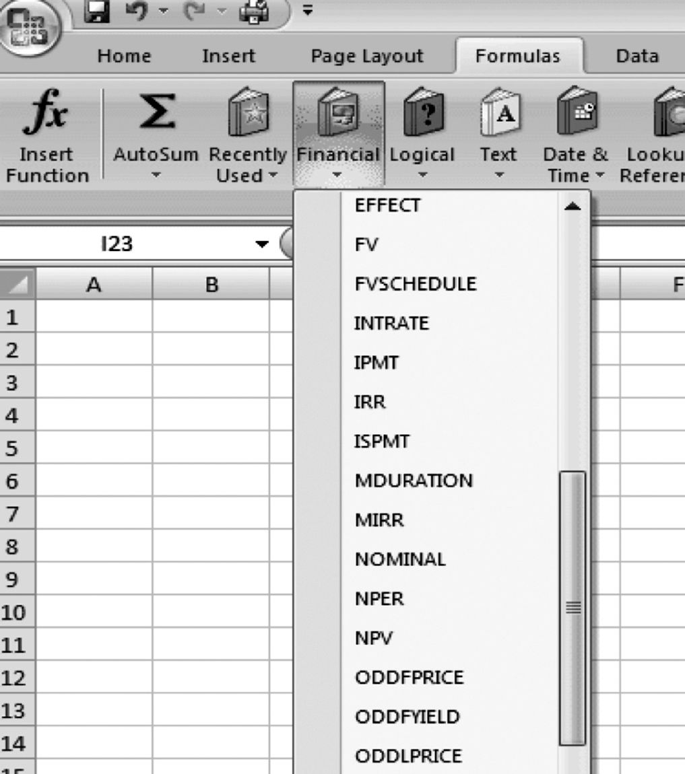

**FIGURE B.9** Financial functions in Excel.

flows must be constant throughout the investment.* This difference will be discussed in detail later.

As previously stated, the NPV of any project cash flow can be determined using the NPV() function, which has the following syntax:

Net present value = NPV(rate, value1, value2,…) (B.1)

where rate = MARR or the discount factor and value1, value2,… are 1 to 254 arguments representing the payments and income. Example B.3 provides a sim- ple NPV calculation using both the traditional PW formula as well as spreadsheet application.

Thus, it can be seen from Figure B.10 that the final value of NPV using the Excel financial NPV() function comes out to be exactly the same as the one arrived at using the traditional PW equation. Thus, the PW equation can be replaced by the NPV() function in Excel to facilitate calculations. This is especially true in cases of very long periods of cash flow.

Although similar in nature, the NPV and the PV functions in Excel have some basic differences. Both of them return the present value of an investment, but the

* <http://office.microsoft.com/en-us/Excel/HP052091991033.aspx>

**EXAMPLE B.3**

Calculate the Net Present Value or Present Worth (PW) of an investment that has an initial investment of $1,000, an annual cash inflow of $100, and a sal- vage value of $200. The life of the project is 5 years and the MARR associated with the project is 10%.

**Answer:**

**1. Traditional Method**

*PW*  *P*  *A* *P* , *i*, *n*  *S*  *P* , *i*, *n*

 *A*   *F* 

Hence,

*PW*  $1000  $100  *P* , 10%, 5  $200 *P* , 10%, **5**

 *A*



 *F*



Thus,

*PW*  $1000  ($100 * 3.7908)  ($200 * 0.6209)

*PW*  ($496.7**4**)

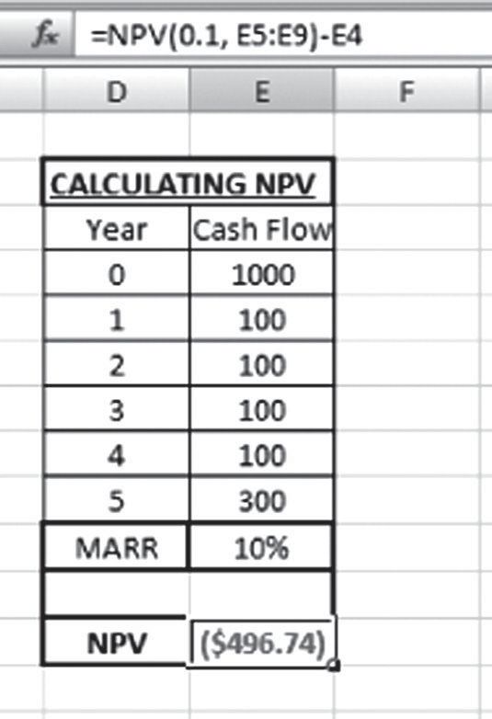

*Re salvage value of $200 is added to the final year’s cash* flow ($100

+ $200 = $300)

*Re initial investment is deducted from the NPV cash flow as stated earlier*

**FIGURE B.10** Calculating NPV using Excel.

PV() function preferably should be used only if there is a uniform cash flow span- ning over the given time period. In addition, when determining the present worth of a project using the PV() function, consider the uniform annual cash flows as cash inflows (hence, they have a positive sign) and thus must be inserted with a negative sign. The syntax of the PV() function in Excel is

Present value = PV(rate,nper,pmt,fv,type) (B.2)

where rate = MARR, nper = number of years, pmt = uniform annual cash flow, fv = the cash balance you want to attain after the last payment is made, and type = numbers 0 and 1, which basically indicate when the payments are due (a value of 0 indicates an EOY payment, whereas a value of 1 indicates the payments being made at the beginning of year). At this point, Example B.3 will be revisited and the problem will be solved using the PV() function in Excel. The solution is provided in Figure B.11.

As you can see in Figure B.11, using the PV() function results in the same answer. The NPV() function is simpler to use than its PV() counterpart; thus, you are advised to use the NPV() function for the sake of simplicity. However, you are welcome to use the PV() function to verify the answer obtained with NPV().

When using the PV() function in Excel, you must use blank spaces for the vari- ables that are absent from the data set. If you ignore the blank spaces, Excel may interpret the formula variables differently than you intended, thereby resulting in an incorrect value for NPV.

One of the most commonly used concepts in the domain of financial decision making is that of amortization. Whether you are applying for a loan to finance an investment or the mortgage for a house, regular uniform payments often hold the key

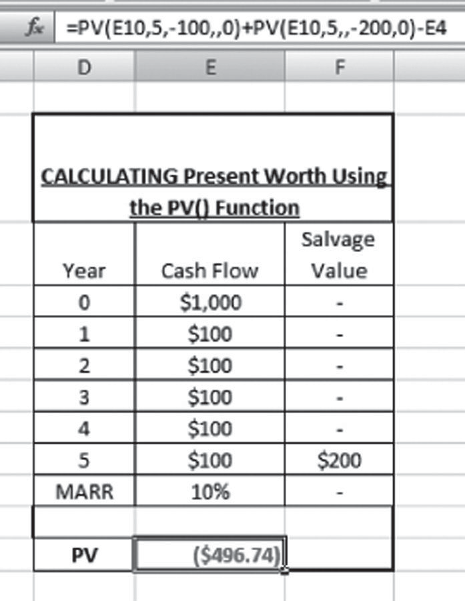

*Important: Since there is no annual value, the place is left blank*

*Important: Since there is no future value, the place is left blank*

*Note that the cash flows are inserted as negative and so is the salvage value*

**FIGURE B.11** Solving Example 2.3 using the PV() function.

to a proper analysis of any financial investment decision. Microsoft Excel provides users with a built-in financial function that aids in determining the uniform pay- ments required over time. The PMT() function in Excel can be used to determine the annual worth of a project based on a series of uniform payments and a constant interest rate.

The syntax for the PMT() function in Excel is

Annual worth = PMT(rate,nper,PV,FV,type) (B.3)

where rate = effective interest rate, nper = number of periods, PV = initial invest- ment, FV = future value of the investment (optional), and type = numbers 0 and 1, which basically indicates when the payments are due (a value of 0 indicates an EOY payment, whereas a value of 1 indicates payments will be made at the beginning of the year). Example B.4 presents a simple annual worth calcula- tion problem using both the traditional AW formula and the PMT() spreadsheet function.

Use of the PMT() function results in the same answer. The PMT() function is simpler than the traditional method and thus you are advised to use the PMT() func- tion to calculate the annual worth of a financial investment decision. When you use the PMT() function in Excel, you must use blank spaces for the variables absent in the data set. This is shown in Figure B.6. If you ignore the blank spaces, Excel may interpret the formula variables differently than you intended, thereby resulting in an incorrect equivalent annual value, or AW.

**EXAMPLE B.4**

Calculate the Annual Worth of a financial project that has an initial investment of $1,000 with an annual cash inflow of $300 and a salvage value of $350. The life of the project is 5 years and the interest associated with the project is 10%.

**1. Traditional Method**

*AW*  *A*  *P*  *A* , *i*, *n*  *S*  *A* , *i*, *n*

 *P*   *F* 

Hence,

*AW*  $300  $1000 , 10%, 5  $350 , 10%, 5



*A*





*A*

*P*

*F*



Thus,

*AW*  $300  ($1000 * 0.2638)  ($350 * 0.1638)

***AW***  $**93.53**

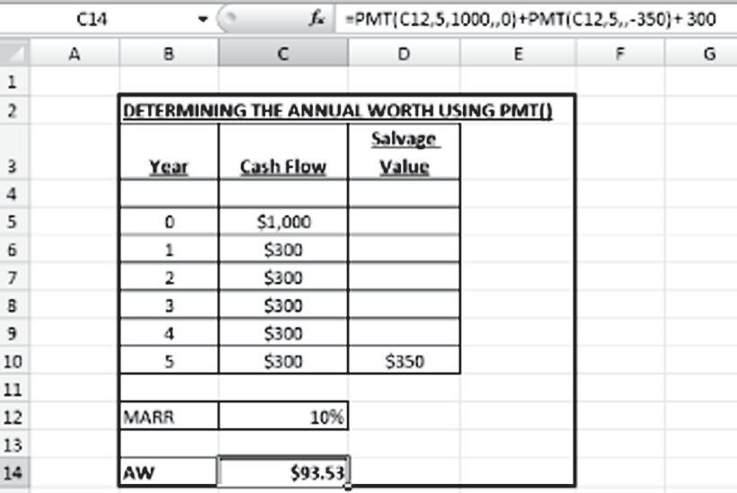

**2. Spreadsheet Method**

*Note that the initial in*

*inserted as positive an*

*value is negative*

*blank*

*Important: Since there is no*

*present value, the place is left*

*blank*

*future value, the place is left*

*Important: Since there is no*

*vestment is*

*d the salvage*

*s (A) are*

*ack*

*ting*

*added b*

*annuitie*

*Re exis*

The future value of a project can be stated as the value of a cash flow stream at the end of a given time period. Microsoft Excel’s FV() function provides the user with easy calculations of a future value when given the present value, the rate of interest, and the number of compounding periods. The syntax of Excel’s FV() function is given as

Future value = FV(rate,nper,PMT,PV,Type) (B.4)

where rate = interest rate, nper = number of periods (*n*), PMT = the annuities, PV = initial investment, and type = numbers 0 and 1, which basically indicate when the payments are due (a value of 0 indicates an EOY payment, whereas a value of 1 indicates the payments are made at the beginning of the year). Example B.5 provides a simple future worth calculation problem using both the traditional FW formula as well as the FV() spreadsheet function.

**EXAMPLE B.5**

Calculate the Future Value of Future Worth of a financial project that has an initial investment of $1,000 with an annual cash inflow of $500 and a salvage value of $700. The life of the project is 5 years and the MARR associated with the project is 10%.

**1. Traditional Method**

*FW*  *S*  *A* , *i*, *n*  *P* , *i*, *n*



*F*

*A*





*F*

*P*



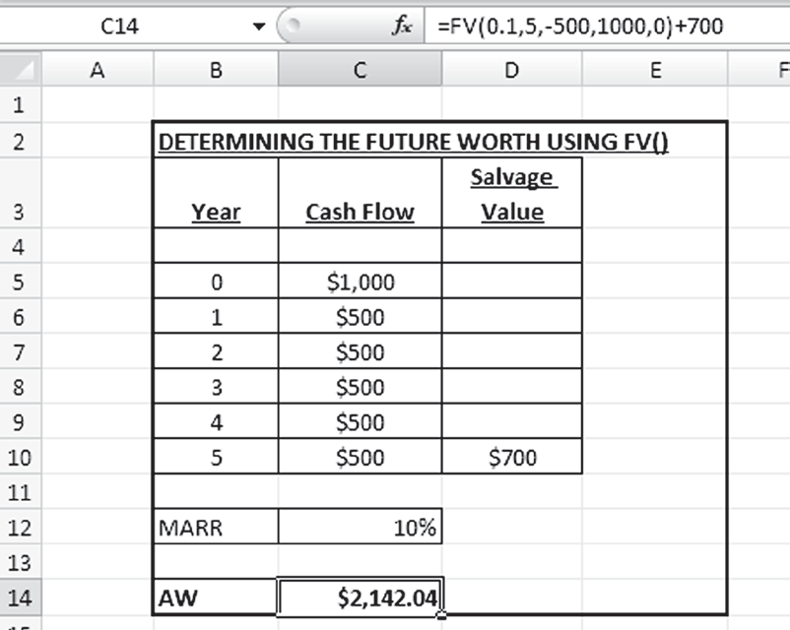

Hence,

*FW*  $700  $500 , 10%, 5  $1000 , 10%, 5



*F*

*A*





*F*

*P*



Thus,

*FW*  $700  ($500 * 6.0151)  ($1000 *1.6105)

***FW***  $**2142.04**

**2. Spreadsheet Method**

*Note that the initial investment is inserted as positive and the cash inflows are negative*

*value back*

*Re salvage*

*(S) is added*

FW

As can be seen from the example, the same answer is obtained using the FV() function. When you use the FV() function in Excel, you must use blank spaces pre- ceded and followed by commas for the variables absent in the data set. If you ignore the blank spaces, Excel may interpret the formula variables differently than you intended, thereby resulting in an incorrect value for FW.

* + 1. **CALCULATING THE RATE OF RETURN FACTORS USING EXCEL**

One of the most important components of time-value-of-money calculations is the rate of return factors. The rate of return factors are used to move around a certain sum of money over time, either through spreading it over a given time period (the annuity factors) or to determine the present worth of a future sum of money (present worth factors). Table B.2 contains the commonly used rate of return factors, their mathematical formulas, and their Excel functions for present worth, annuity, and the future worth factors.

The internal rate of return (IRR) can be determined using Excel’s built-in IRR() function. IRR can be stated as the interest rate for which the present worth (PW/NPV/PV) of a project is zero. Although the method of interpolation is commonly

#### TABLE B.2

**Commonly Used Rate of Return Factors (without Gradients)**

**Name of Factor**

**Factor Symbol**

**Functional Format**

**Factor**

**Formula Excel Function**

**Present Worth Factors for Discounting**

Single payment P/F (*P*/*F*,*i*,*N*) 1

(1  *i*)*N*

= PV(*i*,*N*,0,*FV*,0)

Uniform series (annuity)

P/A (*P*/*A*,*i*,*N*) (1  *i*)*N*  1

*i*(1  *i*)*N*

= PV(*i*,*N*,Pmt,0,0)

**Future Worth Factors for Compounding**

Single payment F/P (*F*/*P*,*i*,*N*) (1 + *i*)*N* = FV(*i*,*N*,0,PV,0)

Uniform series (annuity)

F/A (*F*/*A*,*i*,*N*) (1  *i*)*N*  1 i

**Annuity Factors for Uniform Series**

= FV(*i*,*N*,Pmt,0,0)

Capital recovery A/P (*A*/*P*,*i*,*N*) *i*(1  *i*)*N*

(1  i)*N*  1

Sinking fund A/F (*A*/*F*,*i*,*N*) i

(1  *i*)*N*  1

= PMT(*i*,*N*,PV,0,0)

= PMT(*i*,*N*,0,FV,0)

used to determine the IRR, Excel’s built-in IRR() function can return the IRR value given the basic financial data of a project, such as initial investment, annuities, and salvage value. The cash flows used to determine IRR, although not required to be even, must occur at regular intervals, such as monthly or annually. The IRR is the interest rate received for an investment consisting of payments (negative values) and income (positive values) that occur at regular periods.* The syntax for the IRR() vfunction in Excel is given by

Internal rate of return = IRR(value1, value2, value3,…) (B.5)

where values = the cash flows (including the initial investment and salvage value, if any) associated with the project guess (a number that can be guessed as a close one to the final IRR value). Example B.6 presents a simple IRR calculation problem using both the traditional interpolation method as well as the IRR() spreadsheet function.

**EXAMPLE B.6**

Determine the IRR for an economic project that has an initial investment of

$1,500 and a periodic cash inflow of $500 for 5 years. The salvage value for the project is $200, which is recovered at the end of the project’s life.

* <http://office.microsoft.com/en-us/Excel/HP100623651033.aspx>

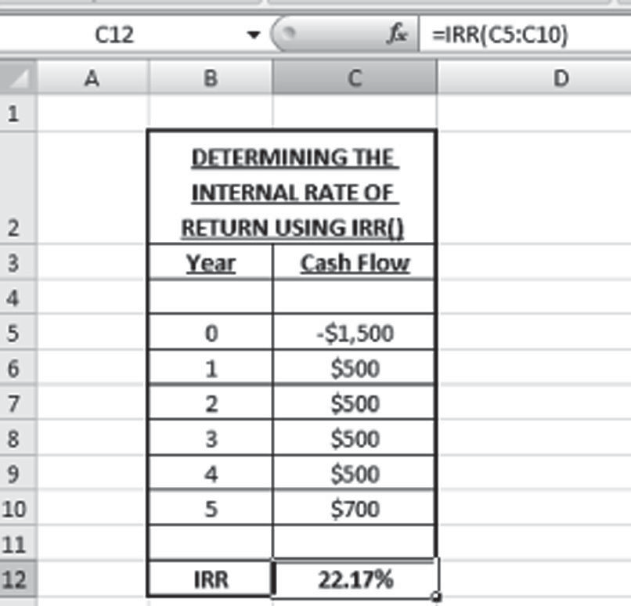

*Note that the salvage value is added to the final year’s cash flow*

*Note that the initial investment is entered as a negative value*

When you use Excel’s IRR() function to determine the IRR, remember that the initial investment is entered as a negative number and the salvage value of the project is added to the final year’s cash flow.

## SENSITIVITY ANALYSIS USING THE EXCEL SPREADSHEET FUNCTION

The premise of any sensitivity analysis problem lies in the “what-if” concept of deci- sion making. Excel spreadsheets, through the use of the built-in function called Table (or Data Table in Excel 2007), incorporates the idea of what-if and thereby can be used successfully to determine the impact of any input parameters to the final value of the output. The Table function in Excel 2007 can be found under the ribbon titled Data, as shown in Figure B.5. (In Excel 2003, it is located under the Data drop-down menu.)

Next we will solve a simple problem on sensitivity analysis (provided in Example B.7) using the Table function in Excel.

**EXAMPLE B.7**

ABC Inc. is planning to invest in a financial project that is worth $100,000. The project will yield annual revenue of $20,000 and has a planning horizon of 10 years. The MARR of the project is 20%. Determine the impact of (a) varying the initial investment, (b) the annual revenue from –10% to + 10% (at an increment of 5%) and the time horizon from 8–12 years. Consider Present Worth as the figure of merit (FOM)

In order to solve this problem, the Data Table function available in MS Excel® was used. The problem requires the readers to determine the impact of the variables on the Present Worth of the investment decision. Thus, the first step of solving the problem was to determine the Present Worth (PW) of the project based on the data provided in the problem statement, i.e., the initial investment, the MARR, the annual revenue and the planning horizon. This will serve as the base case of the sensitivity analysis problem.

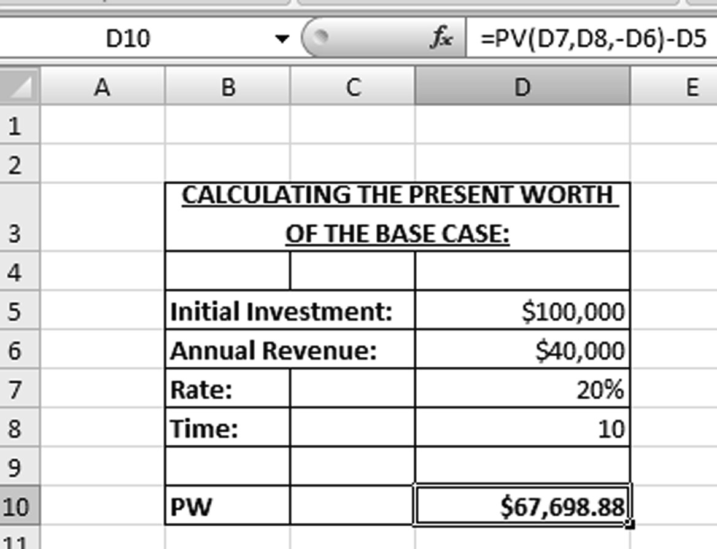

Now that the base case of the investment project has been determined, the next step is to use the Data Table function to perform the sensitivity analysis on the three inputs stated in the problem; namely, initial investment, annual revenue, and plan- ning horizon. Figure B.12 shows the results of the sensitivity analysis using the Data Table function.

The data from Figures B.13 through B.15 indicate the changes in the present worth with respect to the changes in various input variables (initial cost, annual revenue, and planning horizon, in this case). These values can be used by deci- sion makers to arrive at sensitivity ratios, which may serve as an indicator of

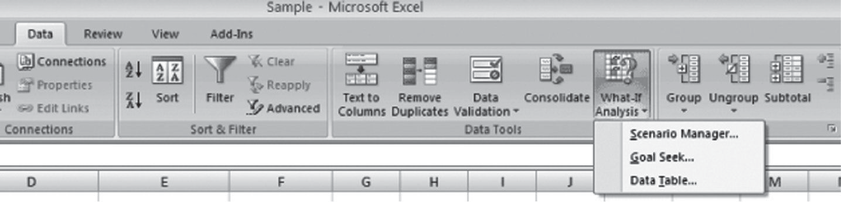

**FIGURE B.12** Data table in Excel 2007.

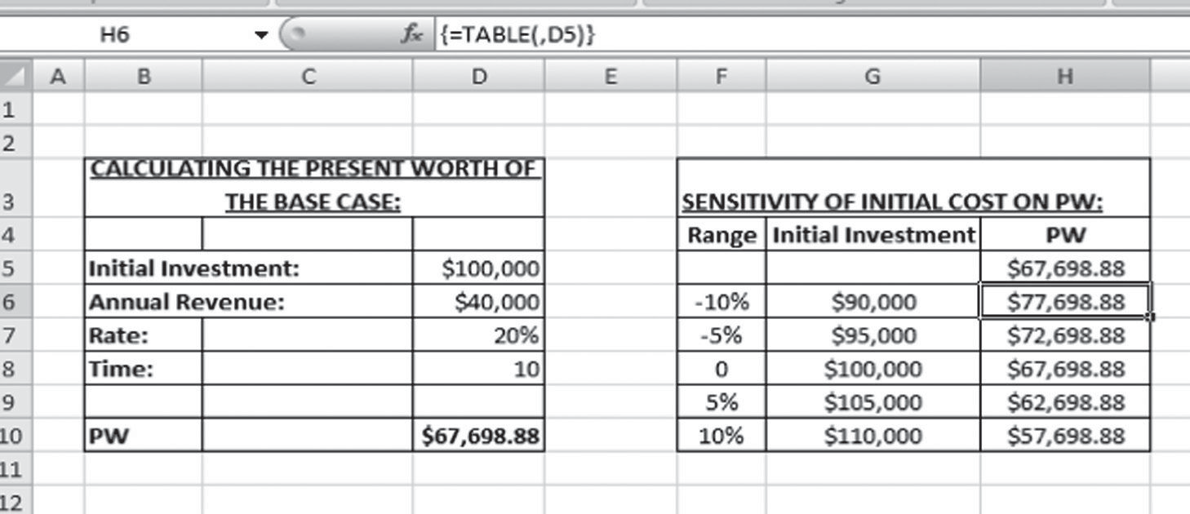

**FIGURE B.13** Sensitivity of initial investment (cost) on PW.

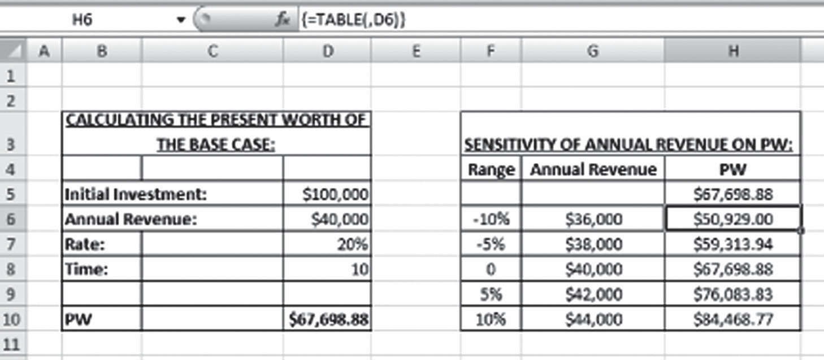

**FIGURE B.14** Sensitivity of annual revenue on PW.

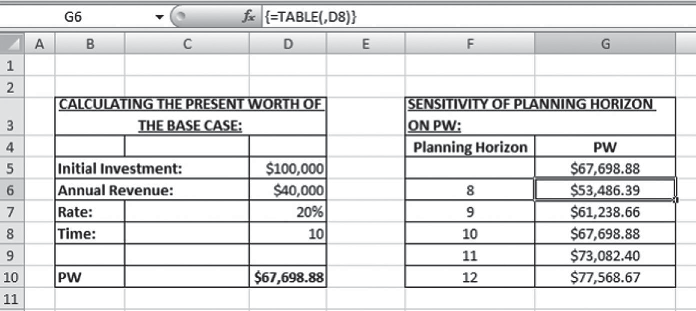

**FIGURE B.15** Sensitivity of planning horizon on PW.

relative sensitivity among the different input variables, as will be discussed later. Strictly adhere to the following guidelines when constructing sensitivity tables in Excel:

* *Perform the base case calculation at the beginning*. For a successful implementation of the Data Table function, the cells from the base case solu- tion should be relatively referred (as indicated by arrows in Figure B.15).
* When you are selecting the data range in the table function, *do not include the header rows in the selection range*. Doing so will result in Excel calcu- lating the wrong values of the output.
* The values of the input parameters (say, the values of initial cost from a range of –10% to +10%) should be *hardcoded* (not cell-referred or math- ematically calculated). Use the Excel command Paste Special—Values to transfer the data from any mathematically calculated source.
* Since the common convention is to arrange the data by columns, in the Data Table window, the cell of the argument for which the sensitivity is studied should be mentioned as a column input cell.

The relative sensitivity graph is considered one of the most common and useful diagrams for displaying the results of a sensitivity analysis in which more than one variable was examined (Lang and Merino, 1993). The graphing ability of Excel is a useful tool in the construction of the relative sensitivity graph. Excel’s scatter plot functionally, located under the Insert ribbon in Excel 2007 (and the Insert menu in Excel 2003), is used to draw relative sensitivity graphs. Figure B.16 shows a relative sensitivity graph for two of the three parameters used in Example B.5 —initial cost and annual revenue—on the figure of merit (PW in this case).

As seen from Figure B.16, the decision maker can get a clear idea about the degree of sensitivity of any particular parameter by looking at the slope of the graph. The steeper the slope of the sensitivity graph, the more sensitive is that particular param- eter. For example, from the figure, it can be stated with a fair degree of certainty that the annual revenue is more sensitive than the initial cost for the project described in Example B.6. Finally, the base case is the value that corresponds to 0% in the graph.

Knowing how to use spreadsheets to solve basic engineering economic problems like the time value of money, coupled with the knowledge of asset depreciation and sensitivity analysis, can go a long way in assisting the engineering (and finance) manager to make more rational choices regarding project selection and more sound investment decisions.

## ADDITIONAL FUNCTIONS OF TIME VALUE OF MONEY

Although most of the important functions with respect to the interest rate and time value of money were discussed in Chapter 2, a brief discussion follows on three more of Excel’s financial functions that deal with loan repayments and amortization. All organizations borrow a certain amount of money from venture capitalists to finance their projects, which they subsequently pay back over a certain period of time and

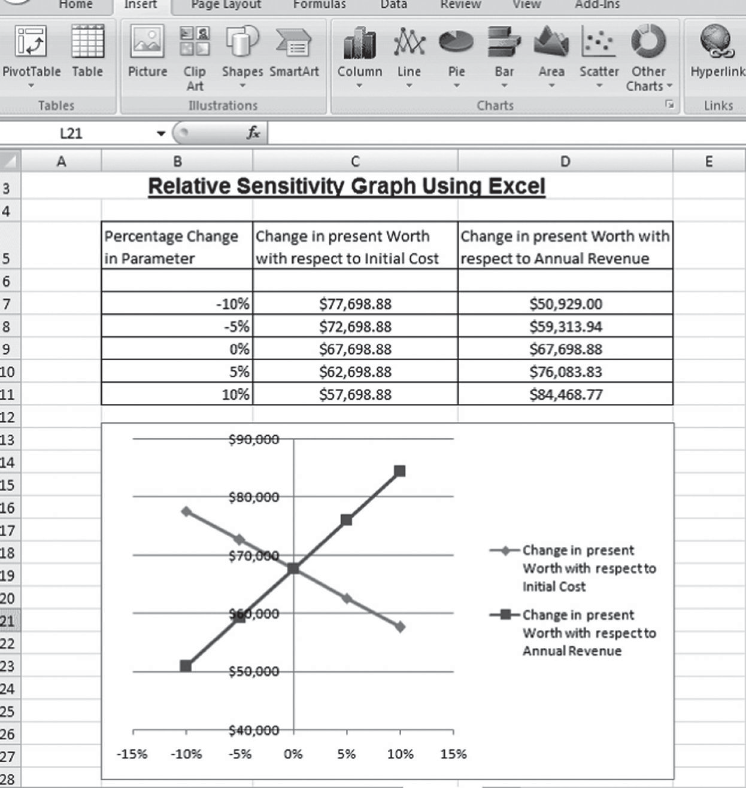

**FIGURE B.16** Relative sensitivity graph.

at a certain rate of interest. Thus, having knowledge about the interest rate and the principal payment associated with the borrowed capital will prove helpful to any managerial decision maker in an organization. The following subsections present three basic financial functions in Excel associated with borrowing capital funds and subsequently repaying them.

The interest rate for an annuity can be calculated using Excel’s **=**Rate() function. The =Rate() function returns the interest rate per period of an annuity.* The syntax of the =Rate() function in Excel is provided by

Rate = Rate(nper,pmt,PV,[FV],Type,[guess]) (B.6)

where nper = number of periods, pmt = annual payment amount, PV = present value, FV = future value, and type = numbers 0 and 1, which basically indicates when the

* <http://office.microsoft.com/en-us/excel/HP052092321033.aspx>

payments are due (a value of 0 indicates an EOY payment, whereas a value of 1 indicates payments being made at the beginning of the year). Example B.8 presents a simple application of the =Rate() function in Excel.

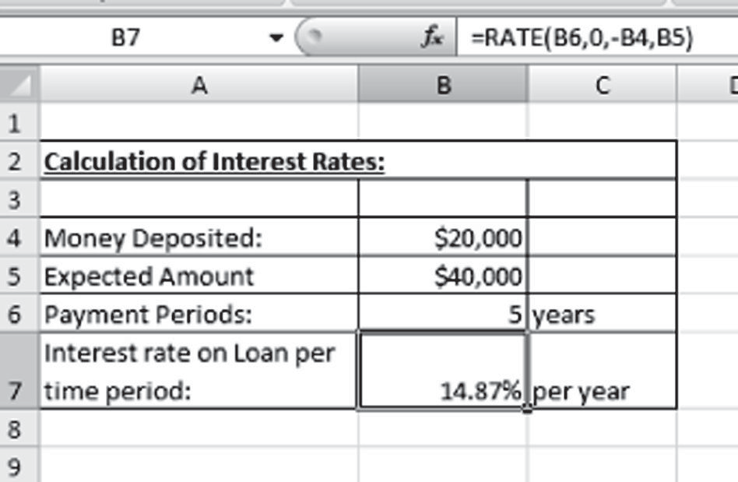

**EXAMPLE B.8**

Mr. ABC wants to invest $20,000 and would like it to get it doubled within the next 5 years. What periodic interest rate does Mr. ABC need to receive in order to get his money doubled within the given time period.

In order to solve this problem, we use the **=Rate()** function in Excel®. The rate function is given below:

*Re initial amount is taken as negative as it is considered as a cash outflow y Excel*

*Re annual payment is considered as zero since it is not mentioned in the problem*

Mr. ABC has to receive an annual interest rate of 14.87% in order for his money to double in 5 years.

The amount of interest paid on a loan is an important concern to the borrower. Excel’s =IPMT() function can help an investor assess the interest he or she will have to pay on the amount of money loaned. Knowing the periodic interest rate prompts the investor to decide whether to borrow the funds. On the other hand, a financial institution can assess the interest rate to decide whether the loan is worth providing. The syntax for Excel’s =IPMT() is given as

Interest on loan = IPMT(rate,per,*n*per,PV,FV,Type) (B.7)

where rate **=** interest rate per period, per = is the period for which the interest is calculated, *n*per = is the total number of payment periods in an annuity, PV = pres- ent worth, FV = future worth, and type = is the number 0 or 1 and indicates when payments are due. If type is omitted, it is assumed to be 0. Example B.9 provides a simple example of calculation of interest on loans using an Excel spreadsheet.

**EXAMPLE B.9**

An investor borrows $2,500 at an interest of 8% APR. Using Equation A-2, determine the interest on borrowed capital that the investor has to pay for year 1 and 2.

Interest for Year 1:

*Interest on Loans* = *IPMT* (0.08, 1, 2, 2500) = −$200.00 Interest for Year 2:

*Interest on Loans* = *IPMT* (0.08, 2, 2, 2500) = −$103.85

The **=IPMT()** function in Excel® returns a negative value for the interest amount. The rationale behind this negative value is that interest amount paid is considered as a cash outflow.

Much like the amount of periodic interest to be paid on a loan, the periodic princi- pal payment is vitally important information for the investor. Excel’s =PPMT() helps the investor determine the periodic principal repayment on the loan. The =PPMT() function returns the payment on the principal for a given period for an investment based on periodic, constant payments and a constant interest rate.* The syntax of the

=PPMT() function in Excel is

Principal payment on loans = PPMT(rate,per,nper,PV,FV,Type) (B.8)

where rate **=** interest rate per period, per = the period for which the interest is calcu- lated, nper = the total number of payment periods in an annuity, PV = present worth, FV = future worth, and type = the number 0 or 1 and indicates when payments are due. If type is omitted, it is assumed to be 0. At this point, we revisit Example B.8 and calculate the principal payment based on the *problem data*.

Principal for Year 1:

Interest on loans = PPMT(0.08,1,2,2500) = –$1201.92 Principal for Year 2:

Interest on loans = PPMT(0.08,2,2,2500) = –$1298.08

The = PPMT() function in Excel returns a negative value for the principal pay- ment. The rationale behind this negative value is that the principal amount paid on the loan is considered a cash outflow.

* <http://office.microsoft.com/en-us/excel/HP052092181033.aspx>

Excel’s =NPER() function can be used to calculate the number of periods of any investment of a loan. The =NPER() function returns the number of periods for an investment based on periodic, constant payments and a constant interest rate. The syntax of the function is as follows:

Number of periods = NPER(rate,pmt,PV,FV,type) (B.8)

where rate = interest rate per period, per = the period for which the interest is calcu- lated, nper = the total number of payment periods in an annuity, PV = present worth, and type = the number 0 or 1 and indicates when payments are due. If type is omit- ted, it is assumed to be 0. Example B.10 provides a simple problem for calculating the number of periods of an investment. Thus, the number of periods required to pay off the loan is 27.33 (approximately 28) months.

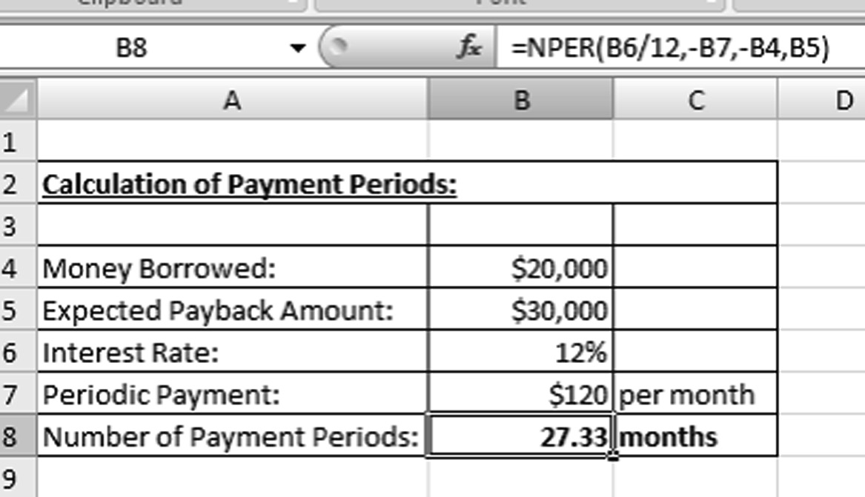

**EXAMPLE B.10**

A friend of yours lends you $20,000. You end up paying $30,000 at an annual interest rate of 12% with a monthly payment of $120. What is the number of payments that are required to pay off the loan?

When you use the =NPER() function in Excel, note that there are negative signs imposed before the periodic payment rate and the amount of funds borrowed. The rationale behind this negative value is that they are considered a cash outflow. You should use *i*per rather than simply dividing the interest by 12 when dealing with a monthly payment, interest payment, or period determination.

## REFERENCES

Eschenbach, Ted G. 2003. *Engineering Economy: Applying Theory to Practice*. New York: Oxford University Press.

Larsen, Ronald W. 2008. *Engineering with Excel*. Upper Saddle River: NJ: Prentice Hall.

**MANUFACTURING AND INDUSTRIAL ENGINEERING**

**Systems Life Cycle Costing**

**Economic Analysis, Estimation, and Management**

### Although technology and productivity have changed much of engineering, many topics are still taught very similarly to how they were taught in the 1970s. Using a new approach to engineering economics, **Systems Life Cycle Costing: Economic Analysis, Estimation, and Management** presents the material that a modern engineer must understand to work as a practicing engineer conducting economic analysis.

Organized around a product development process that provides a framework for the material, the book presents techniques such as engi- neering economics and simulation-based costing (SBC), with a focus on total life cycle understanding and perspective, and introduces techniques for detailed analyses of modern complex systems. The author includes rules of thumb for estimation grouped with methods, processes, and tools (MPTs) for conducting a detailed engineering buildup for costing. He covers how to estimate costing of complex systems and software and then explores concepts such as design to cost (DTC), cost as an indepen- dent variable (CAIV), the role of commercial off-the-shelf technology, the cost of quality, and the role of project management in life cycle cost (LCC) management.

### No product or services are immune from cost, performance, sched- ule, quality, risks, and tradeoffs. Yet engineers spend most of their formal education focused on performance and most of their professional careers worrying about resources and schedules. Too often, the design stage becomes about the technical performance without considering the down- stream costs that contribute to the LCC of a system. This text presents the methods, processes, and tools needed for the economic analysis, estimation, and management that bring these costs in line with the goals of pleasing the customer and staying within budget.



an **informa** business [www.taylorandfrancisgroup.com](http://www.taylorandfrancisgroup.com/)

6000 Broken Sound Parkway, NW Suite 300, Boca Raton, FL 33487

711 Third Avenue New York, NY 10017

K11422

ISBN: 978-1-4398-2891-5

90000

9 781439 828915

w w w . c r c p r e s s . c o m

2 Park Square, Milton Park Abingdon, Oxon OX14 4RN, UK